(nR, nROO, QOOH1, O2QOOH1) ordered at different times

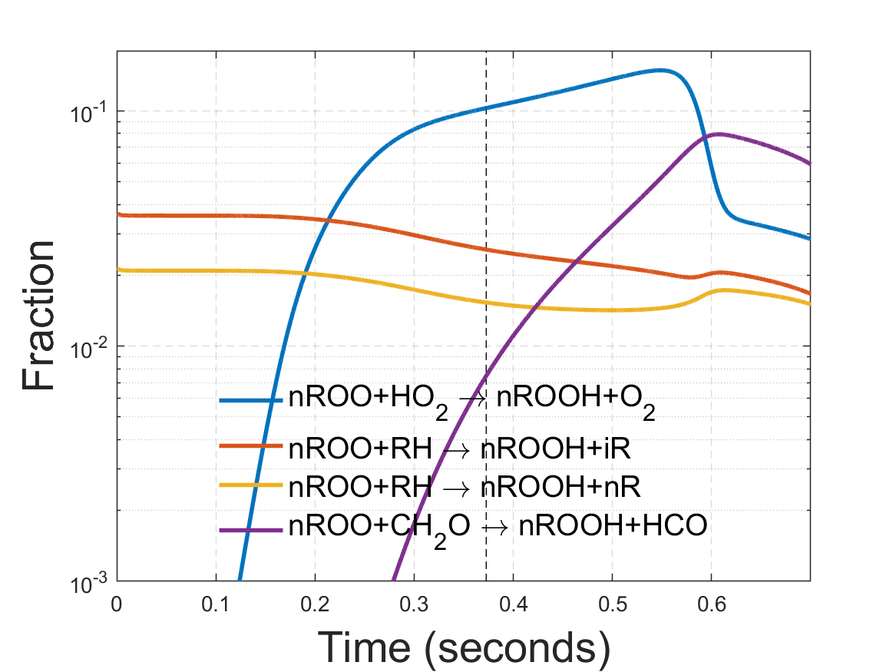

(iR, iROO) ordered at different times

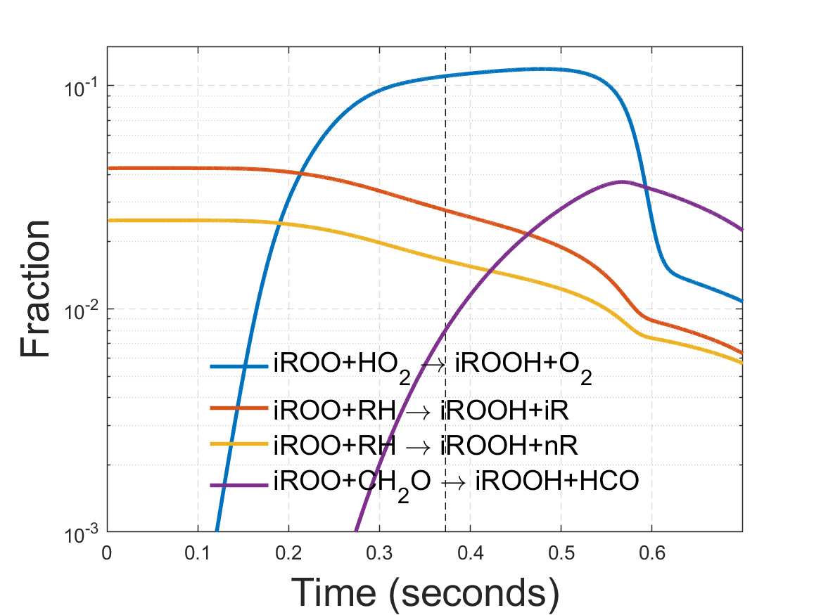

(CH3, CH3OO) ordered at different times

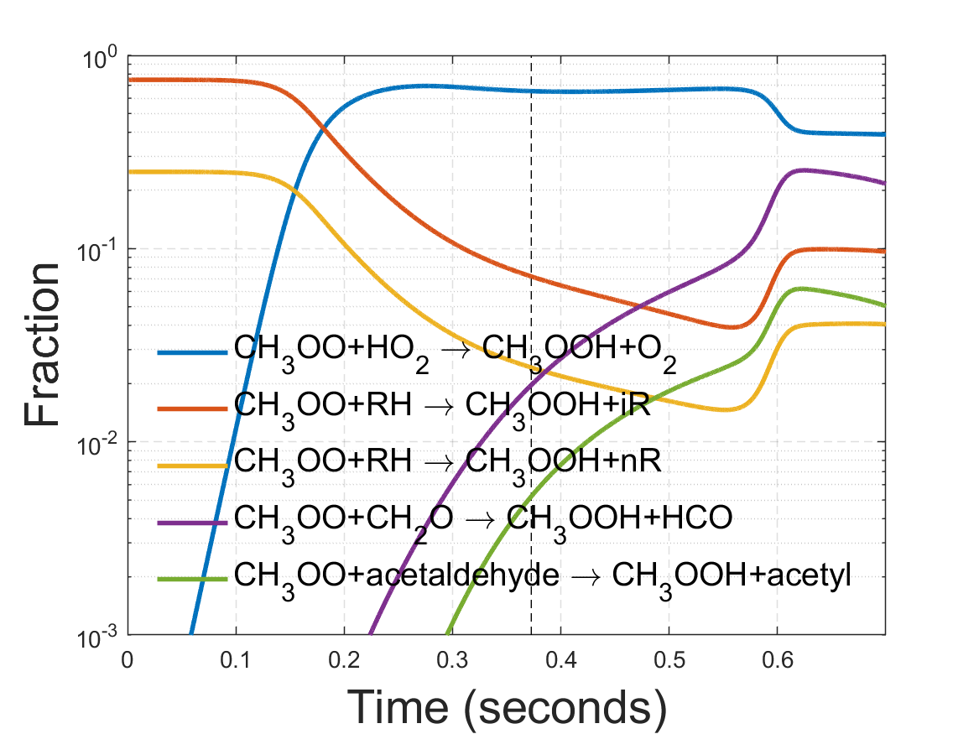

(C2H5, CH3CH2OO) ordered at different times

