Question 1. How much difference it will make using full picture compared to using limited number of species and reactions from Merchant paper. In other words, how much important chemistry is missing in Merchant paper?

This is not a trivial question. First, non-negligible numbers of OH source reaction are missing in the Merchant cycle. Second, significant n-propyl sink reaction is not included. Which means it is not a simple plus or minus issue that more complete picture of the npropyl chemistry in stage1A shall be considered. This chemistry, is completely described by SOHR, that takes time-dependent species propensity function, time-ordered reaction sequence, and time-dependent branching ratio into account.

Table . Table 1. Top 5 source of OH pathway missing in Merchant f.

|  |  |
| --- | --- |
| Pathway Index | Pathway |
| 5 | [npropyl]<-chattering->[well_1]well_1=>HO2+prod_2-->[prod_2]prod_2=>allyloxy+OH-->[allyloxy]<-chattering->[allyloxy]allyloxy=>acrolein+H-->[acrolein] |
| 7 | [npropyl]<-chattering->[npropyloo]npropyloo+C3H8=>npropylooh+ipropyl-->[npropylooh]npropylooh=>npropyloxy+OH-->[npropyloxy]npropyloxy=>C2H5+CH2O-->[CH2O] |
| 8 | [npropyl]<-chattering->[npropyloo]npropyloo=>OH+propoxide-->[propoxide] |
| 9 | [npropyl]<-chattering->[npropyloo]npropyloo=>QOOH_2-->[QOOH_2]<-chattering->[QOOH_2]QOOH_2=>OH+propoxide-->[propoxide] |
| 13 | [npropyl]<-chattering->[QOOH_1]O2+QOOH_1=>OH+OH+frag_1-->[frag_1]<-chattering->[frag_1]frag_1=>vinoxy+CH2O-->[CH2O] |

Table . Top 5 sink of OH pathway missing in Merchant f.

|  |  |
| --- | --- |
| Pathway Index | Pathway |
| 11 | [npropyl]<-chattering->[npropyloo]npropyloo+C3H8=>npropylooh+ipropyl-->[ipropyl]<-chattering->[ipropyl]O2+ipropyl=>HO2+C3H6-->[C3H6] |
| 63 | [npropyl]<-chattering->[npropyl]npropyl=>CH3+C2H4-->[C2H4] |
| 93 | [npropyl]<-chattering->[npropyl]npropyl+C3H8=>ipropyl+C3H8-->[ipropyl]<-chattering->[ipropyloo]ipropyloo=>HO2+C3H6-->[C3H6] |
| 153 | [npropyl]<-chattering->[npropyl]npropyl=>H+C3H6-->[C3H6] |
| 260 | [npropyl]<-chattering->[well_1]well_1=>HO2+prod_2-->[prod_2]prod_2=>acrolein+H2O-->[acrolein] |

Table 3. Two pathways Merchant cycle corresponds to.

|  |  |  |
| --- | --- | --- |
| Pathway Index | #OH produced | Pathway |
| 1 | 3 | [npropyl]<-chattering->[well_1]well_1=>OH+prod_1-->[prod_1]<-chattering->[frag_1]frag_1=>vinoxy+CH2O-->[vinoxy]vinoxy+O2=>CH2O+CO+OH-->[CO] |
| 2 | 3 | [npropyl]<-chattering->[well_1]well_1=>OH+prod_1-->[prod_1]<-chattering->[frag_1]frag_1=>vinoxy+CH2O-->[vinoxy]vinoxy+O2=>CH2O+CO+OH-->[CH2O] |

Since Merchant defines f as

$$f=3αβ$$

Then only two pathways enumerated in Table 1 can be inferred. Use only these two pathways, we calculated the f value.

Table 4. f from selected pathways and top 500 pathways.

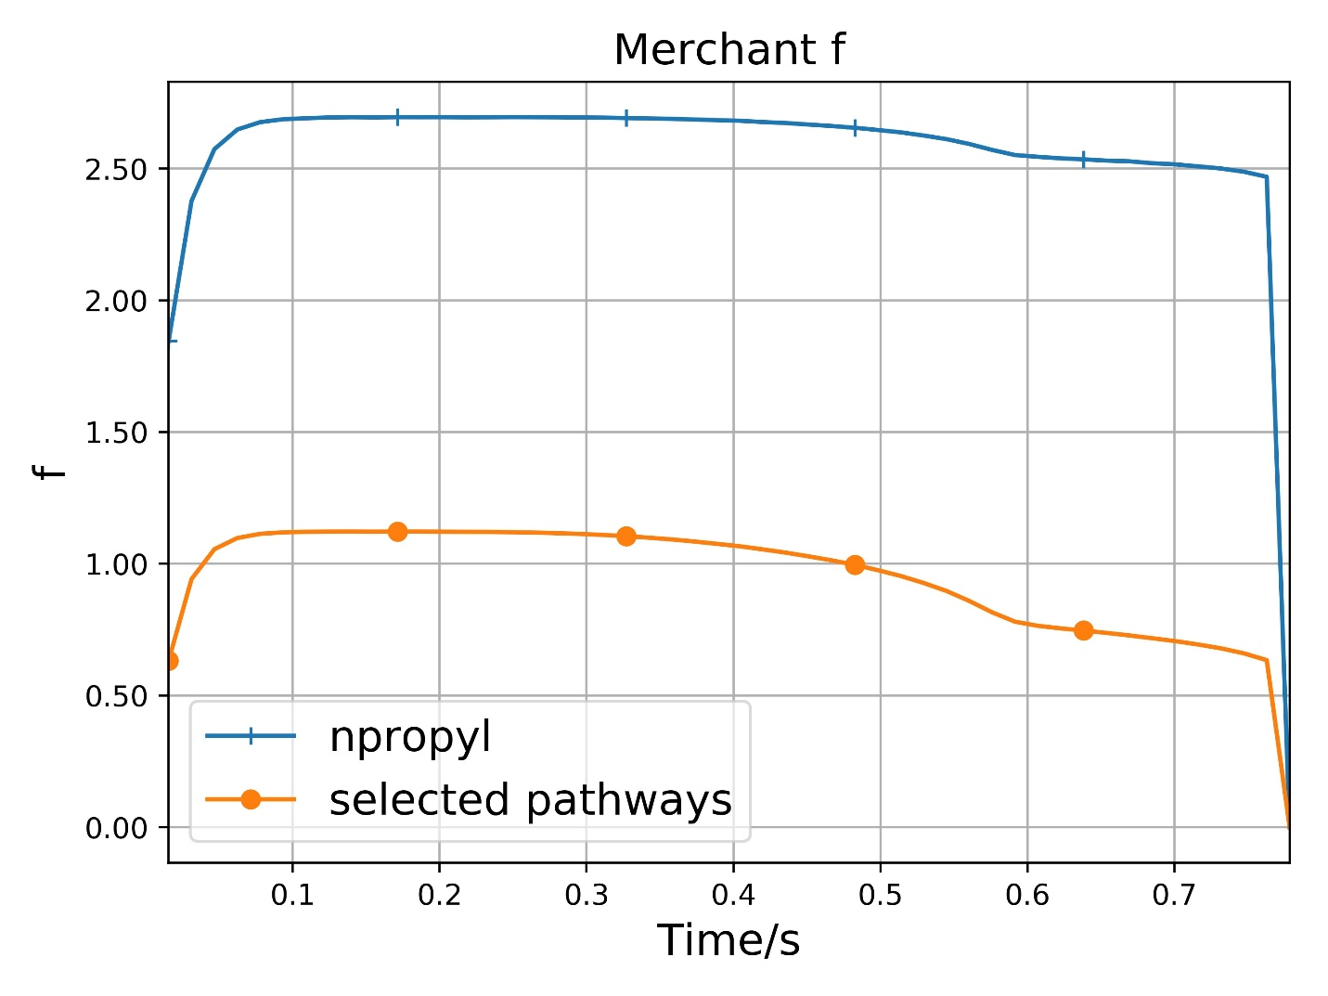

Question 2. How important is the time-dependent effect?

This question can be divided into two question. Time-dependent network question and sum-over-histories effect.

??? How important is time-dependent effect of reaction network?

Probably not too much.

???Question 3. How important is the sum-over-histories effect?

Pathway probability tells the story. In terms of f value, shall decompose f into individual pathway contribution and analyze.