## Supplemental Material for Merchant et al. “Understanding Low-Temperature First-Stage Ignition-Delay: Propane”.

**Validation of the Full Propane Model**

The full propane model used in this work gives reasonable predictions against low temperature ignition delay data obtained using rapid compression machine as seen from Fig below

**Figure 16**: Comparison of experimental measured overall (filled symbols) and simulated (line) ignition delays in a rapid compression machine (RCM) for propane [74] at *P0*= 30 bar, *φ* = 1 and *φ* = 0.5. The simulations are performed using the constant volume assumption and do not account for the heat loss.

The reduced model provided in Table 1 provides reasonable predictions of the first-stage ignition delay for propane as illustrated in Figure 17.

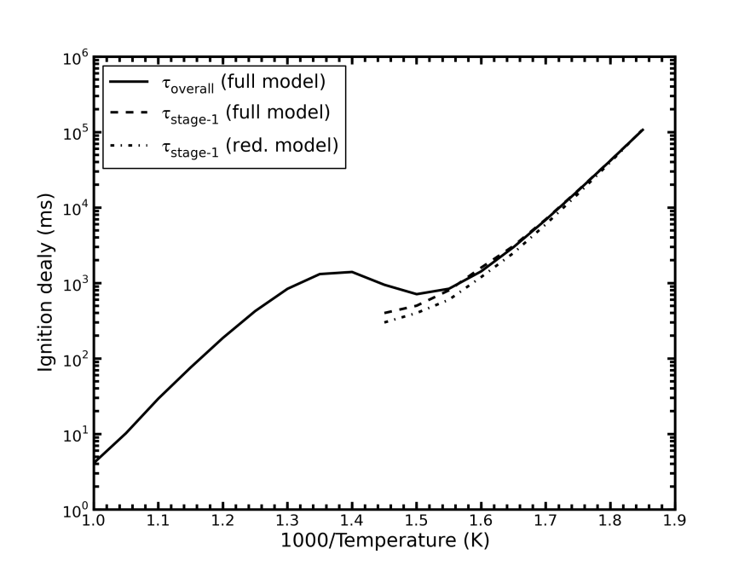

**Figure 17**: Comparison of the predicted first-stage ignition delay for constant volume adiabatic simulations using the full and reduced propane model, for *P0* = 10 bar, stoichometric mixture of propane in air. The τstage-1 was obtained using the first inflection in the temperature profile.

### Derivation for explosive eigenvalue using reduced model for stage-1A

|  |  |
| --- | --- |
| The following set of ODE’s can be constructed from the reduced model | (S 1) |
|  | (S 2) |
|  | (S 3) |
|  | (S 4) |
|  | (S 5) |
|  | (S 6) |
|  | (S 7) |
|  | (S 8) |
|  | (S 9) |
|  | (S 10) |
|  | (S 11) |
|  | (S 12) |

After the induction period, several radical species will be in QSS including nR, iR, OH, QOOH, O2QOOH, OQ´O and CH2CHO

|  |  |
| --- | --- |
|  | (S 13) |
|  | (S 14) |
|  | (S 15) |
|  | (S 16) |
|  | (S 17) |
|  | (S 18) |
|  | (S 19) |

We make the following simplifications:

1. For pressures greater than one atmosphere, the vast majority of QOOH is formed via isomerization from RO2, such that the chemically activated production of QOOH from R + O2 is sufficiently small that its contribution can be considered negligible.
2. Similarly the contributions of reaction 10 and 11 are also negligible, as confirmed by flux analysis with the complete model.
3. For temperatures less than 800 K (those considered here) the decomposition of H2O2 to OH is not significant during stage-1 and can be neglected.

Applying these simplifications to (S 13)-(S 19):

|  |  |
| --- | --- |
|  | (S 20) |
|  | (S 21) |
|  | (S 22) |
|  | (S 23) |
|  | (S 24) |
|  | (S 25) |
|  | (S 26) |

Substituting for O2QOOH (S 23) in (S 22) and solving gives

|  |  |
| --- | --- |
|  | (S 27) |

Substituting for QOOH (S 22) in (S 23) and solving gives:

|  |  |
| --- | --- |
|  | (S 28) |

Substituting for CH2CHO (S 24) and (S 26) in the expression (S 25) for OH:

|  |  |
| --- | --- |
|  | (S 29) |

Initially during stage-1 the concentrations of intermediates and products is sufficiently small that their contributions to OH consumption can be neglected. However this assumption breaks down as the fuel is consumed, which leads to the production of secondary products.

|  |  |
| --- | --- |
|  | (S 30) |

We can simplify the notation by introducing three non-dimensional parameters:

|  |  |
| --- | --- |
|  | (S 31) |
|  | (S 32) |
|  | (S 33) |

Using (S 27) in ODE for OQ´OOH (S 7):

|  |  |
| --- | --- |
|  | (S 34) |

Using (S 20), (S 28) and (S 30) in (S 3):

|  |  |
| --- | --- |
|  | (S 35) |

Using (S 27) in (S 35) and simplifying:

|  |  |
| --- | --- |
|  | (S 36) |

Using (S 14) and (S 30) in (S 4):

|  |  |
| --- | --- |
|  | (S 37) |

Using (S 27) in (S 37) and simplifying:

|  |  |
| --- | --- |
|  | (S 38) |

The ODE for HO2 after ignoring contributions from R10 and R11 is given by:

|  |  |
| --- | --- |
|  | (S 39) |

At early times the concentration of secondary product (CH2O, H2O2) can be considered negligibly small. The HO2 concentration is also sufficiently small that the rate of its self- reaction can be neglected, which allows for simplification of (S 39) to:

|  |  |
| --- | --- |
|  | (S 40) |

We can also neglect the consumption terms for CH2O simplifying (S 12) to

|  |  |
| --- | --- |
|  | (S 41) |

The above equation can be simplified using (S 24) and (S 26) to (S 42), which is valid during early times when the concentration of CH2O has not grown significantly

|  |  |
| --- | --- |
|  | (S 42) |

During stage-1 the concentration of the fuel and oxygen remains nearly constant such that

|  |  |
| --- | --- |
|  | (S 43) |

Since *α*, *β* and *θ* are approximately constants, equations (S 34), (S 36), (S 38) and (S 40) are linear ODE’s which can be solved using eigenvalue analysis

|  |  |
| --- | --- |
|  | (S 44) |

The system of linear ODE’s can be written in terms of a concentration vector C, coefficient matrix M and source term R.

|  |  |
| --- | --- |
|  | (S 45) |

For which M can decomposed into an eigenvector matrix, V and eigenvalue matrix, Λ as

|  |  |
| --- | --- |
|  | (S 46) |

Transforming variables from the concentration vector to the eigenvectors, diagonalizes the equation

|  |  |
| --- | --- |
|  | (S 47) |

where 

Another change of variables to further simplifies the equation to

|  |  |
| --- | --- |
|  | (S 48) |

This has a general solution of the form

|  |  |
| --- | --- |
|  | (S 49) |

Substituting for C we get back

|  |  |
| --- | --- |
|  | (S 50) |

where the value of can be obtained from and the true initial conditions 

|  |  |
| --- | --- |
|  | (S 51) |

Hence if the complete eigenvectors and the true initial conditions are used, then the numerical solutions to the above can be found exactly (without any further approximations).

Since only one of the eigenvalues (λ1) has a positive real number, after a brief induction period of time *C* can be approximated as

|  |  |
| --- | --- |
| where we assume | (S 52) |

The initial conditions for HO2, RO2 and OQ´OOH in stage-1A is given by

|  |  |
| --- | --- |
|  | (S 53) |

Initial conditions for all other species will just be linear combinations of HO2, RO2 and OQ´OOH.

If desired we can take the ratio of concentrations to eliminate the initial condition

|  |  |
| --- | --- |
|  | (S 54) |

Figure 18 compares the ratio of concentrations obtained from the eigenvectors (S 54) and the full model simulation.

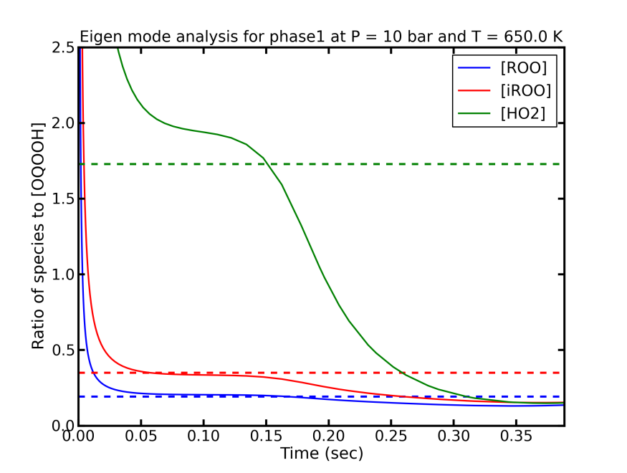

**Figure 18**: Predictions (dotted lines) for relative concentrations of species involved in first-stage ignition (stage-1A) by eigen mode analysis for simulations at *P0* =10 bar and *T0* = 650 K for a stoichiometric mixture of propane in air. The solid lines are obtained from full model simulations, the dotted lines are the ratio of the eigenvector elements V(species)/V(OQ´OOH) corresponding to the positive eigenvalue in stage-1A.

### Analytical solution for the explosive eigenvalue for stage-1A

An analytical solution to the system of linear ODE’s, equation (S 44), can be achieved if the quartic system is reduced to a cubic equation by making the following assumption for HO2

|  |  |
| --- | --- |
|  | (S 55) |
| The left hand side of the above expression comes from rearranging (S 40) using (S 37) and (S 38). |  |

Figure 19 gives the comparison of the net HO2 flux and the flux estimated by the approximation made in (S 55). As seen from Figure 19 the approximation provides a satisfactory reproduction of the net HO2 flux until the HO2 self-reaction becomes a significant contributor to HO2 consumption near the end of stage-1A.

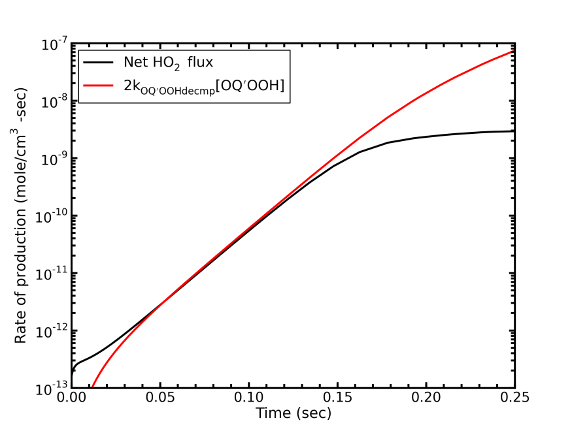

**Figure 19:** Comparison of the net HO2 flux (from the full model simulation) and the approximation 2kOQ´OOH decmp[OQ´OOH] for *P0* =10 bar and *T0* = 650 K.

This approximation effectively decouples iRO2 from the system of differential equations (S 44), reducing it to a cubic system.

|  |  |
| --- | --- |
|  | (S 56) |

The eigenvalues are roots of the following cubic characteristic equation

|  |  |
| --- | --- |
|  | (S 57) |

The characteristic equation is a general cubic of the form  and will have three roots.

|  |  |
| --- | --- |
|  | (S 58) |
|  | (S 59) |
|  | (S 60) |

where



**Table 5:** Comparison of the positive eigenvalue (λ1A) obtained solving (S 44) numerically and the positive root of the cubic equation (S 57) for *P0* = 10 bar, stoichometric mixture of propane in air.

|  |  |  |
| --- | --- | --- |
| T0 (K) | λ1A  (Numerical) | λ1A  (Cubic approx.) |
| 550 | 0.7 | 0.9 |
| 600 | 8.5 | 9.8 |
| 650 | 55.4 | 61.0 |

### Simplification of the explosive eigenvalue for stage-1B

The expression for the explosive eigenvalue for a general fuel (for *γ* = 1) is given by:

|  |  |
| --- | --- |
|  | (S 61) |
|  | (S 62) |

The above expression can be further approximated as

|  |  |
| --- | --- |
|  | (S 63) |
|  | (S 64) |

For high pressures and low temperature and high pressures (T < 600 K, P > 10 bar) , which yields

|  |  |
| --- | --- |
|  | (S 65) |

For *α* = 1 and *β* = 1 we get

|  |  |
| --- | --- |
|  | (S 66) |

Note this approximation has significant error in the absolute value of λ1B and not recommended to be used above the limited temperature and pressure range.

### Prediction for first-stage ignition delay for propane under varying equivalence ratios and pressure

Figure 20 provides the comparison of first-stage ignition delay for propane under varying equivalence ratios in air for *P0* = 10 bar. The first-stage ignition delay does not change significantly with fuel concentration.

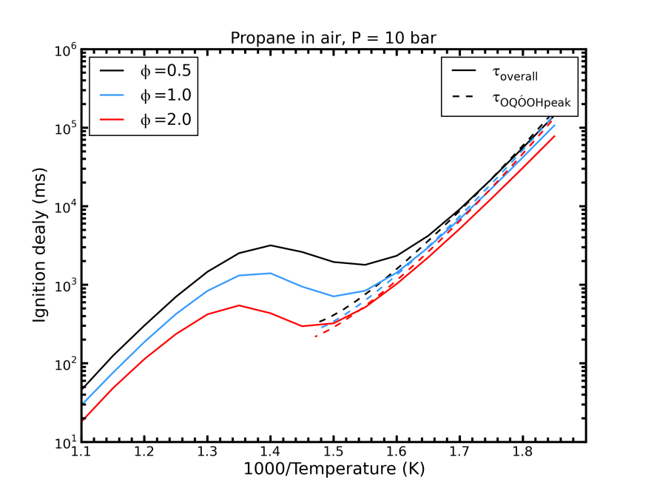

**Figure 20**: Comparison of the simulated adiabatic isochoric overall ignition delay with the predicted first-stage ignition delay for various equivalence ratios of propane in air. All simulations are for *P0* = 10 bar.The overall ignition delay (solid line) is obtained from the full model simulations, while the predicted first-stage ignition delay (dashed line) is obtained using equation (41).

Figure 21 provides the comparison of first-stage ignition delay for propane under varying pressure for *φ* = 1. The first-stage ignition delay is a function of pressure (or oxygen concentration) as the temperature is increased (T > 650 K).

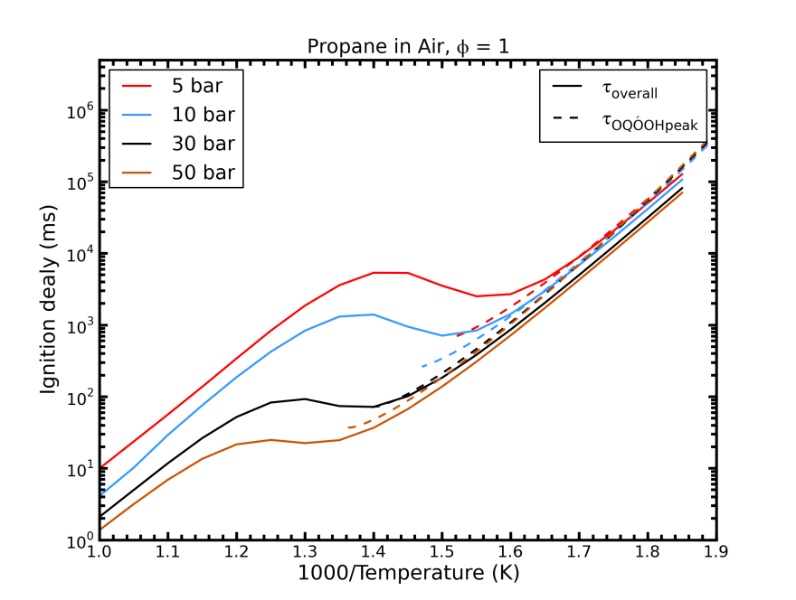

**Figure 21**: Comparison of the simulated adiabatic isochoric overall ignition delay with the predicted first-stage ignition delays for various pressures. All simulation are for stoichometric mixture of of propane in air. The overall ignition delay (solid line) is obtained from the full model simulations, while the predicted first-stage ignition delay (dashed line) is obtained using equation (41).

**Table 6**: Comparison of important parameters used in predicting first-stage ignition delay for propane under varying *T0*, *P*0 and equivalence ratio.

|  |  |  |  |  |
| --- | --- | --- | --- | --- |
|  | *T0 =* 600 K | | *T0 =* 650 K | |
| *φ* = 1 | *P0* =10 bar | *P0* =50 bar | *P0* =10 bar | *P0* =50 bar |
| *α*(T0) | 0.5 | 0.5 | 0.5 | 0.5 |
| *β*(T0) | 0.94 | 0.95 | 0.85 | 0.9 |
| *θ*(T0) | 0.75 | 0.93 | 0.46 | 0.8 |
| *λ1A*(T0) (s-1) | 8.5 | 13.1 | 55.4 | 102.9 |
| *λ1B*(T0) (s-1) | 3.0 | 3.2 | 25.3 | 37.5 |
| τstage-1A (s) | 1.2 | 0.7 | 0.2 | 0.1 |
| *τ*OQ´OOHpeak (s) | 3.2 | 1.8 | 0.4 | 0.2 |
| *T*stage-1,max (K) | 690 | 760 | 690 | 760 |
|  | *T0 =* 600 K | | *T0 =* 650 K | |
| *φ* = 0.5 | *P0* =10 bar | *P0* =50 bar | *P0* =10 bar | *P0* =50 bar |
| *α*(T0) | 0.5 | 0.5 | 0.5 | 0.5 |
| *β*(T0) | 0.94 | 0.95 | 0.85 | 0.9 |
| *θ*(T0) | 0.75 | 0.93 | 0.46 | 0.8 |
| *λ1A*(T0) (s-1) | 7.0 | 11.4 | 46.1 | 87.3 |
| *λ1B*(T0) (s-1) | 3.0 | 3.2 | 25.5 | 37.6 |
| τstage-1A (s) | 1.5 | 0.8 | 0.24 | 0.11 |
| *τ*OQ´OOHpeak (s) | 4.0 | 2.1 | 0.51 | 0.25 |
| *T*stage-1,max (K) | 690 | 760 | 690 | 760 |

### First-stage ignition delay under isothermal conditions for propane

Under isothermal conditions, the criticality of the system will be completely determined by the concentrations of CH2O and HO2. Substituting (33) and (34) in (30) and solving for the OQ´OOH concentration yields:

|  |  |
| --- | --- |
|  | (S 67) |

The first-stage ignition delay under isothermal conditions is then approximated by:

|  |  |
| --- | --- |
|  | (S 68) |

where λ1B(T0) is the rise rate at start of stage-1B. Figure 22gives a comparison between various estimates for *τ*OQ´OOHpeak obtained from 1) the time at which OQ´OOH peaks in the full model simulation, 2) the time at which the simulated OH multiplication factor is equal to 1, where *f*OH is defined as:

|  |  |
| --- | --- |
|  | (S 69) |

3) the time when the system becomes subcritical using the time predicted by equation (S 68). The predictions are within a factor of 2 for the entire low temperature regime and the accuracy increases as we approach the negative temperature coefficient (NTC) region.

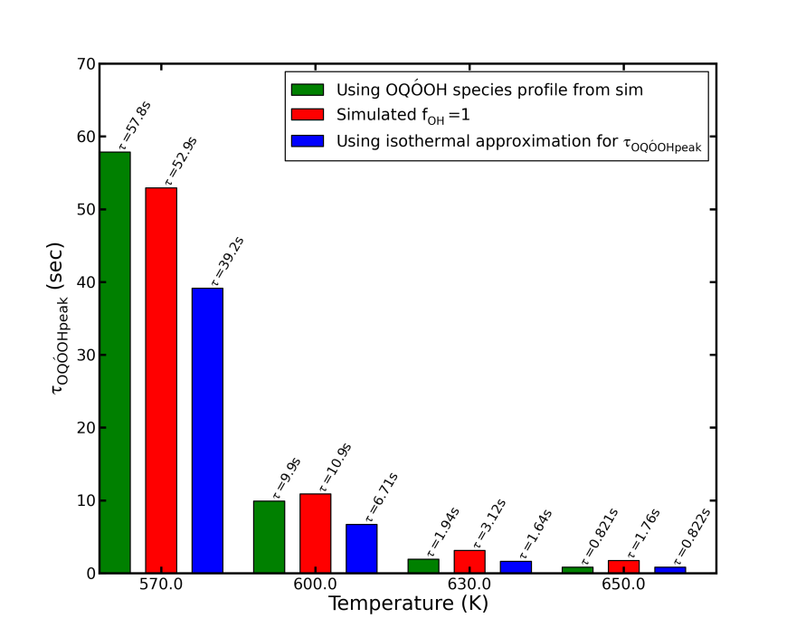

**Figure 22**: Comparison of the *τ*OQ´OOHpeak obtained from 1) the OQ´OOH peak computed numerically from the full model, 2) the time at which criterion set by equation (30) is met using reaction fluxes obtained from full-model simulations, 3) the time predicted by equation (S 68), all for an isothermal isochoric simulation of a stoichiometric mixture of propane and air.