SOHR on single source system

Shirong Bai

Suppose we have a reaction network of Lotka-Volterra model as in Figure 1. The initial conditions are in Table 1.

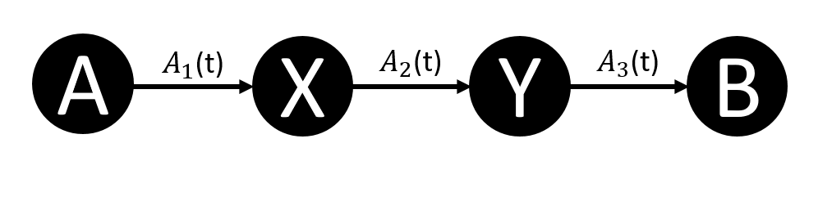

Figure . Reduced reaction network of Lotka-Volterra model

Table Initial conditions of Lotka-Volterra model

|  |  |  |  |
| --- | --- | --- | --- |
| Reactions | | Rate coefficients | Initial conditions |
| $$R_{1}$$ | $$A+X\underset{→}{k_{1}}2X$$ | $$k_{1}=10.0 (M^{-1}•s^{-1})$$ | $$A\left(0\right)=1.0 M$$ $$X\left(0\right)=1.0 M$$ $$Y\left(0\right)=1.0 M$$ $$B\left(0\right)=0$$ |
| $$R_{2}$$ | $$X+Y\underset{→}{k_{2}}2Y$$ | $$k_{2}=10.0 (M^{-1}•s^{-1})$$ |
| $$R_{3}$$ | $$Y\underset{→}{k_{3}}B$$ | $$k_{3}=10.0 (s^{-1})$$ |

Suppose we want to calculate the concentration of B at time t. First, we enumerate the path ending with species B as in Table 2.

Table . Path ending with species B.

|  |  |  |
| --- | --- | --- |
| Paths | Path Length | Path Index |
| B | 0 | 1 |
| Y $→$ B | 1 | 2 |
| X $→$ Y $→$ B | 2 | 3 |
| A $→$ X $→$ Y $→$ B | 3 | 4 |

If there is no external source, then the conservation law holds. The concentration of species B has an expression as

|  |  |
| --- | --- |
| $$\left[B(t_{f})\right]=\sum_{i=1}^{4}{P_{i}\left(t_{0},t_{f}\right)\left[X_{P_{i}}\left(t_{0}\right)\right]}$$ | (1) |

Where $X_{P_{i}}$ represents the starting species of path $P_{i}$ and $P_{i}$ ends with species B. We have proved SOHR converges to conventional kinetics regarding of closed system. By saying closed system, we mean there is no mass exchange with the surroundings.

What if there is a single source? For instance, to methanol decomposition model on a metal surface, we keep pumping methanol into the system; To the Lotka-Volterra system above, we keep the concentration of species A to be constant, which means we must keep adding A into the system with source rate equal to sink rate of A. These two example shows the necessity to develop a single source oriented SOHR method.

Still, if we think of mass conservation, the species that exist in the system from time zero will be delivered the same way as before. How about the new coming species? To the Lotka-Volterra system above, the concentration of species B will have a form of

|  |  |
| --- | --- |
| $$\left[B(t_{f})\right]=\sum_{i=1}^{4}{P_{i}\left(t_{0},t_{f}\right)\left[X_{P_{i}}\left(t_{0}\right)\right]}+Source Term$$ | (2) |

Since the new species A can be added at any time before $t_{f}$, we should sum over times before $t_{f}$. We end up with a formula as below,

|  |  |
| --- | --- |
| $$\left[B(t_{f})\right]=\sum_{i=1}^{4}{P_{i}\left(t_{0},t_{f}\right)\left[X_{P_{i}}\left(t_{0}\right)\right]}+\int_{t_{0}^{+}}^{t_{f}}{dt×P_{4}\left(t,t_{f}\right)R_{source}\left(t\right)}$$ | (3) |

Where $R_{source}\left(t\right)$ represents the pumping rate of species A. $t_{0}^{+}$ represents any infinitesimal time after time $t_{0}$. Recall the path integral definition and its numerical implementation

|  |  |
| --- | --- |
| $$P_{path}\left(t_{0},t_{f}\right)={\left(-1\right)}^{n}\int_{t_{n-1}}^{t_{f}}{dt_{n}}\int_{t_{n-2}}^{t_{f}}{dt_{n-1}}…\int_{t_{0}}^{t_{f}}{dt_{1}}\prod_{i=1}^{n}{\left.\left(\frac{dP_{i-1}\left(t_{i-1},t_{i}\right)}{dt_{i}}Γ_{i-1}\left(t_{i}\right)\right)P_{n}(t_{n},t_{f}\right)}$$ | (4) |
| $$P_{path}\left(t_{0},t_{f}\right)=\frac{1}{N}\sum_{q=1}^{N}{\left(P_{n}(t_{n}^{q},t_{f})\prod_{k=1}^{n}{\left(Γ_{k-1}(t_{k}^{q})\left(\left.1-P_{min}^{k-1}(t_{k}^{q}\right)\right)\right)}\right)}$$ | (5) |

Here, we can incorporate the new integral over initial time point $t_{0}$ into the path integral scheme. So the second term in eqn. (3) becomes

|  |  |
| --- | --- |
| $$I≡\int_{t_{0}}^{t_{f}}{dt×P_{4}\left(t,t_{f}\right)R_{source}\left(t\right)}$$ | (6) |
| $$I=\int_{t_{0}}^{t_{f}}{dt×R_{source}\left(t\right)×{\left(-1\right)}^{n}\int_{t}^{t_{f}}{dt_{n}}\int_{t}^{t_{f}}{dt_{n-1}}…\int_{t}^{t_{f}}{dt_{1}}\prod_{i=1}^{n}{\left.\left(\frac{dP_{i-1}\left(t_{i-1},t_{i}\right)}{dt_{i}}Γ_{i-1}\left(t_{i}\right)\right)P_{n}(t_{n},t_{f}\right)}}$$ | (7) |

The numerical implementation will be simple as well since we only need to sample the initial time of a path uniformly.

|  |  |
| --- | --- |
| $$I=\sum_{t_{1}=t_{0}}^{t_{f}}{\left(\frac{1}{N}\sum_{q=1}^{N}{\left(P_{n}(t_{n}^{q},t_{f})∆S\left(t_{1}^{q}\right)\prod_{k=1}^{n}{\left(Γ_{k-1}(t_{k}^{q})\left(\left.1-P_{min}^{k-1}(t_{k}^{q}\right)\right)\right)}\right)}\right)}$$ | (9) |

In which $∆S\left(t_{1}^{q}\right)$ represents the concentration change of the source species between time $\left[\left.t_{1}^{q},t_{1}^{q}+dt\right)\right.$, where $t_{1}^{q}$ is randomly sampled between $\left[t_{0},t_{f}\right]$. Rearrange eqn. (9), we gain

|  |  |
| --- | --- |
| $$I=\frac{1}{N}\sum_{q=1}^{N}{\left(\sum_{t_{1}^{q}=t_{0}}^{t_{f}}{\left(P_{n}(t_{n}^{q},t_{f})∆S\left(t_{1}^{q}\right)\prod_{k=1}^{n}{\left(Γ_{k-1}(t_{k}^{q})\left(\left.1-P_{min}^{k-1}(t_{k}^{q}\right)\right)\right)}\right)}\right)}$$ | (10) |