NPH rate position analysis

Adam

October 2, 2015

library(ggplot2)  
library(dplyr)  
library(knitr)  
library(tidyr)

#load all the .csv files in the data folder, then add a column naming the neuron,   
#using the file name as the default name, then put them all together in one long data frame  
path<-"~/GitHub/NPH-Analysis/data/"  
files <- list.files(path=path,pattern='*.csv')  
t<-data.frame()  
for (i in 1:length(files)) {  
 temp <- read.csv(paste(path,files[i],sep=''))  
 temp$neuron<-gsub('.csv','',files[i])  
 t <-rbind(t,temp)  
}

First I will plot the average firing rate of the neuron while the eyes are in various positions. I've restricted my analysis to periods when the eyes are not in motion using a simple eye velocity threshold. I require both the vertical and horizontal eye position to be less than one. This allows for pre-movement burst activity to potentially interfere with the static analysis.

thresh=1.5 #points with velocity below threshold are considered fixation  
  
#choose just the points of fixation, then bin the data into 1 degree bins (using round)  
#and calculate the mean firing rate during all the times when the eye is at each position  
t %>%  
 filter(abs(rev)<thresh,abs(revV)<thresh,abs(lev)<thresh,abs(levV)<thresh) %>%  
 mutate(R.Hep=round(rep),R.Vep=round(repV), L.Hep=round(lep),L.Vep=round(lepV)) %>%  
 group_by(R.Hep,R.Vep,L.Hep,L.Vep,neuron) %>%  
 summarize(fr=mean(sdf)) %>%  
 ungroup(.) %>%  
 #use tidyr functions to make columns for eye (left or right), vertrical and horizontal eye position  
 mutate(time=row_number(fr)) %>%  
 gather(temp,P,1:4) %>%  
 separate(temp,c("Eye","HV")) %>%  
 spread(HV,P) ->  
 s  
levels(s$Eye)<-c("Right Eye","Left Eye") #Change R/L into Right Eye/Left Eye

#Just show cells I want  
#s <- filter(s,neuron %in% c("Bee6","BeeX1","BeeX2","BeeX3a","BeeX3b","BeeY1","BeeZ1"))  
#s <- filter(s,neuron %in% c("Bee6","BeeZ1"))  
  
#Create a scaled firing rate by simply dividing by the maximum firing rate in any bin  
s %>%  
 group_by(neuron) %>%  
 mutate(maxFR=max(fr),scaledFR=fr/maxFR) ->  
 ss  
  
#plot  
qplot(Hep,Vep,data=ss,fill=scaledFR)+geom_tile()+facet_grid(neuron~Eye)+  
 scale_fill_gradient(low='black',high='orange')

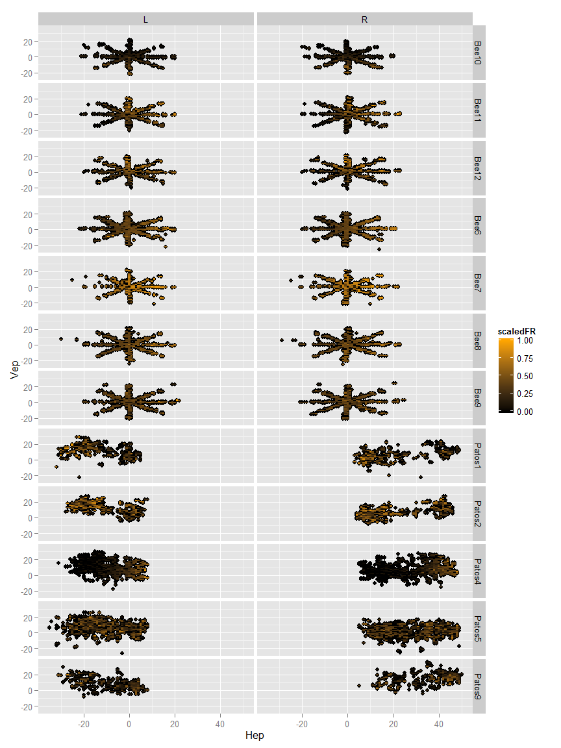

Next, let's show the rate position curves for horizontal and vertical individually.

t %>%  
 filter(abs(rev)<thresh,abs(revV)<thresh,abs(lev)<thresh,abs(levV)<thresh) %>%  
 select(1,2,4,6,8,10) %>%  
 rename(R.Hep=rep,R.Vep=repV, L.Hep=lep,L.Vep=lepV,fr=sdf) %>%  
 #use tidyr functions to make columns for eye (left or right), vertrical and horizontal eye position  
 mutate(time=row_number(fr))%>%  
 gather(temp,P,2:5) %>%  
 separate(temp,c("Eye","HV")) ->  
 static

static$plotHV<-as.factor(static$HV)  
levels(static$plotHV)<-c("Horizontal Eye Position","Vertical Eye Position")  
  
static %>%  
 filter(Eye=="R") %>%  
 qplot(P,fr,data=.)+facet_grid(neuron~plotHV)+  
 ggtitle('Right Eye')+  
 stat_smooth(method='lm')

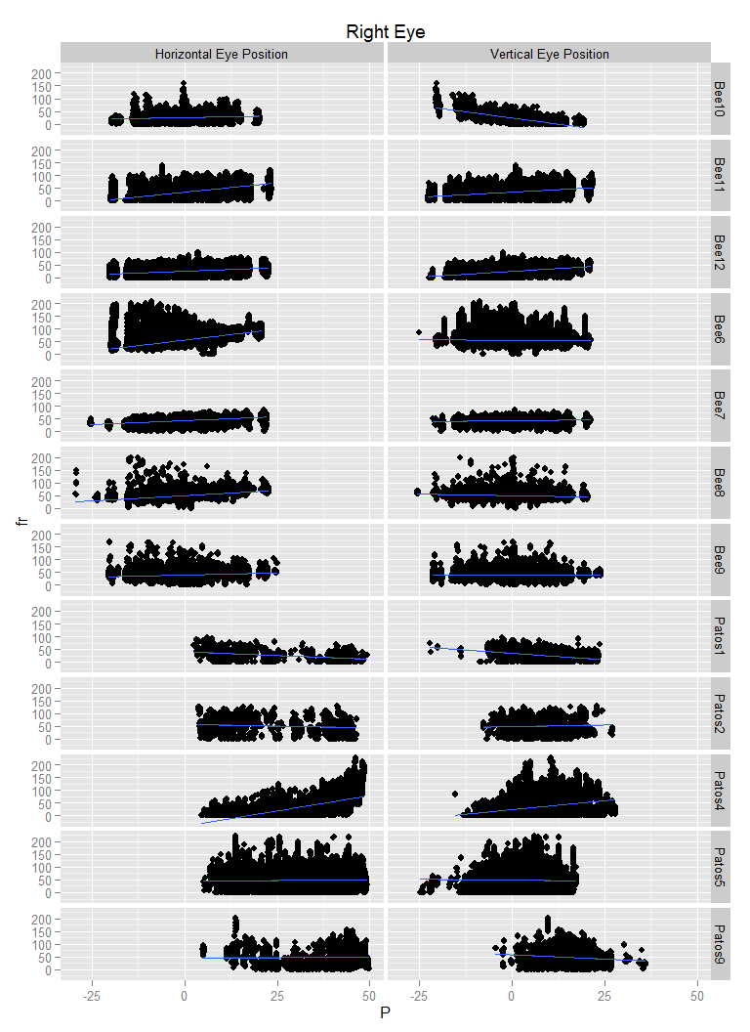

static %>%  
 filter(Eye=="L") %>%  
 qplot(P,fr,data=.)+facet_grid(neuron~plotHV)+  
 ggtitle('Left Eye')+  
 stat_smooth(method='lm')

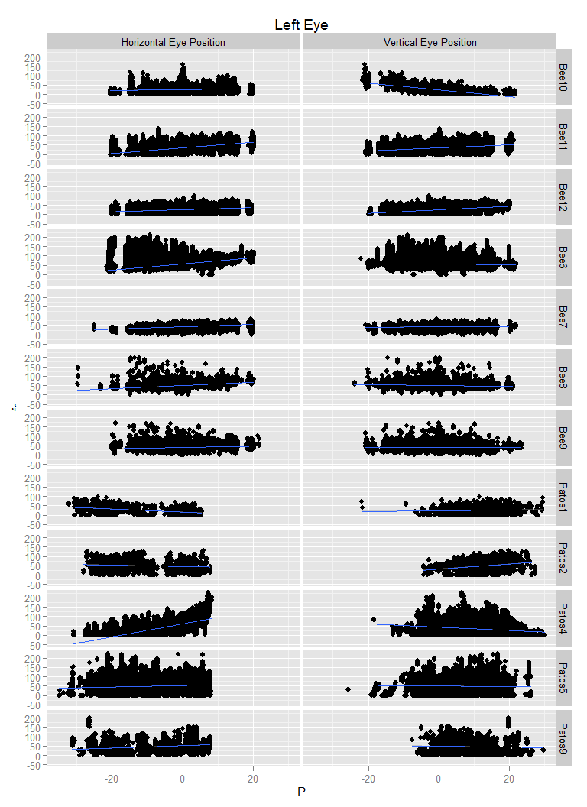

Next, I will create a table of the linear regression coefficients for the formula

$$F_{r}=b+k_{h}E_{h}+k_{h}E_{v}$$

, where $E_{h}$ and $E_{v}$ are the horizontal and vertical eye positions during periods where the eye velocity is less than 1.5.

static %>%   
 select(-plotHV) %>%  
 spread(HV,P) %>%  
 filter(Eye =="R") %>%  
 group_by(neuron) ->   
 x  
  
x %>%  
 do(h.slope=summary(lm(fr~Hep+Vep,data=.))$coefficients[2],v.slope=summary(lm(fr~Hep+Vep,data=.))$coefficients[3]) ->  
 xx  
kable(xx)

|  |  |  |
| --- | --- | --- |
| neuron | h.slope | v.slope |
| Bee10 | 0.1800969 | -1.937002 |
| Bee11 | 1.469062 | 0.788065 |
| Bee12 | 0.5284778 | 0.8859174 |
| Bee6 | 1.735839 | -0.05681147 |
| Bee7 | 0.6158252 | 0.1529736 |
| Bee8 | 0.8226882 | -0.2534351 |
| Bee9 | 0.3358553 | -0.07143891 |
| Patos1 | -0.3932655 | -0.5568464 |
| Patos2 | -0.747143 | 1.359032 |
| Patos4 | 2.293573 | 0.576631 |
| Patos5 | 0.1240371 | -0.1737813 |
| Patos9 | 0.2074481 | -0.8128656 |