NPH static analysis

Adam

September 23, 2015

This is my first effort at analysis of the activity of the purported NPH cells.

In Matlab, I did spike sorting and created a spike density function by convolving the spiketimes with a Gaussian with a standard deviation of 20ms. I then saved that as a table containing the right and left eye position and velocity (calculated using a 7 point parabolic differentiation function) and the spike density function, scaled to approximate firing rate.

t1 <- read.csv("~/GitHub/NPHanalysis/917BTcell.csv")  
#t2 <- read.csv("~/GitHub/NPHanalysis/datatest1914.csv")  
t2 <- read.csv("C:\\Users/setup/Desktop/NPH Data/Patos_2014_03_27_1439_Radial.csv")  
library(ggplot2)  
library(dplyr)  
library(knitr)

First I will plot the average firing rate of the neuron while the eyes are in various positions. I've restricted my analysis to periods when the eyes are not in motion using a simple eye velocity threshold. I require both the vertical and horizontal eye position to be less than one. This allows for pre-movement burst activity to potentially interfere with the static analysis.

meanfr <- function(t){  
 t %>%  
 filter(rev<1, revV<1) %>%  
 mutate(Hep=round(rep),Vep=round(repV)) %>%  
 group_by(Hep,Vep) %>%  
 summarize(fr=mean(sdf)) ->  
 s  
 return(s)  
}  
s1<-meanfr(t1)  
s2<-meanfr(t2)  
m<-ggplot(s1,aes(Hep,Vep,fill=fr,z=fr))  
m+geom_tile()+scale_fill_gradient(low='black',high='orange')+  
 xlab('Horizontal Eye Position')+  
 ylab('Vertical Eye Position')

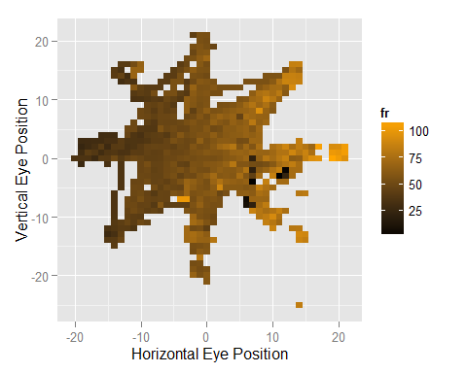

m<-ggplot(s2,aes(Hep,Vep,fill=fr,z=fr))  
m+geom_tile()+scale_fill_gradient(low='black',high='orange')+  
 xlab('Horizontal Eye Position')+  
 ylab('Vertical Eye Position')

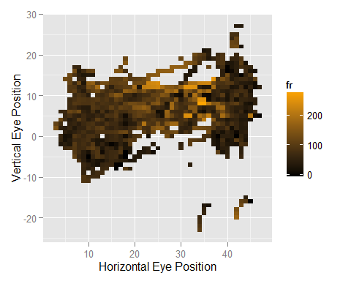

Next, I calculate the sensitivity of the neuron to horizontal and vertical eye position:

compareslope <- function(s) {  
 horizontalSlope<-summary(lm(fr~Hep,data=s))$coefficients[2]  
 verticalSlope<-summary(lm(fr~Vep,data=s))$coefficients[2]  
 preferredDirection<-atan2(verticalSlope,horizontalSlope)*180/pi  
 return(data.frame(horizontalSlope=horizontalSlope,verticalSlope=verticalSlope,preferredDirection=preferredDirection))  
}  
x1<-compareslope(s1)  
x2<-compareslope(s2)  
  
x<-rbind(x1,x2)  
kable(x,digits=2)

|  |  |  |
| --- | --- | --- |
| horizontalSlope | verticalSlope | preferredDirection |
| 1.44 | -0.08 | -3.05 |
| -0.04 | 1.47 | 91.39 |

For the first cell: The slope is 1.441 (spikes/s per degree) for horizontal eye positions and -0.077 for vertical eye positions. This corresponds with a preferred angle of -3.05 degrees.

For the second cell: The slope is -0.036 (spikes/s per degree) for horizontal eye positions and 1.471 for vertical eye positions. This corresponds with a preferred angle of 91.393 degrees.