NPH static analysis

Adam

September 23, 2015

This is my first effort at analysis of the activity of the purported NPH cells.

In Matlab, I did spike sorting and created a spike density function by convolving the spiketimes with a Gaussian with a standard deviation of 20ms. I then saved that as a table containing the right and left eye position and velocity (calculated using a 7 point parabolic differentiation function) and the spike density function, scaled to approximate firing rate.

t1 <- read.csv("~/GitHub/NPHanalysis/Patos_2014_03_27_1435_Radial.csv")  
t2 <- read.csv("~/GitHub/NPHanalysis/Bee_Mark_2015_09_17_1440_Radial.csv")  
  
library(ggplot2)  
library(dplyr)  
library(knitr)

First I will plot the average firing rate of the neuron while the eyes are in various positions. I've restricted my analysis to periods when the eyes are not in motion using a simple eye velocity threshold. I require both the vertical and horizontal eye position to be less than one. This allows for pre-movement burst activity to potentially interfere with the static analysis.

meanfr <- function(t){  
 thresh=1.5  
 t %>%  
 filter(abs(rev)<thresh,abs(revV)<thresh,abs(lev)<thresh,abs(levV)<thresh) %>%  
 mutate(RHep=round(rep),RVep=round(repV), LHep=round(lep),LVep=round(lepV)) %>%  
 group_by(RHep,RVep,LHep,LVep) %>%  
 summarize(fr=mean(sdf)) %>%  
 ungroup(.) ->  
 s  
 return(s)  
}  
s1<-meanfr(t1)  
s2<-meanfr(t2)  
  
plottile<-function(s){  
 m<-ggplot(s,aes(RHep,RVep,fill=fr,z=fr))  
 m1<-m+geom_tile()+scale_fill_gradient(low='black',high='orange')+  
 xlab('Horizontal Eye Position')+ylab('Vertical Eye Position')+  
 ggtitle('Right Eye')  
 m<-ggplot(s,aes(LHep,LVep,fill=fr,z=fr))  
 m2<-m+geom_tile()+scale_fill_gradient(low='black',high='orange')+  
 xlab('Horizontal Eye Position')+ylab('Vertical Eye Position')+  
 ggtitle('Left Eye')  
 return(list(m1, m2))  
}  
  
m1<-plottile(s1)  
m2<-plottile(s2)  
  
m1[1]

## [[1]]

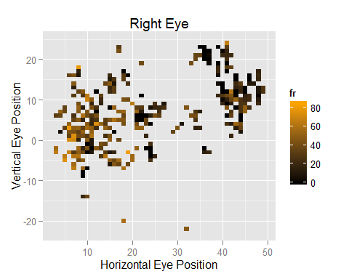

m2[1]

## [[1]]

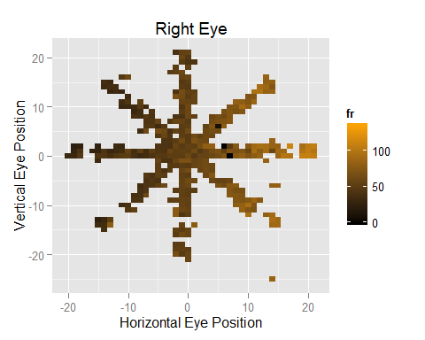

m1[2]

## [[1]]

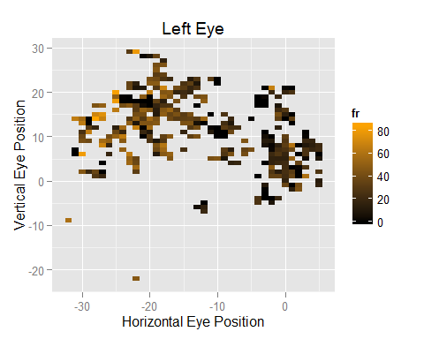

m2[2]

## [[1]]

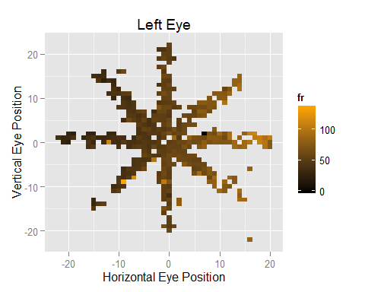

Next, I calculate the sensitivity of the neuron to horizontal and vertical eye position:

compareslope <- function(s) {  
 Left.Horizontal.Slope <- summary(lm(fr~LHep,data=s))$coefficients[2]  
 Left.Vertical.Slope <- summary(lm(fr~LVep,data=s))$coefficients[2]  
 Left.Preferred.Direction <- atan2(Left.Vertical.Slope,Left.Horizontal.Slope)*180/pi  
   
 Right.Horizontal.Slope<-summary(lm(fr~RHep,data=s))$coefficients[2]  
 Right.Vertical.Slope<-summary(lm(fr~RVep,data=s))$coefficients[2]  
 Right.Preferred.Direction<-atan2(Right.Vertical.Slope,Right.Horizontal.Slope)*180/pi  
 return(data.frame(Left.Horizontal.Slope,Left.Vertical.Slope,Left.Preferred.Direction,  
 Right.Horizontal.Slope,Right.Vertical.Slope,Right.Preferred.Direction))  
}  
  
x1<-compareslope(s1)  
x2<-compareslope(s2)  
  
x<-rbind(x1,x2)  
kable(x,digits=2)

|  |  |  |  |  |  |
| --- | --- | --- | --- | --- | --- |
| Left.Horizontal.Slope | Left.Vertical.Slope | Left.Preferred.Direction | Right.Horizontal.Slope | Right.Vertical.Slope | Right.Preferred.Direction |
| -0.81 | 0.40 | 153.43 | -0.59 | -0.87 | -124.08 |
| 1.66 | -0.21 | -7.15 | 1.74 | -0.18 | -5.80 |