NPH static analysis

Adam

September 23, 2015

This is my first effort at analysis of the activity of the purported NPH cells.

In Matlab, I did spike sorting and created a spike density function by convolving the spiketimes with a Gaussian with a standard deviation of 20ms. I then saved that as a table containing the right and left eye position and velocity (calculated using a 7 point parabolic differentiation function) and the spike density function, scaled to approximate firing rate.

t <- read.csv("~/GitHub/NPHanalysis/917BTcell.csv")  
library(ggplot2)  
library(dplyr)

First I will plot the average firing rate of the neuron while the eyes are in various positions. I've restricted my analysis to periods when the eyes are not in motion using a simple eye velocity threshold. I require both the vertical and horizontal eye position to be less than one. This allows for pre-movement burst activity to potentially interfere with the static analysis.

t %>%  
 filter(rev<1, revV<1) %>%  
 mutate(Hep=round(rep),Vep=round(repV)) %>%  
 group_by(Hep,Vep) %>%  
 summarize(fr=mean(sdf)) ->  
 s  
m<-ggplot(s,aes(Hep,Vep,fill=fr,z=fr))  
m+geom_tile()+scale_fill_gradient(low='black',high='orange')+  
 xlab('Horizontal Eye Position')+  
 ylab('Vertical Eye Position')

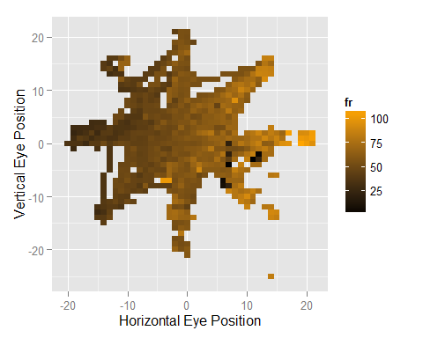

Next, I calculate the sensitivity of the neuron to horizontal and vertical eye position:

horizontalSlope<-summary(lm(fr~Hep,data=s))$coefficients[2]  
verticalSlope<-summary(lm(fr~Vep,data=s))$coefficients[2]  
  
preferredDirection<-atan2(verticalSlope,horizontalSlope)*180/pi

The slope is 1.441 (spikes/s per degree) for horizontal eye positions and -0.077 for vertical eye positions. This corresponds with a preferred angle of -3.05 degrees.