Modeling Activity of Neurons from NRG recording study

## Introduction

Humans and other primates use combinations of eye and head movements to move the line of sight. Depending on the behavioral task, different types of movements may be employed. Gaze shifts are used to quickly acquire a new target using a rapid head rotation combined with a saccadic eye movement. Gaze pursuit can be used to follow a moving target and combines head rotation with smooth pursuit eye movements. These behaviors are often used in combination to efficiently view objects of interest within the natural world.

Investigations of the neural correlates of these behaviors reveal that separate neural mechanisms are employed. The superior colliculus (SC) is a key structure in the control of gaze shifts. Experimental evidence demonstrates that the SC contains an organized motor map that represents a desired gaze displacement signal used to generate gaze shifts. No analogous organized structure has been identified for pursuit movements. Instead, pursuit seems to be controlled by a reciprocal cerebro-ponto-cerebellar circuit. This circuit includes areas of visual motion processing and the frontal eye fields in the cortex, pontine nuclei that relay these signals to the cerebellum and follicular neurons, which are likely to be responsible for generating smooth pursuit eye movements. Although there is evidence of gaze-related signals at each stage in this circuit, it has not been demonstrated that these commands are used to generate head movements during pursuit.

The identification of brain regions responsible for dissociating gaze signals into the appropriate eye and head motor commands is an ongoing scientific pursuit. The technique of restraining the head has allowed researchers to understand the pathways driving eye and gaze movements, but does not distinguish between the two. When the head is free to move, behavioral paradigms can be employed to dissociate gaze from eye-related signals. This, combined with head-restrained studies, has allowed for significant progress in the mapping of the oculomotor premotor circuits. A similar method can be used to map the promotor circuits responsible for driving head movements.

Anatomic evidence exists for the neurophysiologic basis of head control in gaze shifts. In particular, some neurons in the reticular formation receive inputs from the SC and project to motor neurons in the cervical spinal cord. This places them in the ideal location to transform gaze displacement signals from the SC into appropriate head motor commands, though the activity of these neurons has not been described in primates performing head-unrestrained movements.

Recordings from the medullary and pontine reticular formation in cats have identified some neurons with activity correlated with certain dynamics of head movement. Microstimulation of analogous structures in monkeys has been shown to produce movements of the eyes, head, ears, mouth and produce other movements, depending on the region stimulated. Quessy and Freedman investigated a region of NRG that produces ipsilateral horizontal head rotation when stimulated, with kinematics similar to those observed during horizontal gaze shifts. They further demonstrated that while stimulating these regions does not produce eye movement directly, stimulation does alter ongoing eye movements initiated as part of a gaze shift, implying that NRG is part of the circuit used to produce gaze shifts.

In addition to likely gaze-shift-related inputs from the SC, NRG also receives input from many other areas, including motor and prefrontal cortex, the cerebellum and basal ganglia. This diversity of inputs suggests the potential for a greater role for NRG, including the potential for involvement in producing the head movements associated with gaze pursuit. Cats do not employ smooth pursuit movements like humans and monkeys do, so no physiologic evidence exists for the activity of this region during such movements.

In this study, we return to the portion of NRG stimulated by Quessy and Freedman to record the activity of neurons that may be responsible for producing the head movement observed during stimulation. We use established behavioral paradigms to dissociate gaze, eye and head movement during gaze shifts that allow us to identify neurons whose activity is associated with head movement apart from gaze or eye movements. New techniques for dissociating the gaze, eye and head movements associated with gaze pursuit are also employed, enabling us to identify any neurons involved in producing the head movements associated with pursuit and to determine whether these are a separate population from those involved in producing head movements during gaze shifts. Our behavioral paradigms also allow us to assess neurons for activity related to eye position in the orbits. This is information required to produce a head-specific motor command from gaze-related signals.

## Methods

The two resus monkey subjects from chapter 1 also served as subjects in this experiment. The neurophysiologic recordings described in this chapter were made concurrently with the behavior described in the previous chapter.

### Neurophysiology

A tungsten microelectrode (microprobes) was inserted into the brainstem via a supporting canula through the trephine craniotomy. The depth of the canula was chosen to reach the bottom of the 4th ventrical. The electrode was then lowered further using a microdrive (koph). The anterior/posterior position of the electrode in the chamber was chosen using the characteristic firing pattern of the abducens motor nucleus as a landmark. We close electrode tracts that traveled posterior to the nucleus to avoid damaging motor neurons, and continued deeper. On most tracts, the characteristic population bursting for horizontal gaze shifts of PPRF was noted, as well as occasional MLBs and LLBNs. On many tracts, once we were below the level of population gaze-shift-related activity, we also characterized the location's response to microstimulation. We sought regions that produced horizontal head rotation on stimulation. Superficial to this region, we observed evoked ear movements as well as head movements with vertical or roll components. Any neurons isolated deep to the level of population gaze activity was recorded as a candidate for inclusion in this study.

### Modeling

We are attempting to find a function of the recorded eye and head movements that will predict the firing rate of the neuron during the trial. We convert the recorded spike times into a continuous function by convolving them with a Gaussian with a 15ms standard deviation to create a spike density function. We scale the spike density function so that it approximates the firing rate in spikes per second. For this analysis, we separate leftward and rightward movements to produce 12 possible predictor variables: (right/left)(eye/head)(position/velocity/acceleration), represented by the abreviations: *rhp, lhp, rep, lep, rhv, lhv, rev, lev, rha, lha, rea* and *lea*.

We use Matlab’s **stepwiselm** function, beginning with a constant model. The function evaluates the set of available terms, which includes the predictor variables described above, as well as pairwise interactions. If any of these terms improve the R2 of the model by 0.05 or more, the threshold criterion we chose, it includes the best term and then repeates the evaluation to see if any other terms could improve the model further. If these neurons were involved in generating the observed eye and head behavior, we assume that there would be a time delay between neural activity and movement. We repeated this stepwise model fitting to shifted data, in 10ms increments up to 200ms. We employed stepwise fitting method to find the best fit at each location independently. We then chose the delay that gave the best fit, determined by the R2 weighted by the number of terms in the model. Each additional term must improve the fit by at least 0.05. For example, if the best fit at a 50ms delay was a model with two terms an R2 of 0.29, and the best fit at 60ms was a model with three terms and an R2 of 0.30, we chose the simpler model.

## Results

library(xtable)

## Warning: package 'xtable' was built under R version 3.1.2

print(xtable(head(d)),type="html")

Neuron

shift

rsquared

f

int

rhp

lhp

rhv

lhv

rha

lha

rep

lep

rev

lev

rea

lea

1

SB21Oct11

120

0.83

fr ~ 1 + rhv + rep

9.76

0.59

-0.09

0.46

-0.03

0.02

0.00

4.02

1.09

-0.03

-0.09

0.00

0.00

2

UB22may12

70

0.63

fr ~ 1 + rhv + lhv

-0.18

-0.09

0.00

0.30

-0.40

0.00

0.00

0.30

0.03

0.01

-0.03

0.00

-0.00

3

SB10Oct11

160

0.63

fr ~ 1 + rhp + rhv

41.45

0.91

0.41

1.08

-0.02

-0.01

0.02

-0.58

1.53

-0.07

-0.02

0.00

-0.00

4

SC23Sep11

160

0.58

fr ~ 1 + lhp + lhv

54.25

-0.14

-0.37

-0.10

-0.75

-0.01

-0.00

-0.87

0.81

0.03

0.07

-0.00

-0.00

5

SE17Oct11

170

0.56

fr ~ 1 + rhv

14.24

-0.07

0.19

0.52

0.05

-0.00

0.00

-0.26

0.13

-0.02

-0.01

0.00

0.00

6

UC22may12

90

0.56

fr ~ 1 + rhv + lhv

-0.00

0.02

-0.03

0.23

-0.31

-0.00

0.00

0.04

0.20

0.00

-0.01

0.00

-0.00

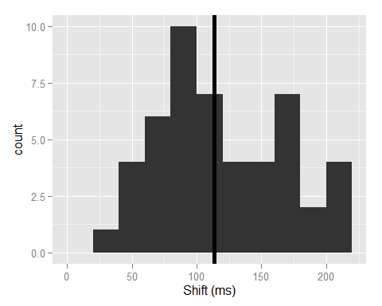

The average shift was 113.27ms, with a standard deviation of 49.09.

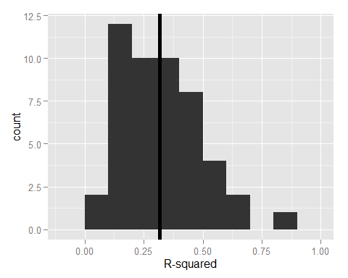

The average $R^{2}$ was 0.32, with a standard deviation of 0.17.

Regarding the final best-fit formulas from our 49 neurons, 25 models included rightward head velocity, 26 included leftward head velocity and 8 included head velocity in both directions. Similarly, 5 models included rightward eye position, 3 included leftward eye position and 0 included eye position in both directions.

Of the 8 models that included an eye position component, 6 also indluded a head velocity component and 2 did not.

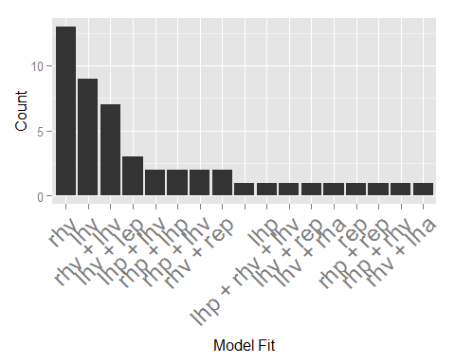

From this, we see that head velocity alone is a common fit. Also prevailent are combinations including head velocity and either eye or head position.

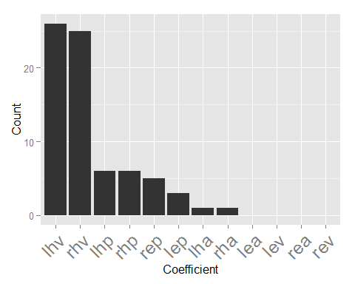

Next, we show how many times each term was included in a model. Left and right head velocity shows up the most often, followed by head position and eye position. Leftward and Rightward head acceleration were each included just once and eye velocity or acceleration was not included in any models.