|  |  |
| --- | --- |
| INF397b Web Appl Development Using Java, with Spring and Hibernate  Spring 2017  Instructor: Nikolay Minchev | Student: Dimitar Kumanov  ID# 100101031  e-mail: dak140@aubg.edu |
|  |  |

**Class Project**

Student Portal

The general purpose of the project is to provide comprehensive student portal. There are 5 main entities: Departments, Courses, Rooms, Professors and Students.

Use **university.sql** to create the database then in order to run the project go into the root directory and type in a command prompt:

***start mvnw spring-boot:run***

Screenshots from **Postman**:

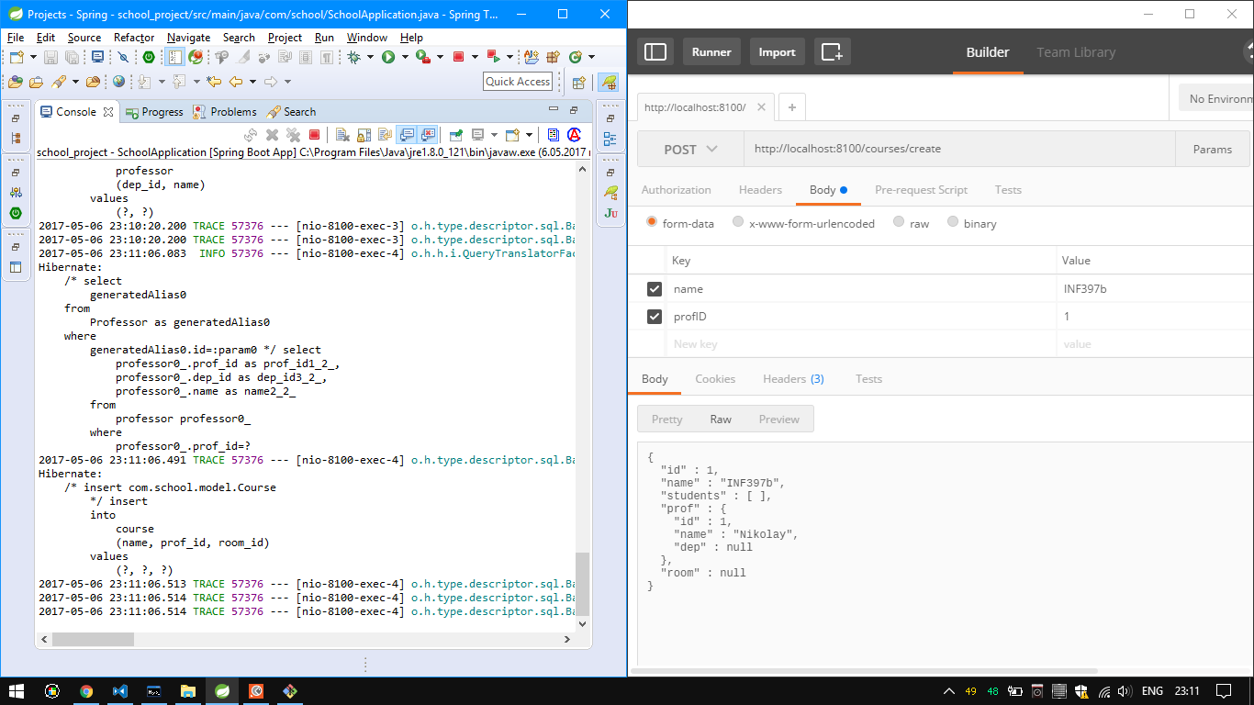*Creating a course:*

*Creating a Department:*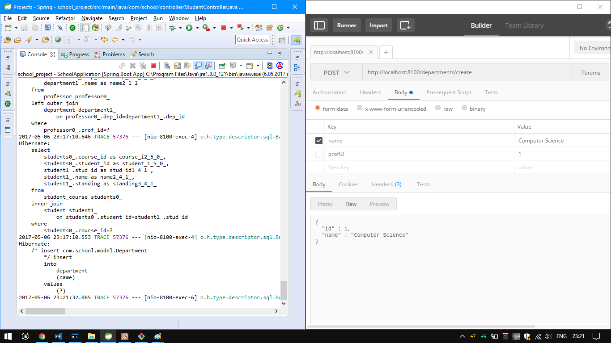

*Creating a professor:*

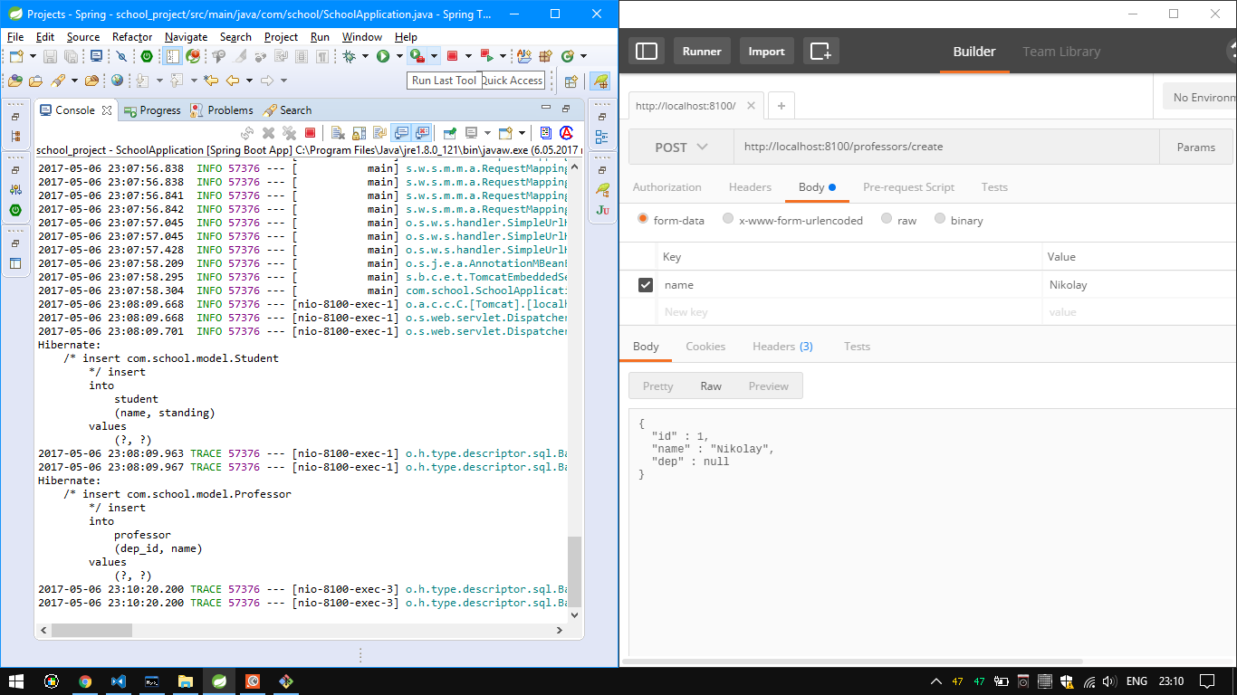

*Creating a Student:*

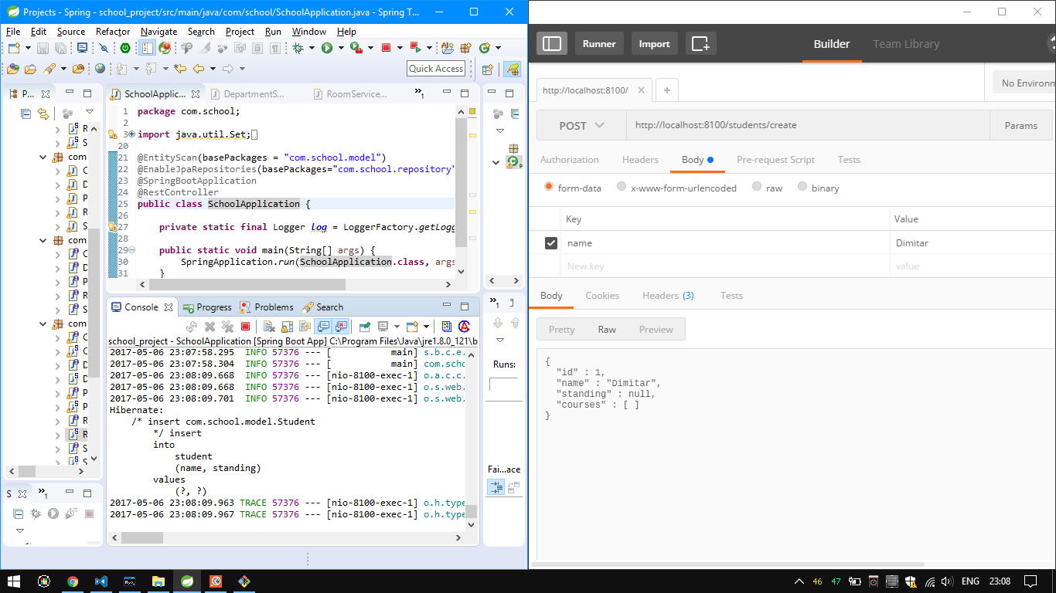

*Deleting a Student:*

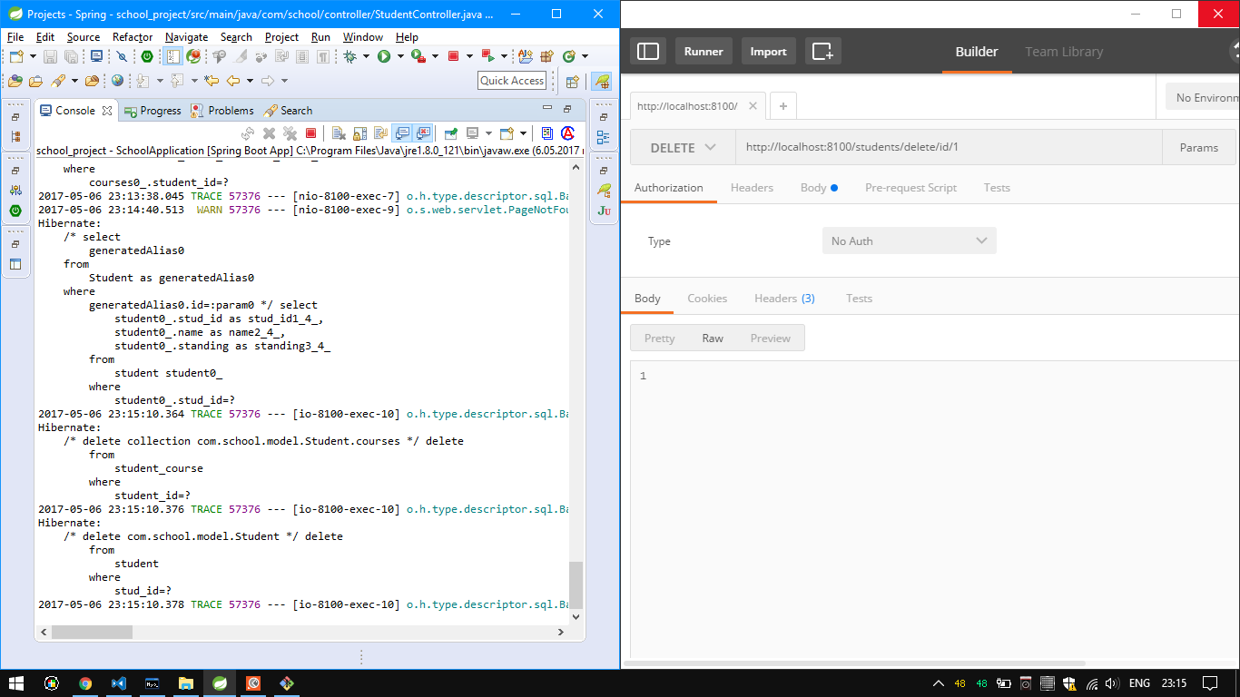

*Finding a Course by name:*

