diveR – By Capstone Group 11

How-To Guide

# How to Guide

This document outlines how to use the various features provided by the diveR GUI application. It is assumed that you have already read the installation guide. If you have not read the installation guide, we recommend that you go read it now to familiarise yourself with how to access the diveR application.

Contents

How to Guide 1

Getting started 2

How to create desktop shortcut 2

Features of the application 3

Usage pipeline 4

How to upload files 5

How to save files 6

How to run the program 6

How to change halftime-set / decompression model 7

How to add/delete custom gases 8

How to toggle gradient factor calculations on/off 9

How to output addition compartment pressure values 9

How to change theme 9

How to change language 10

How to add additional Languages 10

# Getting started

On installing the program, we recommend you run the program as administrator. Please refer to the installation guide step 6 on how to do this.   
  
We also recommend creating a desktop shortcut, so you can easily access the application. We will describe how to do this momentarily.  
  
to start the application, the user must simply double click the diver.exe application to get started.

## How to create desktop shortcut

To create a desktop shortcut, right click the diveR.exe application and hover over the “send to” option, this will show another menu which will have the option to send a shortcut to your desktop. (See below)

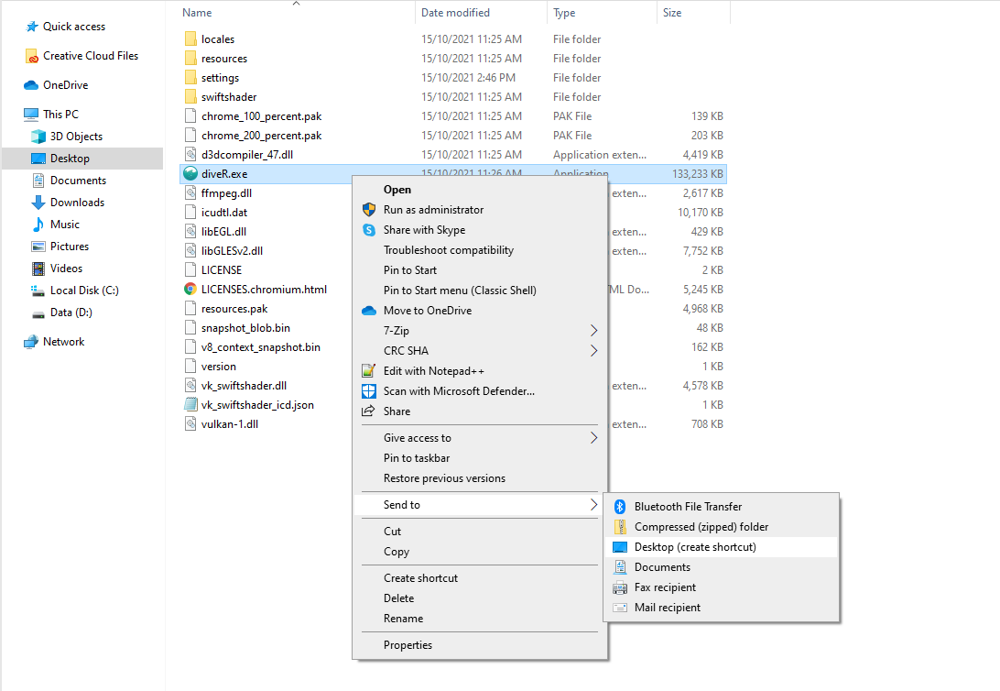

# Features of the application

Once you open the program, you will be greeted with the main page of the diveR application. We have highlighted the main points of interaction in this guide and will describe how to use them shortly.

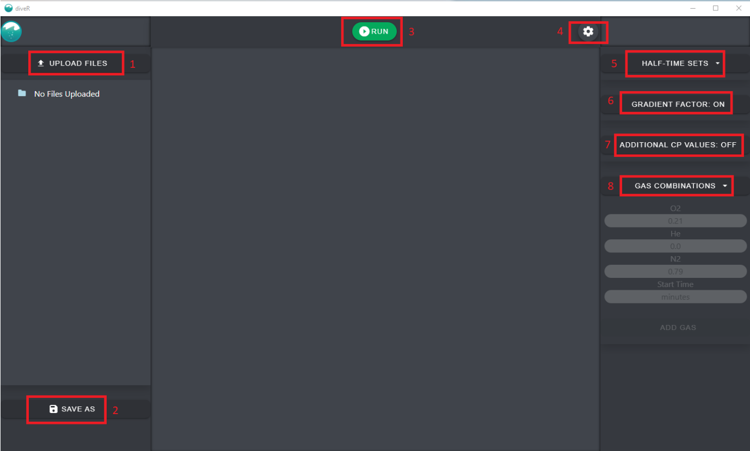

1. **Upload files**: This button will allow the user to select the .csv files and .ans/.txt files you wish to process using scuba.
2. **Save as**: This button will allow the user to select the output file destination.
3. **Run**: This is the button used to run the diveR application.
4. **Settings**: The image of the cogwheel lets the user access the different UI settings the dive application offers.
5. **Half-Time Sets**: This button allows the user to change the decompression model used when processing different dive profiles. By default, this is set to use Haldane’s decompression model.
6. **Gradient Factor**: This button allows you to toggle on/off the calculation of gradient factors. By default, this is set to ON.
7. **Additional CP values**: This button allows you to toggle on/off the output of additional compartment pressure values. By default, this is set to OFF
8. **Gas Combinations**: This button allows you to manually enter which gases were used in the dive profile. By default, the application assumes air is used.

# Usage pipeline

To successfully use the program, the user must follow the actions outlined below in the usage pipeline.

Required Settings

1. Upload file(s): Upload the dive profile files you wish to process.
2. Save as: select an output file destination.
3. Select Half-Time Set: Select the half-time set you wish to use. If none is chosen, Haldane will be used.
4. Run: Press the run button to begin the calculations.

Optional settings

1. Gas combinations: If the user wants to specify specific gas mixtures inhaled by the diver at different time points, select the Gas combinations setting. By default, air is used.
2. Gradient Factor toggle: Turn on/off gradient factor calculations.
3. Additional CP values: Turn on/off additional output of compartment pressure values.

# How to upload files

Upon selecting the upload files option, the user will be presented with a windows file explorer. Simply navigate to where the files are located and select the files you want to process.

If selecting multiple files, the program will allow roughly 1000 files to be uploaded at any given time. To do this highlight the ones you want, otherwise if uploading a single file, double click the file.   
  
It should also be mentioned that if the number of files uploaded exceeds the allowed limit. An error message will be displayed letting the user know.

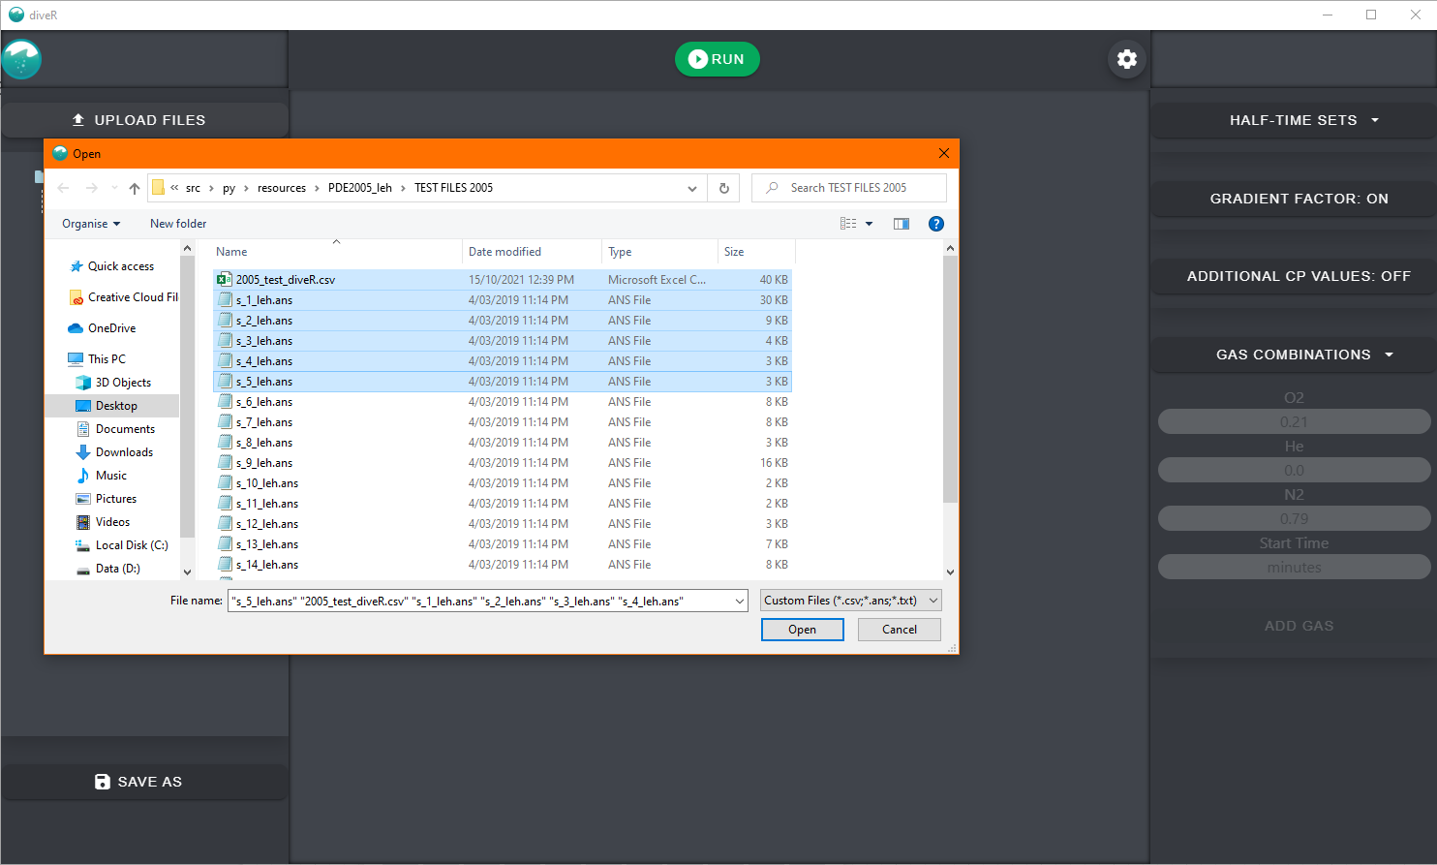

Upon selecting the files, you will be able to see them on the left-hand side of the program. As seen below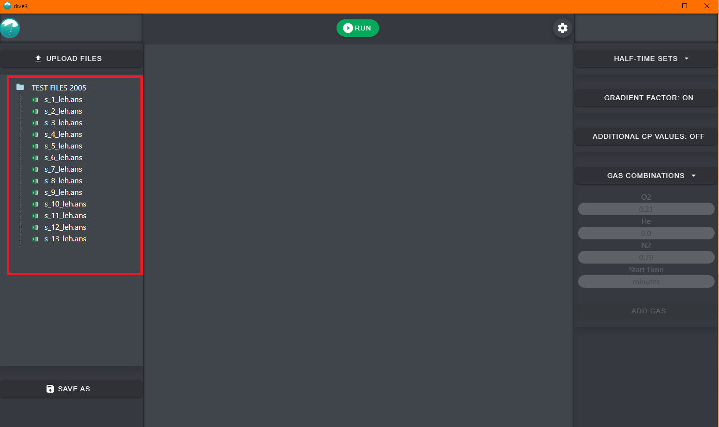  
*Note: If the file is of an invalid type. The program will allow you to upload it, however when the program is run, the file will be ignored or otherwise treated as if it is not there.*

# How to save files

Upon selecting the save files option, the user will be presented with a windows file explorer. Simply navigate to where you would like to save the files, type in a name for the file, and click save.

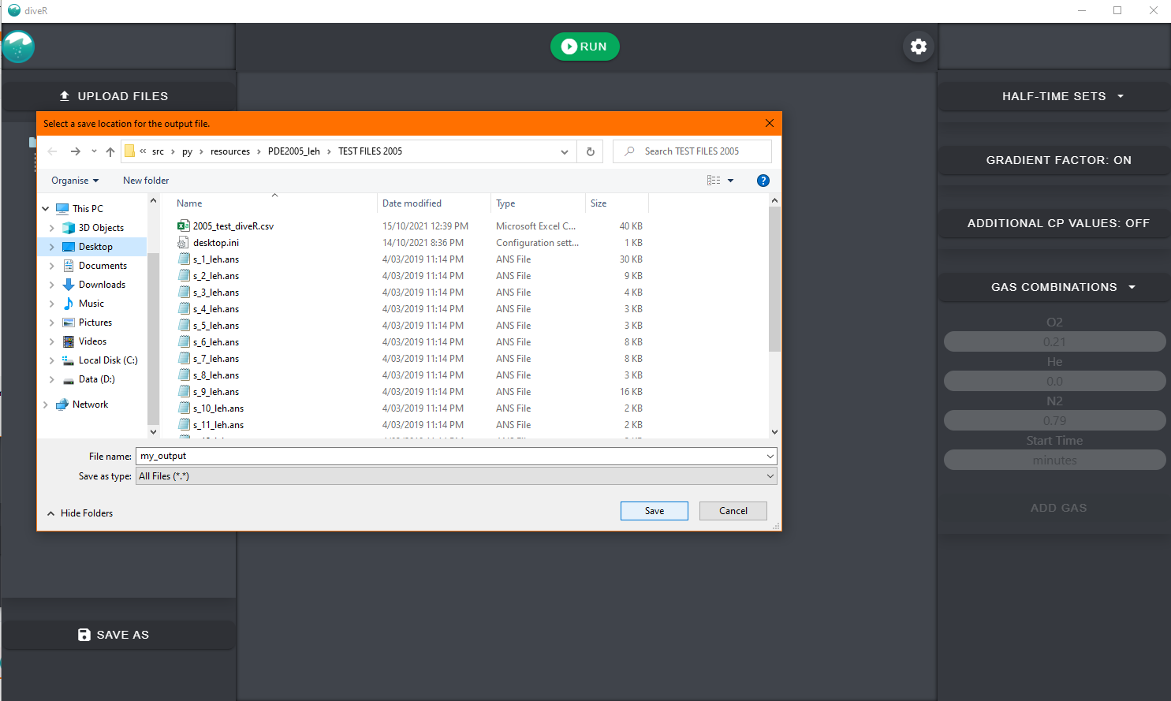

# How to run the program

To run the program, simply click the green button titled “Run” This will run the program, and upon completion, the program will display the results of the calculations.

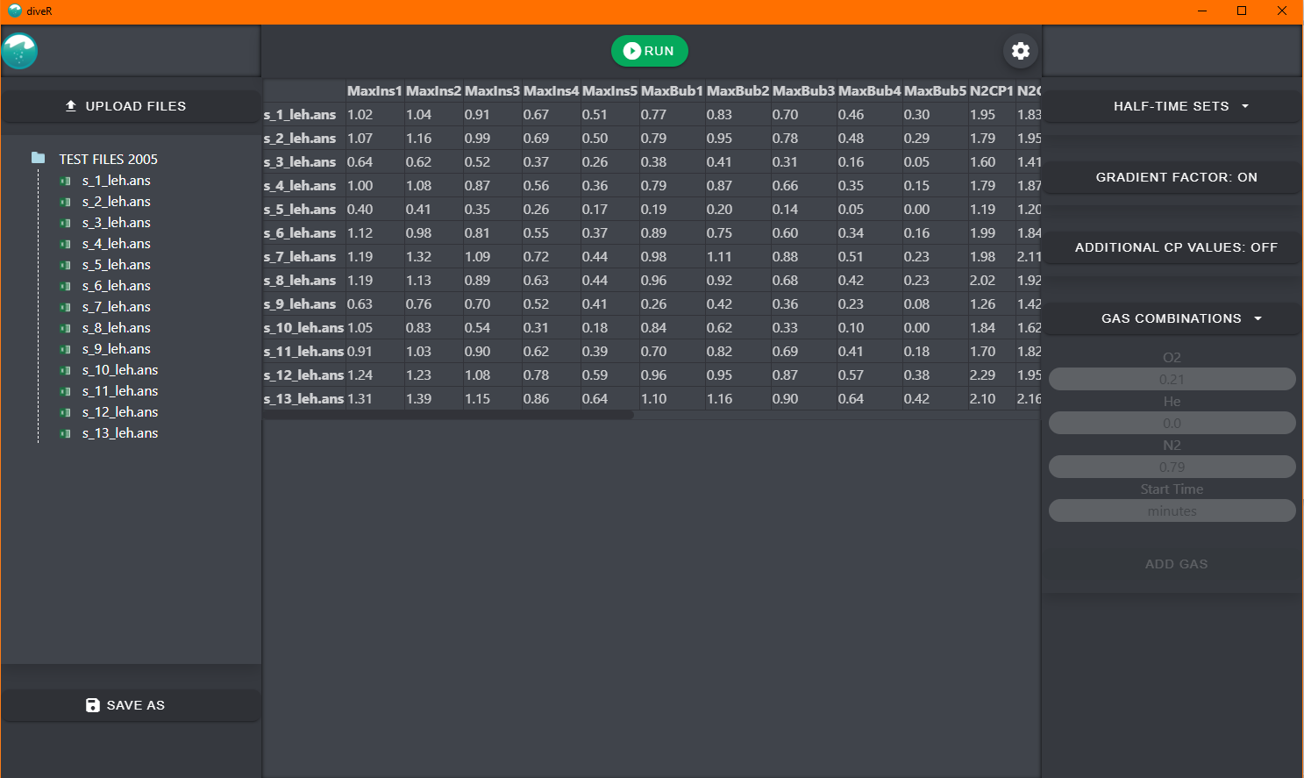

# How to change halftime-set / decompression model

To change the decompression model, click the Half-Time Sets button, this will cause a drop-down menu to appear with a selection of supported decompression models.

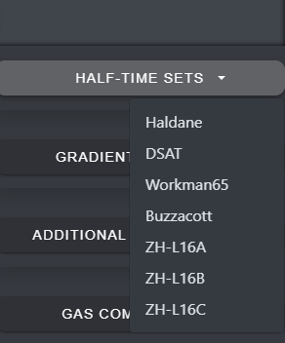

# How to add/delete custom gases

To add custom gases, the user will select ‘custom’ from the drop-down menu. This allows the user to enter the different amounts of oxygen, helium, and nitrogen as well as the starting time (in minutes) that the gas mixture was used. Once a gas is added, it will show up underneath the entry fields with a cross to remove it.   
  
By default, the application assumes that air was used. Below is an example of how the user would add a gas.

Note: If the user is processing .ans files and there are gases in the table, they will be ignored.

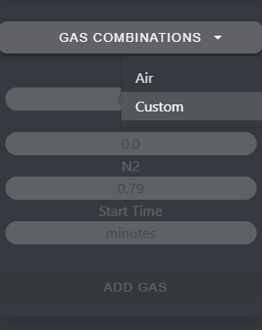

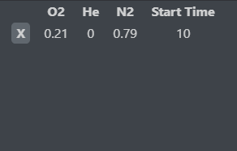

# How to toggle gradient factor calculations on/off

Simply click the toggle button to turn on/off gradient factor calculations.

# How to output addition compartment pressure values

Simply click the toggle button to turn on/off additional cp value output.

# How to change theme

The diveR application supports a dark and light theme. To change this theme, the user must click on the settings icon and click on the `Light Mode` toggle button. 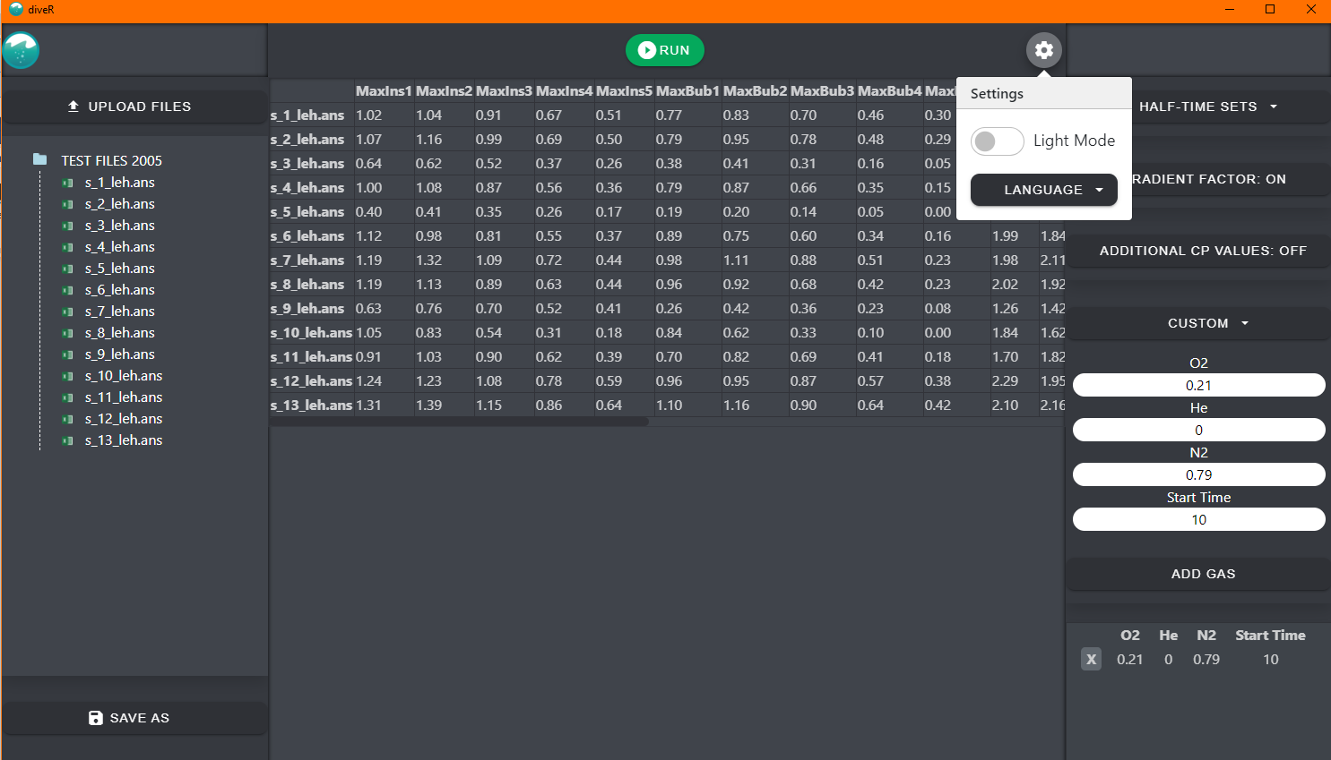



# How to change language

The diveR application supports multiple languages. To change the language, the user must click on the settings icon and select the language button to show a list of supported language, and then click on the language they want the program use.

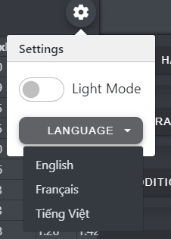

## How to add additional Languages

More advanced users may want to add their own languages. To do this, some knowledge of JSON format is required. See <https://developer.mozilla.org/en-US/docs/Learn/JavaScript/Objects/JSON> for information about JSON.   
  
To add a language, a user must navigate from the diveR directory (titled diveR-win32-x64) to the sub directory: **diveR-win32-x64\resources\app\settings**

Once in this directory, the user should see a file titled languages.json

We recommend opening this folder with a text editor such as Notepad++ or VScode to show useful text highlighting.

To add a new language, scroll to the bottom of the file, and select the last language as shown in the picture below, ensuring that the symbols highlighted in yellow are copied.



Copy and paste this selection directly after the yellow highlighted curly brace “}”. Once this has been done, the user must then replace the strings (in this case the text highlight maroon) with their language equivalent of what is written in purple.

You should have something that looks like the following:

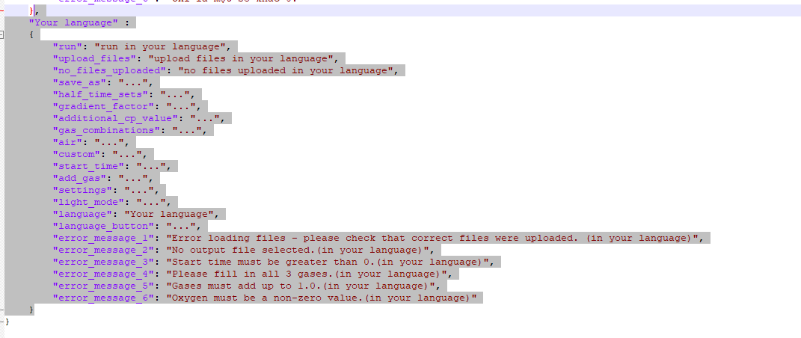

To test if the addition of the language has been successful, re-open the application, and go to the languages setting. You should now see your language in the list of supported languages. If it is unsuccessful, you will no longer be able to see any languages. In which case we recommend you delete your changes or alternatively re-download the application if deleting your changes was unsuccessful.

