Level Title: Escape Inevitability

Level Description:
You find yourself in an old, dark and eerie mansion with one goal… escape. While exploring you learn through notes that you aren’t alone. It is clear the last thing you want to do is meet, but you might not have a choice. Once you finally make your way downstairs and through a puzzle, a chase sequence occurs as you make a mad dash for the exit.

Paper Map:
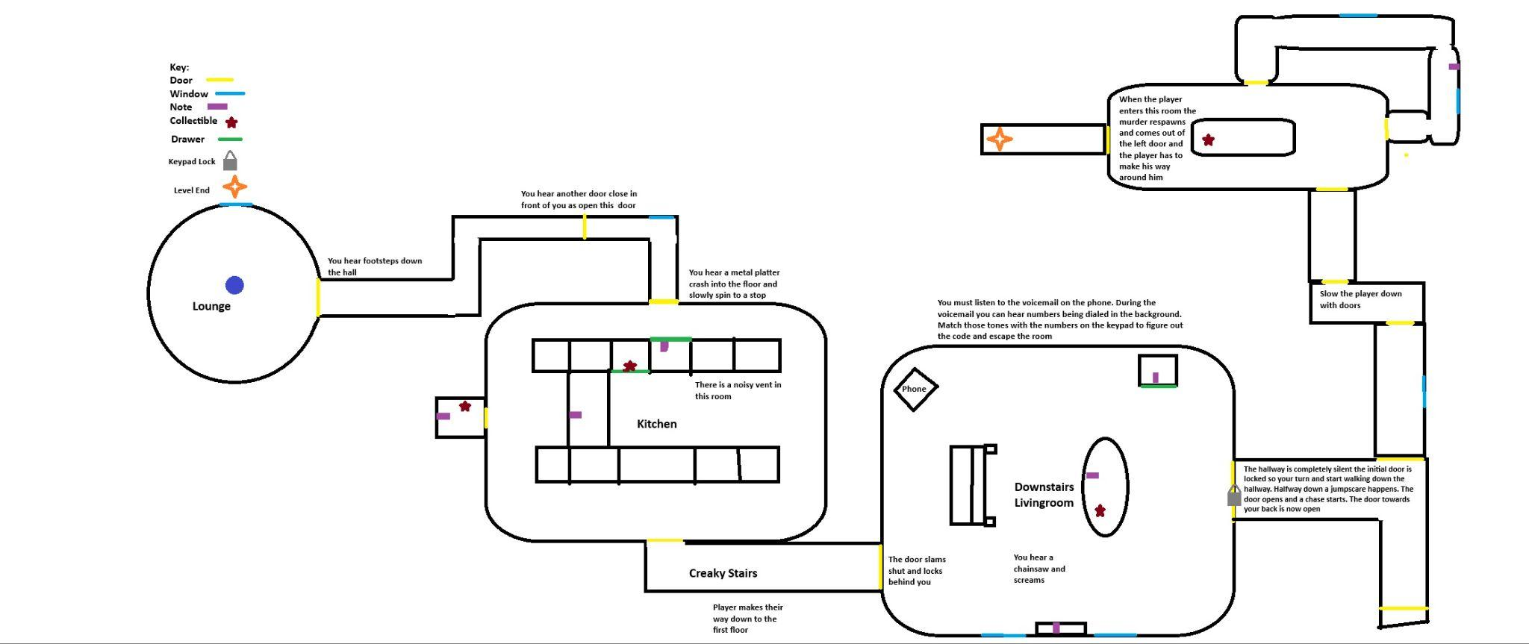
Design Goals & Inspirations:
Some of my inspiration came from my horror quote. “The oldest and strongest emotion of mankind is fear, and the oldest and strongest kind of fear is fear of the unknown” - H.P. Lovecraft. I wanted to visually and mechanically exclude the killer from the majority of my level. Then use tension building techniques to heighten the intensity of exploring the level and to make the chase sequence feel more impactful. One of the tension building techniques and my overall design goals was to focus on audio, because I think audio is extremely important to immerse the player and have them in the headspace to get scared. This included an eerie ambience track and startling stingers as you explore the house as well as audio feedback for interactions.

Whitebox Images: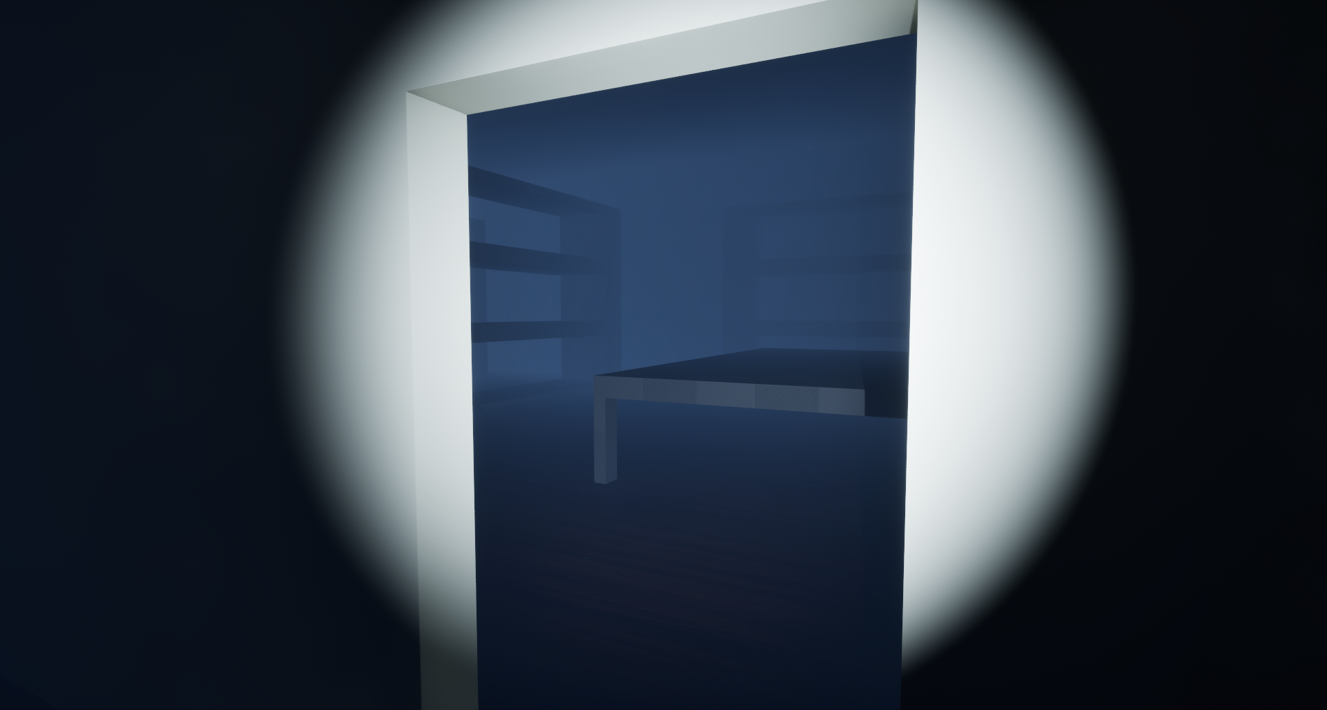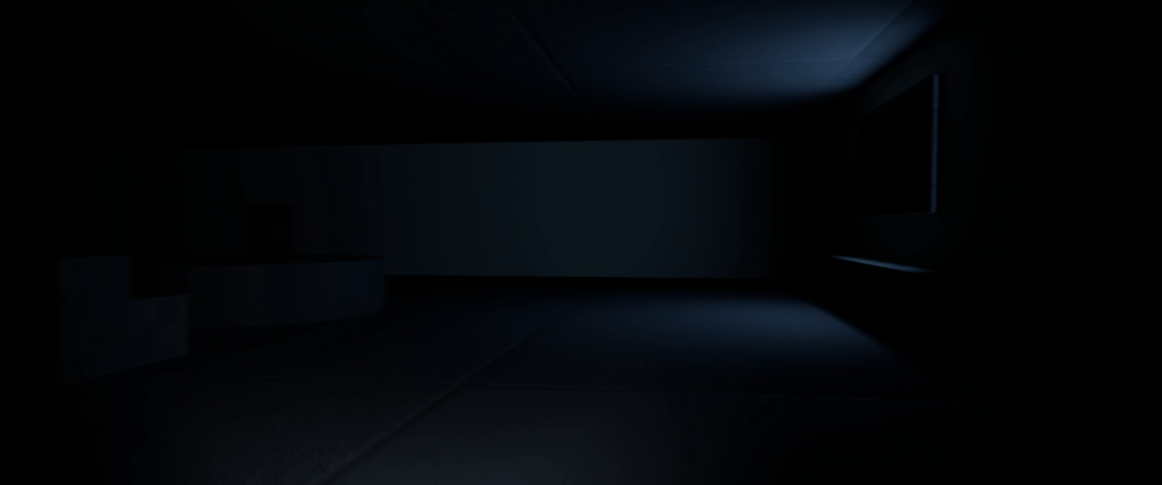 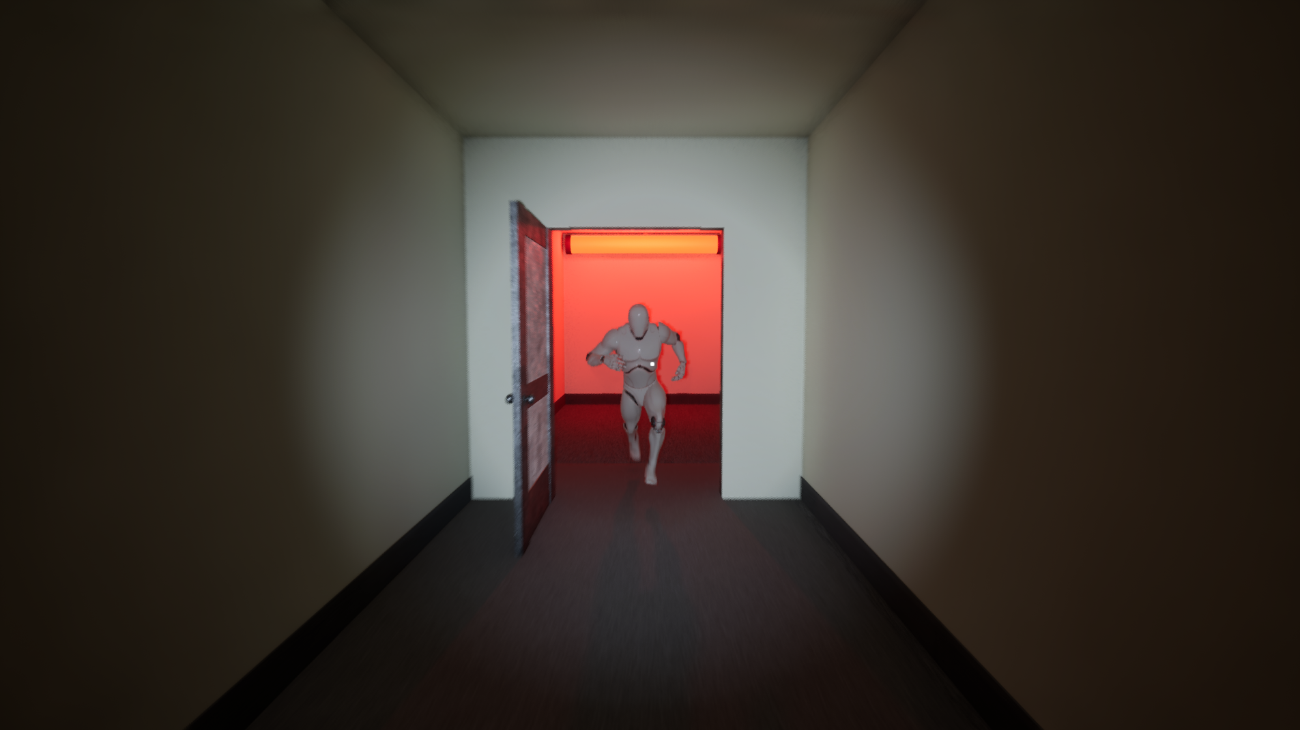

Challenges and lessons learned:
Scope: I definitely made myself more work than was necessary with large areas to decorate and multiple level mechanics (puzzle, AI enemy). I ended up not getting in all the audio feedback and ambience that I wanted to, as well as some scripted events. I am still getting used to blueprints and event graphs as most of my scripting experience for games has been in C# for unity. How all the nodes connect and everything is super intuitive and I can see why it is such a powerful tool for non-programmers, but as someone with a lot of scripting experience, it did/is taking me longer to learn than a new language.

Finals images: 