Stained Glass Image Filter

COMP 4102 - Computer Vision

Project Proposal

Adam Prins,

100 879 683

**Abstract**

This project seeks to create images resembling stained glass using photos. It uses K-Means colour grouping to spilt the image into colour regions. Numerous settings are available for the user to tweak the program so that the output is pleasing.

**Introduction**

The application processes images so that they resemble stained glass. It is an image processing software designed to be accessible to users looking to edit their images with this effect. The difficulty of this application is how to perform the analysis of the image so that the output is both accurate to the original image, and pleasing to the eye.

**Background**

This application uses openCV2 to perform many of the algorithms used to process the image, and QtPy5 for running the GUI. The primary algorithms from OpenCV used in the application are k-means, findContours, and drawContours.

**Approach**

The image processing begins with a gaussian blur to reduce noise in the final image, and to smooth the contours. Then the image is broken up into a grid of NxN squares. This allows different regions of the image to highlight local colour features without having to use a vary large size for K. For each square in the grid, a K-means colour grouping is performed to split the image into groups based on the concentration of colours in the image. Once the colour regions are determined, each one is isolated, and the contours are collected.

The list of all the contours is then passed to the drawing function, that will use the drawing settings to create the processed image. The first part of processing is that contours that do not meet the minimum area requirement are removed from the drawing pool. Then, for each contour the average colour of its area is determined. This colour is modified by the saturation and lightness controls. Finally, the outline of each contour is drawn onto the canvas to give the boundaries between each region. There are also additional options for selecting the colours, including using a random colour for each region.

I was not able to find another application that produces images of a similar style to the one I have made.

**Results**

The application has a simple to use GUI, and is accessible to almost all users. It consists of a tab of options for changing the groupings and how they are displayed, and a tab for the colours and how they are represented.

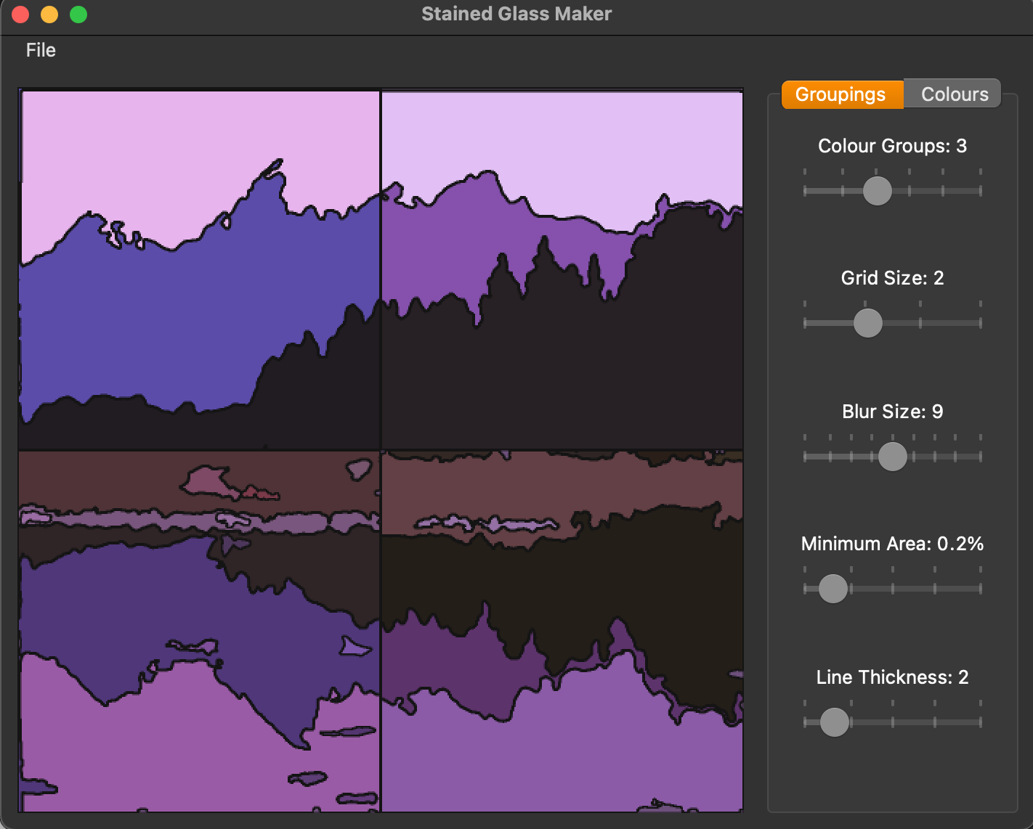

Figure 1 - The GUI

The application can be used to create many interesting images.

Figure 2 - Standard Colours

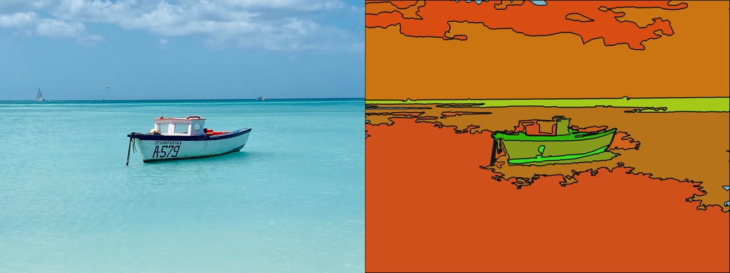

Figure 3 - Pop Colours

Figure 4 - Random Colours

The application also uses a cache, so while processing new configurations may take a few seconds, switching back to previously used ones is instant.

The image is processed at its native resolution, even though the UI displays it as a square. So when you save the results of the application, the output is correctly done at the native resolution.

**GitHub Page**

[**https://github.com/AdamPrins/Stained-Glass**](https://github.com/AdamPrins/Stained-Glass)