Shots Made by the Bucks in 2024 & 2025

Adam Rafique

2025-04-03

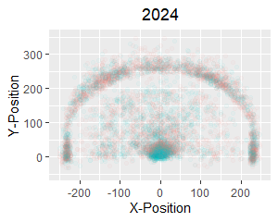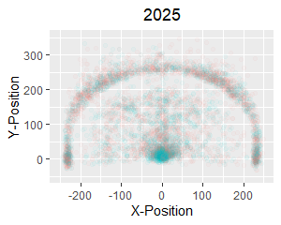 Note: Blue represents shots that were made, orange represents shots that were missed.

# Main Insights

* The area with the highest density of shots is around the net
* There appear to be more slam dunks attempted in 2024 than 2025
* There is a more even spread of shots attempted along the 3-point line in 2025 than 2024
* There are more shots attempted just beyond the 3-point line in 2024 than 2025
* Shots within the 3-point line are more concentrated towards the center in 2025
* Shots within the 3-point line are more concentrated to the left in 2024

# Elaboration on Main Insights

Before elaborating on the insights made, a disclaimer: My insights are limited and surface-level due to my limited and surface-level knowledge of basketball. I set the opacity of an individual point incredibly low so a high density of shots in a single area becomes more pronounced as it appears more opaque. As such, I noticed that the area around the net was the most opaque out of any location on the graph, so I inferred that it is the area with the highest density of shots. I also noticed that, for both graphs, the area around the net has the same opacity, but is bigger for the 2024 graph than the 2025 graph, so I inferred that more slam dunks were attempted in 2024 than 2025.

I noticed that the 3-point line was more consistent in its opacity in the 2025 graph than the 2024 one, so I inferred that the spread of shots attempted was more consistent in 2025 than 2024. I also noticed that there are considerably more points just beyond the 3-point line in the 2025 graph than the 2024 one, so I inferred that more shots were attempted just beyond the 3-point line in 2024 than 2024.

Lastly, for the shots within the 3-point line, I noticed that the center had a higher density of points in the 2025 graph whereas the left had a higher density of points in the 2024 graph. Therefore, I inferred that shots made within the 3-point line are more concentrated towards the center in 2025 and to the left in 2024.

# Above and Beyond: Four-Point Line

If the NBA were to implement a 4-point shot, I would draw a 4-point arc to be 29 feet from the center of the net. It is far enough away from the 3-point line that it would not effectively eliminate the 3-point shot while still being close enough that we can expect over a quarter of players who attempt the shot to make it, which would result in an expected value above 1. I believe that, were the 4-point shot implemented, the graphic shown on the first page would feature a thin yet noticeable line around the 4-point arc as more players would attempt to make 4-point shots, particularly around the arc.