**Backend Project Structure**

Backend Solution contains 4 projects.

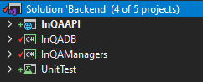

1. **InQADB** project contains all the necessary files which are related to Database tables (Models) and the attributes, this also includes the Connection class for database (AppDbContext.cs).  
   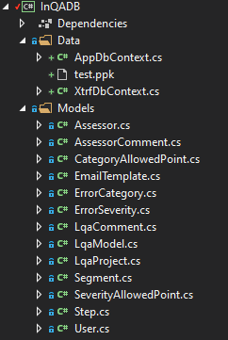
2. **InQAManagers** project contains operations such as Business logics (CRUD operation) and othermiscellaneous classes (e.g. Email, XLIFF converter).   
   View Model is class which we can use for rendering data on View.  
   All the interfaces in **InQAManagers** are accessed by the **InQAAPI** Controllers/Actions  
   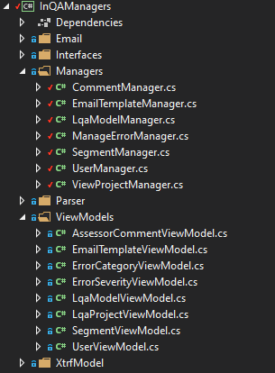
3. **InQAAPI** project contains all API Controllers which we will be calling from front-end.  
   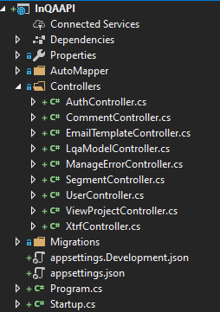
4. **UnitTest** project contains all the Test classes and methods. It will be accessing the interfaces in the **InQAManagers** project.