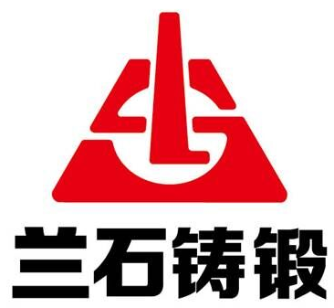 | 兰 州 兰 石 铸 锻 有 限 责 任 公 司  LANZHOU LS CASTING AND FORGING CO.,LTD
质 量 证 明 书
QUALITY CERTIFICATE
订货单位  Order Unit |  |  |  | 材质  Material |  |  |  | 40Cr |  |  | 单重  Weight Kg |  |  |  |  |  |  | T |  |  |  |  |  | 交货状态  Estate
合同号  Contract No. |  |  |  | 数量  Quantity |  |  |  | 件/炉 |  |  | 总重  Totalweight Kg |  |  |  |  |  |  | T |  |  |  |  |  | 冶炼方法 |  |  |  |  | VD
化学成份%  Chemical Composition |  |  |  | 材料进厂验收编号  Check No. |  |  |  |  |  |  |  |  |  |  |  |  |  |  |  |  | 化验单号  Test Report No.
炉号  Furnace No. |  | C |  |  | Si | Mn |  |  | P | S |  |  | Ni |  | Cr |  |  |  | Cu |  |  | Mo |  |  |  | Nb |  |  |  | V
B18-
要求含量%  Ladle Analysis Specified |  | 0.37  ~  0.44 |  |  | 0.17  ~  0.37 | 0.50  ~  0.80 |  |  | ≤0.030 | ≤0.030 |  |  | ≤  0.30 |  | 0.80  ~  1.10 |  |  |  | ≤  0.20 |  |  | ≤  0.10 |  |  |  | / |  |  |  | /
实测含量%
Part Analysis
炉号  Furnace No. |  | Ti |  |  | Al | As |  |  | Sn | Sb |  |  | H |  | O |  |  |  | N |  |  | W
B18-
要求含量%  Ladle Analysis  Specified |  | / |  |  | / | / |  |  | / | / |  |  | / |  |  | / |  |  |  | / |  |  | /
实测含量%
Part Analysis
其他项目检查结果：(Remark)
合 格
工件经检查合格，符合（GB/T3077-2015）技术标准，同意发货。
质量保证工程师  Quality Assurance  Engineer |  |  | 2018.06. |  |  |  | 检查责任人  Quality Director |  |  |  |  | 2018.06. |  |  |  |  | 检查员  Examiner |  |  |  |  |  |  |  | 2018.06.

