Lab 3 DeMorgan’s Theorems

Dr Chandra Bajracharya

Will Baker

Adam Rolek

2/26/2020

3/4/2020

**Objective**

The objective of this lab is to prove DeMorgan’s theorem. This will be achieved by constructing several circuits using basic logic gates, verifying the operation of the circuits by completing truth tables, and comparing the truth tables to verify the theorem.

**Apparatus**

* HEATHKIT ET-3700 LOGIC TRAINER
* 388A Digital Multimeter
* Connecting Wires at least 6 inches

**Method**

Step 1: Draw the diagram for an AND gate with 2 inverted inputs.

Step 2: Build the circuit with the trainer and your IC chips.

Step 3: Test the circuit and complete a truth table for all 4 input combinations.

Step 4: Write the Boolean equation for the circuit.

Step 5: Repeat steps 1 – 4 for an OR gate with an inverted output.

Step 6: Repeat steps 1 – 4 for an OR gate with 2 inverted inputs.

Step 7: Repeat steps 1 – 4 for an AND gate with an inverted output.

**Data**

Part A: Inverted inputs to the AND gate

|  |  |  |
| --- | --- | --- |
| SW1 | SW2 | L1 |
| 0 | 0 | 1 |
| 0 | 1 | 0 |
| 1 | 0 | 0 |
| 1 | 1 | 0 |

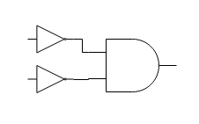

Part B: Inverted output of the OR gate

|  |  |  |
| --- | --- | --- |
| SW1 | SW2 | L1 |
| 0 | 0 | 1 |
| 0 | 1 | 0 |
| 1 | 0 | 0 |
| 1 | 1 | 0 |

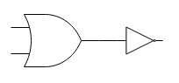

Part C: Inverted inputs to the OR gate

|  |  |  |
| --- | --- | --- |
| SW1 | SW2 | L1 |
| 0 | 0 | 1 |
| 0 | 1 | 1 |
| 1 | 0 | 1 |
| 1 | 1 | 0 |

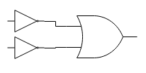

Part D: Inverted output of the AND gate

|  |  |  |
| --- | --- | --- |
| SW1 | SW2 | L1 |
| 0 | 0 | 1 |
| 0 | 1 | 1 |
| 1 | 0 | 1 |
| 1 | 1 | 0 |

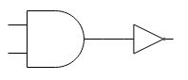

**Results** **and** **Analysis**

We used the circuits built in this lab to prove DeMorgan’s theorem. We did this by comparing the truth table from Part A and Part B to show that they are equal (). We also compared Part C and Part D to show that those truth tables were also equal ().

**Conclusion**

We feel as though the objective of this lab was met. We were able to construct all the circuits. We were able to verify their operations by completing the truth tables. And after comparing every part of the lab, we were able to prove DeMorgan’s theorem.