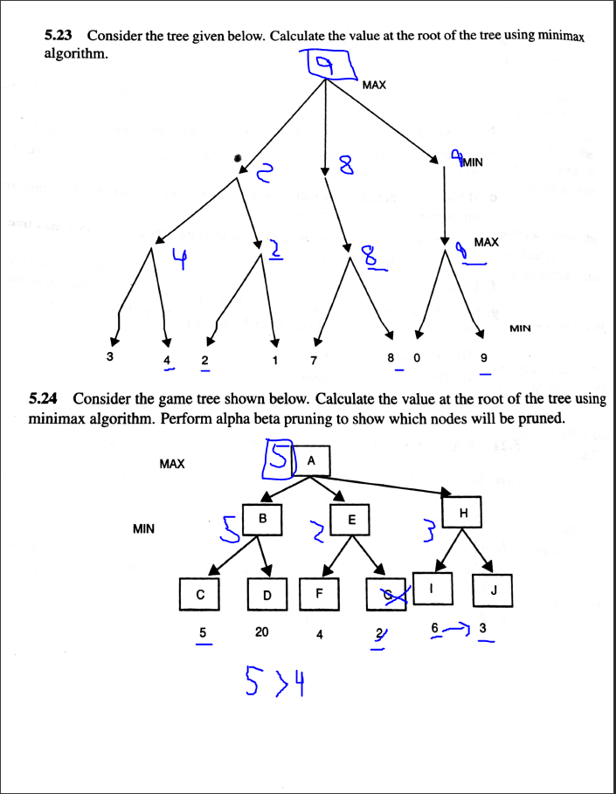

‘G’ will be pruned.

18. Enlist the three operators used in genetic algorithms.

The three operators used in genetic algorithms would be:

* Mutation
* Crossover
* Selection

19. Can you differentiate between hill climbing methods and simulated annealing algorithms?

With Hill Climbing you would modify a solution only locally which makes Hill Climbing very prone to finding optimal local solutions.

With simulated annealing there are Bad moves made from time to time to fix the issue with Hill climbing of becoming a local answer. Therefore, it is more likely to find a global optimum.

Simulation annealing is better for large scale optimization tasks.