CS-316 Midterm Exam, Spring 2020

* This exam is similar to the midterm review you received last week, however DO NOT copy answers from the review – EVERY question has been changed to varying degrees, so be careful.
* The midterm will be open book and open notes and will be 2 hours. You can leave class when you finish.
* The exam covers chapters 1-5.
* Upload your exam to the assignment when done (do NOT hand it in late after the assignment closes!)
* Make sure to get the bonus points at the end!

1. **Short Answer Questions (20 pts)**

For each of the following questions, give a short answer and support your answer where appropriate with examples or explanations.

**a**. In your own words, what is the difference between a *heuristic* and a *goal test*?

**A heuristic is information that improves the performance of a choice.**

**A goal test is a check to make sure a state is met or not.**

**b**. Describe one *uninformed* search algorithm we studied and explain why it is uninformed vs informed.

**Breadth first search is one of the uninformed searches we discussed. It Is uninformed because it has no additional information from the current state to the goal. Informed algorithms such as A* have additional information from the current state to the goal**

**c**. Describe a heuristic that could be used for the game of *checkers* and explain why it’s a useful heuristic.

**Keep more pieces around your most forward piece. This could be helpful for advancing on the board and keeping your pieces protected and allowing for retaliation if any are taken.**

**d**. Why does graph search require that we check whether a node has already been visited?

**Graphs may have cycles that could cause infinite looping if we do not track the visited nodes.**

1. **PEAS (10 pts)**

For each of the following activities, give a PEAS description of the task environment

and characterize it in terms of the properties listed in Section 2.3.2. of your book

Example: • Playing soccer.

PEAS: *goals scored, games won (performance), soccer field, players, refs and coaches (environment), players legs and hands (actuators), player’s, refs and coaches eyes, ears (sensors)*

Environment: *Partially observable, stochastic, sequential, dynamic, continuous, multi-agent*.

1. 3d-printing a model of a teapot. (A 3d printer if you’re not familiar is like a regular printer, but it lays down layers of hot plastic, building up layers into a solid 3D shape)

PEAS: Smoothness (P), Speed (P), Print bed (E), Motors (A), Slides (A), Belts (A), Operators eyes (S), Heat Sensor (S) ___________________________________________________________________

________________________________________________________________________

Environment: Partially observable, deterministic, sequential, static, discrete, single agent ________________________________________________________________________

________________________________________________________________________

1. Navigating an autonomous probe to land on Mars (after being launched from a rocket outside Earth’s atmosphere).

PEAS: landing placement (p), geo-location (p), Mars (e), Dirt/sand (e), rockets (a), pistons/actuators (a), shock sensors (s), cameras (s)

________________________________________________________________________

________________________________________________________________________

Environment: Partially observable, stochastic, sequential, dynamic, continuous, no agent

________________________________________________________________________

________________________________________________________________________

1. **Problem formulation (10 pts)**

Give a complete problem formulation for each of the following. Choose a formulation

that is precise enough to be implemented.

1. You are trying to find the cure for novel Coronavirus. You are running models of potential vaccines against a simulation to check whether the vaccine works. Each model represents a fragment of DNA from the virus, and you must run the simulation which represents the immune system on that virus and get a positive result (> 50% probability of success). Future fragments should be chosen from the most successful previous models.

Initial State: There is a number of vaccine models that are ready to be tested

Goal test: Does testing the model give >50% probability of success

Successor function: Choose the next untested vaccine

Cost function: Cost is 1

1. You are programming an AI for a video game in which the player must play the role of a parking attendant who is trying to park cars with his competitive coworkers. Coworkers park cars simultaneously and compete for spaces on a first come first service basis.

Initial State: There are a number of cars ready to be parked

Goal test: Is the car parked?

Successor function: Begin to park the next unparked car

Cost function: Cost is 1

1. **Greedy Best First Search (15 pts)**

Trace the operations of A* Search applied to the problem of getting to Dobreta to Bucharest using the straight-line distance heuristic. That is, show the sequence of nodes that the

algorithm will consider and the f, g, and h score for each node. You start at Dobreta and must end up in Bucharest using A*star. Show the operations as we did in the review.

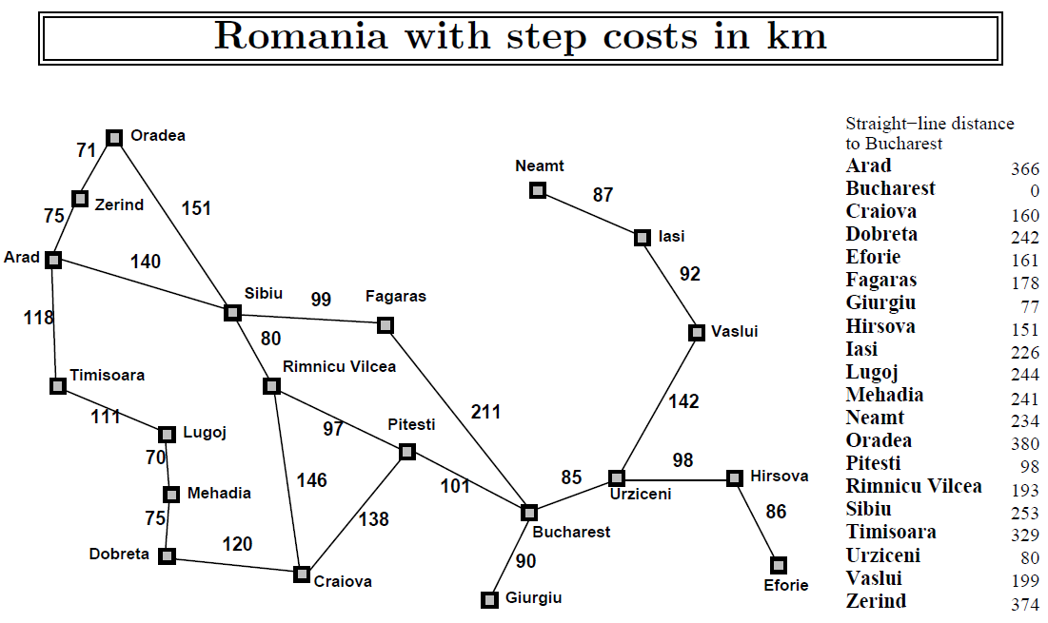

**Dob -> Meh (75 + 241 = 316), Cra (120 + 160 = 280)**

**Cra -> Dob (120 + 120 + 242 = 482), Rim (120 + 146 + 193 = 459), Pit (120 + 138 + 98 = 356)**

**Pit -> Cra, Rim, Bucharest**

**Bucharest**

1. **Apply a Heuristic with informed search (10 pts)**

If the heuristic is Manhattan distance is used, from the start state, which is the next state that would be chosen by A* search? (hint: manhattan distance is the number of moves needed to move all pieces to correct position and remember f score = g + h where g in this case is # of turns). Justify your choice using a calculation if possible.

**The Manhattan distance for the 5 tile the lowest of any tile not already in the correct position so this should be the best move (1 tile down).**

**Tile6 = 0 moves**

**Tile5 = 1 move**

**Tile4 = 3 moves**

1. **Local search (5 pts)**

From the current state, explain how simulated annealing could be used to reach a more helpful state within this state space:

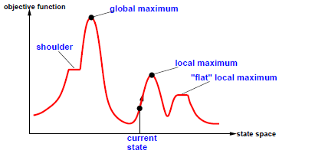

**simulated annealing uses a lot of randomness at first to move around, and then less randomness as time goes on. Hill climbing would get stuck at the local maximum and that would be the best result. Simulated annealing has a better chance at finding the global maximum due to the randomness.**

1. **Genetic algorithms (5 pts)**

label each phase of this diagram with the following labels (initial population, fitness function, selection, cross-over, and mutation). Which step do you think is most important and why?

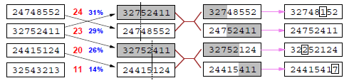

**initial population, fitness function, selection, cross-over, and mutation**

**I believe that the mutation step is the most important. The mutation step is the most important because it is where variation is introduced into the algorithm. In my opinion this is where things start to get interesting.**

1. **Minimax (15 pts)**

Describe the steps taken by minimax and fill in the Max level and Root level. Which value(s) could be pruned with alpha-beta pruning and what could be done to make pruning more efficient/possible if no pruning is already possible?

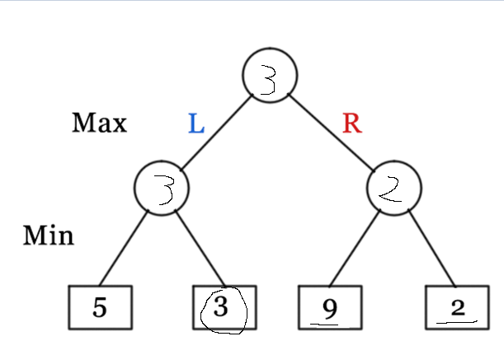

**To make pruning possible in this scenario. The two would have to be before the 9, then the 9 could be pruned.**

1. **DFS and BFS (10 pts)**

What’s the DFS traversal of the following tree (assume we always go left first, visit the node, then go right as usual)?

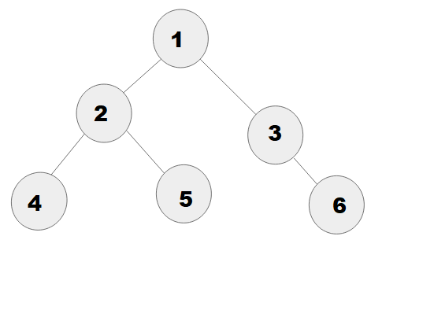

**DFS: 1 -> 2 -> 4 -> 5 -> 3 -> 6**

**BFS: 1 -> 2 -> 3 -> 4 -> 5 -> 6**

1. **Bonus questions (15 pts)**
2. **Describe the premise of the Turing Test very briefly**

**The premise of the Turing test is for a human interrogator to determine if he is currently speaking with a human or a computer.**

1. **Name one AI developed in the past 5 years which has gained worldwide attention, and say what it is famous/infamous for.**

**OpenAI Five is famous recently for beating the worlds best Dota 2 players.**

1. **What is the underlying assumption behind the minimax algorithm? Yes, it assumes a “zero sum game”, but what does that imply?**

**A zero sum game is a game in which only one player can win, the amounts won and loss must add up to 0. I believe the assumption would be that one player is optimal.**