CS-316 Midterm Exam, Fall 2019

* This exam is similar to the midterm review you received last week.
* The midterm will be open book and open notes and will be 2 hours. You can leave class when you finish.
* The exam covers chapters 1-5.
* Upload your exam to the assignment when done (do NOT hand it in late after the assignment closes!)
* Make sure to get the bonus points at the end!

1. **Short Answer Questions (20 pts)**

For each of the following questions, give a short answer and support your answer where appropriate with examples or explanations.

**a**. What is a *heuristic* in Artificial Intelligence, and why is it useful?

A heuristic information (which could be generated by an algorithm or calculation) that improves the performance of my choice. It is useful for example to bring additional information to a search problem, or to make the best move in a game.

**b**. Explain the difference between Greedy Best First Search and A* Search. Why is one superior to the other? (Hint: You can use the Romania map example for support)

A greedy best first search only incorporates the heuristic value for the overall cost function: f = h.

A star incorporates both the path cost and the heuristic value

**c**. Describe a heuristic that could be used for Tic-Tac-Toe and why it’s a useful heuristic.

Keep the most options open for the next turn (or how many ways I can win) is one example and it’s useful because it generates the best move

**d**. What’s the main difference between TREE search and GRAPH search?

Graphs may have cycles, nodes may have any number of parents or children, and are not necessarily directional, and due to all these things it is not safe to traverse a graph unless you keep track of and void visited nodes

1. **PEAS (10 pts)**

For each of the following activities, give a PEAS description of the task environment

and characterize it in terms of the properties listed in Section 2.3.2. of your book

Example: • Playing soccer.

PEAS: *goals scored, games won (performance), soccer field, players, refs and coaches (environment), players legs and hands (actuators), player’s, refs and coaches eyes, ears (sensors)*

Environment: *Partially observable, stochastic, sequential, dynamic, continuous, multi-agent*.

1. Knitting a sweater.

PEAS: consistent pattern of stitching (p), efficient use of material (p), needles (a), eyes(s), hands (s, a)

________________________________________________________________________

Environment: Partially observable, stochastic, sequential, static, continuous

________________________________________________________________________

1. Bidding on an item at an auction.

PEAS: ________________________________________________________________________

________________________________________________________________________

Environment: ________________________________________________________________________

________________________________________________________________________

1. **Problem formulation (10 pts)**

Give a complete problem formulation for each of the following. Choose a formulation

that is precise enough to be implemented.

1. You have a program that outputs the message “illegal input record” when fed a certain file of input records. You know that processing of each record is independent of the other records. You want to discover what record is illegal.

Initial State: There are a number of input records ready to be processed in order and we are ready to start on the first one.

Goal test: Does processing this file produce an error?

Successor function: Choose the next unprocessed record.

Cost function: Cost is the same for each. Cost is 1. There is no cost.

1. You have three jugs, measuring 12 gallons, 8 gallons, and 3 gallons, and a water faucet. You can fill the jugs up or empty them out from one to another or onto the ground. You need to measure out exactly one gallon.

Initial State: _________________________________________________________________

Goal test: _________________________________________________________________

Successor function: _________________________________________________________________

Cost function: _________________________________________________________________

1. **Greedy Best First Search (15 pts)**

Trace the operations of Greedy Best First Search applied to the problem of getting to Bucharest from Dobreta using the straight-line distance heuristic. That is, show the sequence of nodes that the

algorithm will consider and the f, g, and h score for each node.

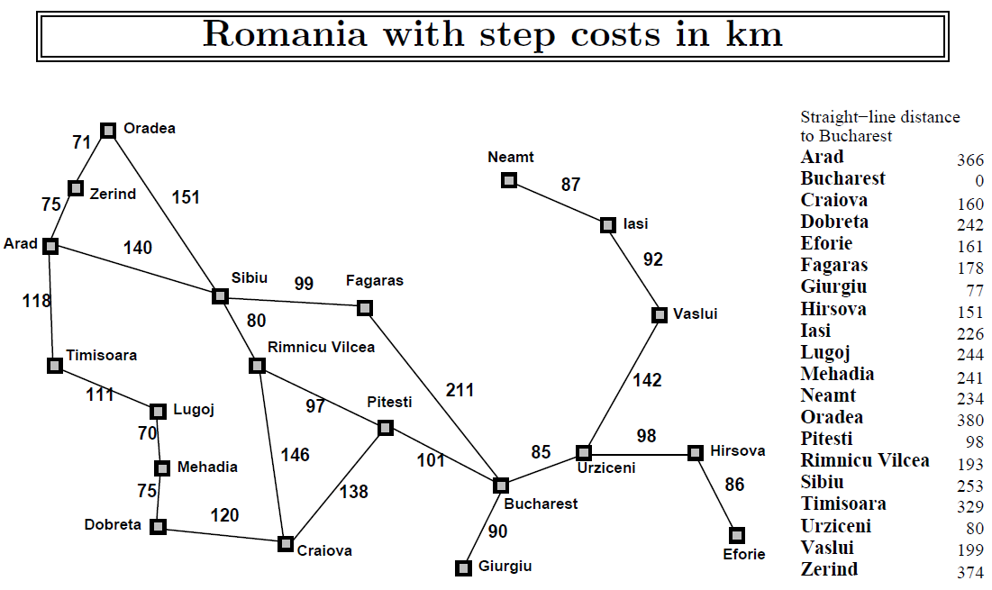

Arad -> Zerind (374), Timisora (329), Sibiu (253)

Sibiu -> Arad (366), Fagaras (176), Oradea (380)

Fagaras -> Sib (253), Bucharest (0)

Bucharest

A*star search example (Arad to Bucharest)

Arad -> Zerind (75 + 374 = 449), Timisoara (118 + 239 = 447), Sibiu (140 + 253 = 393)

Sibiu -> Arad (140 + 140 + 366 = 553), Fagaras (140 + 99 + 178 = 417), Oradea(140 + 151 + 380 = 671), Rim (140 + 80 + 193 = 413)

Rim -> Sib (140 + 80 + 80 + 253 = 553), Pit (140 + 80 + 97 + 98 = 415), Cra (140 + 80 + 146 + 160 = 526)

Pit -> Rim (140 + 80 + 97 + 97 + 193 = 607), Cra (140 + 80 + 97 + 138 + 160 = 615), Buch (140 + 80 + 97 + 101 + 0 = 418)

Bucharest

1. **Apply a Heuristic with informed search (10 pts)**

**If the heuristic is Manhattan distance is used, from the start state, which is the next state that would be chosen by A* search? (hint: manhattan distance is the number of moves needed to move all pieces to correct position and remember f score = g + h where g in this case is # of turns)**

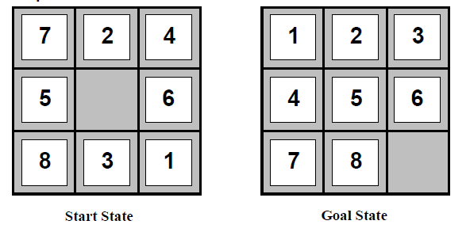

The Manhattan distance for the 5 tile the lowest of any tuile not already in the correct position so that would be a good move (move right 1 tile).

1. **Local search (5 pts)**

**Given the below state space, from the current state, describe one algorithm that could be used to reach the global maximum.**

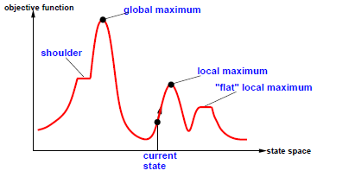

One alternative to hill climbing strategy is simulated annealing in which we use a lot of randomness to move around at first and then less randomness as time goes on

1. **Genetic algorithms (5 pts)**

**If the below strings represent features of a program, point out one mutation in the diagram, and explain why a mutation would be helpful or not.**

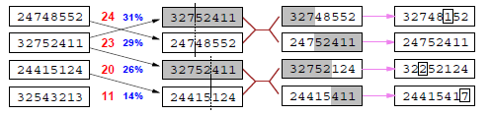

The 7 with the box around it is one mutation in the diagram. This mutation could be helpful because, presumably, after 4 generations a change should be beneficial

1. **Minimax (15 pts)**

**Describe the steps taken by minimax and fill in the Max level and Root level. Which value(s) could be pruned with alpha-beta pruning?**

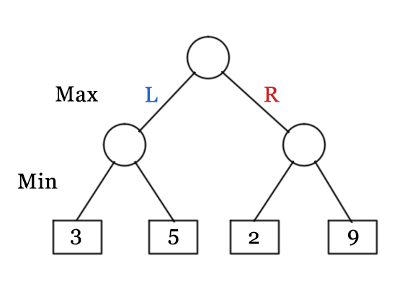

2

3

3

1. **DFS and BFS (10 pts)**

**What’s the BFS traversal of the following tree?**

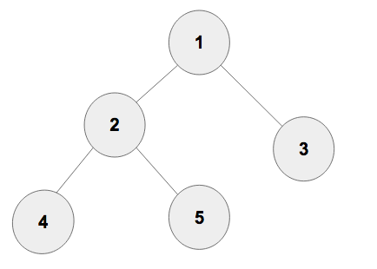

DFS: 1 -> 2 -> 4 -> 5 -> 3

BFS: 1 -> 2 -> 3 -> 4 -> 5

1. **Bonus questions (15 pts)**
2. **From Alan Turing’s 1950 paper on the Imitation Game, describe one objection he addressed that you feel is most relevant today.**
3. **What was your favorite part of the CS-316 so far?**
4. **What is your least favorite part of CS-316 so far?**