Open Source POS

Capitol Technology University

Adam Rolek

CS-405

3/14/2020

Introduction

A point of sale (POS) system is a system that allows a customer to make payment for a product or service. Every time a customer makes a purchase, they are completing a point of sale transaction. The POS system is where most sales, inventory, and customer information is stored and managed. “As evident as the benefits of a POS system are, we found that 56 percent of single-store retailers are still not using one. Instead, we found, many are still using a combination of manual methods, cash registers, QuickBooks and Excel for bookkeeping” (Stubbs, 2019). Most modern POS systems require a subscription License. Therefore, there is need for a lightweight, simplistic, open source POS system.

Inception

There are many small businesses in America that only complete transactions with cash and keep hard copies of all sales. An open source POS system would be beneficial to these businesses to save the owners money. The benefits of an open source system do not end there, all the source code should be available which will allow for custom solutions that better fits the business needs.

Requirements

This system should fulfill the following requirements:

* The system must track sales and payment.
* The system must allow management of the products and services.
* The system must assist in payment.
* The system must give reports.
* The system must complete audits.
* The system must be used by workers, and supervisors.
* The system must be modular (could be adjusted for multiple business types).

Diagrams

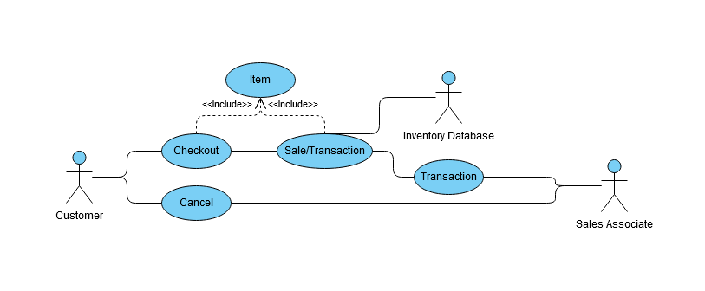

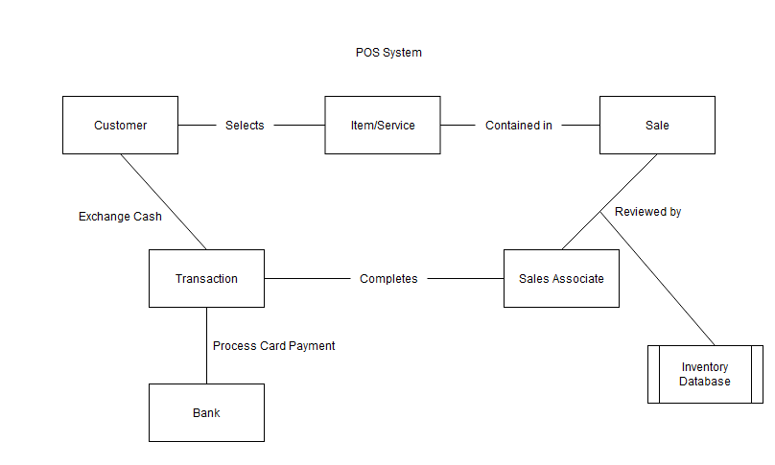 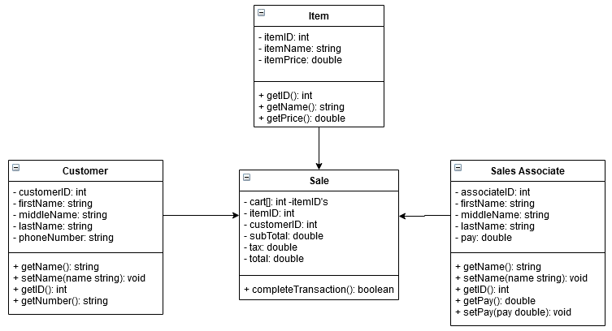

References

Stubbs, A. T. (2019, October 25). What Is a POS System? Retrieved March 26, 2020, from

https://www.softwareadvice.com/resources/what-is-a-point-of-sale-system/