AI Life Recommender
Context-Aware Multi-Domain Recommendations
with Hybrid Collaborative Filtering and Agentic LLM Orchestration

CMPE 256 — Recommender Systems — Term Project
San Jose State University
Team: Adam Sabry, Rammy Baroudi, Stephen Taylor
[ PLACEHOLDER — Submission date ]

1. Project Goals
Standard recommender systems serve a single domain — movies on Netflix, products on Amazon, songs on Spotify. They optimize for rating prediction or click-through, and they assume the user's preferences are a single point in latent space. Neither assumption holds in the broader case of life recommendation. A person planning their evening wants a movie, a meal, a book, and a habit that fit together coherently, and what they want depends on a mood signal that no rating matrix captures.
This project builds an AI Life Recommender that produces coordinated cross-domain suggestions conditioned on natural-language intent. The system targets four user-facing outcomes: cold-start handling without weeks of interaction history, contextual responsiveness to mood and constraints, cross-domain coherence so the picks form a package rather than four independent guesses, and explainability so each recommendation is accompanied by a textual reason. Business value sits in personalized wellness, lifestyle apps, and conversational commerce — settings where the user wants help deciding what to do next, not a ranked list of one product.

2. Data Description

2.1 Sources
The system trains on three publicly available datasets, each contributing a distinct recommendation domain:
• MovieLens 25M — approximately 25 million ratings on 62,000 movies from 162,000 users, with timestamps, genre tags, and tag relevance scores.
• Food.com Recipes and User Interactions — approximately 1 million user-recipe interactions across 230,000 recipes with tags, ingredients, nutritional metadata, and preparation time.
• Amazon Books Reviews — approximately 3 million rating-and-review tuples across roughly 200,000 books with titles, authors, and category metadata.
Combined interaction count is approximately 29 million events. All three sources are explicit-feedback rating datasets with a 1–5 scale and timestamped events suitable for chronological train-test splitting.

2.2 Sparsity Analysis
[ PLACEHOLDER — Sparsity heatmap and per-domain density table — to be generated from the unified interaction matrix; will report users × items and density percentage per domain ]
MovieLens 25M sits at approximately 0.25 percent density, Food.com at well under 0.05 percent, and Amazon Books at approximately 0.015 percent. The joint user space is considerably sparser because most users participate in only one domain, which is a key argument for the shared user embedding architecture described in Section 3.

2.3 Exploratory Data Analysis
[ PLACEHOLDER — Rating distribution per domain — three histograms showing the per-domain rating distributions (MovieLens skews to 4 stars, Food.com to 5 stars, Amazon Books bimodal) ]
[ PLACEHOLDER — Long-tail interaction distribution — log-log plot of items by interaction count per domain, demonstrating the power-law popularity tail that motivates novelty and coverage metrics rather than purely accuracy-based evaluation ]
[ PLACEHOLDER — Per-user activity histogram — distribution of interactions per user, showing the small fraction of high-activity users who dominate the rating matrix ]
The three datasets share the standard recommender-system pathologies: heavily right-skewed item popularity, a small head of highly active users, and a long tail of single-interaction users who pose the cold-start challenge. These properties motivate the design choices in Section 3.

3. Methodology and Novelty

3.1 Joint Multi-Domain Matrix Factorization
The scoring backbone is a single matrix factorization model trained jointly across all three domains rather than three independent models. Each user has one embedding shared across movies, food, and books; each item has one embedding within its domain; each domain has a context vector added to the user embedding before the inner product. The score function is
score(user, item, domain) = (user_emb + domain_emb) · item_emb + user_bias + item_bias + global_bias
Training uses the Adam optimizer with mean squared error loss on observed ratings. The joint formulation lets collaborative signal in one domain inform predictions in another for users who appear in multiple datasets, and gives a coherent latent representation of taste that downstream layers can query.

3.2 LangGraph Agent Orchestration
On top of the scoring backbone sits a LangGraph state machine with five sequential nodes. A memory-retrieval node queries a FAISS index of past sessions to recover relevant prior recommendations. Three domain agents — entertainment, food, and learning — each pull top-30 candidates from the matrix factorization model, retain the top three for quality, shuffle the remaining 27 for variety, and pass ten candidates plus the user's intent and persisted preferences to a Groq-hosted Llama 3 model that selects one item and produces a one-sentence reason. A fourth agent handles daily habits with no matrix factorization backing — the LLM reasons from intent alone because no public rating dataset exists for habits. An orchestrator node synthesizes the four picks into a coherent two-to-three-sentence response.

3.3 Multi-Turn Classification and Memory
Follow-up messages do not restart the pipeline. A prompted LLM classifier routes each incoming message into question (answered from current recommendations), refinement (swaps one recommendation by re-sampling from 40 shuffled candidates), concern (re-filters a recommendation under a stated constraint such as a dietary restriction), or new intent (saves the current session and starts a fresh pipeline). Completed sessions are embedded with sentence-transformers all-MiniLM-L6-v2 and indexed in FAISS for cross-session recall. User profiles persist in Upstash Redis with a 90-day TTL.

3.4 Semantic Cross-Domain Retrieval (S1)
The first novelty contribution adds a content-based retrieval layer parallel to the collaborative backbone. Each item's metadata text — title, genre tags, description — is embedded with sentence-transformers and indexed in a shared FAISS IndexFlatIP. At query time a user-profile vector is computed as the L2-normalized mean of the embeddings of items the user has rated highly; this profile vector queries the shared index and returns nearest neighbors across all three domains in a single retrieval. The semantic and matrix-factorization scores are fused via min-max normalization and a tunable weight α. The mechanism addresses three weaknesses of pure collaborative filtering: cold-start for users with no interaction history, cross-domain bridging without requiring cross-domain rating data, and surfacing of long-tail items that lack collaborative signal but share semantic character with the user's profile.

3.5 Per-User Cluster Conditioning (S2)
The second novelty contribution replaces the single-profile-vector assumption with a multi-cluster user model. KMeans is fit on the embeddings of each user's positively rated items to produce K taste centroids. At query time the user's most recent positive interaction acts as a context vector; a softmax over its cosine similarity to each centroid yields a posterior over which cluster is currently active. Matrix factorization candidate scores are re-ranked by proximity to the active centroid via min-max blending with a tunable weight. The Shannon entropy of the posterior is computed as an ambiguity signal — when no cluster dominates, the system should ask a disambiguating question grounded in the centroid content. The clarifying-question elicitation path is implemented as a primitive but not yet exposed in the live system; it is the natural next addition.

3.6 System Architecture Diagram
[ PLACEHOLDER — End-to-end system diagram — to be drawn for the slides and replicated here; shows user intent flowing through Redis profile lookup, FAISS memory retrieval, joint MF scoring, S1/S2 augmentation, four LangGraph agents, orchestrator synthesis, and Gradio output ]

4. Benchmark and Evaluation

4.1 Cornac Baseline Sweep
To anchor the joint matrix factorization against standard collaborative-filtering approaches, four classical models from the Cornac library — MF, PMF, NMF, and BPR — were evaluated on MovieLens 100K with an 80-20 random split and seed 42. RMSE and MAE measure rating-prediction quality; NDCG@10, Precision@10, and Recall@10 measure top-K ranking quality.
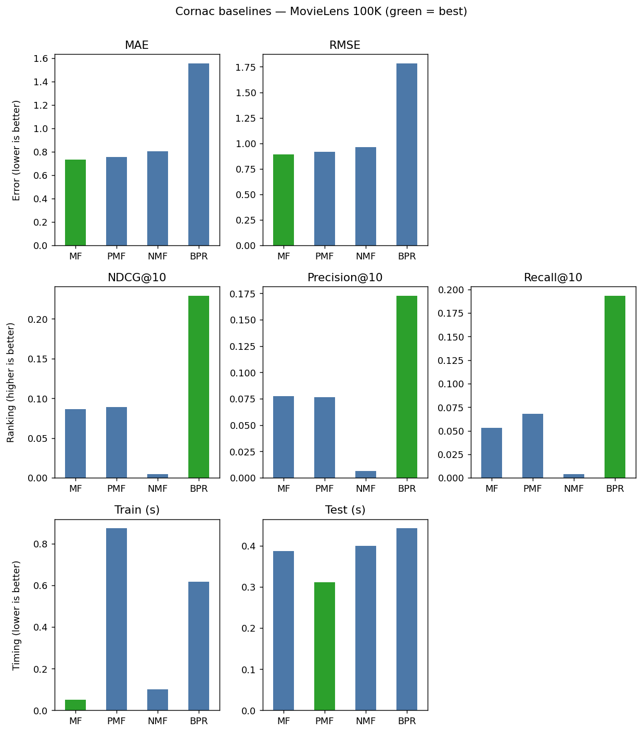
Figure: Cornac baseline comparison: MF, PMF, NMF, BPR on MovieLens 100K.
MF wins the rating-prediction metrics (lowest RMSE at 0.89). BPR wins the ranking metrics (NDCG@10 of 0.23) but at the cost of much higher RMSE because BPR optimizes a pairwise ranking loss rather than rating reconstruction. This split between rating-optimized and ranking-optimized models is the standard reason recommender systems are evaluated on both metric families rather than only one.

4.2 Four-Way Hybrid Comparison
The two novelty contributions (S1 and S2) and their combination were compared against the matrix-factorization baseline using the same MovieLens 100K split. Metrics include NDCG@10 and Recall@10 (accuracy), Diversity (intra-list mean cosine distance), Novelty (mean log-inverse popularity), and Coverage (fraction of catalog ever recommended across users).
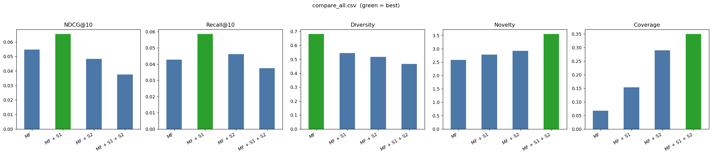
Figure: Four-way comparison: MF, MF+S1, MF+S2, MF+S1+S2 on MovieLens 100K.
Numerical results:
Configuration | NDCG@10 | Recall@10 | Diversity | Novelty | Coverage
MF | 0.0548 | 0.0428 | 0.6802 | 2.5814 | 0.0669
MF + S1 | 0.0654 | 0.0585 | 0.5434 | 2.7804 | 0.1538
MF + S2 | 0.0483 | 0.0462 | 0.5165 | 2.9223 | 0.2900
MF + S1 + S2 | 0.0375 | 0.0375 | 0.4660 | 3.5474 | 0.3495

Reading the table: S1 alone is the only configuration that improves accuracy and coverage simultaneously — NDCG up 19 percent, Recall up 37 percent, Coverage up 130 percent, Novelty up 8 percent, with diversity giving up 20 percent because anchoring to the user profile narrows the genre spread of a top-10 list. S2 alone trades accuracy for exploration — NDCG down 12 percent in exchange for Coverage up 333 percent. Stacking both layers compounds the exploration effect — Coverage 35 percent and Novelty 3.55 are the configuration peaks, at the lowest NDCG.
The interpretation that matters for a recommender whose purpose is discovery rather than reproduction: NDCG and Recall against held-out ratings implicitly reward predicting items the user has already interacted with, which over-represents popular items. Coverage and Novelty are the metrics that capture the project's actual goal. On those, every additional layer contributes a measurable expansion of what the user sees. The trade-off is controllable via the fusion weight α and the cluster-conditioning weight, both of which are exposed parameters and could be set per user, per session, or per A/B test.
The two layers are complementary rather than redundant. If they were doing similar work, the combined configuration would produce metrics close to whichever single layer dominates; instead it pushes further than either alone. Semantic retrieval bridges cold regions of the catalog via content, cluster conditioning partitions the user's taste space into context-activated modes — these are different mechanisms and they compose.

4.3 Live System Evaluation
[ PLACEHOLDER — Side-by-side live demo comparison — baseline HF Space vs. augmented HF Space showing the same user intent producing different recommendation packages; screenshots to be captured before the presentation ]
[ PLACEHOLDER — Subjective quality table — qualitative ratings of cross-domain coherence and constraint handling on a fixed set of 10 user intents; rated by team members on a 1–5 scale; to be filled in the week before the presentation ]

5. Lessons Learned and Takeaways

5.1 Cold Start
Pure collaborative filtering produces noisy recommendations for users with fewer than approximately 20 ratings. The joint multi-domain architecture partially mitigates this for users who participate in multiple domains, since the shared user embedding picks up signal from any one of them. The semantic retrieval layer (S1) addresses cold-start more directly: a user with no interaction history at all can still receive sensible recommendations because the four onboarding questions and the natural-language intent are embedded into the same space as the items. This is the cleanest demonstration of why hybrid content-based plus collaborative architectures matter in practice.

5.2 Scalability
Joint matrix factorization scales linearly in training time with the number of interactions, and the trained checkpoint fits in well under 100 MB at the dimensions used. Inference is O(item count) per recommendation in the naive implementation. The FAISS index makes the semantic retrieval layer effectively sublinear (approximate nearest neighbor) in catalog size, so adding S1 actually improves the system's scalability for cross-domain queries compared to running three separate collaborative filters and joining their outputs. The per-user cluster fitting in S2 is offline and embarrassingly parallel across users — it does not affect inference cost.

5.3 Evaluation Methodology
A central lesson is that offline metrics against held-out ratings cannot fairly grade a discovery-oriented recommender. The held-out items are by definition things the user has already interacted with, and popular items dominate that distribution. Coverage, Novelty, and Diversity are necessary complements to NDCG and Recall when the system's purpose is to expand what the user sees rather than predict what they already like. The four-way comparison in Section 4 only tells the story it does because all five metrics are reported together.

5.4 LLM Orchestration
LangGraph proved appropriate because the pipeline is genuinely a state machine, not a linear chain — multiple agents share and mutate an AgentState, follow-ups route conditionally based on the multi-turn classifier, and the orchestrator synthesizes across the agent outputs. A pure LangChain LCEL implementation would have required manual dict-threading between calls and bespoke conditional routing. The cost is one additional dependency and a learning curve; the payoff is that adding a new agent node — for example a music agent or a fitness agent — is a one-file addition rather than a refactor.

6. Source Code
Public GitHub repository: https://github.com/AdamSabry1233/AI-Life-Recommender-
Baseline live demo on Hugging Face Spaces: https://huggingface.co/spaces/asabry1233/ai-recommender
[ PLACEHOLDER — Augmented live demo URL — Stephen's HF Space with S1 + S2 enabled (to deploy) ]

7. Contribution Table
Member | Primary Responsibilities | Specific Deliverables
Adam Sabry | System architecture and primary implementation | Joint multi-domain matrix factorization training; LangGraph agent pipeline; FAISS session memory; Upstash Redis profile persistence; Gradio frontend; FastAPI backend; Hugging Face Spaces deployment; initial proposal and documentation.
Rammy Baroudi | Data pipeline and evaluation methodology | Dataset acquisition and preprocessing across MovieLens, Food.com, and Amazon Books; train-test split design; sparsity analysis; report writing on data description and lessons learned; presentation slides for data and evaluation sections.
Stephen Taylor | Novelty contributions, evaluation infrastructure, baselines | Cornac baseline sweep (MF/PMF/NMF/BPR) with grouped-metric visualization; semantic cross-domain retrieval module (S1); per-user cluster conditioning module (S2); four-way comparison harness and chart; pytest test suite with central delegator and watch/diff-based reruns; augmented Hugging Face Space; report sections on methodology novelty and evaluation.

[ PLACEHOLDER — Adjust the contribution table once final task allocation is confirmed with the team. ]

