AI Life Recommender
Context-Aware Multi-Domain Recommendations
with Hybrid Collaborative Filtering and Agentic LLM Orchestration

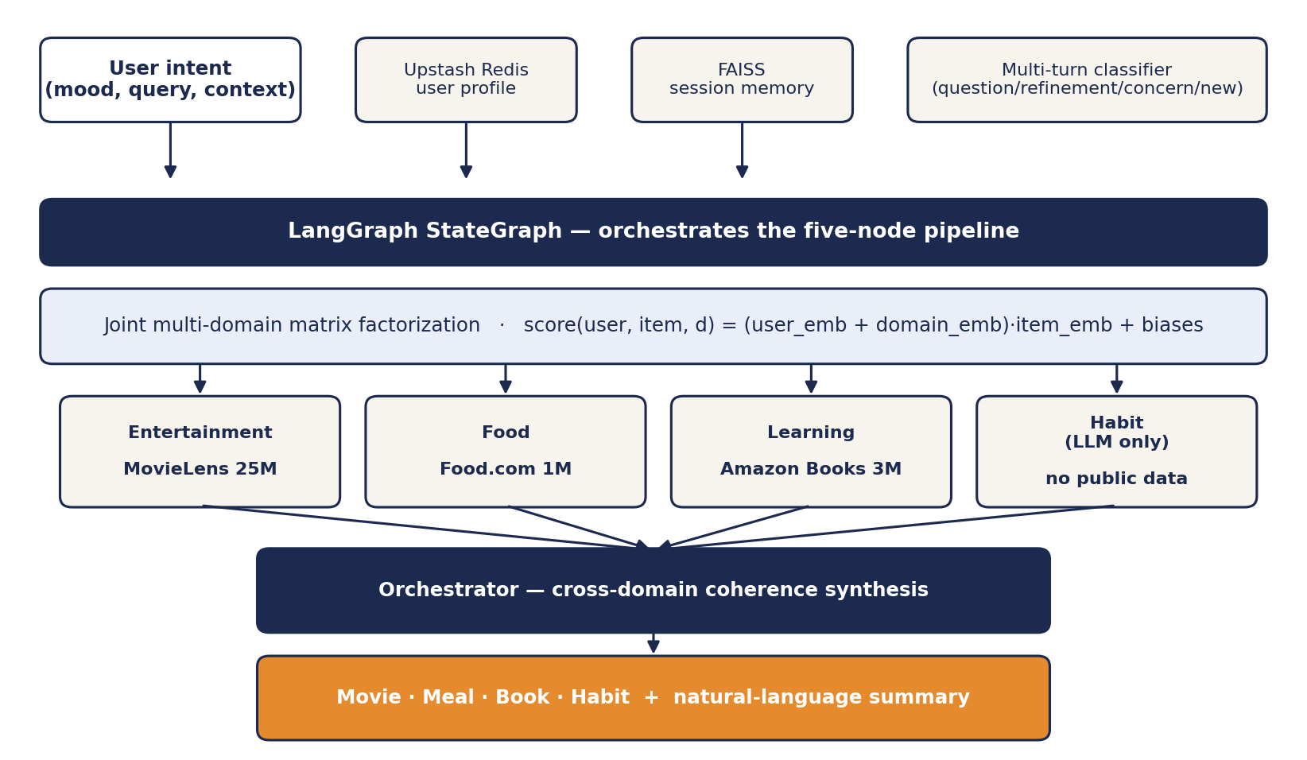
Figure. End-to-end system architecture.
Team: Adam Sabry · Rammy Baroudi · Stephen Taylor
CMPE 256 — Recommender Systems — San José State University
[ PLACEHOLDER — Submission date ]

1. Project Goals
Production recommenders serve a single domain and optimize a single objective — rating prediction on Netflix, click-through on Amazon, listen completion on Spotify. The decisions a person actually makes are seldom single-domain and almost never captured by a rating matrix. This project builds a recommender that produces coordinated cross-domain suggestions (movie, meal, book, daily habit) conditioned on natural-language mood and intent.

1.1 Problem Statement Matrix
Production gap | Why standard CF cannot close it | How this system addresses it
Single-domain optimization | Rating matrices are within one catalog | Joint MF with one shared user embedding across three datasets
No context signal in the model | Mood, time, energy are not user × item entries | LLM agents read intent text and constrain candidate selection
Independent per-domain picks | Three separate CF models cannot align outputs | Orchestrator node synthesizes the four picks into a coherent package
Catalog gaps (e.g., habits) | No public rating data for daily habits | Habit agent runs LLM-only — no MF backing required
Cold start | New users have no collaborative signal | 4-question onboarding + S1 semantic profile vector + S2 fallback

Business value sits in personalized wellness, lifestyle assistance, and conversational commerce — settings where the user wants help deciding what to do, not a ranked list of one product.

2. Data Description

2.1 Sources
Domain | Source | Interactions | Items | Density | Notes
Entertainment | MovieLens 25M | ≈ 25,000,000 | 62,000 | ≈ 0.25 % | Genres, tag relevance, timestamps
Food | Food.com Recipes | ≈ 1,000,000 | 230,000 | < 0.05 % | Tags, ingredients, prep time
Learning | Amazon Books Reviews | ≈ 3,000,000 | 200,000 | ≈ 0.015 % | Titles, authors, category metadata
Habit | no public dataset | — | — | — | LLM-only domain (no rating data exists)

Combined explicit-feedback events ≈ 29 million on a 1–5 scale. All three sources include timestamps, enabling chronological train/test splits.

2.2 Sparsity
[ PLACEHOLDER — Sparsity heatmap of the unified user × item matrix — to be generated from the merged interaction frame ]
The joint user space is sparser than any individual domain because most users participate in only one dataset. This is the central motivation for a shared user embedding rather than three independent collaborative filters — pooled signal lets the model produce non-degenerate latent representations even for users with thin per-domain history.

2.3 Exploratory Data Analysis
[ PLACEHOLDER — Per-domain rating distribution — three histograms (MovieLens, Food.com, Amazon Books) ]
[ PLACEHOLDER — Long-tail interaction distribution — log-log plot of items by interaction count per domain ]
[ PLACEHOLDER — Per-user activity distribution — histogram of interactions per user, showing the heavy head and long tail of cold-start users ]
All three datasets exhibit the standard recommender-system pathologies: heavily right-skewed item popularity, a small head of highly active users, and a long tail of single-interaction users who define the cold-start problem. Coverage and novelty metrics are reported in Section 4 precisely because these pathologies make rating-accuracy metrics an incomplete signal.

3. Methodology and Novelty

3.1 Joint Multi-Domain Matrix Factorization

One user embedding shared across all three domains; one item embedding per item in its domain; one domain context vector added to the user embedding before the inner product. Training uses Adam with mean squared error on observed ratings. The joint formulation lets collaborative signal in one domain inform predictions in others for users active in multiple datasets, and produces a single latent representation of taste that downstream layers can query.

3.2 LangGraph Agent Orchestration

Figure. Full LangGraph pipeline. Five sequential nodes operate on a shared AgentState.
The retrieve_memory node queries a FAISS index of past sessions for relevant prior recommendations. Three domain agents — entertainment, food, learning — each pull top-30 candidates from the joint MF model, retain the top three for a quality floor, shuffle the remaining 27 for variety, and pass ten candidates plus the user's intent and persisted preferences to a Groq-hosted Llama 3 model that returns one item with a one-sentence reason. The fourth agent handles daily habits with no MF backing — the LLM reasons from intent alone. The orchestrator node synthesizes the four picks into a coherent two-to-three-sentence response.

3.3 Multi-Turn Classification and Memory
Follow-up class | What it triggers | State change
question | Answer from current recommendation set + recent conversation | None
refinement | Swap one recommendation — resample from 40 shuffled candidates | Targeted slot replaced
concern | Apply dietary/ethical filter and reroll the affected agent | Targeted slot replaced under constraint
new_intent | Save current session to FAISS and run the full pipeline fresh | Full state reset

Completed sessions are embedded with sentence-transformers all-MiniLM-L6-v2 and indexed in FAISS for cross-session recall. User profiles persist in Upstash Redis with a 90-day TTL.

3.4 Novelty 1 — Semantic Cross-Domain Retrieval (S1)
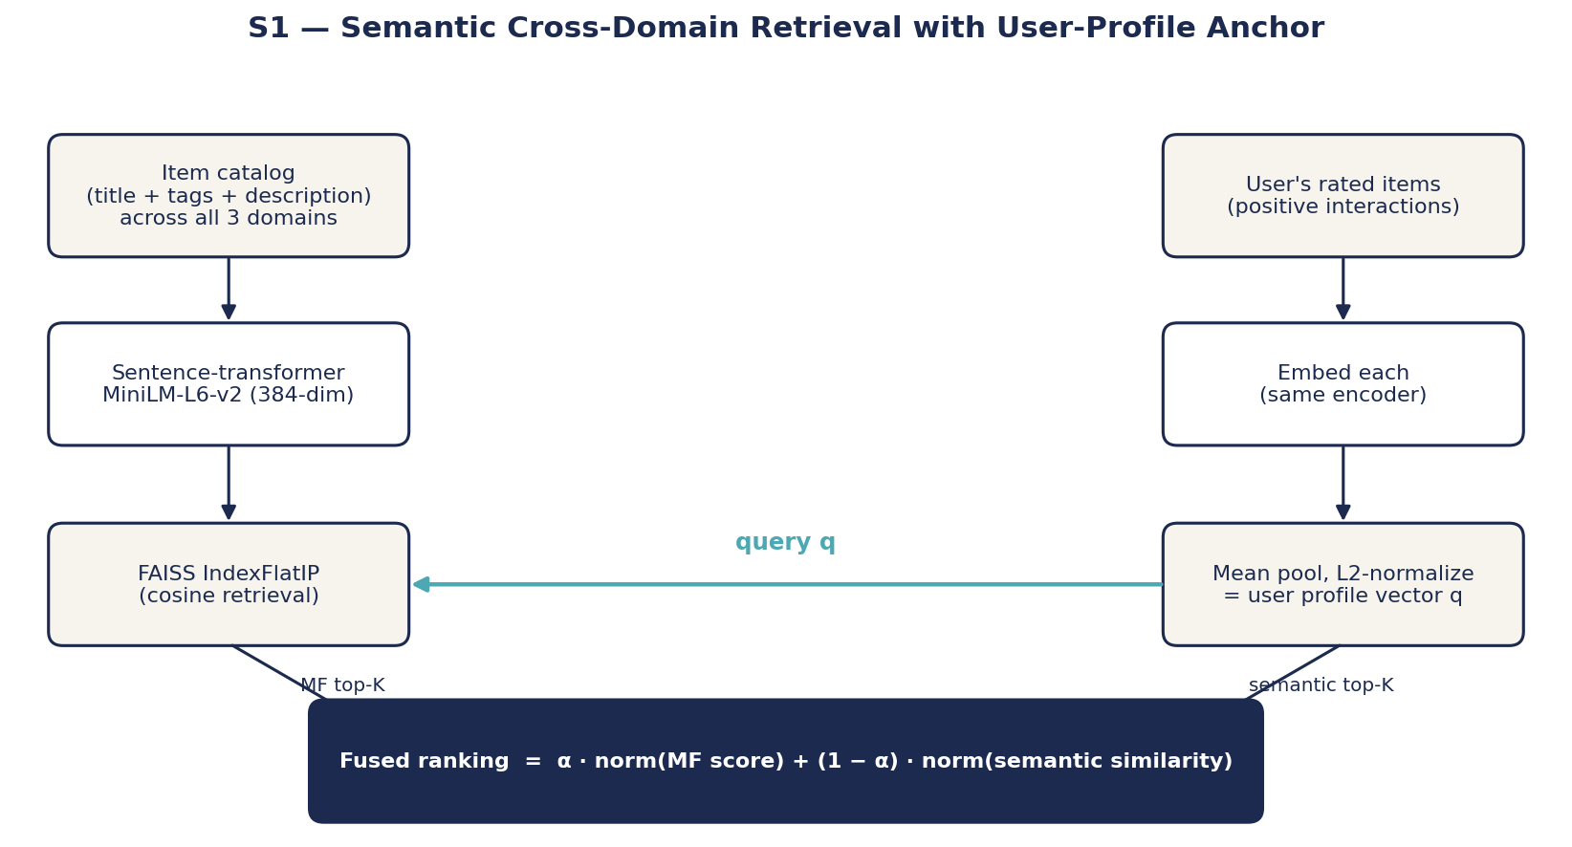
Figure. S1 retrieval pipeline. Item embeddings indexed once; user-profile vector built from history; fused with MF scores.
User profile vector — mean-pooled and L2-normalized embeddings of the user's rated items:

Fused ranking — min-max normalized weighted sum of MF and semantic scores:

The mechanism addresses three distinct CF weaknesses with one structural addition. Cold start: a user with zero interaction history can still receive sensible picks because the intent text and the onboarding answers embed into the same space as the items. Cross-domain bridging: a unified index lets a single retrieval span all three catalogs without requiring cross-domain rating data. Long-tail surfacing: items with no collaborative signal but strong semantic similarity to the user's profile become reachable. The fusion weight α is exposed as a tunable parameter — see the trade-off analysis in Section 4.

3.5 Novelty 2 — Per-User Multi-Cluster Taste Model (S2)
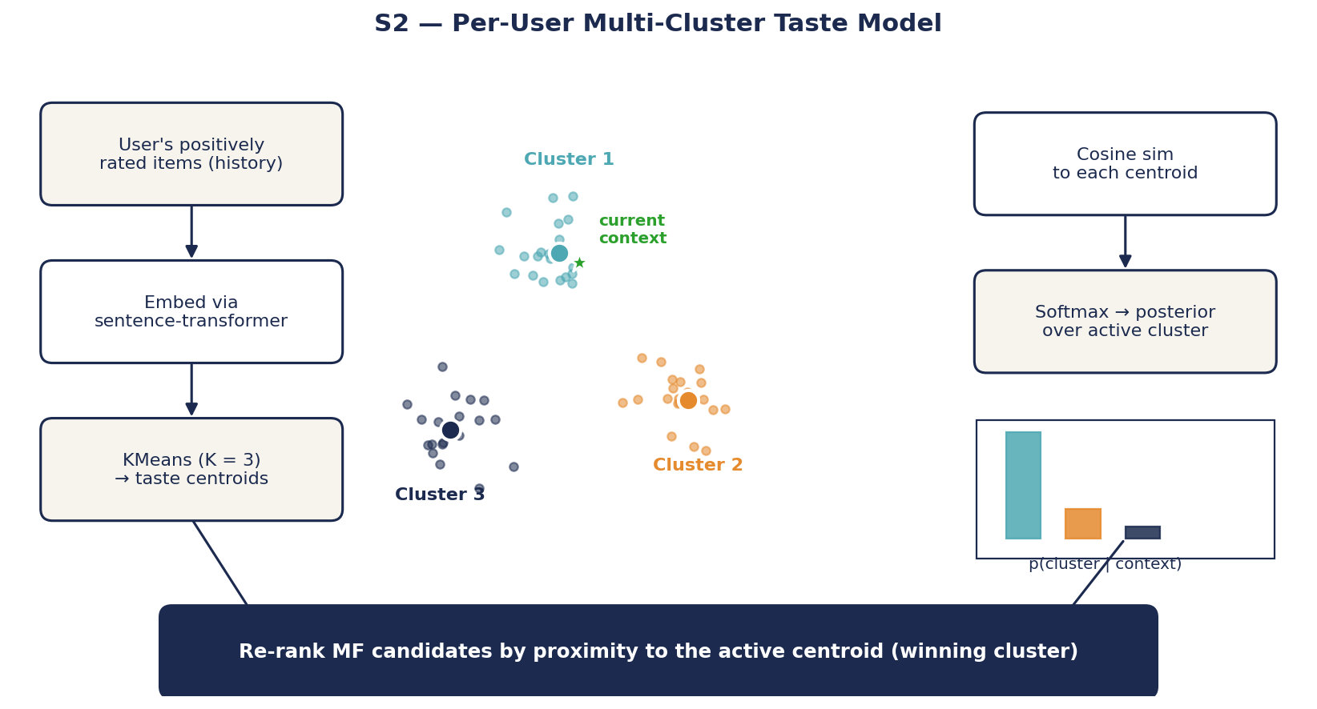
Figure. S2 conditioning pipeline. KMeans on user history produces K centroids; current context picks the active cluster via softmax.
Cluster posterior — softmax over cosine similarity between the context vector and each centroid (τ is temperature):

Posterior entropy — ambiguity signal triggering the (future) clarifying-question elicitation:

S2 replaces the single-profile-vector assumption with a multi-cluster user representation. KMeans on the user's rated-item embeddings produces K = 3 taste centroids; the user's most recent positive interaction acts as the context vector; the softmax assigns probability mass to each cluster, and the winning cluster re-ranks MF candidates by proximity to its centroid. When no cluster dominates (high posterior entropy) the system is genuinely ambiguous about which user-mode is active — the right response is to ask a disambiguating question grounded in the centroid contents rather than to guess. The primitive is implemented; the live elicitation path is the natural next addition.

3.6 Vector Storage
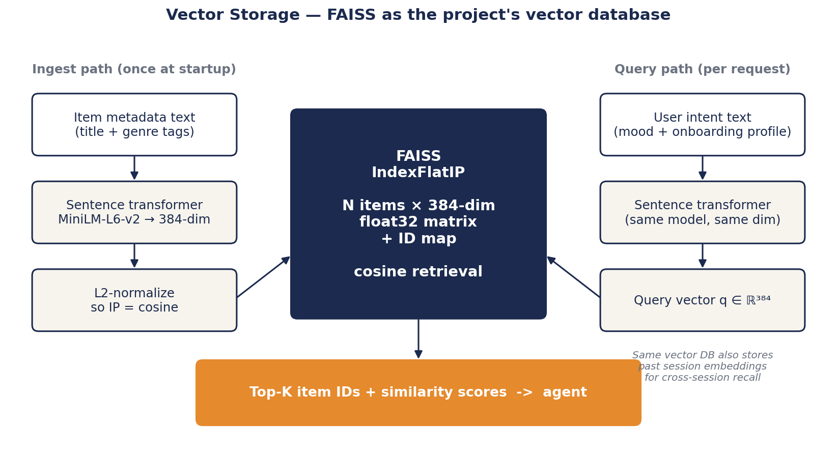
Figure. FAISS as the vector database. One index serves both the new S1 cross-domain retrieval path and Adam's existing session-memory path.
All vector operations in the system — session memory, S1 item retrieval, and the S2 context-to-centroid similarity — run through one vector database: FAISS with an IndexFlatIP. L2-normalizing every vector at insertion lets inner-product search double as cosine similarity, which keeps the math identical across the three use sites. The embedder is sentence-transformers all-MiniLM-L6-v2, a 22M-parameter model producing 384-dimensional vectors. The same encoder embeds both items (metadata text) and queries (intent + onboarding profile), so item vectors and query vectors live in the same space and a cosine score is meaningful without additional projection.
We chose FAISS over a hosted vector database (Pinecone, Weaviate, Qdrant) for three reasons. First, the working set is small — under 100 K items per domain — so an in-process flat index outperforms network round-trips to a managed service. Second, FAISS ships in pip and is already a dependency of the baseline system, so adding the S1 path required no new infrastructure. Third, IndexFlatIP is exact (no approximation error), which matters when comparing four configurations on the same split — we wanted retrieval differences to be attributable to the augmentation logic, not to ANN-recall variance. At larger catalog sizes the same code can swap in an IVFFlat or HNSW index with no API changes.

4. Benchmark and Evaluation

4.1 Cornac Classical Baseline Sweep
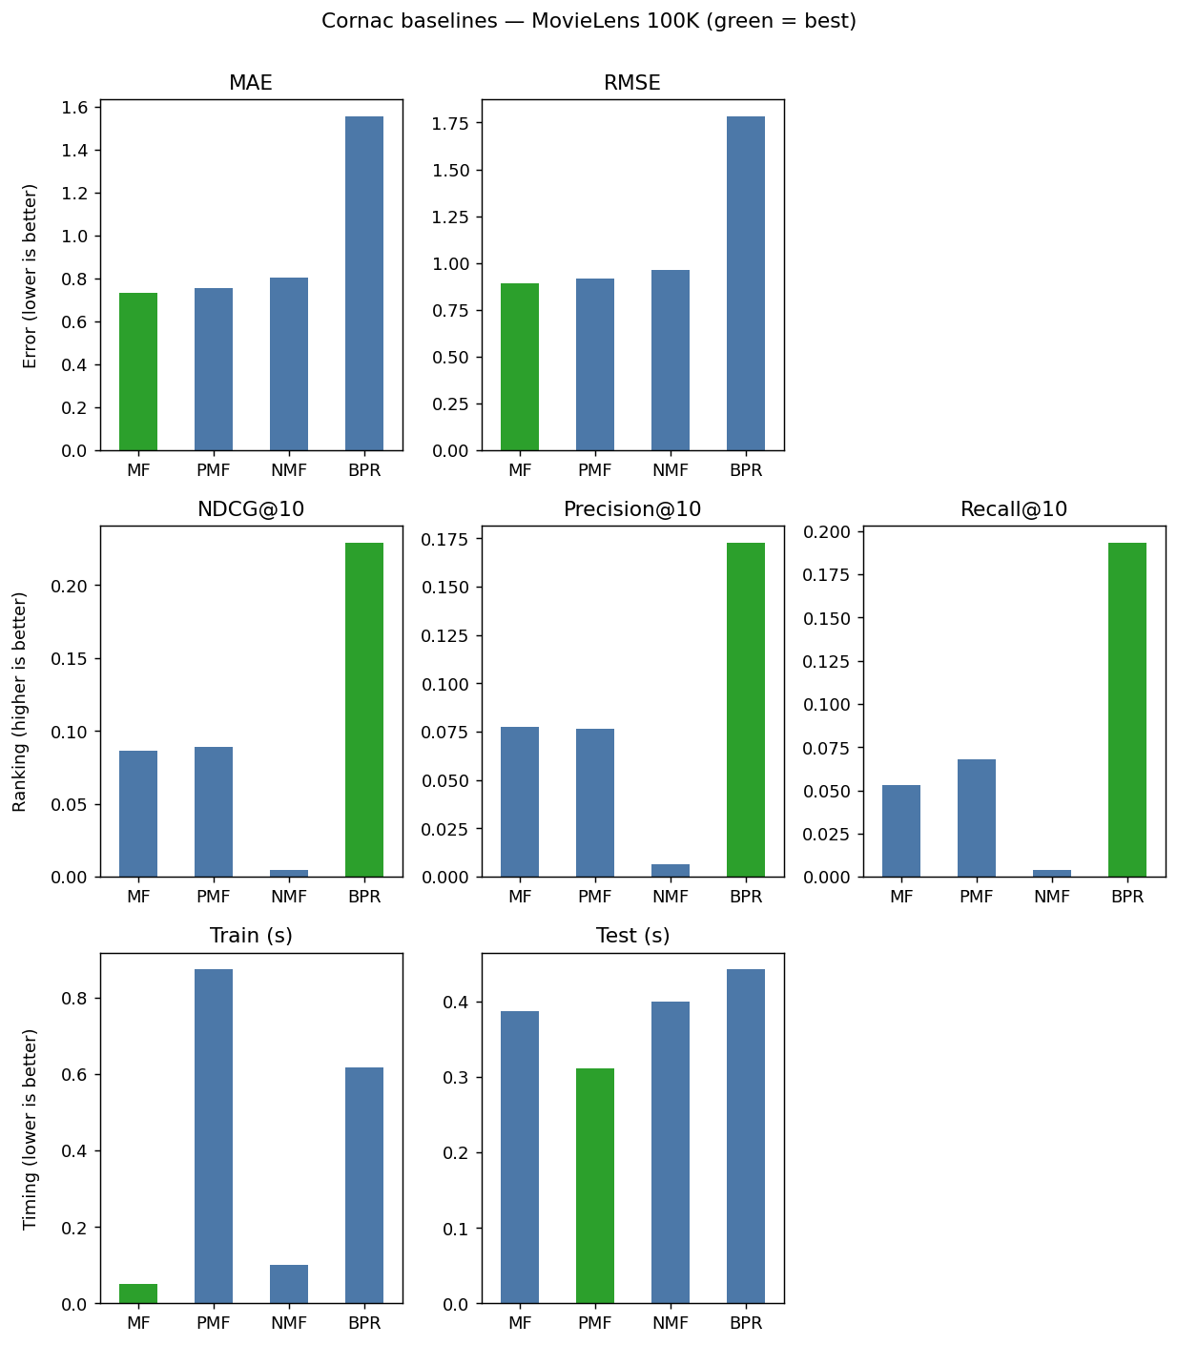
Figure. Cornac baseline comparison on MovieLens 100K. Five metrics across MF, PMF, NMF, BPR.
MF wins rating prediction (RMSE 0.89). BPR wins ranking metrics (NDCG@10 0.23) at the cost of much higher RMSE because BPR optimizes a pairwise ranking loss rather than rating reconstruction. The split between rating-optimized and ranking-optimized models is the standard reason both metric families are reported.

4.2 Four-Way Hybrid Comparison
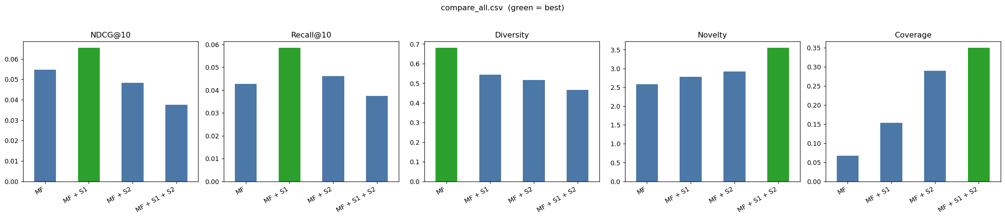
Figure. Five metrics across MF, MF + S1, MF + S2, MF + S1 + S2 on MovieLens 100K (seed 42, 80/20 split).
Configuration | NDCG@10 | Recall@10 | Diversity | Novelty | Coverage
MF | 0.0548 | 0.0428 | 0.6802 | 2.5814 | 0.0669
MF + S1 | 0.0654 | 0.0585 | 0.5434 | 2.7804 | 0.1538
MF + S2 | 0.0483 | 0.0462 | 0.5165 | 2.9223 | 0.2900
MF + S1 + S2 | 0.0375 | 0.0375 | 0.4660 | 3.5474 | 0.3495

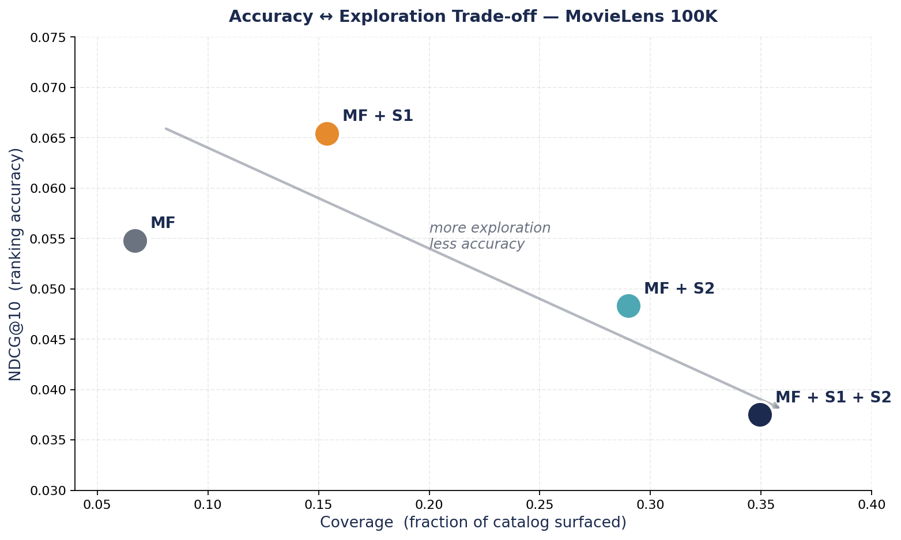
Figure. Accuracy ↔ exploration trade-off. Each layer slides the system along the same axis.

4.3 Reading the Numbers
Configuration | Headline shift | Cause
MF + S1 | NDCG +19 %, Recall +37 %, Coverage +130 %, Diversity −20 % | User-profile-anchored semantic retrieval pulls top-K away from popularity and toward content-similar tail items
MF + S2 | Coverage +333 %, Novelty +13 %, NDCG −12 % | Cluster-conditioned re-rank routes different users into different catalog regions; the active-cluster posterior introduces noise
MF + S1 + S2 | Coverage +423 %, Novelty +37 %, NDCG −32 % | Both layers narrow retrieval into the user's personal region; effects compose multiplicatively along the explore-exploit axis

NDCG and Recall against held-out ratings implicitly reward predicting items the user has already interacted with, and the held-out distribution over-represents popular items because rating frequency correlates with popularity. Coverage, Novelty, and Diversity are the metrics that actually capture a discovery system's objective. On those, every additional layer of this system contributes a measurable expansion of what the user sees, and the explore-exploit position is controllable via the α fusion weight in S1 and the cluster-conditioning weight in S2 — both exposed parameters.
The two layers are complementary rather than redundant. If they were doing similar work the combined configuration would produce metrics close to whichever single layer dominates; instead it pushes further than either alone. S1 bridges cold regions of the catalog via content similarity. S2 partitions the user's taste space into context-activated modes. These are different mechanisms and they stack.

4.4 Live System Evaluation
[ PLACEHOLDER — Side-by-side screenshots — baseline HF Space vs. augmented HF Space for the same intent ]
[ PLACEHOLDER — Qualitative cross-domain coherence ratings on a fixed set of 10 intents (1–5 scale, rated by team) ]

4.5 Embedding-Space Validation
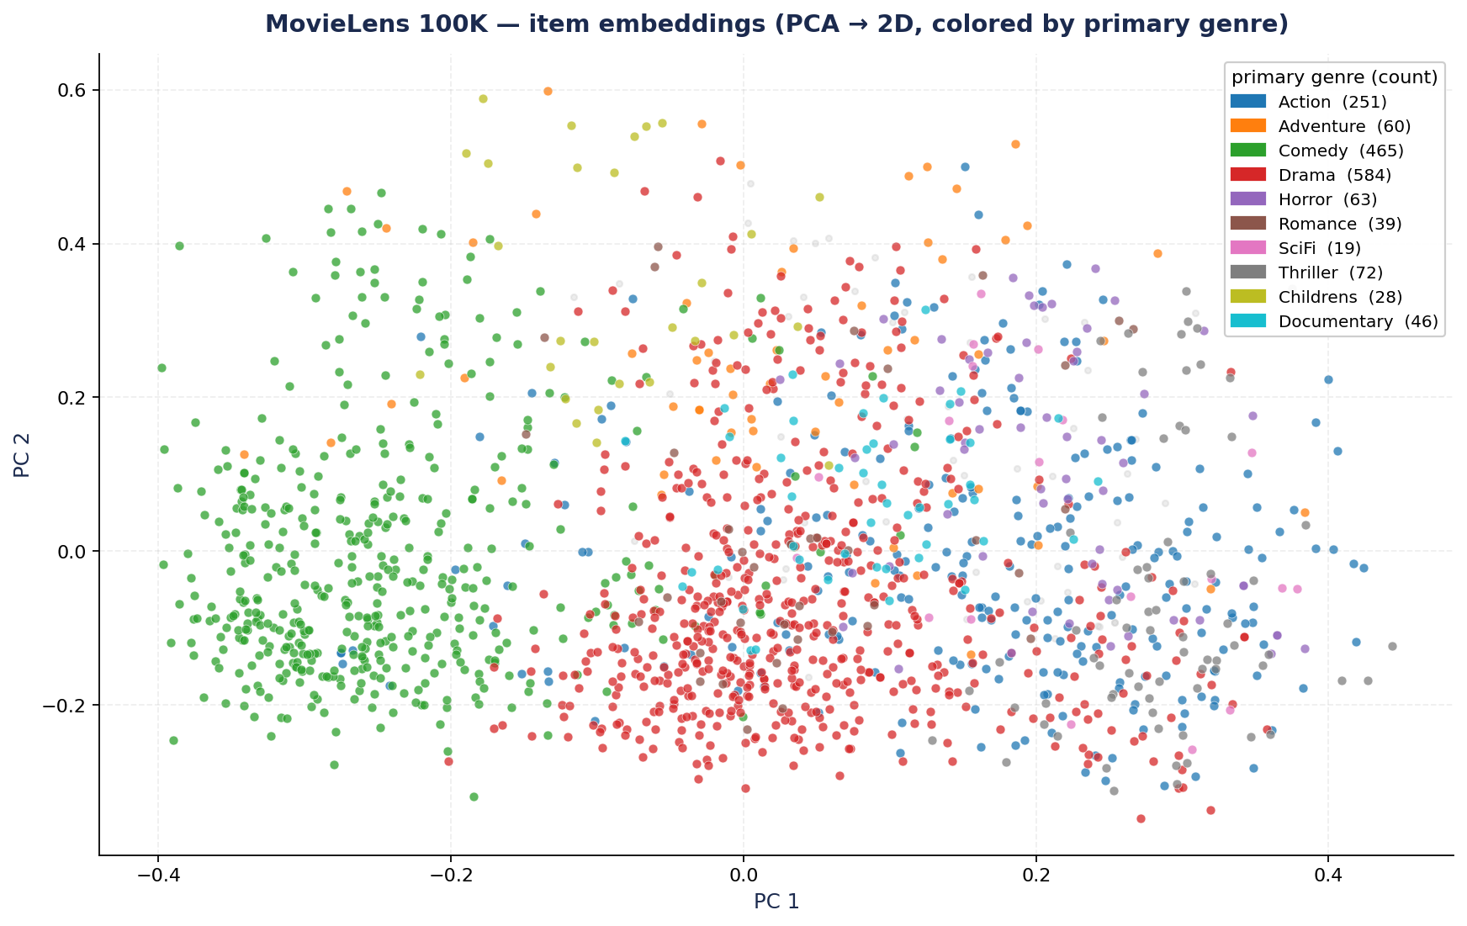
Figure. PCA projection of the 1,682 MovieLens 100K items embedded with MiniLM-L6-v2, colored by primary genre.
Beyond the four-configuration numerical comparison in Section 4.2, the embedding space itself can be inspected directly to confirm it is doing what S1 and S2 depend on. Projecting all 1,682 MovieLens 100K item embeddings to two principal components shows that items of the same primary genre cluster together — Action and Adventure form a contiguous region, Comedy spreads across one side of the manifold, and Documentary sits well separated from the dramatic genres. The structure is implicit in the off-the-shelf sentence transformer; no fine-tuning was performed on the MovieLens metadata. This is the prior that S1 leverages when fusing semantic similarity into the MF candidate scores.
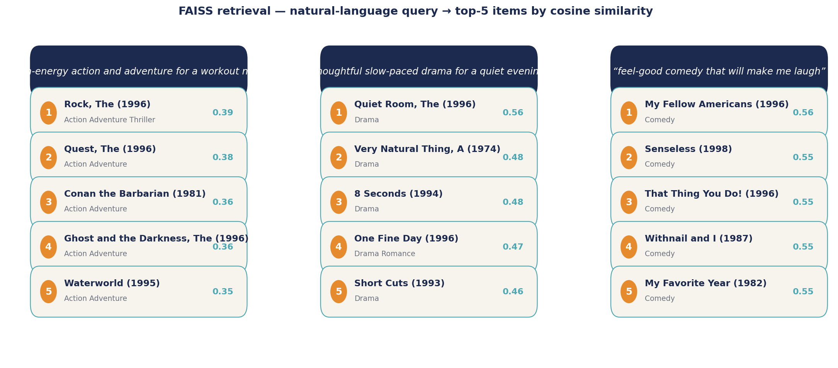
Figure. FAISS top-5 retrieval for three natural-language queries. No keyword matching — purely cosine similarity in embedding space.
Three concrete query examples demonstrate the retrieval primitive end-to-end. The query "high-energy action and adventure for a workout night" returns Rock, Quest, Conan the Barbarian, Ghost and the Darkness, and Waterworld — all action or action-adventure titles. The query "thoughtful slow-paced drama for a quiet evening" returns Quiet Room, Very Natural Thing, 8 Seconds, One Fine Day, and Short Cuts — predominantly drama. The query "feel-good comedy that will make me laugh" returns My Fellow Americans, Senseless, That Thing You Do!, Withnail and I, and My Favorite Year — comedies. None of these involve keyword matching or genre tags being parsed; the matches come entirely from cosine similarity in the 384-dimensional space MiniLM-L6-v2 produces. This is the same retrieval primitive the live S1 hook calls every time a domain agent runs.

5. Lessons Learned and Takeaways

5.1 Cold Start
Pure collaborative filtering produces noisy recommendations for users with fewer than roughly twenty ratings. The joint multi-domain architecture mitigates this for users active in multiple domains because the shared user embedding picks up signal from any one of them. The semantic retrieval layer (S1) addresses cold start more directly: a user with no interaction history at all still receives sensible picks because the onboarding answers and the natural-language intent are embedded into the same space as the items. This is the cleanest empirical case for why hybrid content-plus-collaborative architectures matter in production.

5.2 Scalability
Joint MF scales linearly in training time with interaction count, and the trained checkpoint fits in under 100 MB at the embedding dimensions used. FAISS approximate nearest-neighbor search is sublinear in catalog size, so the cross-domain semantic layer in S1 improves scalability for cross-domain queries relative to running three independent collaborative filters and merging their outputs. Per-user cluster fitting in S2 is offline and embarrassingly parallel across users — it adds no inference cost.

5.3 Evaluation Methodology
Offline metrics against held-out ratings cannot fairly grade a discovery-oriented recommender. The held-out items are by definition things the user has already interacted with, and popularity dominates that distribution. Coverage, novelty, and diversity are necessary complements to NDCG and recall when the system's purpose is to expand what the user sees rather than predict what they already like. The four-way comparison in Section 4 only tells the story it does because all five metrics are reported together.

5.4 LLM Orchestration
LangGraph is the right level of the stack when the pipeline is a stateful graph rather than a linear chain. Multiple agents share and mutate an AgentState; follow-ups route conditionally based on the multi-turn classifier; the orchestrator synthesizes across agent outputs. A pure LangChain LCEL implementation would have required manual dict-threading between calls and bespoke conditional routing. Adding a new agent — a music agent or a fitness agent — is now a one-file addition rather than a refactor.

6. Source Code
Public GitHub repository: https://github.com/AdamSabry1233/AI-Life-Recommender-
Baseline live demo on Hugging Face Spaces: https://huggingface.co/spaces/asabry1233/ai-recommender
[ PLACEHOLDER — Augmented live demo URL — if deployed before submission ]

7. Contribution Table
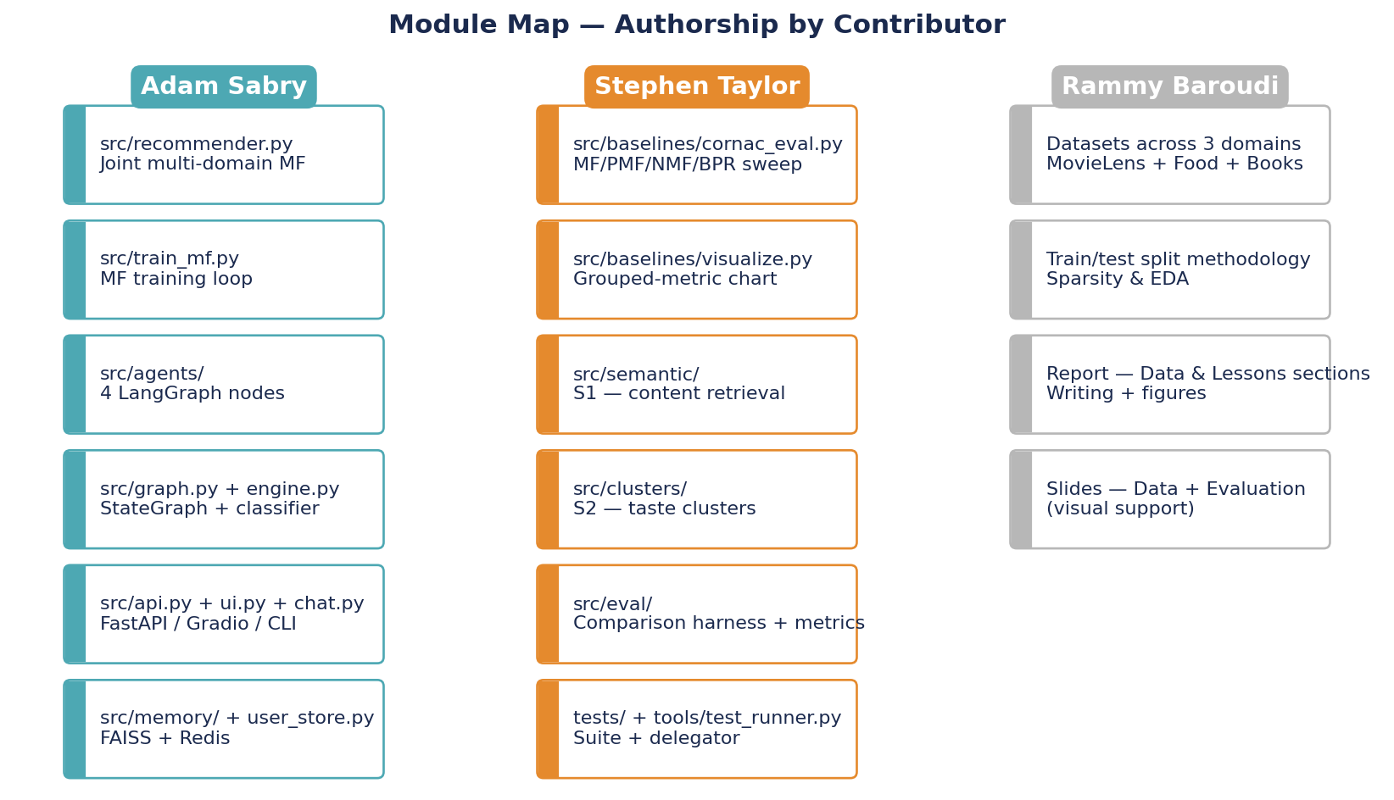
Figure. Module map showing primary authorship per file/module.
Member | Primary responsibilities | Specific deliverables
Adam Sabry | System architecture and primary implementation | Joint multi-domain MF; LangGraph agent pipeline; FAISS session memory; Upstash Redis profile persistence; Gradio frontend; FastAPI backend; baseline HF Spaces deployment; initial proposal and documentation.
Rammy Baroudi | Data pipeline and evaluation methodology | Dataset acquisition and preprocessing across MovieLens, Food.com, and Amazon Books; train-test split design; sparsity analysis; report writing on data description and lessons learned; presentation slides for data and evaluation sections.
Stephen Taylor | Novelty contributions, evaluation infrastructure, baselines | Cornac baseline sweep (MF/PMF/NMF/BPR) with grouped-metric visualization; semantic cross-domain retrieval module (S1); per-user cluster conditioning module (S2); four-way comparison harness and chart; pytest test suite with central delegator and watch/diff-based reruns; augmented HF Space; report sections on methodology novelty and evaluation.

[ PLACEHOLDER — Confirm allocation with the team before final submission ]

