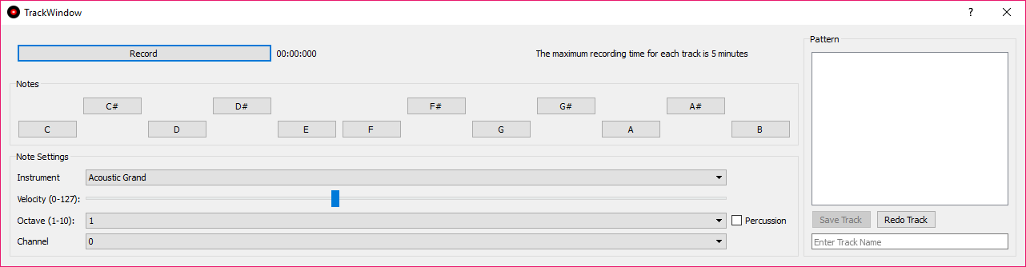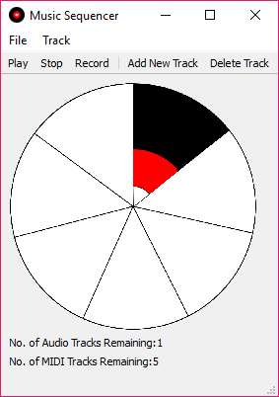

**References:**

Iqbal, I. M., 2016. *C# : UNDERSTANDING THREADS AND THREADPOOLS.* [Online]   
Available at: https://programmium.wordpress.com/2016/04/02/c-understanding-threads-and-threadpools/  
[Accessed 20 April 2018].

MIDI ASSOCIATION, 2018. *WELCOME TO THE MIDI ASSOCIATION.* [Online]   
Available at: https://www.midi.org/  
[Accessed 20 April 2018].

Udemy, 2018. *Create Simple GUI Applications with Python and Qt.* [Online]   
Available at: https://udemy-images.udemy.com/course/750x422/522076_eb46_2.jpg  
[Accessed 20 April 2018].

**Research Collage**

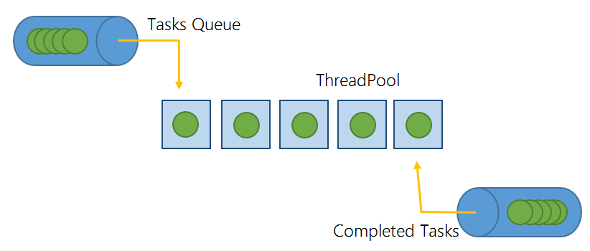

**Aim**

To create an application to accompany a musician. The application must be able create backing tracks and to record and playback audio. This application should demonstrate computing techniques that are relevant to the product.

**Objectives**

* The project must demonstrate an understanding of computer music and what musicians currently use
* The project must be designed with the research in mind to create an easy to use interface that requires little to no learning curve
* The project must be created with for the needs of a musician and that for of someone who is not. This will be achieved by having an implementation of which both users can make use of
* The project must adapt current music techniques used by musicians obtained from research
* The program must demo some sort of concurrency running within
* The project must include an evaluation report

A Music Sequencer Application

Adam Lloyd Simons 14077485