* Team Spirit Fingers – Group 1

User guide

Simon’s Besom – User guide COMP 2714 Created by andrew kult

Table of Contents

Getting started 2

Gameplay 2

The Store 3

The Leaderboard 3

Achievements 3

# http://puu.sh/hVzPb/23044fb7ee.jpgGetting started

Start the app by running index.php through WAMP, Webmatrix, or another server based application that can properly run a php file.

After launching index.php found in the zip folder, your default browser will load the Main Page.

From here you may start the game by clicking “Play”, or you need instructions click “Instructions”; alternatively, you may visit the leaderboards by clicking “Leaderboards”. There is a Settings button (Cog Icon) that will allow you to mute in-game audio, such as music or sound effects (e.g. clicking).

# Gameplay

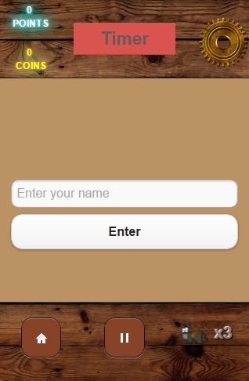See getting started. After clicking play, enter your name in the input field and press the “enter” button. This will be used to identify your score on the leaderboard so be sure to remember it. It takes a maximum of six characters.

After pressing the enter button a timer will count down from 3. before displaying the path you will have to repeat in order to move to the next round. You will not be able to click on the grid or press any buttons (aside from setting which is also on the game page) until the path has finished blinking. This is the same procedure before every round.

The first round is a single tile, afterwards it is periodically divided into smaller squares, based on what level you are on. The length of the path is also determined by the level, where the length of the path you have to repeat is equal to your level. If you fail to repeat the path correctly twice you lose a life and are stepped down a level, lowering the path length by one and potentially reducing the size of the grid. The grid increases by one row and one column at levels, 2, 5, 8, and 11.

A timer also starts counting down after your first click each round. If the timer reaches 0 you lose a life. Your time after each round carries over to the next and after you round you are also awarded extra time

For each tile in the path you get correct you earn one point and for every level you complete you get 10 coins.

If you need, you can go back to the main menu at any time by clicking the home button in the bottom left.

# 02f578e4ec.jpg (318×489)The Store

Coins can be used in the store which is accessed by pressing the pause button at the bottom. Achievements determine what you can use in the store, but from here you can access the different backgrounds, skills and gambles available during gameplay.

# The Leaderboard

After getting a game over, you can submit your score and be taken to the leaderboards. Only the top 10 scores are stored and the rest are deleted.

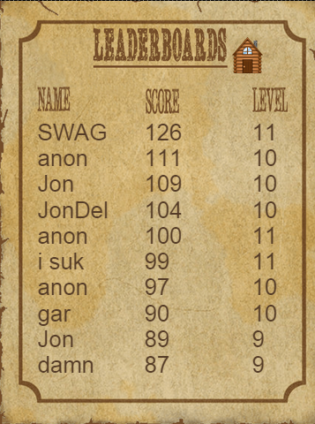The name you selected before started playing is what will appear here on the leaderboard, if you got a score that ranks in the top ten.

Once you are finished, you can press the little wooden house icon to go back to the main page.

# Achievements

The achievement page can be reached by pressing the trophy button on the main page.

The