Adam Sparkes Java Qap 2

Submission: Oct. 8, 2024.

Questions:

1. How many hours did it take you to complete this assessment? (Please keep try to keep track of how many hours you have spent working on each individual part of this assessment as best you can - an estimation is fine; we just want a rough idea.)

It took roughly 8 hours, however a large issue came forth when I arrived at an issue involving rounding cents, unfortunately after many attempts I failed to resolve the issue and will need an explanation during class.

2. What online resources you have used? (My lectures, YouTube, Stack overflow etc.)

I have used YouTube videos, explaining compareTo and equals Methods, as well as referring to class recordings for a refresher on specific information regarding the use of specific data types.

3. Did you need to ask any of your friends in solving the problems. (If yes, please mention name of the friend. They must be amongst your class fellows.

No

4. Did you need to ask questions to any of your instructors? If so, how many questions did you ask (or how many help sessions did you require)?

No

5. Rate (subjectively) the difficulty of each question from your own perspective, and whether you feel confident that you can solve a similar but different problem requiring some of the same techniques in the future now that you’ve completed this one.

Outside of my issue involving the math rounding incorrectly on the output of CreditCardDemo, the rest for the assignment was not an issue, though due to hte difficulties I experienced in the final stretch, I’d say this was about a 7/10 difficulty.

Test My Line Output: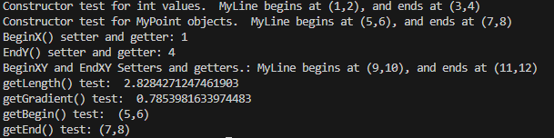

Test My Rectangle Output: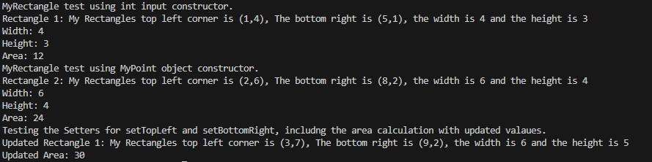

Credit Card Demo Output:

