**Product Design**

**Team TBD**

Adam Spinhirne, Jovanny Frias, Dai Nguyen, Lance Wahlert, Jorge Martinez

***Note: this is a “living document”, meaning its content will change with the implementation of the project. Use it to capture key project concepts and document your product design and decisions. Make sure the design is traceable to the requirements. Remove/replace the blue text and the descriptive paragraphs in each section prior to your submission as directed by your instructor. REMOVE THE ITALICIZED TEXT BEFORE SUBMISSION.***

***THIS DOCUMENT IS A STARTING POINT, YOUR TEAM IS EXPECTED TO ADD/MODIFY ALL NECESSARY SECTIONS.***

***You may use any drawing tool for your UML diagrams. If you diagrams are too big to cut and paste into this document, provide a reference to the external image files(s) [JPG or PNG] where they can be found or segment your image into legible sections to make them fit.***

|  |  |  |  |
| --- | --- | --- | --- |
| ***Revision Number*** | ***Revision Date*** | ***Summary of Changes*** | ***Author(s)*** |
| 0.1 | 02/22/2020 | Added design summary | Adam Spinhirne |
| 0.1 | 02/22/2020 | Added wireframes | Jorge Martinez |
|  |  |  |  |

***The Revision Table above must be augmented after any version of this document is updated. Insert any necessary rows at the bottom of the table.***

# **Class Diagram(s)**

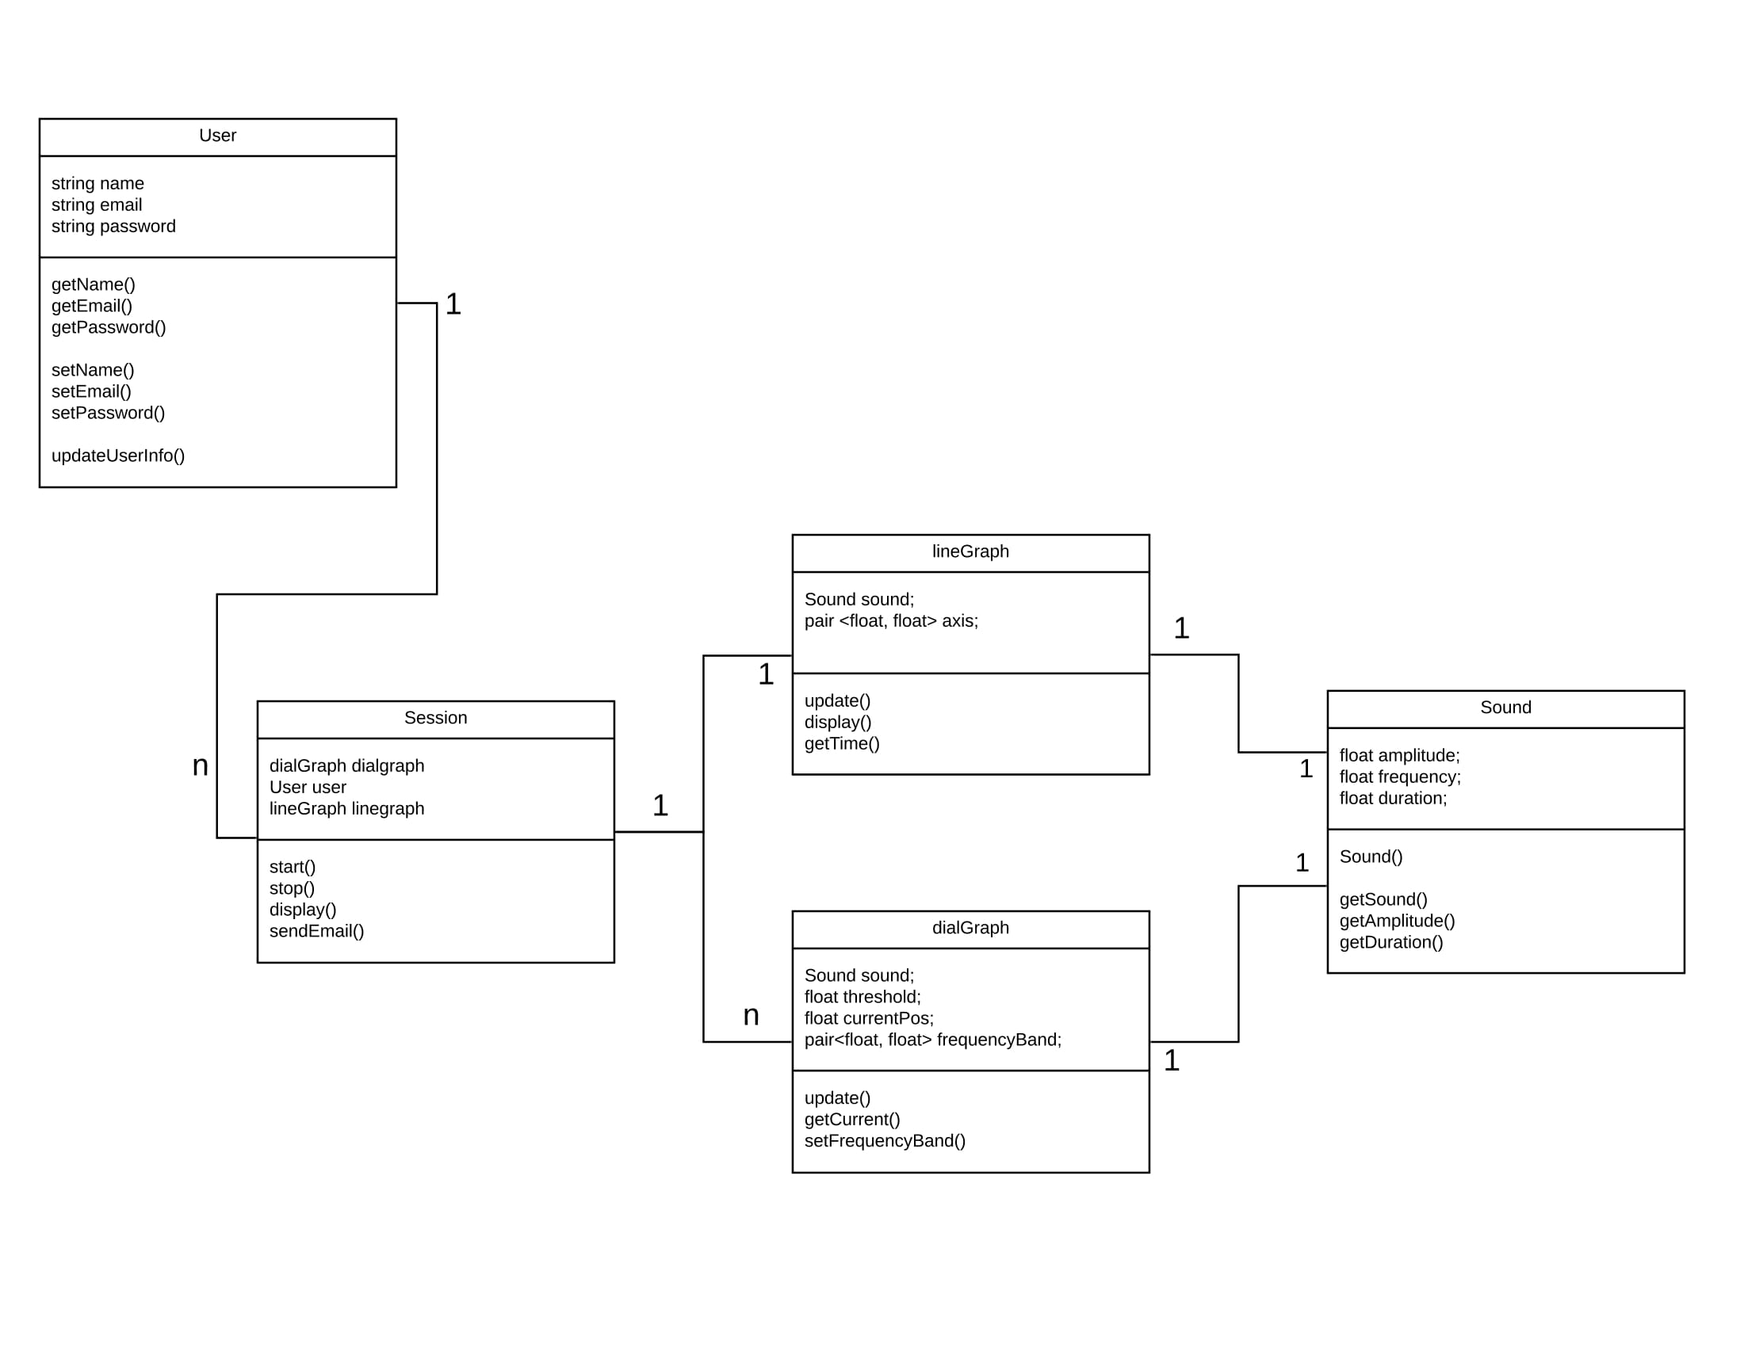

**This is for UML class diagram capturing the relationships between classes. It is only necessary to show methods that are publically accessible by other classes. Only show an instance variable of a class if it is publically accessible**

# **ER Diagram(s)**

**This is for ER diagram capturing the structure of your database.**

# **Information Architecture Diagram**

**If your project is web-based, you can show the structure of your website here.**

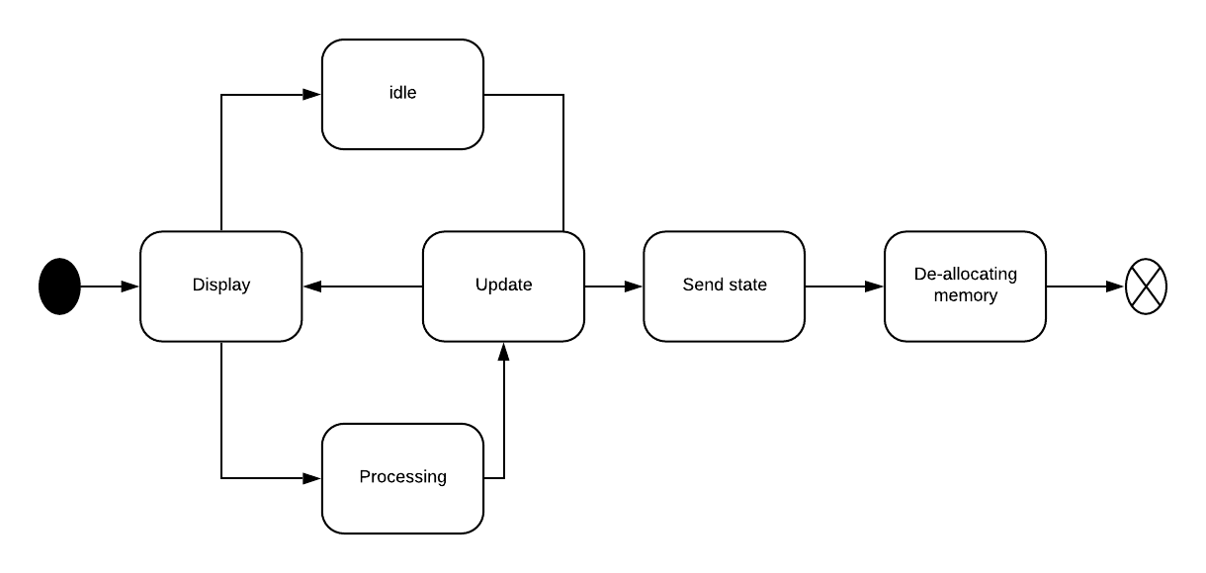

# **User Interface Wireframe(s)/Screenshot(s)**

|  |  |
| --- | --- |
|  |  |
| **Login Screen** - The login screen allows the user to login to access their sessions or begin a new one. If the user presses the register button a password confirmation box will appear and a new user will be registered with the given username. | **Begin Session** - This screen requests access to the microphone. It also allows the user to begin a session or view the data from previous sessions. |
|  |  |
| **Dashboard** - This is the main screen of the system. It displays the intensity of sound at different frequencies and the accumulated sound exposure. This screen also allows the user to pause or stop a session. | **Save** - When the user presses the stop button, the session is paused and this dialogue box is displayed. The cancel button resumes the session. The discard button asks the user for confirmation and stops and deletes the session. The save button allows the user to save the session locally, to a cloud service, or to their email. |

**These are meant to show the appearance and structure of your key screens. If you are developing an app, present these to the scale of the typical phone that you are designing for. Also provide unique screenID’s, captions and annotations that elaborate on your screens.**

# **Design Summary**

Our design implements classes for all of the items we process through our app. Users can start multiple sessions in which they see multiple graphics showing them relevant information. These graphics each have access to the sound information which is constantly updated and processed through the app. Each of these objects has methods and variables which pertain to the main functions of the app. The user needs an email address so a data summary can be sent at the end of each session. The Session needs to be able to display graphics for the users to use the application, and each graphic needs to be able to process the sound data in a way that makes it clear to a user what is happening.

# **Design Rationale**

Our sponsor, Mark Albert, is looking for a simple plug and play solution for this software that we are designing. To fulfill this ease of use aspect, he gave us options to either use an Amazon Firestick or an Asus Chromebit. None of us has had any experience in development for either of these tools so research was conducted and we decided on using an Asus Chromebit for development. The chromebit will allow us to configure an easy plug and play solution as the users of this software will not be the most computer savvy people .

To develop on the chromebit, we either had the option of trying to create an Android application or a web app that would run in the browser. Seeing as most of us have more experience in web development with React, we have made the conscious decision of taking the web development route. The strengths in this include the use of technologies most of us are familiar with as well as the power of said technologies in team settings. From here, we can all develop without even using the chrombit and finish the project on our own devices. Our final thoughts would be to create some sort of bash script that once the chromebit is turned on, it would run our web application locally and full size the screen to make it look just like any other normal application.

***This is a running list of issues that arise as your design process proceeds. This is an important section of the design document as it captures the thought process of the product's designers. It includes why or why not (rejected solutions) a design decision was made and supports future changes to the product. It should be updated whenever a design change occurs.***

***It is RARELY the case that the first design you consider is the best one that you can come up with that meets the requirements and that can be implemented, tested, and delivered on schedule. Your instructor will be looking for signs that you considered at least a few approaches, and that you had a coherent rationale for preferring the design your team eventually adopts.***

***This is the place to record such thoughts – what alternatives did you consider? What are the strengths (and deficiencies) of the final design compared to the other alternatives considered? Why did you select the approach you finally chose? This last question should be answered with an eye to the tradeoffs inevitably involved in creating an appropriate design.***

***In addition, if (not when) the design has to be adjusted to meet unexpected problems or new requirements, this is the place to record what changes were made, what effect these had on the work that had been completed to date, and the rationale for the making changes (as opposed to “just toughing it out”).***