Cardboard Tube Coin Flip

This game can be played alone or competitively. It could also easily be made into a drinking game if one is wont to do that.

What you will need:
Empty Cardboard Tube (sizes will effect difficulty)
Coin(s)* (type will effect difficulty)
Flat Surface at least 1’x1’

1. Start by placing the cardboard tube vertical on the surface.

2. Place your and on the surface at least 6” away from the tube.

3. Using your thumb, attempt to flip a coin into the top of the tube without knocking it over.

4. Keep trying until you get the coin in. If the tube is knocked over, pick it back and continue trying.

To make it competitive: have more than one person aim to get a coin into the tube and race to see who can get it first.

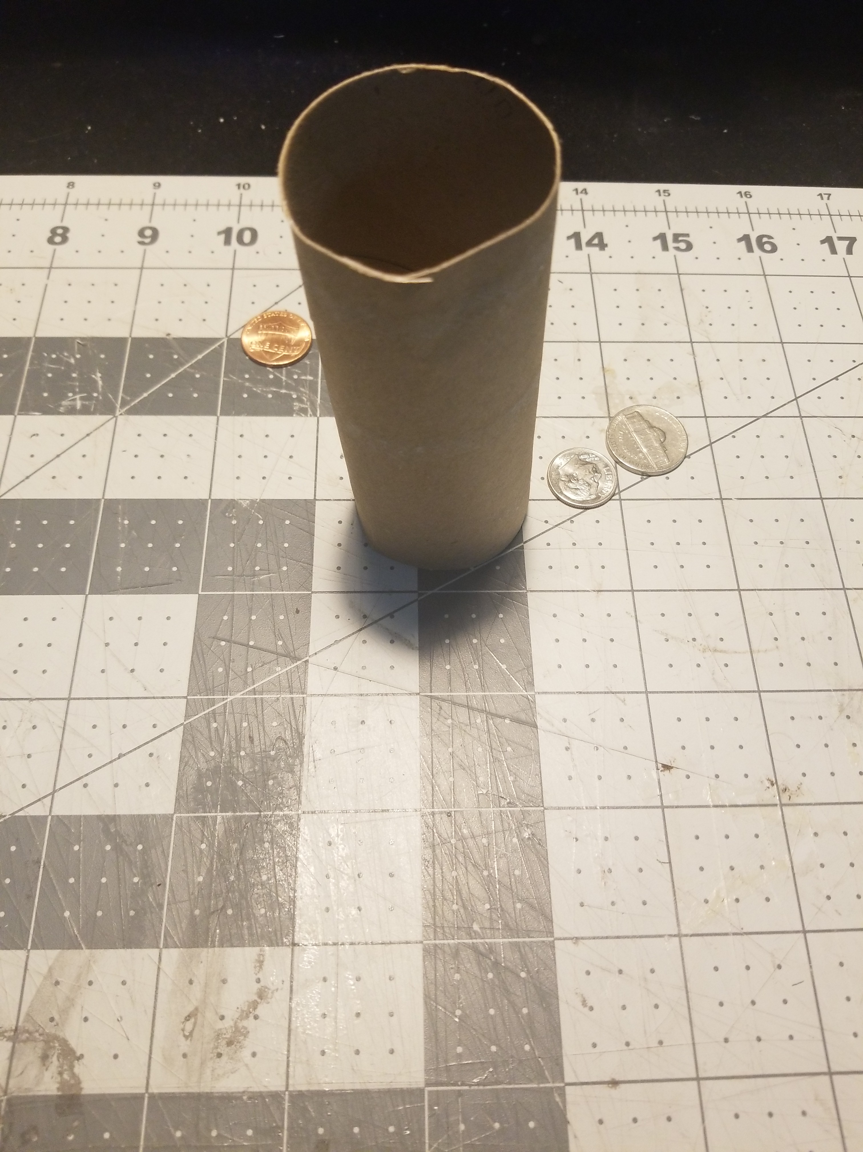
Another fun spin: Use different coins and make each one a different point value. You can do this however you want but I prefer to do it by size, since the heavier the coin, the harder it is to not knock the tube over. For example: Dime(1), Penny(2), Quarter(3), Nickle(4)

