1. (2 pts) Sketch out how you’d connect the Arduino to the LM34 so that you can measure temperature with the sensor. Typical values for Vs are +5v.

**I’m not sure whether we need to have the 2kOhm resistor shown below, or if it is integrated into the LM36.**

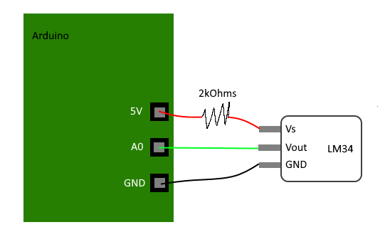

1. (1 pt) In figure 13, there’s a capacitor in parallel with the sensor output. Why might it be there?

**The capacitor would smooth out the incoming signal and make fluctuations less of a problem. It could also slow down the measurements. The bigger the capacitor the bigger these effects would be.**

1. (8 pts) Please write an Arduino program that will read (voltage) from the temperature sensor via the ADC pin A0. The Arduino should print the time (in ms), ADC value, voltage, and temperature in F at 500ms intervals.