Chi-Square Test of Independence

Example 8.1 Consider data from the Minnesota Study Survey regarding the opinions of marijuana use for 12th grade students in Fillmore County.

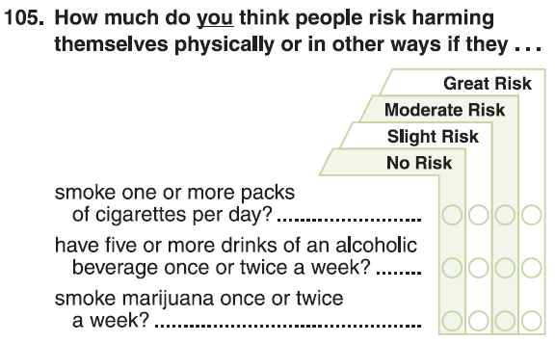

The following data was obtained from the Minnesota Department of Education website for Fillmore County.

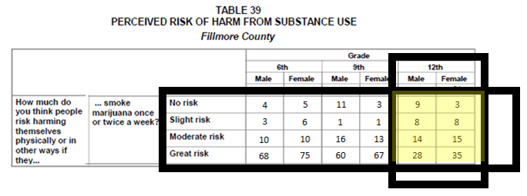

*Source*: Minnesota Department of Education; <http://education.state.mn.us/MDE/Learning_Support/Safe_and_Healthy_Learners/Minnesota_Student_Survey/index.html>

Consider the following investigation comparing Males to Females for Grade 12.

Research Question: Do differences exist between Genders in the opinions regarding marijuana use for 12th graders in Fillmore County?

|  |  |
| --- | --- |
| Data in JMP | Analyze > Fit Y by X |

Initial JMP output – again, fix the order of the response variable using Value Ordering

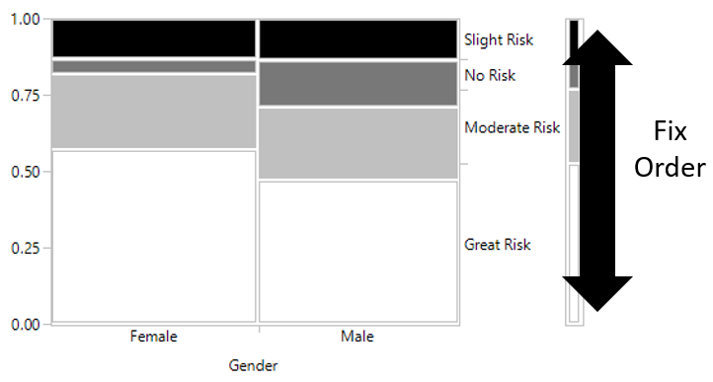

Observed Outcomes (Observed)

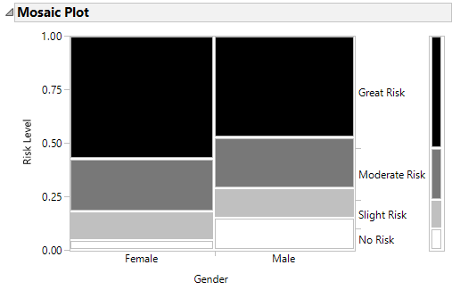

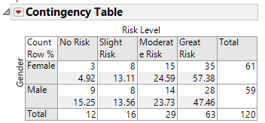

Compare Against No Difference Situation (Expected)

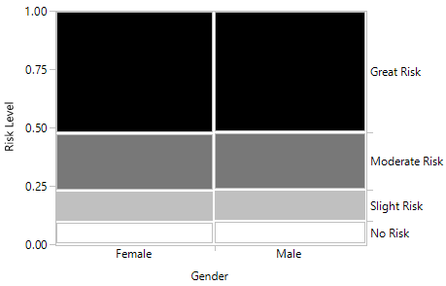

|  |  |  |
| --- | --- | --- |
|  | Proportions under No Difference | |
|  | Great Risk | $\frac{63}{120}=0.525$ |
| Moderate Risk | $\frac{29}{120}=0.2417$ |
| Slight Risk | $\frac{16}{120}=0.133$ |
| No Risk | $\frac{12}{120}=0.10$ |

Computing the Expected Counts

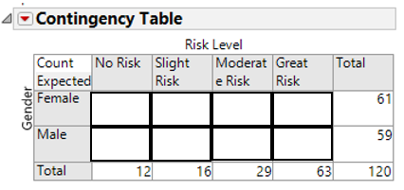

Test of Significance: Chi –Square Test

|  |  |
| --- | --- |
| Observed Graph | Expected Graph (No Difference) |

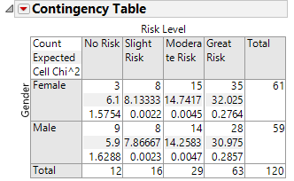

Recall, the test statistic for a Chi-Square Test has the following form.

$χ^{2}=\sum_{all categories}{}\frac{{\left(observed-expected\right)}^{2}}{expected}$

|  |  |
| --- | --- |
| JMP Testing Output | <http://www.di-mgt.com.au/chisquare-calculator.html> |

Example 8.2: Next, we will investigate the possible association between opinions of marijuana use and grade level. Certainly, young children have a belief, typically a strong belief, that drugs are “bad”. The question here centers around the possible shift in opinions from Grade 9 and Grade 12 students from Fillmore County.

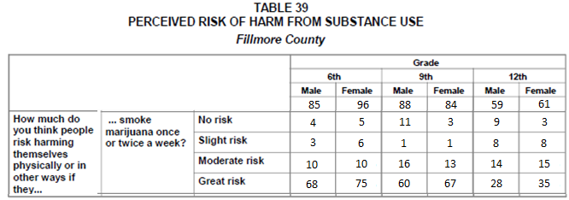

Consider the following investigation which compares across grade levels 9 and 12.

Research Question: Are there differences in the opinions regarding marijuana use between Grade 9 and Grade 12 students from Fillmore County?

Writing the appropriate null and alternative hypothesis for your investigation.

Ho: Opinions regarding marijuana are independent of Age (Grade 9 & 12)

HA: Opinions regarding marijuana depend on Age (Grade 9 & 12)

The *observed* data from the study.

|  |  |  |  |  |  |
| --- | --- | --- | --- | --- | --- |
| Grade Level | No Risk | Slight Risk | Moderate Risk | Great Risk | Total |
| Grade 9 | 14 | 2 | 29 | 127 | 172 |
| Grade 12 | 12 | 16 | 29 | 63 | 120 |
| Total | 26 | 18 | 58 | 190 | 292 |

The analysis in JMP

|  |  |
| --- | --- |
| Data in JMP | Mosaic Plot |

Questions:

1. How do the trends differ between Grade 9 and Grade 12? Why might these trends be expected? Discuss.

1. What is the likelihood of a No Risk outcome from a Grade 9 student? How about a Grade 12 student? What might this imply about the age in which a student makes the decision to believe that smoking marijuana once or twice a week is of No Risk? Explain.

|  |  |
| --- | --- |
| Observed Outcomes | Expected Outcomes |

Testing Output

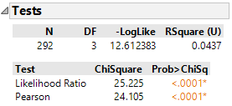

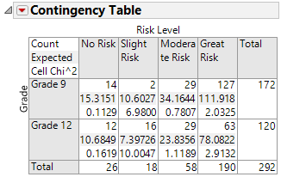

Questions:

1. Make the appropriate statistical decision.

Decision: If the p-value < 0.05, then data is said to support the research question.

* **Data supports research question**
* Data does not support research question

1. Write a final conclusion that would be appropriate for the DARE administrator from Fillmore County.

A Test for Trend: Cochran Armitage Trend Test

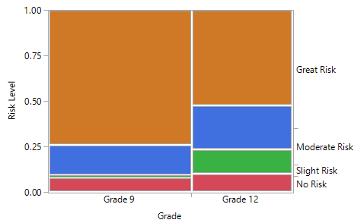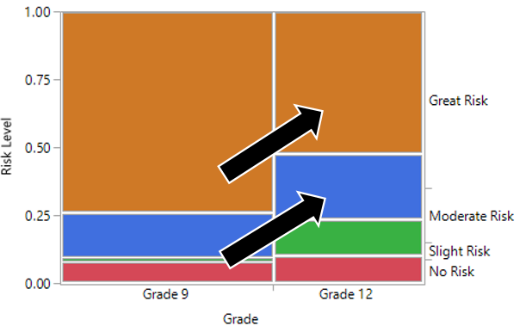

Comment: A **Cochran Armitage Trend Test** can be used to verify whether or not the trend see in the above mosaic plot is likely to appear on repeated sampling from the population. Search Wikipedia for additional information regarding this test.

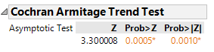

The **one-sided p-value** for the Cochran Armitage Trend test is less than 0.0005 (i.e. Prob > Z value).

Question:

1. What is the practical interpretation of this p-value? Write a statement regarding this test that would be useful for a DARE officer in Fillmore County.