STAT 210: Quiz #4 Name(s): _____________________________  
Spring 2020  
Points: 20 _____________________________  
  
 _____________________________

|  |  |
| --- | --- |
| For this quiz, we will investigate information about Traffic Stops made by the St. Paul MN Police Department for 2018.  Data Source: <https://information.stpaul.gov/Public-Safety/Traffic-Stop-Dataset/kkd6-vvns> |  |
| Article Source: <https://www.twincities.com/2018/01/26/how-many-people-did-st-paul-police-pull-over-last-year-police-stops-by-the-numbers/> | |

This quiz requires the use of the Local Data Filter in JMP. A Local Data Filter will be applied to YEAR OF STOP for many of the questions.

Step 1: Right Click on YEAR OF STOP, and select Column Info…

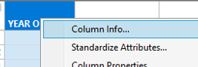

Step 2: Change Data Type to Character and Modeling Type to Nominal. Click OK.

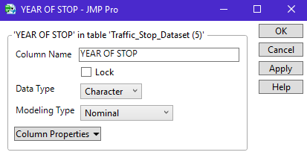

1. Recreate the following summary in JMP. This table/chart provides a summary for Citations Issued for Year = 2018.

*<Delete my version and paste a copy of your table and chart in its place >*

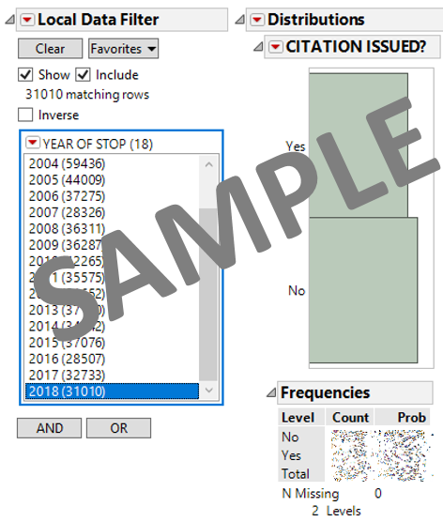

1. How many citations were issued by the St. Paul Police Department in 2018? (1 pt)
2. What percentage of the stops in 2018 resulted in a citation being issued? (1 pt)
3. Recreate the following summary in JMP. This chart summarizes the proportion of stops that received a citation over the past 15 years or so.

*<Delete my version and paste a copy of your table and chart in its place >*

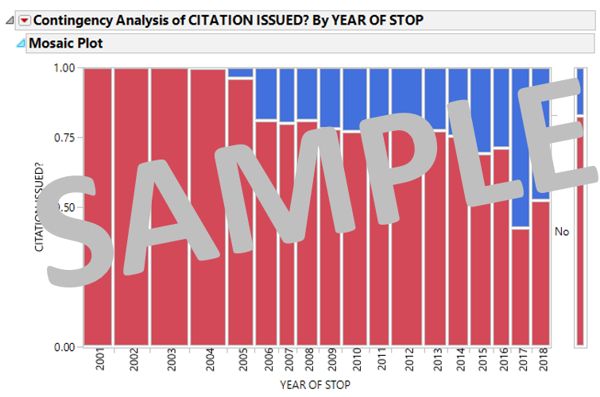

What can be said about the relationship between years and proportion of stops that received a citation? Briefly discuss. (3 pts)

1. Recreate the following summary in JMP. This summary is again for Year = 2018.

*<Delete my version and paste a copy of your table and chart in its place >*

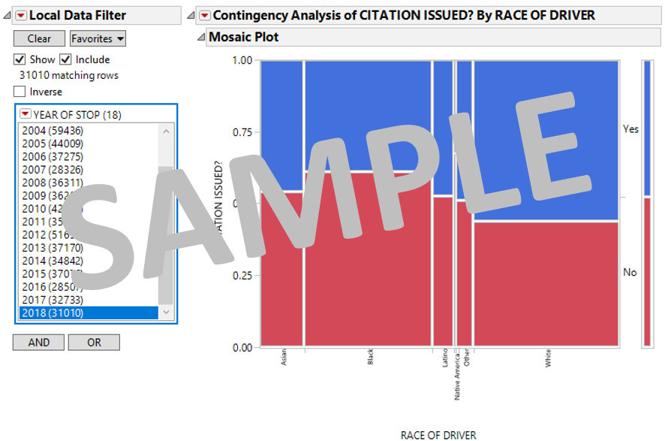

Identify whether or not the following statements are TRUE or FALSE using the table/chart. (2 pts each)

|  |  |  |
| --- | --- | --- |
| 1. Of the races considered here, whites were most likely to get a citation. | TRUE | FALSE |
| 1. A majority of whites stopped received a citation. | TRUE | FALSE |
| 1. Of the races considered here, blacks were least likely to receive a citation. | TRUE | FALSE |

1. Consider the following statement: “For Year = 2018, women are more likely to get a citation than men”. Provide a table and/or chart that either supports or refutes this statement. (3 pts).

*<Provide a screen-shot of the table or chart used to either support / refute this answer>*

1. Consider the following statement: “For Year = 2018, women are more likely to get a citation than men; but, this is only true for some of the races.” Provide a table and/or chart that either supports or refutes this statement. (3 pts).

*<Provide a screen-shot of the table(s) or chart(s) used to either support / refute this answer>*

1. The Ferguson Uprising involved protests and riots that began immediately after the shooting of Michael Brown by police in Ferguson Missouri. These protests caused police department to evaluate their policing polices – especially the policing of African-Americans / Blacks.

Consider the following statement: “For the St. Paul Police Department, there appears to have been a systemic change, with respect to citations being issued, of African-Americans / Blacks around 2014.” Provide a table and/or chart that either supports or refutes this statement. (3 pts).

*<Provide a screen-shot of the table(s) or chart(s) used to support your suggestion>*