Stevenage Borough Council
LGR Service Cluster Model
County-Level Service Inclusion Summary
Supporting Appendix B – Service Cluster Model

Date created | June 2026
Approved by | Executive Director – Transformation & Digital
Owner | Head of Enterprise Architecture
Version | 1.0 Draft
Author | Adam Staples, Head of Enterprise Architecture
Business Unit | Transformation & Digital
Strategy Review Date | June 2027
Equality Impact Assessment Completed | To be confirmed

1. Executive Summary
This summary document brings together the Appendix B county-level service inclusion report and the visual service-cluster model. It shows how county responsibilities can be absorbed into the same five-cluster architecture model rather than treated as a separate LGR workstream.
The model keeps the resident front door first, then connects people services, place-based services, corporate enabling services and shared technology, data and AI foundations. It is designed to help four Enterprise Architects work as a supportive team across Business, Data, Application & Digital, and Technology & Security Architecture.
Thinking and justification: The document is intended for senior leaders, programme teams and service representatives who need a clear summary of how county-level services fit into the proposed Appendix B model.

2. Purpose
The purpose of this document is to provide a concise reference pack for the Appendix B service-cluster model, with particular focus on the inclusion of county-level services as part of Local Government Reorganisation.
• summarise the five service clusters;
• show which county-level services should be included in each cluster;
• illustrate how the four architecture domains support every cluster;
• identify the main implications for service discovery, data, applications, technology, governance and transition planning.
Thinking and justification: This helps avoid separate county and district design silos. LGR should be treated as one future operating model, not as a mechanical joining of existing organisations.

3. Visual Model
The visual below shows the five service clusters, the district/borough services, the county-level additions, the four Enterprise Architecture domains and the governance spine.
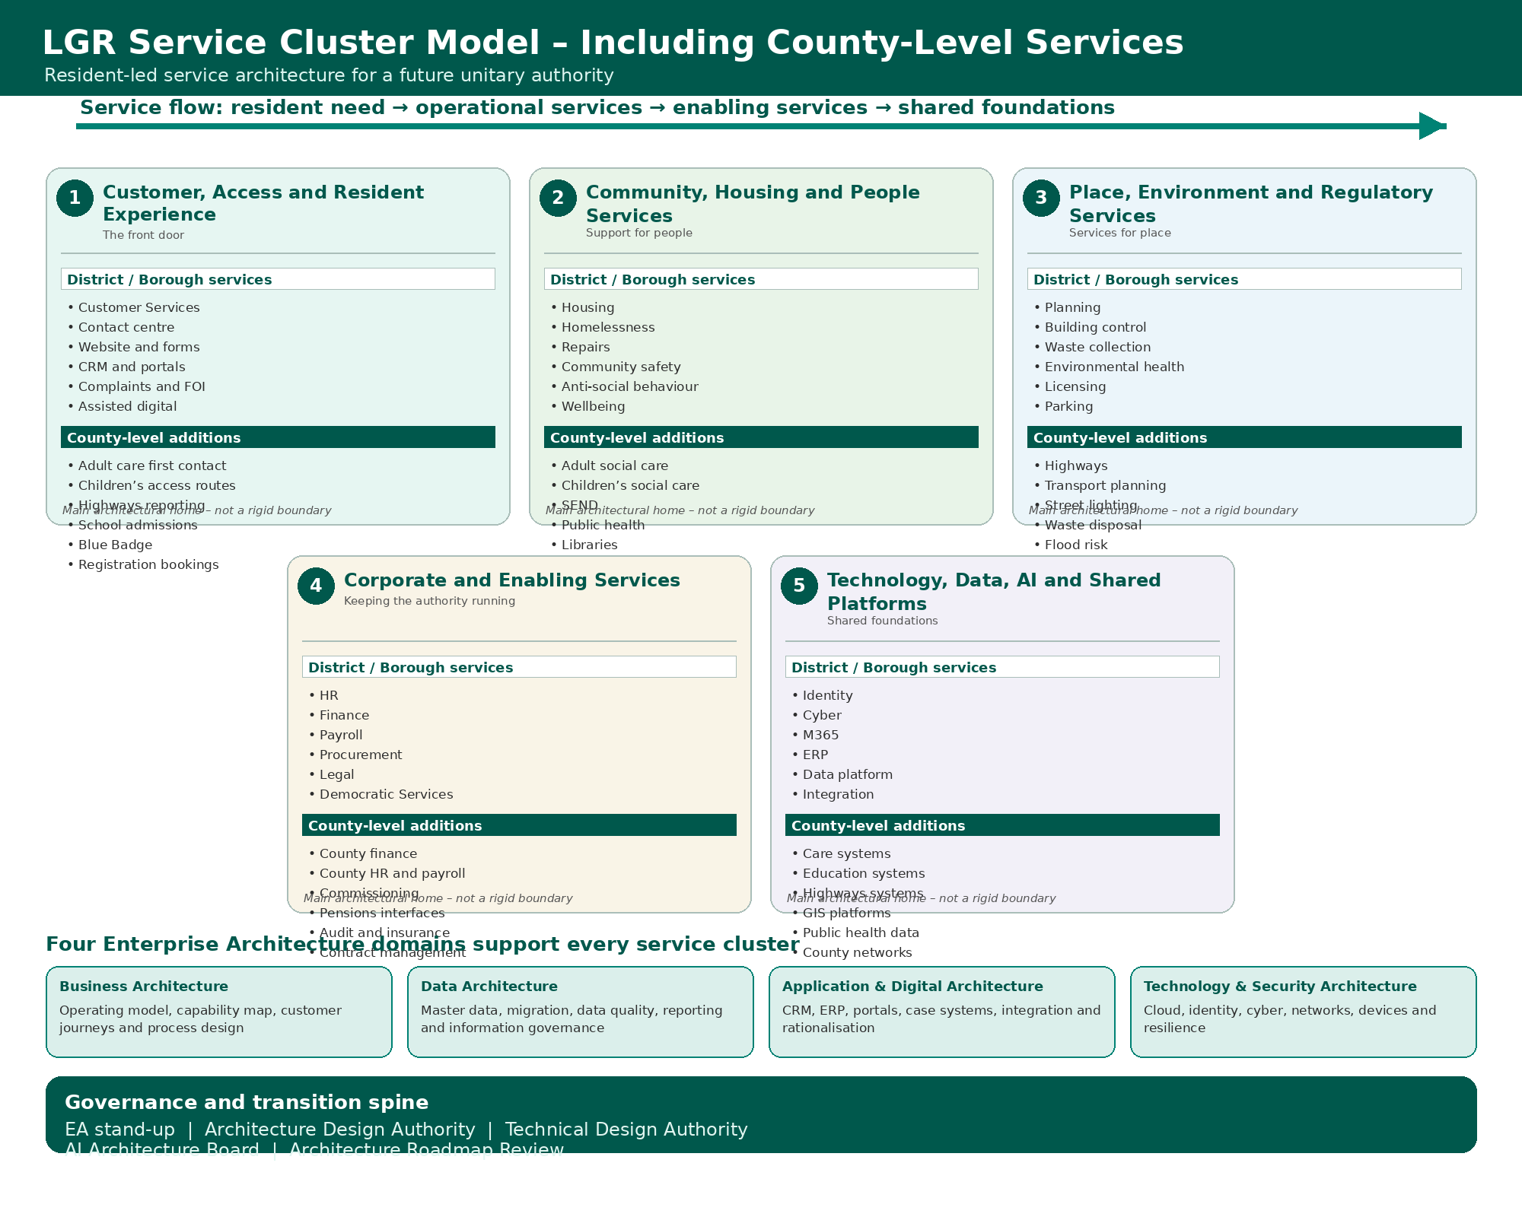
Thinking and justification: The visual is deliberately structured from resident access through to operational services, enabling services and shared foundations. It demonstrates that county-level services strengthen the existing model rather than require a separate architecture model.

4. Expanded Service Cluster Summary
No. | Service Cluster | District / Borough Services | County-Level Additions
1 | Customer, Access and Resident Experience | Customer Services, contact centre, website, CRM, complaints, FOI, assisted digital. | Adult care first contact, children’s access routes, highways reporting, school admissions, Blue Badge, registration bookings.
2 | Community, Housing and People Services | Housing, homelessness, repairs, community safety, anti-social behaviour, wellbeing. | Adult social care, children’s social care, SEND, public health, libraries, youth services.
3 | Place, Environment and Regulatory Services | Planning, building control, waste collection, environmental health, licensing, parking. | Highways, transport planning, street lighting, waste disposal, flood risk, trading standards.
4 | Corporate and Enabling Services | HR, Finance, Payroll, Procurement, Legal, Democratic Services. | County finance, county HR and payroll, commissioning, pensions interfaces, audit and insurance, contract management.
5 | Technology, Data, AI and Shared Platforms | Identity, cyber, M365, ERP, data platform, integration. | Care systems, education systems, highways systems, GIS platforms, public health data, county networks.

Thinking and justification: This table is the core summary of the report. It retains the original Appendix B structure and expands each cluster with the relevant county-level services that would need to be considered in a future unitary model.

5. Key Architecture Implications
Architecture Domain | Implication of County-Level Services
Business Architecture | Expand the service value chain to include adult care, children’s services, education, highways, public health, libraries and county corporate functions.
Data Architecture | Account for sensitive care data, children and family data, education data, highways asset data, public health data, GIS and statutory reporting.
Application & Digital Architecture | Map specialist systems for care, education, highways, libraries, fire interfaces, trading standards, ERP and county-wide case management.
Technology & Security Architecture | Assess larger-scale identity, cyber, cloud, network, device, field-working, resilience and secure collaboration requirements.

Thinking and justification: County-level services expand both the breadth and risk profile of the architecture work. This reinforces the need for a collaborative four-architect model rather than single-person ownership of complex service areas.

6. Priority Areas for Discovery
Priority Area | Discovery Focus
Customer and access | Understand future front-door routing for adult care, children’s services, highways, admissions, Blue Badge and registration services.
People services | Prioritise discovery of adult social care, children’s social care, SEND, public health, libraries and youth services because of statutory and safeguarding impact.
Place services | Map highways, transport planning, waste disposal, flood risk, trading standards and GIS dependencies alongside district place services.
Corporate services | Confirm HR, payroll, finance, legal, procurement, democratic governance, audit and pensions dependencies required for vesting day.
Shared platforms | Identify county systems, identity platforms, data platforms, reporting, integrations, cyber controls and network dependencies.

Thinking and justification: Discovery should start with the highest-risk and highest-dependency services. In LGR this means statutory people services, core corporate services and shared technical foundations.

7. Recommended Next Steps
Step | Action | Owner
1 | Validate the expanded service-cluster model with LGR programme leads and service representatives. | Head of Enterprise Architecture
2 | Use the visual model in senior leadership and service-cluster workshops. | Head of EA / Business Architect
3 | Create service discovery packs for adult social care, children’s services, SEND, highways, public health and corporate services. | Business Architect and Data Architect
4 | Develop a county-level application and data dependency map. | Application & Digital Architect and Data Architect
5 | Assess shared identity, cyber, infrastructure, GIS, data platform and integration dependencies. | Technology & Security Architect
6 | Update the LGR architecture roadmap to include county-level transition milestones. | Head of Enterprise Architecture

Thinking and justification: The next steps focus on validation before detailed design. County-level services carry statutory, safeguarding, operational and technical complexity, so assumptions should be tested with service experts.

8. Conclusion
The Appendix B service-cluster model remains suitable for LGR when county-level services are added. The model provides a coherent structure for bringing together district, borough and county functions around resident journeys, statutory services, corporate enabling capabilities and shared digital foundations.
The key principle is that county-level services should not be designed as a separate architecture layer. They should be absorbed into the same five service clusters, with each cluster supported by all four architecture domains.
Thinking and justification: This creates one practical, resident-led service architecture that can support future operating model design, transition planning and architecture governance.

9. References
• Stevenage Borough Council Enterprise Architecture and Artificial Intelligence Strategy 2026–2030 – internal draft.
• Appendix B – Service Cluster Model – draft architecture appendix.
• Hertfordshire County Council services: https://www.hertfordshire.gov.uk/services/our-services.aspx
• MHCLG Local Government Reorganisation policy and programme updates: https://www.gov.uk/government/collections/local-government-reorganisation-policy-and-programme-updates
• GDS Technology in Government Blog – Publishing a common architectural model for local government: https://technology.blog.gov.uk/2026/04/14/publishing-a-common-architectural-model-for-local-government/

