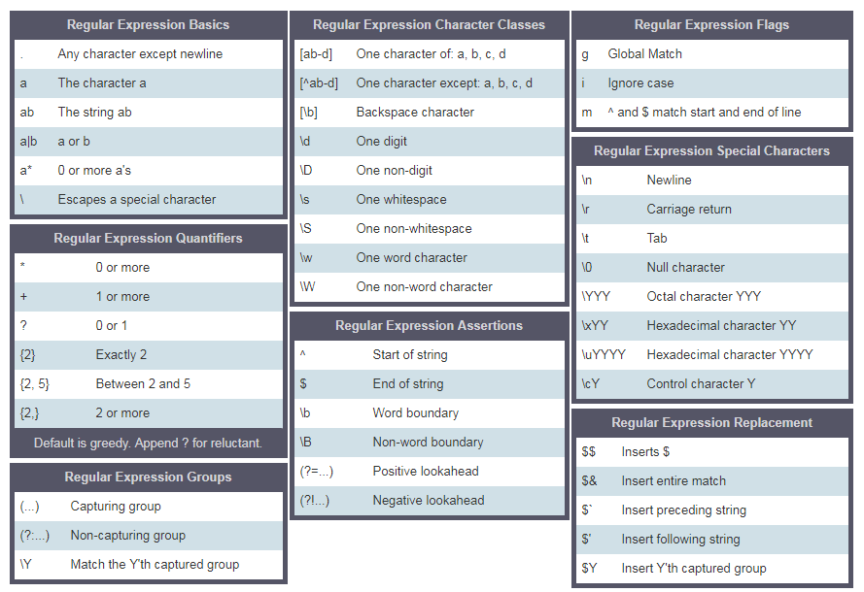
RegEx Characters Cheat Sheet

