**ReadMe**

Run Assignment 2.jar

You should be presented with an input screen like the following. Please specify your machine details

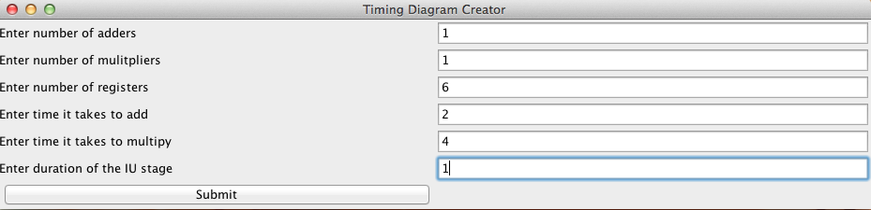

Hit Submit, you will be presented with a screen prompting you to input the number of instructions in your program

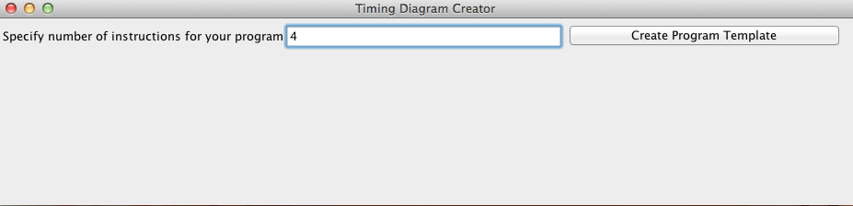

Hit create program template and specify your program

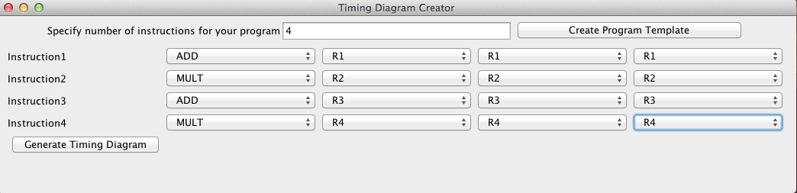

Press generate timing diagram and you will be presented with your HP style graph

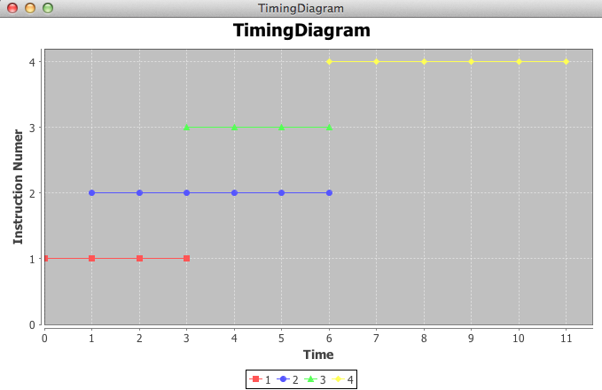

Note that in this case instruction 3 needed to wait for an adder and instruction 4 needed to wait for a multiplier

Here is an example where data dependencies prevent an instruction from issuing.

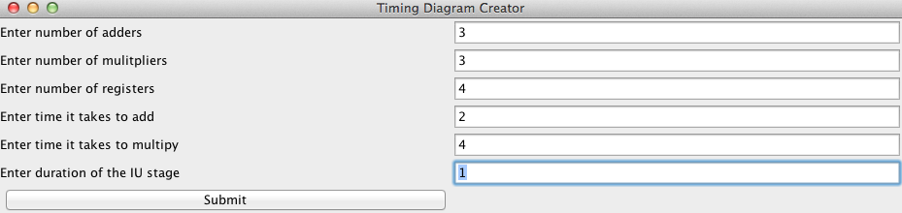

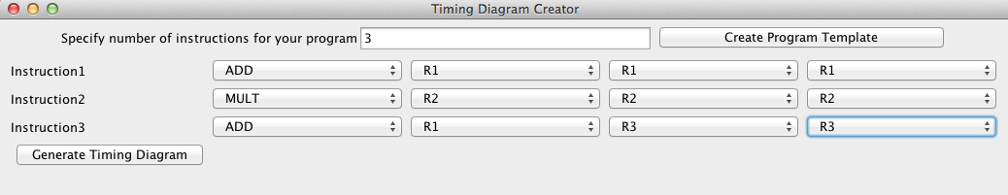

Instruction 3 needs instruction 1 to clear the pipeline before issuing

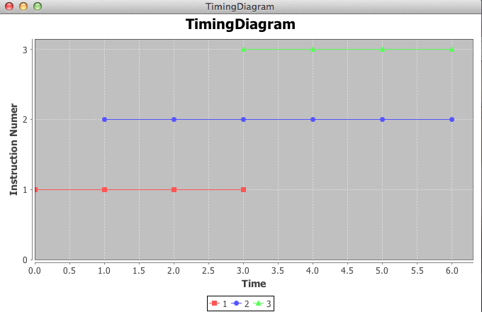

Instruction 2 had no dependencies so it issued right away.