

Metreos Active Relay v2.1
User Guide

Copyright © 2005 Metreos Corporation
All Rights Reserved
Table of Contents

Active Relay 3
Using Active Relay 3
Receiving a Call 3
Answering a Call on an Office Phone 3
Answering a Call on a Find Me Phone 3
Swapping a Call 3
Configuring Your Office Phone for Active Relay 5
1. Login 5
2. Edit Your Profile 6
3. Adding a Phone Device 7
4. Configuring a Phone Device 7
Determining Phone Device Name 7940/7960 8
Determining Phone Device Name 7970 8
5. Adding Your Main Line 9
Determining Main Line 7940/7960/7970 9
6. Visual Confirmation (a) 10
7. Visual Confirmation (b) 10
Configuring Find Me Phone Numbers 11
1. Login 11
2. Edit Your Profile 12
3. Adding a Find Me Number 13
4. Configure a Find Me Number 14
5. Visual Confirmation 14

Active Relay

Active Relay is a presence and mobility enhancement application. By bridging your office phone to any number of “Find Me” phone numbers, you no longer need miss important calls destined for your office phone. You can now chose to distribute your office number to professional contacts only, while managing your Find Me numbers as you see fit.

Once a call has been answered on an Active Relay Find Me number, the call is no longer bound to that device. At any time, the call can be swapped to your office phone, or any Active Relay-enabled IP Phone.

Using Active Relay

Receiving a Call
When a call comes into your office phone, the phone will ring as usual. After a brief delay, devices at your Find Me numbers will also begin ringing. All phones must of course have previously been configured with the Metreos Application Suite.

Answering a Call on an Office Phone
Active Relay does not impact this scenario. Answering a call on your office phone is the same with or without Active Relay configured.

Answering a Call on a Find Me Phone
When you pick up a call on a Find Me phone, you must then press the ‘#’ key to accept the call. The call then becomes bridged through to your Find Me phone.

Swapping a Call
Once you have answered the call on a Find Me phone, you may transfer the call back to your office phone, or to any other Active Relay-enabled IP phone.

To swap a call, begin by selecting Active Relay from the Services menu of your office phone.

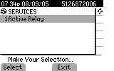
Selecting the Active Relay Service

A Swap key will then be visible on the phone display.

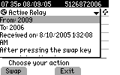
Preparing to Swap

Press Swap. The system will play a series of tones on the Find Me phone, indicating that a call swap request is pending. Press the ‘#’ key on the Find Me phone to confirm the transfer back to your office phone.

A swap call is then placed to the office phone, with visual indication of the swap attempt. Simply answer the call.

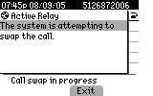
A Swap is in Progress

The swap is complete once you have answered the call.

If you attempt to swap a call from an IP phone other than your office phone, you will be prompted for your account user name and password. The swap display will not be available to you until you supply the requested information.

Also, if the phone is not registered as a device with the Application Suite, you will be prompted via the phone menu for the number of this phone.

Configuring Your Office Phone for Active Relay

- Login

To define your office device, log in to the Metreos Application Suite web page found at http://<MCE Server IP>/appsuiteadmin.

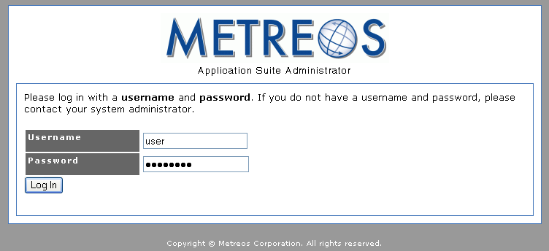
Application Suite Login

- Edit Your Profile

Once logged in, go to the user profile configuration page by clicking Edit Your Profile.

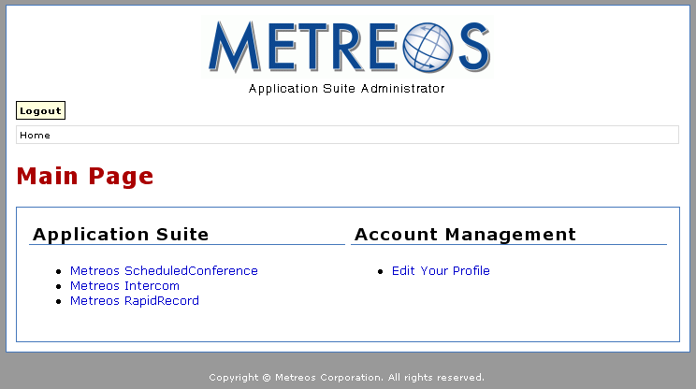
Main Menu

- Adding a Phone Device

Standard configuration settings are shown at the top of the page. Later in the page you will find a section labeled Devices. Click the Add Device button found there to begin configuring your office phone.

Note: If you find that a device is already configured in this section, it is likely that your office phone device is already configured. You will however still need to configure your Find Me numbers, as described in the next section.

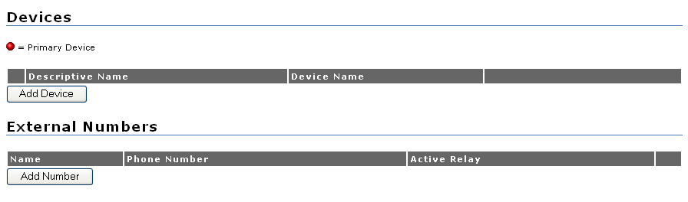
The Devices section of Your User Profile

- Configuring a Phone Device

A display name and a Cisco IP Phone Device Name must be defined.

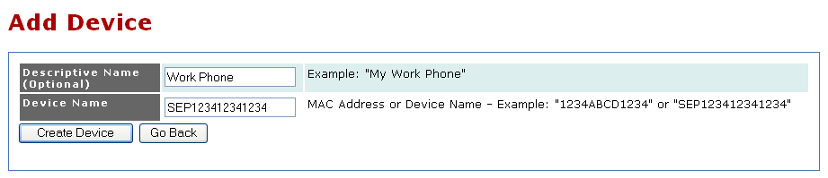
Adding a Device

When configuring your office phone, enter the number exactly as it appears in your phone settings. The Cisco IP Phones Settings menu refers to the device name as Host Name.

Determining Phone Device Name 7940/7960

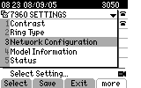  7940/7960 Settings Menu | 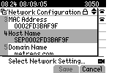  7940/7960 Host Name

Determining Phone Device Name 7970
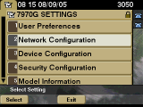  7970 Settings Menu | 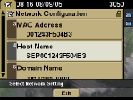  7970 Host Name

- Adding Your Main Line

Once you have created your device, you will need to enter the primary line associated with your Cisco IP Phone, which is usually the top line displayed on the phone. Click the Add Number button.

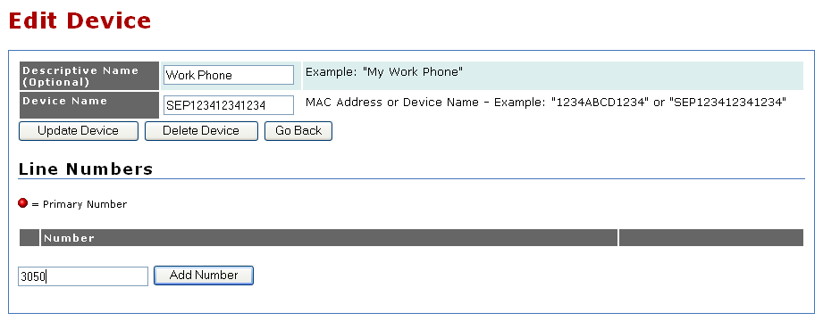
Adding a Line

Determining Main Line 7940/7960/7970

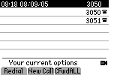  Main Line: 3050 | 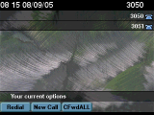  Main Line: 3050

- Visual Confirmation (a)

One line appears for your office phone.

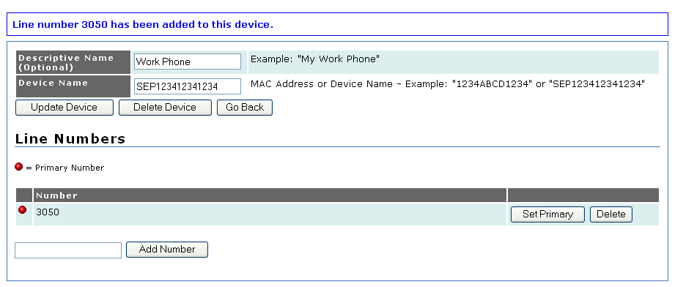
Visual Confirmation of a New Line

- Visual Confirmation (b)

Click the Account for <Your Name> link near the top of the page to go back to the Edit Your Profile page. Verify that one phone device is now configured in the Devices section of your user profile.

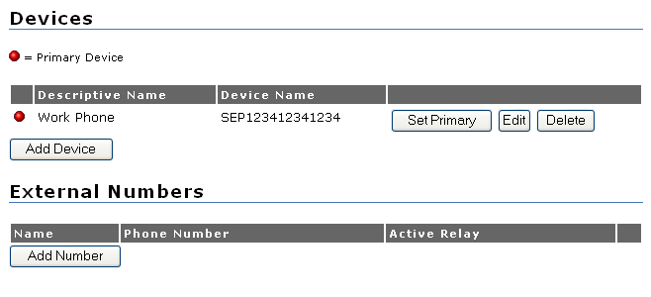
Visual Confirmation of a New Device

Configuring Find Me Phone Numbers

- Login

To define your phone numbers for Active Relay, log in to the Metreos Application Suite web page found at http://<MCE Server IP>/appsuiteadmin.

Application Suite Login

- Edit Your Profile

Once logged in, go to the user profile configuration page by clicking Edit Your Profile.

Main Menu

- Adding a Find Me Number

At the top of the page is found a listing of standard configuration settings. Later in the page you will see a section labeled External Numbers. Click the Add Number button to configure your first Find Me phone number.

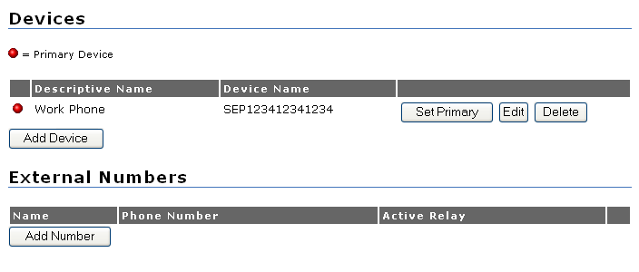
Adding a Find Me Number

- Configure a Find Me Number

For each new Find Me number you configure for Active Relay, a name and calling number must be defined. When configuring a Find Me number, enter the number as you would dial it when calling from your office phone. For example, if you must dial ‘9’ plus area code to call your cell phone, then you should configure your Find Me number similarly, unless otherwise instructed by your System Administrator.

Click Create Number to add the new number.

Check the Active Relay checkbox to enable this Find Me number.

Do not enter any punctuation in the Find Me phone number.

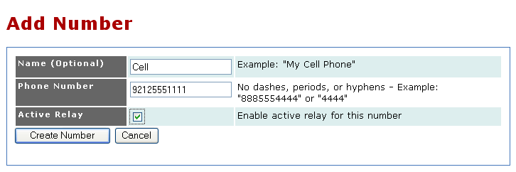
Configuring a Find Me Number

- Visual Confirmation

You should see the number listed in the External Numbers section of your profile configuration page.

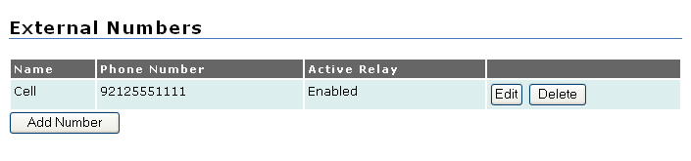
Visual Confirmation of a New Find Me Number

