

Metreos Communications Environment

Administrator’s Guide

August 2004

Version 1.1

Copyright © 2004 Metreos Corporation
All Rights Reserved

Proprietary and Confidential Information
For Release under NDA Only

1. Overview 4
Introduction 4
Who Should Read this Book 4
A Short History of Telephony 4
Metreos Communications Environment 5
The Metreos Media Server 5
The Metreos Application Server 6
Metreos Visual Designer 6
System Control Panel 7
Examples of Use 8
MCE Architecture 9
Overview 9
The Metreos Visual Designer 10
The Metreos Application Server 11
The Metreos Media Server 12
2. Installation 14
The Metreos Communications Environment Appliance 14
Appliance System Configuration 14
Installing Additional Software 14
Virus Scanners 15
The Metreos Visual Designer 15
Installing the MVD 15
Configuring the MCE in Cisco CallManager™ 15
Overview 15
Integration Modes 15
H.323 Phone Device Configuration (CallManager™ 3.2(2c) and later) 16
H.323 Gateway Device Configuration (CallManager™ 4.0 and later) 19
TAPI Configuration 22
DeviceListX Configuration 22
IP Phone Service Configuration 25
3. Using the MCE System Control Panel 28
Accessing the Control Panel 28
Main Control Panel 29
System Status 29
Component Status 30
Component Management 30
User Management 30
Managing Users 30
Overview 30
Types of Users 30
User Management Subsystem 31
Creating New Users 32
Deleting Existing Users 33
Changing Your Password 34
Configuration Settings 35
Making Configuration Changes 35
Types of Configuration Settings 35
Configuration Setting Restrictions 36
System Logs 37
Log Information 37
Log Access 37
Core Services Configuration 37
Application Management and Configuration 40
Metreos Communications Archives 40
Application Management Panel 40
Application Names and Descriptions 41
Application Status Codes 41
Installing New Applications 42
Enabling and Disabling Applications 43
Uninstalling Applications 43
Application Configuration 43
Provider Management and Configuration 44
Provider Configuration 45
Media Server Management 45
Adding and Removing Media Servers 45
Media Server Configuration 45
4. Technical Support 46
Contact Support 46
Appendix A: Glossary of Terms 47
Appendix B: Security Considerations 50
Account Naming 50
Strong Passwords 50
Unique Passwords 50
Password Transport and Storage 50

Overview

Introduction

Welcome to the Metreos Communications Environment Administrator’s Guide. This document will aid you in installing, operating and maintaining the Metreos Communications Environment (MCE).

Who Should Read this Book

This book is intended for system and network administrators who will be deploying, maintaining, or operating the Metreos Communications Environment for their organization. The reader is assumed to have a fairly solid background in system and network administration, including familiarity with installing software and troubleshooting network and system problems. Furthermore, the reader will benefit from a basic understanding of IP Telephony principles.

A Short History of Telephony

No technology has impacted the growth of business and extended the reach of human communications more than the telephone. Though the principle of voice communication through electrical signals has been in use for over a hundred years, new advances in computing technology continue to augment the power of telephony.

Up until the 1960s and 1970s, telephone systems were entirely circuit-switched. A complete electrical circuit had to be established between receivers to facilitate communication, which was often switched on and off by a human operator. A radical change in information processing theory led the creation of packet-switched networks, in which information was broken in to tiny discrete units called packets, and then routed through whatever channels available to reach their common destination.

Meanwhile, the computer networking industry standardized on a similar packet-switched network to enable worldwide communication through a network of networks called the Internet. The various protocols under which these communications occur are lumped together under the term IP, short for Internet Protocol. Since both telephone networks and computer networks used the same principle of quantizing information into packets for individual routing, convergence of the two networks was inevitable. Today there is no distinction between telephone data and Internet data at the core of the largest data networks.

However, at the edges of the network a strong disparity still exists. Regular consumer telephones are still analog, circuit-switched devices that connect via a dedicated line to a local exchange. Most enterprises have an expensive PBX (private branch exchange) system which creates an internal circuit-switched network for use with either standard or specialized analog phones. These phone systems exist in parallel with high speed Internet access options, which are often provided by the same telecom company! Even though businesses and individuals access what is primarily the same global network whether they send email or place phone calls, they must purchase and maintain two separate network systems in their facilities, one for telephones and one for computers.

While widespread usage of IP telephony has not yet supplanted traditional circuit-switched telephony, some medium and large sized companies have deployed IP telephony solutions for their internal communications using specialized servers on their data networks which perform the same functions as a traditional PBX. One such server is the Cisco CallManager ™ which works with specialized phones to emulate the experience of circuit-switched telephony while enhancing the user experience by adding features only available in a packet-switched environment. The Metreos Communications Environment works with CallManager ™ to provide these enhanced services to the phones.

Metreos Communications Environment

The Metreos Communications Environment (MCE) is a feature-rich platform for developing and hosting IP telephony applications. At the core of the MCE is a powerful, software-based Media server which processes, mixes, analyzes, and routes digital audio data. A powerful Application Server controls this media server under the direction of flexible, customized telephony applications, which use media to provide end-user services. Building these software programs is accomplished through a powerful visual designer, which enables developers to create complex telephony applications with literally a few clicks of the mouse. System administrators manage the MCE through a web-based interface called the System Control Panel.

The Metreos Media Server

At the heart of any digital telephony system is media. Managing the digital audio of IP telephone conversations is a task traditionally reserved for expensive, high performance hardware switches. The Metreos Media Server (MMS) is built upon the Intel Host Media Processing ™ framework, a drop-in software replacement for the popular Dialogic line of digital telephony products. This ensures interoperability with fundamental telephony and networking protocols (like RTP and TCP/IP), as well as scalability and redundancy via multiple MMS installations.

The MMS includes a variety of powerful features to enable complex telephony applications, including support for media streaming, DTMF interpretation, multi-party conferencing and recording. This robust feature set enables the creation of many complex, professional telephony applications. Metreos anticipates additional features such as text-to-speech, speech-to-text and support for Voice XML in future releases.

The Metreos Application Server

The Metreos Application Server (MAS) serves as the core component of the MCE. Within the MAS reside all available applications, a virtual machine for executing applications, and a host of protocol providers for extending the capability of the platform to reach third-party components.

Just as applications designed for Microsoft Windows ™ must be installed on a system before use, applications designed for the MCE reside within an application pool in the MAS. The platform provides automatic management of application state, handles side-by-side existence of varying application versions, supports seamless addition of new applications and trouble-free removal of any application not currently in use.

Once applications enter the Enabled state, an internal virtual machine processes incoming events using the logic enforced by the design of each application. This architecture helps ensure reliability by protecting application resource allocation, and will automatically recover in the case of a malformed application.

In addition to internal processing, applications communicate with other components of the MCE as well as third-party systems via protocol providers. Metreos provides an H.323 provider for first-party call control, a TAPI provider for third-party call control, an HTTP provider for network communication, a Cisco DeviceListX provider for lookup of Cisco-specific device information, a Timer provider for creating event-driven delays, and finally a Media Server provider for communication with the MMS. Metreos anticipates releasing additional providers to integrate the MCE with other enterprise systems. Developers interested in creating protocol providers should refer to the Metreos Communications Environment: Advanced Developer’s Guide.

Metreos Visual Designer

Traditionally, developing IP telephony applications required immense resources and intimate knowledge of obscure systems. The MCE radically simplifies the process of developing and deploying applications through the Metreos Visual Designer (MVD).

Developing an application requires neither expertise in programming nor paging through countless lines of arcane program code. Instead, the MVD presents a graphical user interface where application components may be created and interconnected with a few clicks of the mouse. Finished applications can be deployed to the MCE via a menu selection or uploaded using the System Control Panel (described below).

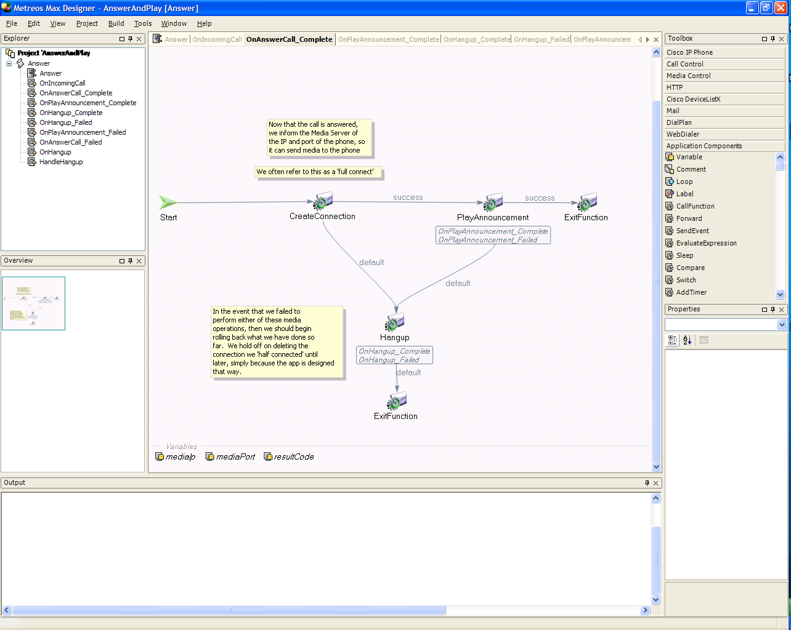
Figure 1: The Metreos Visual Designer
Using the MVD requires technical knowledge of IP telephony and the architecture of the MCE platform. Interested developers should refer to the Metreos Communications Environment: Application Developer’s Guide.

System Control Panel

Administrators managing the MCE utilize the System Control Panel (SCP). This web-based interface permits configuration management of the Metreos Application Server and all associated installations of the Metreos Media Server, user and license management as well as control over system configurations, providers, and applications.

SCP requires Microsoft ASP.NET ™. By default, SCP will co-exist on the same server as the Metreos Application Server, but may be optionally relocated to a dedicated web server if desired. Details regarding use of the SCP reside in Using the MCE System Control Panel.

Examples of Use

Harnessing the power of the Metreos Communications Environment enables developers to produce any imaginable telephony application at a fraction of the cost and time required by traditional systems. Some examples of potential applications include:

- Voicemail: Provide customized, flexible voicemail services to meet individual organizational needs

- Conferencing: Take advantage of the rich features in the Metreos Media Server to support instant recordable conferencing with participant mute and kick.

- Click-To-Talk: Extend a desktop PIM client (such as Microsoft Outlook™) with a protocol provider to enable one-click calling between any parties in your address book.

- Location-Based Forwarding: Integrate with your enterprise IT authentication system to automatically forward incoming calls to your home phone, mobile phone, desk phone, based on your system login trail.

These examples can be produced at remarkably low costs and on short schedules due to the flexibility and power offered by the Metreos Communications Environment. For more information on application development, see the Metreos Communications Environment: Application Developer’s Guide.

MCE Architecture

The MCE architecture offers a rich and flexible framework for telephony application development and execution. Administrators of an MCE installation must comprehend the overall system architecture to adequately maintain applications and support ongoing development efforts, while developers will require intimate knowledge of the internals of each component.

Overview

Three core components work together to enable application development, application management, and media mastering. These are the Metreos Visual Designer (MVD), the Metreos Application Server (MAS), and the Metreos Media Server (MMS).

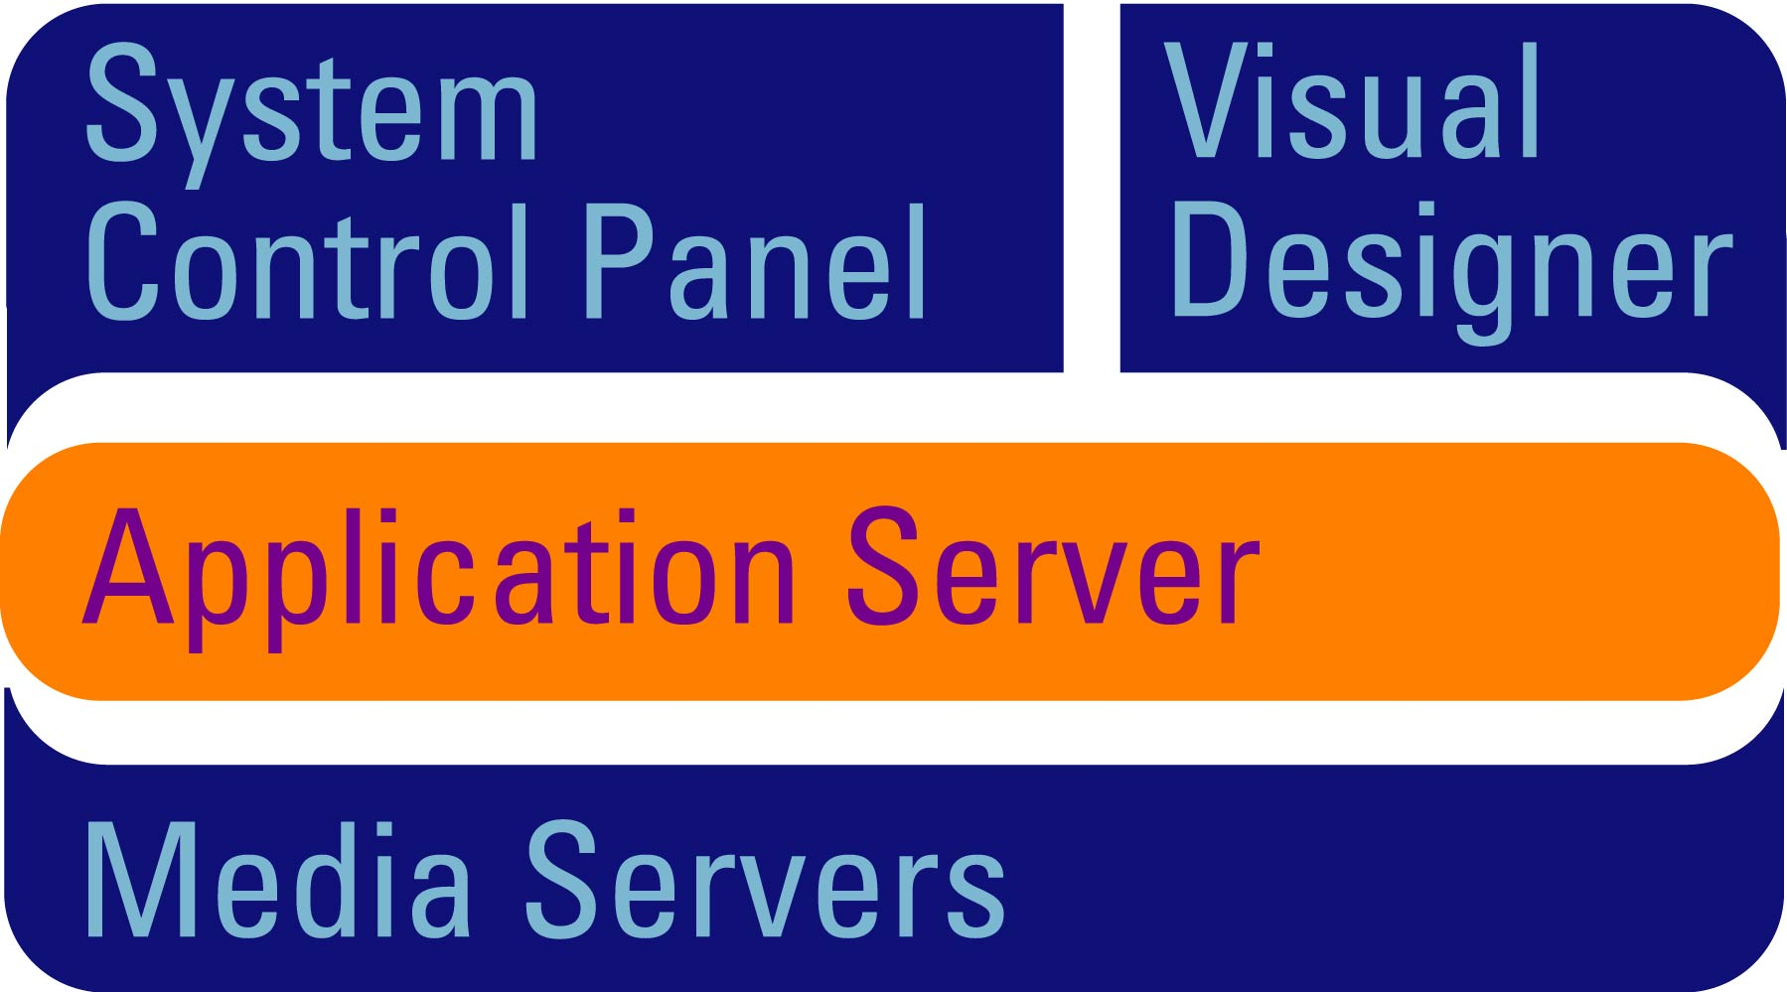
Figure 2: Metreos Communications Environment Block Diagram

Figure 2 illustrates the basic flow of data within the MCE. Developers work in the Metreos Visual Designer to create telephony applications. These applications reside within the Metreos Application Server, and remain available for use. The Application Server, in turn, provides applications access to the Media Server for mixing, analyzing, recording, playing or processing audio data.

While these components together comprise the entire MCE platform, they need not necessarily reside on a single server. Each piece may exist on a distinct machine as long as all hardware and network requirements are sufficiently met. Customers interested in purchasing additional licenses for large scale installations should contact Metreos Sales at http://www.metreos.com.

Furthermore, while these elements interact seamlessly, each operates as a complete unit and does not require the other two to function. Thus, administrators can take individual components offline and add new elements without affecting the stability of the other parts. Naturally, any applications which depend on removed components will remain unavailable for the duration. For more information regarding component control, see Chapter 3: Using the MCE System Control Panel.

The Metreos Visual Designer

Developers utilize the Metreos Visual Designer (MVD) to create applications. A powerful graphical user interface with drag-and-drop programming enables rapid development of complex telephony systems.

Figure 3: The Metreos Visual Designer

Once a developer completes an application, the MVD compiles the visual design into a Metreos Communications Archive (.mca file). A simple one-click menu choice will upload this application to the Application Server. Optionally, an administrator may also use the System Control Panel to upload a .mca file. See the section entitled Application Management and Configuration 46 for details.

For a detailed reference guide on the MVD, see Metreos Communications Environment: Application Developer’s Guide.

The Metreos Application Server

The Metreos Application Server serves as the heart of the MCE. It provides the fundamental framework for application management and execution, as well as control and signaling to external resources through the provider protocol framework. Each component of the MAS works in concert to enable custom-designed telephony applications to connect users, third-party applications, and real-world data.

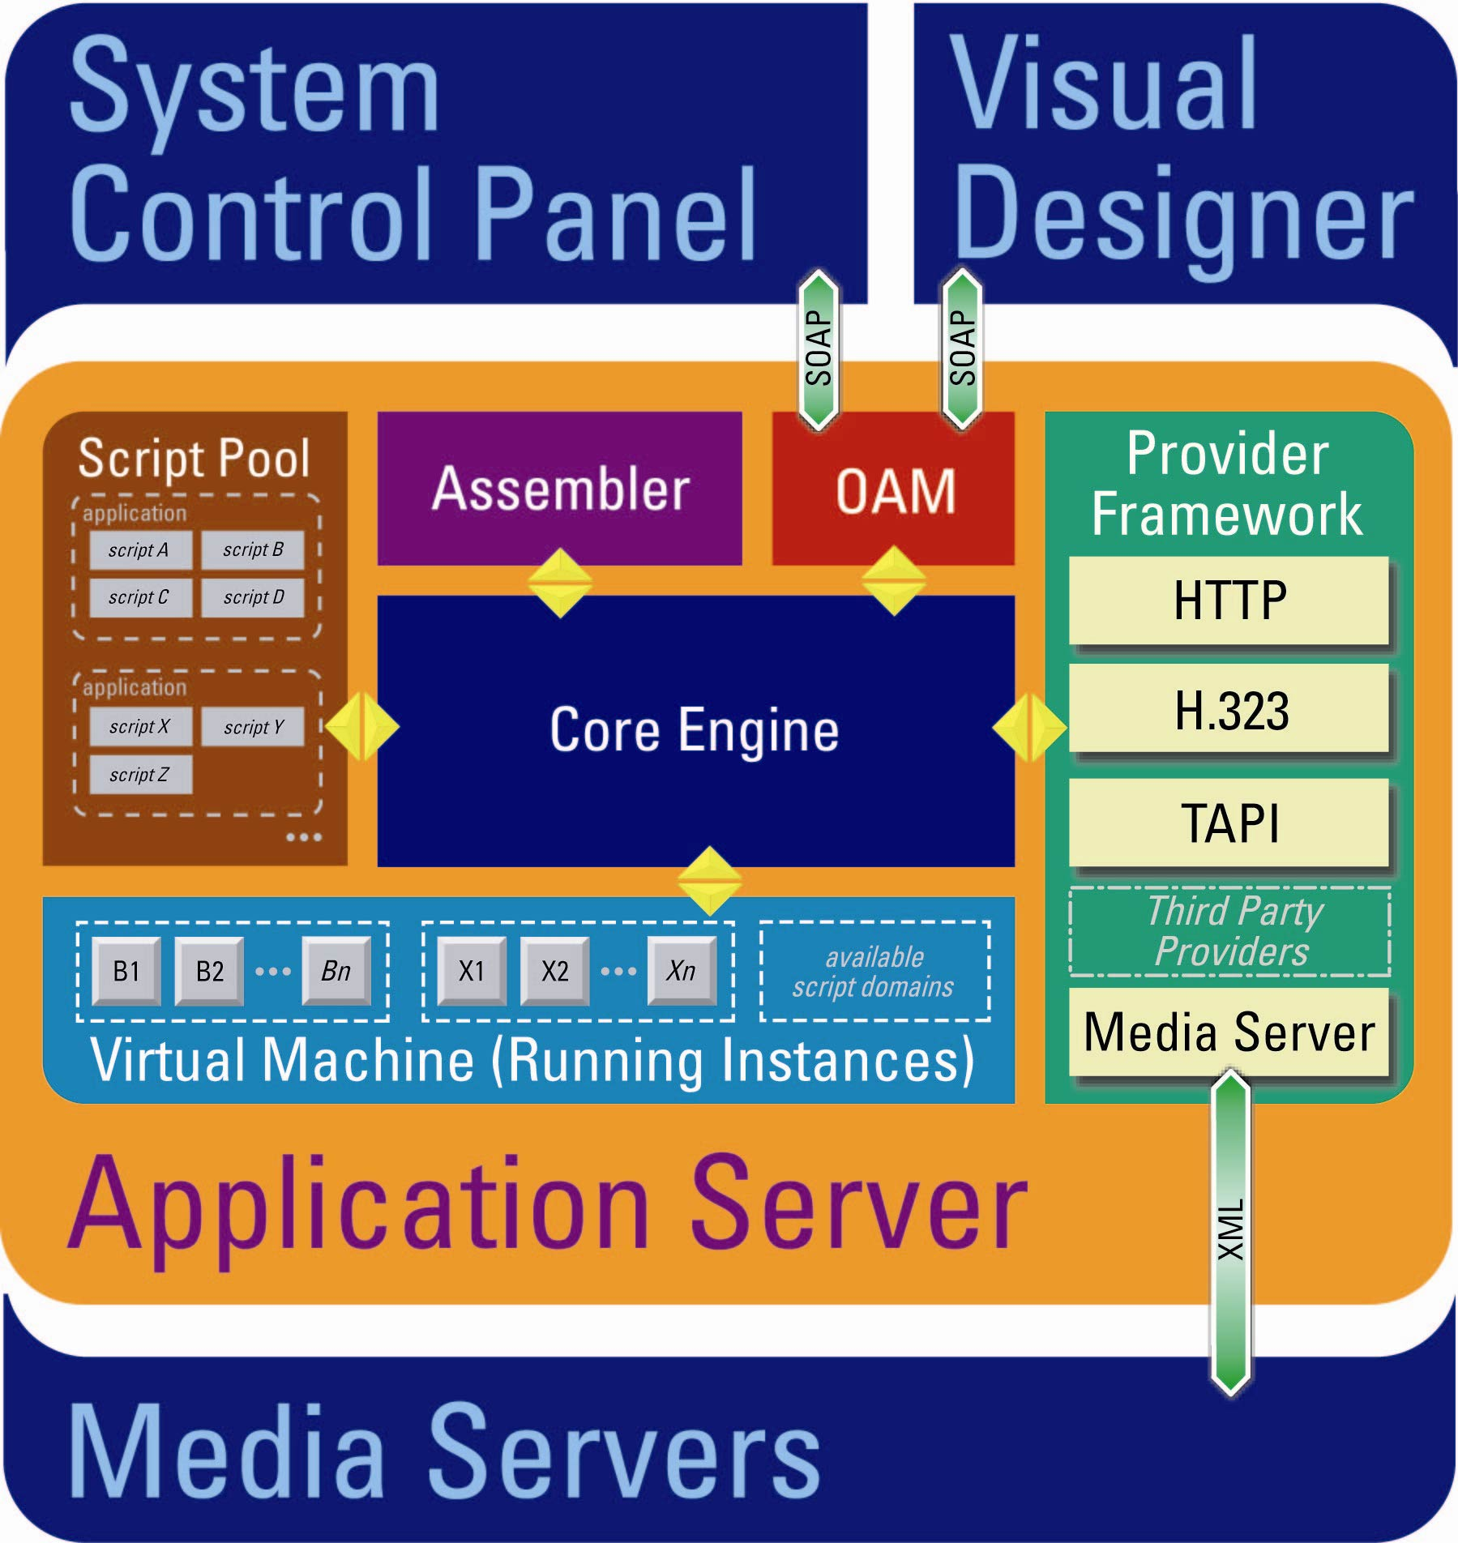
Figure 4: Metreos Application Server

Six primary internal elements power the MAS: The Application Pool, the Application Assembler, the OAM, Provider Framework, the Virtual Machine and the Core Engine. Each provides distinct functionality, communicating with one another through priority message queues (yellow arrows in Figure 4) via the Core Engine.

Installing applications begins with either the Metreos Visual Designer or the System Control Panel. In either case, the OAM (Operations and Maintenance) component authenticates the user and accepts the new application. Then, the Application Assembler unpacks the .mca archive and confirms the application meets the structural requirements of Metreos. This process is akin to compiling in traditional application development.

Next, the application enters the Application Pool where it awaits execution. Only the Core Engine, as instructed by other applications or external events generated by Protocol Providers, can signal the Application Pool to transfer the application to the Virtual Machine.

Since multiple users may require access to the application, the virtual machine manages as many copies of the application as users require (and resources permit). Once an administrator initiates shutdown through the System Control Panel, the Core Engine signals the Virtual Machine to close all connections, delete the instance, and free any related resources.

The Provider Framework supports a variety of protocol providers, which receive messages from applications (actions) as well as send messages to applications (events). Providers typically offer support for an open standard (such as H.323 or HTTP) or enable applications to connect with proprietary third-party systems, like Cisco CallManager ™. Those interested in developing protocol providers should refer to
Metreos Communications Environment: Advanced Developer’s Guide.

The Metreos Media Server

The Metreos Media server provides services for extensive manipulation of audio data—entirely in software. The capabilities include processing, mixing, recording and playback of media, with independent control maintained by multiple applications or application instances in the Metreos Application Server.

The Metreos Media Server surpasses all competition due to a variety of impressive features. These include:

- Half connection: An RTP port can be reserved without a remote endpoint being specified. This allows media negotiation to occur before either leg of the call has started. Not only can this feature be used to ensure connectivity and maintain signal quality, but also to prepare any media resources or actions in advance of user participation in a call.

- One way media streaming: A .vox or .wav file can be played to a designated IP and port using a specified frame size over RTP. If enabled, a provisional response is sent to indicate that the play is commencing normally. Later, an asynchronous callback is sent to indicate that the play has completed. Play can be aborted at any time. This feature can be used to create prompts, announcements, and form the basis of telephony-based interactivity.

- DTMF support: The MMS can listen to and interpret traditional touch-tone dialing in the media stream, or handle digits sent to it by the application server in the signaling path. Once a developer-defined termination condition is satisfied, the value of these digits is available to the relevant application by way of an asynchronous callback.

- Conferencing: A conference mixer, supporting one or more participants, enables multiple media streams to interact. MMS supports the use of different codecs and framesizes for each participant. Conferences can be ended at any time, programmatically or by user termination. Participants can be muted (allowed to hear but not speak), added or removed at any time.

- Recording: MMS supports real-time recording of both conferences and individual connections as a time stamped .vox or .wav file. Recording can be started and stopped on demand.

- Scalability: An MCE configuration may include up to eight MMS installations per Application Server. These servers will automatically share resources to optimize load distribution.

Installation

The Metreos Communications Environment Appliance

Although one may install the Metreos Communications Environment in a variety of configurations, most customers opt for the MCE Appliance. This stand alone, pre-installed system fits directly into an existing network in any 1U slot. Each MCE Appliance complies with all Metreos platform requirements and is fully tested before leaving the Metreos labs.

Appliance System Configuration

Like any computer-based server appliance, you will need to attach a keyboard, mouse, and monitor (for initial configuration only) to operate the Metreos Communication Environment. Because the system relies on Microsoft Windows ™ technology, accessing the appliance requires some knowledge of Windows 2003 Server ™ administration. The default administrator password for the server is metreos. You will be required to change this password during your initial use of the machine.

While the MCE software comes preinstalled on the MCE Appliance, you must configure the device for your specific network, along with any needs defined by your organization. These settings include:

- Static IP Address– The MCE requires a static Internet Protocol address to enable communication between itself, users, and other network services. Contact your network administrator for assignment of a unique, static IP address.

- DNS / WINS / NetBEUI resolution– If you use computer names to enable communications between systems, the MCE Appliance must be configured accordingly. Note that in many network configurations, this is handled automatically by resident broadcast services.

Installing Additional Software

Although the MCE appliance adds a powerful new computer to your network, Metreos does not support the installation of additional software or services. Doing so will void your warranty and forfeit any and all rights to technical support. If your internal policies require additional software, please contact Metreos Support as described in Chapter 4: Technical Support.

Virus Scanners

Due to heightened security awareness, Metreos includes a virus scanner and removal tool with the MCE Appliance. Only this utility has been tested and approved by the Metreos Labs. For more information regarding antivirus software and general security issues, please contact Metreos Support as described in Chapter 4: Technical Support.

The Metreos Visual Designer

In addition to the self-contained Metreos Communications Environment Appliance, an installation CD for the Metreos Visual Designer enables developers to create applications on their own workstations. This CD includes a single license for a single developer. For more licenses, contact the Metreos sales department at www.metreos.com.

Installing the MVD

To setup the MVD on a developer workstation, simply insert the CD and follow the prompts. Note that the MVD does require Microsoft Windows 2000 Professional ™ or Microsoft Windows XP Professional ™.

Configuring the MCE in Cisco CallManager™

Overview
This document details the configuration required to integrate the Metreos Communications Environment with Cisco CallManager™.

Integration Modes
The MCE integrates with Cisco CallManager™ using a variety of interfaces and APIs. The following is an explanation of the various integrations available and their usage scenarios.

Call Control
The majority of applications built using the MCE will utilize some type of 1st party call control. They will either make calls or receive calls using the automated voice processing capabilities of the media server to communicate with the user and retrieve input.

Version 1.0 of the MCE uses the H.323 protocol for call control communication with the MCE. CallManager™ is configured with an H.323 device that points to the MCE. Depending on the version, this can be either a phone or a gateway.

TAPI
The Telephony API exposed by CallManager™ can be used by applications running within the MCE to monitor device status and receive events when device status changes. For example, if someone wished to build an application that displayed information on the IP phone when someone called, TAPI could be used to accomplish this.

Version 1.0 of the MCE does not support using TAPI as a 1st party call control interface. A future release of the MCE will provide this feature. With version 1.0, any 3rd party capability, device monitoring, or device routing feature can be utilized. Integration with CallManager™ is similar to any other JTAPI/TAPI configuration involving adding either CTI ports or route points and associating those with users on the CallManager™.

DeviceListX
The DeviceListX API enables real-time reporting of device status, IP address, and other information that can be utilized by applications when delivering services to IP phones. On a periodic basis the MCE retrieves the DeviceListX report from CallManager™, parses and validates it, and then stores it locally as a cached copy. Applications running within the MCE can then query this report for information about devices on the CallManager™ cluster.

A common scenario where the information from DeviceListX is used by an application would be one in which the IP address of the telephone device needs to be determined. For example, in the Metreos Click-to-Talk application, the user needs only to provide their username and password on CallManager™. The application can then use LDAP and the MCE’s DeviceListX interface to determine the IP address of the user’s IP telephone. Enabling the DeviceListX report feature on the MCE only requires configuration on the MCE itself. No configuration on the CallManager™ is required.

IP Phone Services
Cisco IP Phone Services must be configured as normal for all services deployed within the MCE. Typical configuration of an IP phone service includes giving the service a name and pointing the service URL to the IP address and port of the MCE’s HTTP interface. The service URL should resemble the following:
http://mce-machine-name:8000/someServiceUrl

Call Control Configuration
As described earlier, the primary call control interface used by the MCE is H.323. CallManager™ configuration for call control is different depending on the version of CallManager™ that is deployed in the network.

In CallManager™ version 3.3 and earlier, the MCE must be configured as an H.323 Phone Device.

In CallManager™ version 4.0 and later, the MCE may be configured either as an H.323 Phone Device or an H.323 Gateway Device.

The following steps will detail how to configure both types of devices:

H.323 Phone Device Configuration (CallManager™ 3.2(2c) and later)
- Login to the CallManager™ web management console

- Select “Device->Add New Device”

- For “Device Type” select “Phone” and click “Next”

- For “Phone Type” select “H.323 Client” and click “Next”

- Enter the Configuration Values for the H.323 Phone Device
DeviceName: This configuration value must be set to the IP address of the MCE.

Description: This can be any value.

Device Pool: This setting is dependent on the particular CallManager™ deployment. An H.323 device will be treated in the same way as any other phone device (7960, etc). Placing the MCE into a device pool will affect how CallManager™ switches inbound and outbound calls to and from the MCE; however, this effect will be exactly the same as any other phone device in the pool.

All other values may be left as their default. You may set a Calling Search Space for the MCE. As with Device Pool, this will affect the MCE in the same way as it would affect any other phone.

Note: Do not configure the MCE’s H.323 Phone Device to require a Media Termination Point and do not add a Media Resource Group List to the MCE’s H.323 Phone Device. The MCE is processing media for its calls directly and does not require any media processing resources from the CallManager.

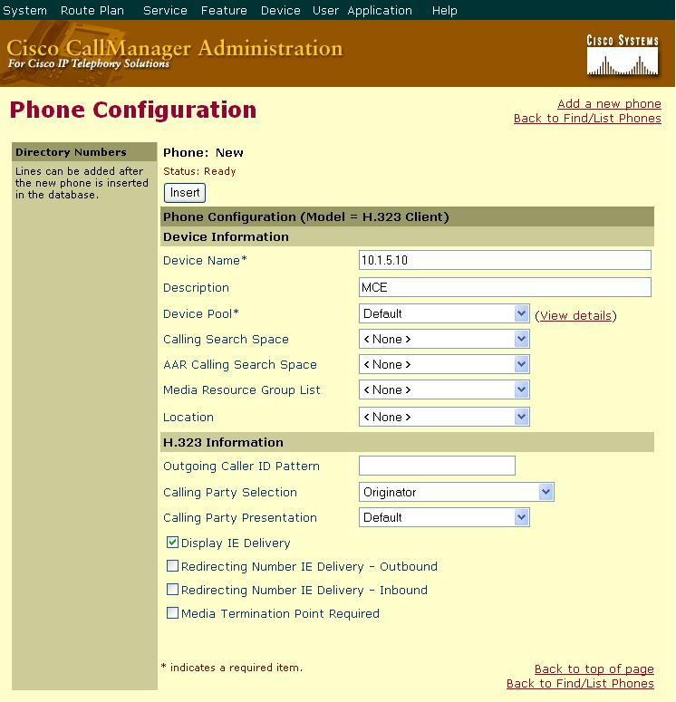
Figure 5: H.323 Phone Device Configuration

- Add a New Line to the H.323 Phone Device
DirectoryNumber: The directory number to assign to the line.

Forward Busy: Enter the directory number to forward calls to when this line is busy. Typically this directory number is another directory number that points to the MCE.

Forward No Answer: Same as Forward Busy.

All other values may remain as their default setting.

Note: You may configure the H.323 Line on this device to be within a particular partition within CallManager™. Doing this will have the same effect on the MCE’s H.323 Device as it would on a normal Cisco IP Phone.
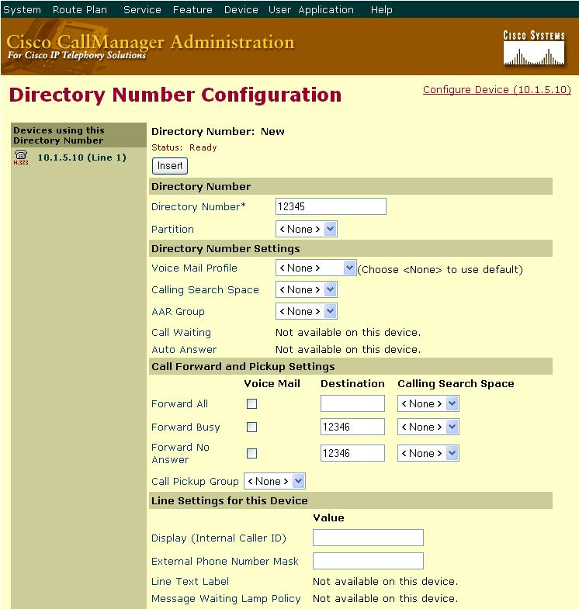
Figure 6: H.323 Phone Device Line Configuration

Repeat this step to add as many lines to the MCE’s H.323 device as required.

- Reset the H.323 Phone Device
After the configuration is complete and lines have been added to the phone device, click “Reset Phone” and then click “Reset”. After the phone resets click “Reset Phone” and then click “Restart”. This step should be done after any configuration change to the MCE’s H.323 Device.

H.323 Gateway Device Configuration (CallManager™ 4.0 and later)
Configuring the MCE as a gateway has the benefit of not requiring individual line configuration on an H.323 Phone Device. The downside is that the system administrator can not use the CallManager™ for concurrent call throttling.

- Login to the CallManager™ web management console

- Select “Device->Add New Device”

- For “Device Type” select “Gateway” and click “Next”

- For “Gateway Type” select “H.323 Gateway”

- For “Device Protocol” select “H.225” and click “Next”

- Enter the Configuration Values for the H.323 Gateway
DeviceName: This configuration value must be set to the IP address of the MCE.

Description: This can be any value.

Device Pool: This setting is dependent on the particular CallManager™ deployment. An H.323 device will be treated in the same way as any other phone or gateway device (7960, etc). Placing the MCE into a device pool will affect how CallManager™ switches inbound and outbound calls to and from the MCE; however, this effect will be exactly the same as any other phone or gateway device in the pool.

All other values may be left as their default. You may set a Calling Search Space for the MCE. As with Device Pool, this will affect the MCE in the same way as it would affect any other phone.

Note: Do not configure the MCE’s H.323 Gateway Device to require a Media Termination Point and do not add a Media Resource Group List to the MCE’s H.323 Gateway Device. The MCE is processing media for its calls directly and does not require any media processing resources from the CallManager.

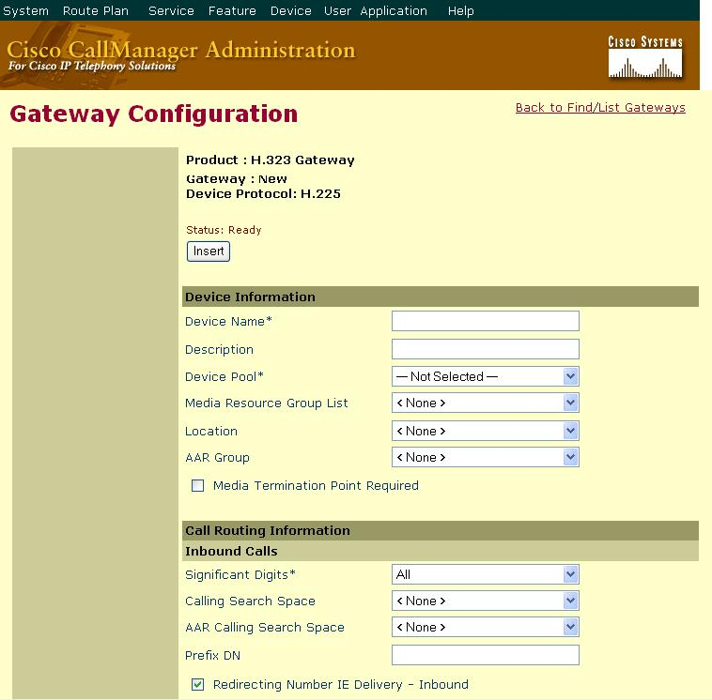
Figure 7: H.323 Gateway Configuration part A

Calling Party Selection: Choose “Originator”.

Calling Party Presentation: Choose “Default”.

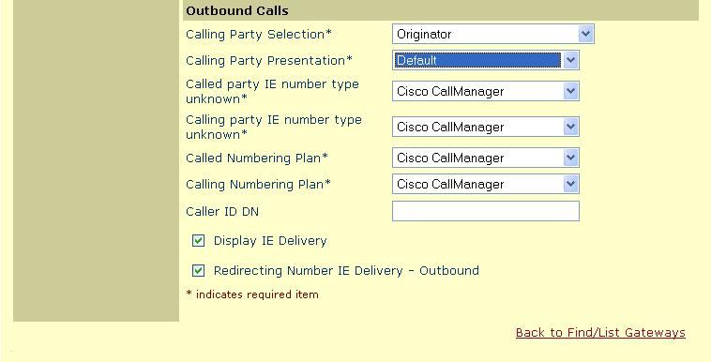
Figure 8: H.323 Gateway Configuration part B

TAPI Configuration
To add a CTI Port follow the same steps outlined in the H.323 Phone Device configuration section except make sure the type of device is “CTI Port”. The configuration is very much the same except “Device Name” does not have to be the IP address of the MCE.

Once the CTI Port devices have been added, associate a user with CTI privileges with the CTI Ports. This user must be the same user that the TAPI Service Provider running on the MCE is using to communicate with CallManager™.

DeviceListX Configuration
To configure the DeviceListX capability of the MCE the settings for the CiscoDeviceListX provider must be updated to reflect your deployment. Primarily, the provider needs to know where the CallManager™ is and what the administrative password is to download the DeviceListX report.

- Login to the MCE Web Management Console
Using a web browser, navigate to the MCE Management Console’s website. Typically, this website is installed on the same machine as the Metreos Application Server and is found at the following URL:
http://mceIpAddress/mceadmin

Note: The Metreos Application Server must be running to access the management console.

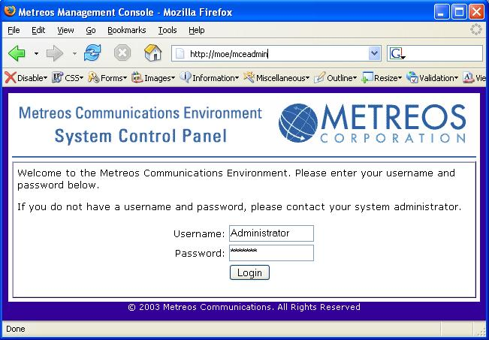
Figure 9: MCE Web Management Console Login Screen

- Navigate to Provider Configuration
Select “Providers” from the main control panel screen.

- Select CiscoDeviceListX
Click the “Configure” link next to CiscoDeviceListX. This will bring up the CiscoDeviceListX provider configuration screen.

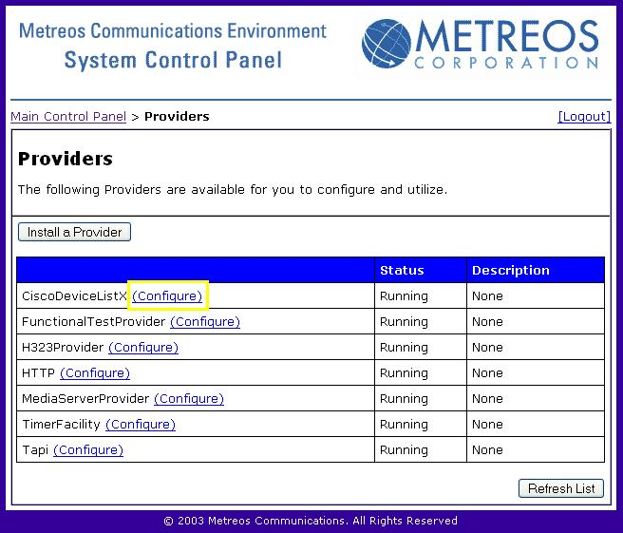
Figure 10: MCE Provider Listing

- Modify the CiscoDeviceListX Provider Settings
URL: Update the URL setting to point to your CallManager™. The default setting is:
http://callmanager/ccmadmin/reports/devicelistx.asp

To update this to reflect your deployment, change the “callmanager” component to the IP address or machine name of your primary CallManager™ subscriber.

Username: Should be “Administrator”.

Password: Enter your CallManager™ administrative password in this field. Cisco requires administrative privileges to download the DeviceListX report.

PollInterval: To modify how often the DeviceListX provider will poll CallManager™ for updated information change this value. This value is in minutes. Note: CallManager™ only allows 1 request per minute to be served by their DeviceListX interface. Settings lower than 5 minutes are not recommended.

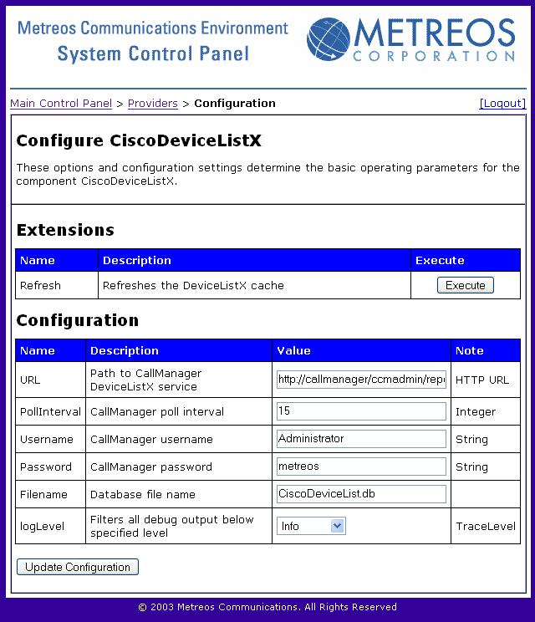
Figure 11: CiscoDeviceListX Provider Configuration

IP Phone Service Configuration
Configuration of Cisco IP Phone Services must be done on a service by service basis. Currently, there is no way for the MCE to provide the CallManager™ with a list of services currently installed on the MCE for display on IP phones. Setting up a Cisco IP Phone Service on the CallManager™ that executes on the MCE is the same as setting up any other IP Phone Service.

Note: An IP Phone Service must be added each time an application is deployed on the MCE if that application wishes to use the Cisco IP Phone as its user interface. Typically, this will be known at design time of the application so the deployment may be properly planned.

- Add a New Service
From CallManager’s administration screen select “Feature->Cisco IP Phone Services”. When the “Find and List IP Phone Services” screen appears, select “Add a New IP Phone Service”. Figure 12 shows the screen that will appear with sample values inserted into the relevant fields.

Service Name: This value may be anything and represents what will be displayed on the Cisco IP phone’s services menu.

Service Description: This value may be anything.

Service URL: This value must be a valid URL and must point to the MCE. The example provided has a URL of http://mceIpAddress:8000/applicationServiceUrl. The “:8000” is required because that is the port on which the MCE’s HTTP interface is listening for incoming requests. The “applicationServiceUrl” must be a valid URL on which an application installed on the MCE is waiting for triggering events. This URL is likely set at design time when the application is built, but may also be configurable depending on whether the application developer has chosen to do so.

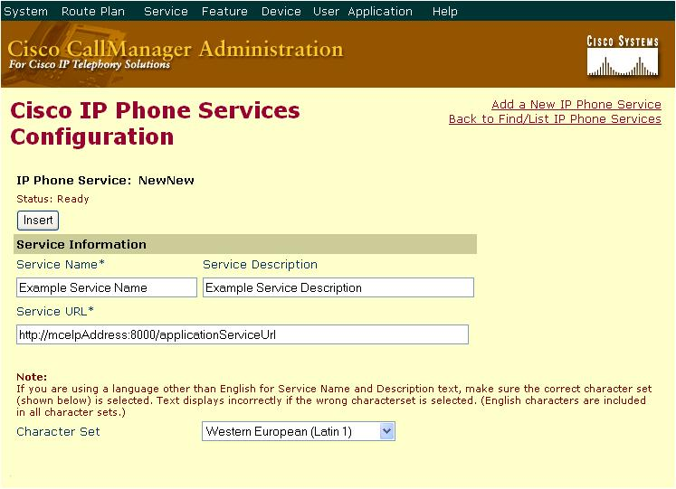
Figure 12: Insert an IP Phone Service

- Subscribe Phones to the Service
Once the IP Phone Service has been added the last step is to subscribe phones to the service. This is done in the same way as any other Cisco IP Phone Service.

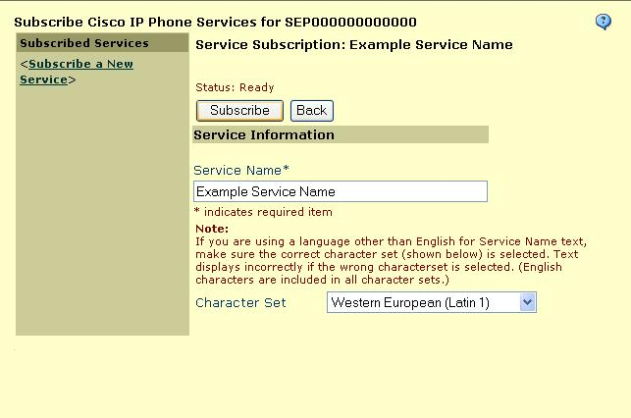

Using the MCE System Control Panel

Accessing the Control Panel

The MCE System Control Panel (SCP) resides as a web application on the server, as described in the section entitled System Control Panel on page 7. To access this site, visit the URL http://servername/mceadmin, where servername is the name of the machine hosting the System Control Panel. You may optionally enter the IP address of the server instead.

A default administrator user named Administrator with password metreos, comes preprogrammed into your installation of the Metreos Communications Environment. Enter this username and password, and click the “Login” button to access the System Control Panel.

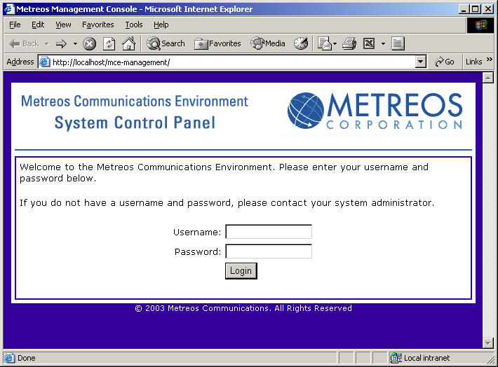
Figure 13: System Control Panel Login Screen

Note: You should change the password for the Administrator immediately to prevent possible security breaches. More information regarding user management appears in the next section, Managing Users.

Main Control Panel

The Main Control Panel serves as the primary dashboard for managing the entire Metreos Communications Environment. It provides general information regarding system status, options for component configuration, and controls for user management.

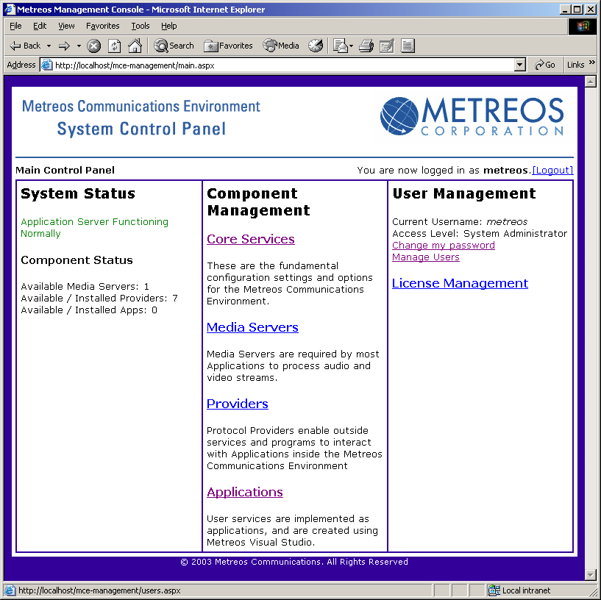
Figure 14: System Control Panel Login Screen

System Status

The first section of the Main Control Panel, located at the far left side of the browser window, indicates the status of the Metreos Application Server. Typically, this will read Application Server Functioning Normally. If any problems occur within the MAS, or, if the server load exceeds expected parameters, this message will change accordingly.

Component Status

Below the system status, the Main Control Panel presents a few basic statistics regarding available Media Servers, Protocol Providers, and Applications. This information serves as a handy indicator for components within Metreos Communications Environment.

Component Management

The center section of the Main Control Panel provides links to the Core Services, Media Servers, Providers, and Applications configuration. Management of these components occurs exclusively through these subsystems.

User Management

The final section of the Main Control Panel indicates the current user, access level, and provides the option to change your password. If the current user possesses sufficient administrative rights, they may also manage the user from this section

Managing Users

Overview

Like any secure system accessible by multiple different people, the MCE features a simple account management interface. Administrators can create any number of user accounts for their MCE installation, each with a unique username and password. These usernames should be provided to individuals, based on their needs.

Note that the MCE authentication and access control system is wholly independent of other systems, such as those identities provided via Microsoft Windows ™ or Cisco CallManager ™. The temptation may be to use identical usernames and passwords from other systems to create access control for the Metreos Communications Environment. This is inadvisable. See Appendix B: Security Considerations for more information.

Types of Users

The MCE Control Panel defines four types of users, each with different capabilities in the system:

- Administrators – These users have full control over the system, and can create additional users of any type. Because administrators have full access, Metreos recommends minimizing the number of administrator users.

- Power Users – Power users have the ability to modify any system parameter, but they can only create user accounts that are Normal or Restricted. This prevents Power Users from creating other Power Users. This account is primarily intended for developers.

- Normal Users – The vast majority of those users with access to the system will be Normal Users. These users do not have the power to create other accounts, nor modify and of the Core Services configuration parameters.

- Restricted Users– These users have no control over the system, but may view the values of any variables. For example, custom monitoring tools should be configured to use a restricted user account so they do not create a potential security risk.

User Management Subsystem

To access the user management subsystem, log in to the System Control Panel and click on Manage Users. Note that this option is only available to users at the Administrator and Power User level.
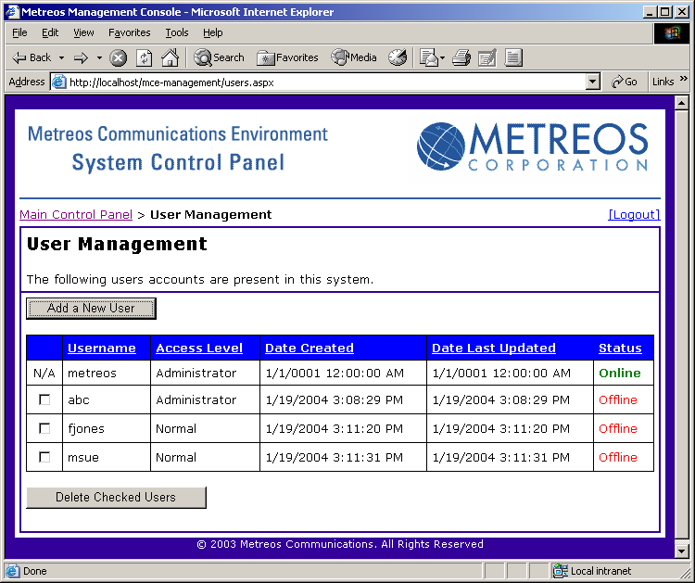
Figure 15: User Management Subsystem

This panel displays all the user accounts within the MCE, and lists their access level, date of creation, date of last update, and their current status. You may sort the list by any of the columns by clicking on the column header. This action also reloads the list to reflect any changes.

Creating New Users

A button entitled Add a New User rests above the grid of user account information. Click this button to visit the “Add a User” screen.

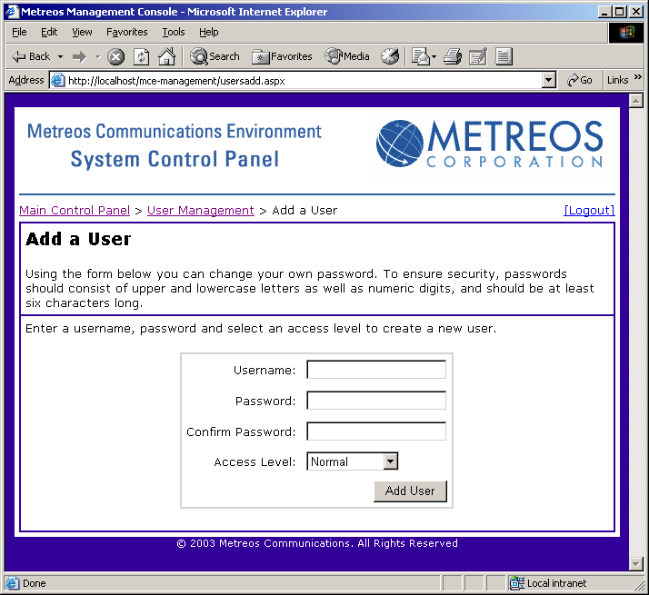
Figure 16: Add a User Screen
To create a new user account, simply complete the forms on this screen. Be certain to enter identical passwords under the Password and Confirm Password boxes. Finally, select an access level using the drop down menu. Click the Add User button to create this new user account.

The System Control Panel requires that usernames be unique, and will inform you if you have entered a username already in use. Although not enforced by the system, you are heavily encouraged to use a strong password. For more information, see Appendix B: Security Considerations.

Deleting Existing Users

On the main User Management subsystem screen (Figure 15), an additional button entitled “Delete Checked Users” appears near the bottom of the page. To remove any number of user accounts, click on the corresponding checkboxes and depress this button. Warning: deleting user accounts is permanent. If you make a mistake, however, you can easily recreate any deleted accounts using the techniques described in the section above, Creating New Users.

Note: You cannot delete yourself from the system. If you want to delete a particular account, you must login as using a different account with adequate privileges. This prevents accidental deletion of the master account, and ensures that the system will always have at least one available user.

Changing Your Password

Users may change their passwords at any time. To reach the Change Password screen, click on the link entitled Change my password.

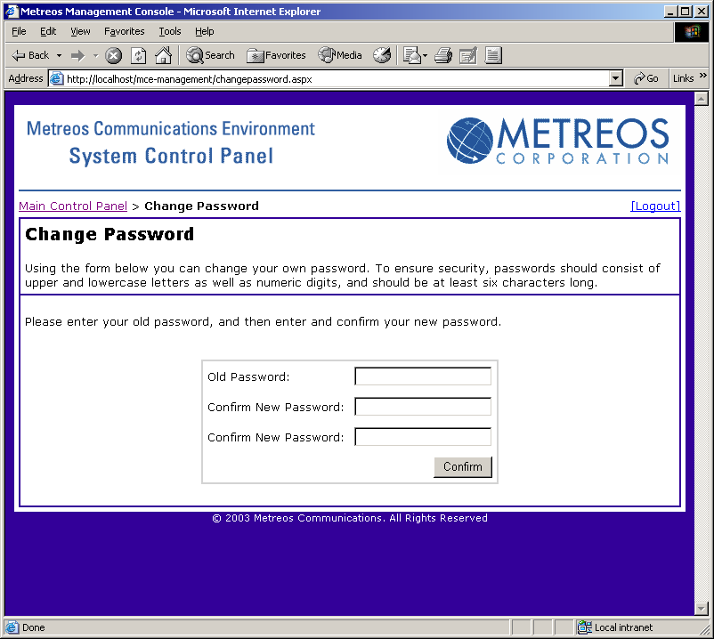
Figure 17: Change Password Screen

Enter your old password, followed by the new password, and finally confirm your new password. Then, click the Confirm button to initiate the change.

Users should change their own passwords on a recurring basis, as defined by your organizations security policy. For more information, see Appendix B: Security Considerations.

Configuration Settings

Hundreds of internal settings permeate the Metreos Communications Environment, and the System Control Panel permits users to control their values. These range from timeout periods to logging levels to filenames. The system divides configuration settings into four main categories: Core Services, Media Servers, Providers, and Applications. Under each of these sections, configuration settings appear by subcomponent, and then alphabetically.

Making Configuration Changes

To modify an individual setting, simply visit the corresponding page, modify the value, and click the Update Configuration button. Configuration changes on a running system take effect immediately. Therefore, Metreos recommends making only a few configuration changes at once, and confirming the system still behaves as expected. This technique applies to any complex system like the Metreos Communications Environment.

Because the SCP supports multiple simultaneous users, several individuals may enact configuration changes simultaneously. If a conflict occurs, the last setting made will take effect. Users may always load the latest configuration using the “Refresh” button on their browser.

Types of Configuration Settings

Due to the large number of configuration settings, each setting possesses one of several distinct data types. These include:

- Integer – Whole number values, which can be either positive, negative or zero.

- Boolean – Values which indicate either a True (Yes) or False (No) value

- String – Text values, used to indicate display information, directory paths, URLs or other names

- TraceLevel -- Indicates a logging level of the component, with the following possible values:

Off | No logging
Error | Only logs errors.
Warning | Logs warnings and errors.
Info | Logs informative status messages, warnings, and errors.
Verbose | Highest setting; all messages logged

- String Collections – List of any number of strings associated with one configuration value. Users may create additional strings by clicking the associated Add Field button, and delete strings by erasing their values.

- Hash Tables – List of any number of name/value pairs associated with one configuration value. Each name and value is stored as a string. Users may create additional name/value pairs by clicking the associated Add Fields button, and delete pairs by erasing their values.

The data type of each configuration value determines the category of permissible values. Integer, String, String Collection and Hash Tables appear as text boxes. TraceLevel renders as a dropdown box. A pair of radio buttons indicate Boolean values. After updating any configuration value, click the Update Configuration button near the bottom of the window to confirm your changes.

Configuration Setting Restrictions

To ensure entry of only valid data into the MCE, many of the configuration settings include restrictions on range, size, and format types. These requirements vary by configuration setting type as described below:

- Minimum Value -- Settings which require a minimum numerical value indicate such in the Note column. The System Control Panel will not permit entry of values smaller than this value.

- Maximum Value -- Settings which require a maximum numerical value indicate such in the Note column. The System Control Panel will not permit entry of values larger than this value.

- Range -- Settings which require numerical values fall within a specified range indicate such in the Note column. The System Control Panel will not permit entry of values outside this range.

System Logs

The Metreos Communications Environment System Logs provide an extensive and powerful tool for supporting development efforts and debugging applications within the Metreos platform. Using the System Control Panel, Administrators can control the size and level of detail of these logs.

Log Information

Data in the system logs serves as diagnostic information. As the system runs, subtle changes, along with continuous infrastructure updates, appear in the logs. If you need to ensure a user action causes the intended effect, or you wish to diagnose performance or behavior issues, consult the appropriate logs.

Log Access

If file logging is enabled, the log files appear in the Logs folder located under the C:\Metreos\AppServer and C:\Metreos\MediaServer directories respectively.

Core Services Configuration

The Core Services configuration page of the System Control Panel permits Administrator to manage fundamental system settings.

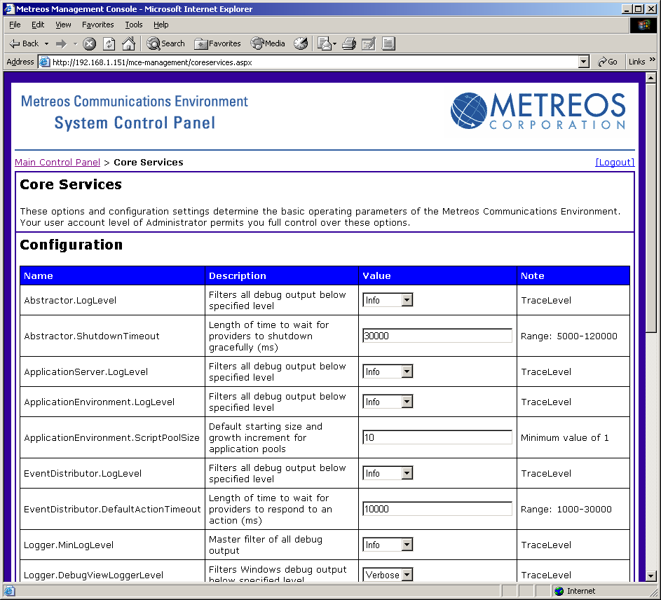
Figure 18: Core Services Control Panel

Each configuration value belongs to a component of the Metreos Application Server. The component name appears before the period character in the Name column. For example, the configuration value Abstractor.LogLevel pertains to the Abstractor component. Each part provides a distinct contribution to the Metreos Application Server:

- Abstractor – Controls the loading and administration of protocol providers.

- Application Server – Global configuration parameters for the entire Metreos Application Server

- Application Environment – Configuration settings for the Metreos virtual machine for application scripts.

- Event Distributor – Component managing the routing of events and actions to and from protocol providers.

- Logger – Controls the logging subsystem, which manages all debug logs.

- OAM – The Operations and Management component. Enables the System Control Panel.

- Session Manager – Handles installation, uninstallation, loading and unloading of applications.

- Task – Internal component. Do not change unless instructed by technical support.

Application Management and Configuration

The Metreos Communications Environment enables straightforward deployment and management of telephony applications through the System Control Panel. For more information on developing applications, see the document Metreos Communications Environment: Application Developer’s Guide.

Metreos Communications Archives

Telephony applications for the MCE exist in a single archive file, with the extension .MCA. The Metreos Visual Designer produces this file, enabling easy sharing of applications within a development community. Additionally, you may download MCA files at www.metreos.com to learn more about the capabilities of the Metreos platform.

Application Management Panel

To manage applications, simply click on the Applications link from the main System Control Panel interface. The SCP presents a list of all applications currently installed on the Metreos Application Server, with the application name, status and description, as well as various options. To retrieve the latest version of this list, use the Refresh List button near the bottom right corner of the screen.
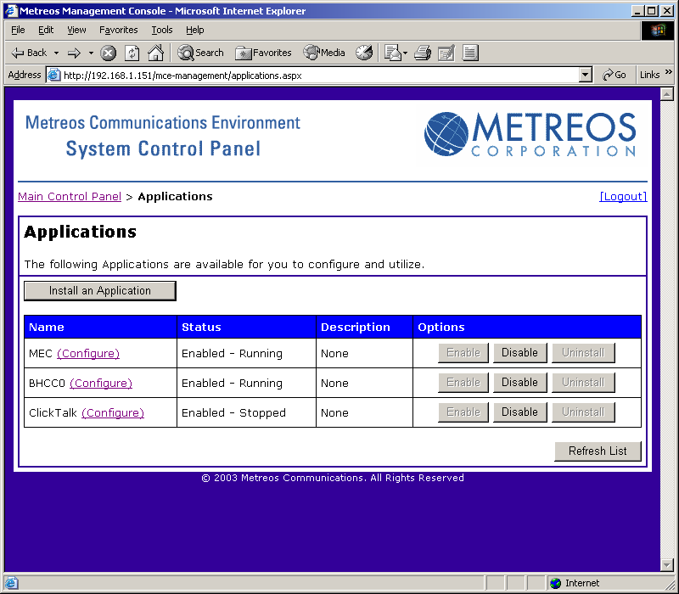
Figure 19: Application Management

Application Names and Descriptions

Before deployment, developers must assign a name and may optionally add a description to every application. These fields appear on the Application pane of the System Control Panel. The MAS does not require unique names; however, developers should consider using the description field to clarify the application name and purpose. Furthermore, if developers update applications with additional features, but administrators or users need access to multiple versions of the same application, the description field will provide considerable benefit in aiding management and reducing confusion.

Application Status Codes

The status column describes the current condition of an installed application. The MAS defines four status codes:

- Enabled–Running – Application available, and currently executing. Disabling the application may affect users.

- Enabled–Stopped – Application available, but not currently in use. Disabling this application should not affect users.

- Disabled – This application is dormant. The administrator may safely uninstall it.

- Error – An error has occurred, or the application crashed. The administrator may remove the application at any time.

Note: Due to the robust design of the Metreos Application Server, applications with a status code of Error will not affect the data or operation of other applications. Stale applications do occupy memory, so administrators should remove malfunctioning programs promptly.

Installing New Applications

The System Control Panel enables administrators to install applications using Metreos Communications Archives (.MCA files). On the Application control panel, click the button entitled Install Application.

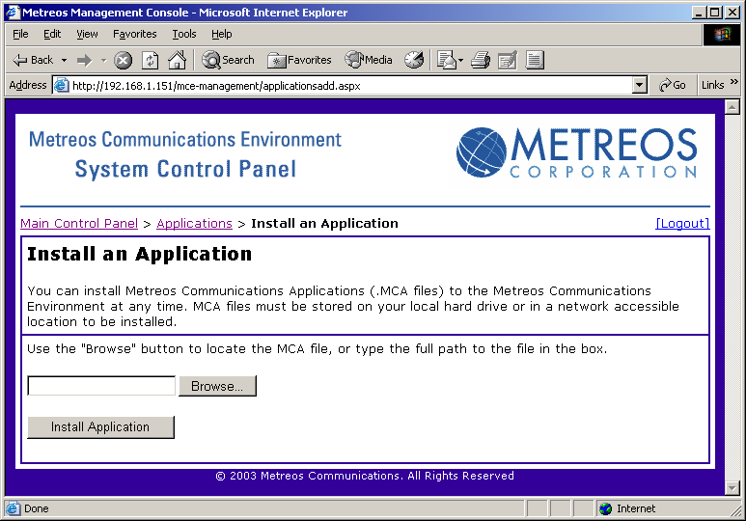
Figure 20: Installing an Application

Use the Browse… button and navigate your file system to select the .MCA file to upload. Then, click the Install Application button. After a short delay, you will return to the main application management panel.

As applications install, they pass through the Disabled state, to the Enabled – Stopped state and finally reach the Enabled – Running state. However, most applications reach this stage so quickly administrators will not often see this transition on the control panel.

Developers may also install applications directly to the MAS using the Metreos Visual Designer. However, you may wish to restrict this access so only administrators may install applications using the System Control Panel. This might be advisable in an environment with development, staging, and/or production installations of the MCE.

Enabling and Disabling Applications

To enable or disable an application, simply click the Enable or Disable button. The System Control Panel only permits you to choose sensible options. Depending on the size and complexity of the application, you may need to use the Refresh List button to view the change in status code.

Uninstalling Applications

If an application crashes, or becomes obsolete, an administrator may uninstall it. First, however, the application must be disabled. Then, click the Uninstall button to remove the application. Uninstalling an application frees system resources and, if the application malfunctioned, helps ensure maximum performance.

Application Configuration

Developers cannot anticipate the particular use of an application, especially if applications will be deployed in multiple organizations or locales. Furthermore, variations in local infrastructure and policy may dictate necessary changes in application operation. The Metreos Communication Environment supports configuration values for applications, which behave similarly to MAS Configuration settings. Application configuration automatically persists even after a MCE restart or a system restart. However, configuration values will be lost if an application is uninstalled.

Changes to application configuration take effect instantly. Therefore, you may want to disable an application before any configuration modifications. Furthermore, if you modify a configuration setting, it may have unintended effects on applications in progress. For example, if an application uses configuration data to cache information, later components of the application may become out of sync.

Provider Management and Configuration

The Metreos Communications Environment supports interconnectivity between the Metreos Application Server and third-party services with Protocol Providers. These components provide applications with the ability to control external systems and respond to external events. The MCE includes a number of providers with installation, and developers can produce additional providers. For more information on provider development, see Metreos Communications Environment: Advanced Developer’s Guide.

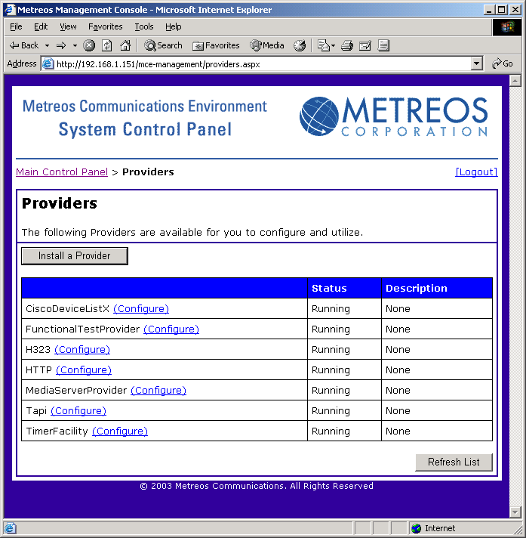
Figure 21: Provider Management

Provider Configuration

Since most providers connect to a specific third-party service, they require some configuration to ensure proper operation. Provider configuration functions similarly to application configuration and core services configuration, but includes a special option called Extensions. Some providers expose particular operations that can be enacted through the Management Console.

For example, the CiscoDeviceListX provider caches the list of devices presented by Cisco CallManager ™ through the DeviceListX.asp interface. However, if a change in CallManager updates the device list, you may want to force a refresh instead of waiting for the cache to expire and automatically refresh.

Note: Configuration changes persist even if you restart the Metreos Application Server or reboot the machine. However, you may want to note provider configuration settings if you are duplicating a deployment elsewhere.

Metreos anticipates heavy development in this area, and plans to release additional provider features in the near future.

Media Server Management

The Metreos Media Server provides powerful media management capabilities. This section is of particular importance for installations involving multiple media servers.

Adding and Removing Media Servers

Additional media servers act as a cluster to provide additional media processing capacity for large deployments. The MCE currently supports up to eight Media Servers per application server.

Media Server Configuration

The Metreos Media Server provides powerful media management using an entirely software solution. The configuration of the MCE Appliance includes a standardized setup for the MMS; therefore the need for configuration changes will be minimal. However, if you need to modify the behavior of the MMS, refer to the file C:\Metreos\MediaServer\mmsconfig.properties.

Technical Support

Contact Support

For support information, visit www.metreos.com.

Appendix A: Glossary of Terms

Action
Messages sent from applications to providers, instructing the provider to carry out a specified task. Also see event.

Application
A piece of telephony software integrating voice, data and possibly other services

Application Pool
Component of the Application Server that retains application code in preparation for execution by the Virtual Machine.

Application Assembler
Component of the Application Server which unpacks MCA files

Application Server
Short for Metreos Application Server

Application State
A term describing the overall status of an application. Applications states can be any of the following: Enabled – Running, Enabled – Stopped, Disabled, or Error.

CallManager ™
Cisco Systems ™ software management platform for IP telephony solutions

Core Engine
Component of the Application Server which manages all other elements and permits inter-component communication.

DTMF
Acronym for Dual Tone Multiple Frequency. A telephone industry standard for encoding touch tone digits using pairs of frequencies.

Enabled
A generic term for normally functioning applications residing within the Metreos Application Server. See Enabled – Stopped and Enabled – Running for specific states.

Enabled – Running
An application state meaning the application was successfully installed and is now executing.

Enabled – Stopped
An application state meaning the application is currently installing, and is not yet ready for use. Applications in this state move quickly to either the Enabled – Running or Error states.

Error
An application state meaning there was a problem in application installation or execution. Applications with this state should be removed by a system administrator and diagnosed before further use.

Event
Messages sent from providers to applications, instructing the application to complete a particular task. See also action.

H.323
An ITU (International Telecommunication Union) standard for VoIP call control.

HTTP
Hypertext Transfer Protocol, the networking standard used to enable communication between users and webservers.
OAM
Operations and Maintenance. A component of the Metreos Application Server which enables control via the System Control Panel or the Metreos Visual Designer.

MCA
Metreos Communications Archive file format, or “.mca”. File produced by the Metreos Visual Designer containing a single package of all necessary code and data for an application. May be uploaded directly to an Application Server through either the MVD or SCP.

MCE
Acronym for Metreos Communications Environment

Media Server
See Metreos Media Server

Metreos Application Server
One of four components in the Metreos Communications Environment. Manages entire MCE platform and executes telephony applications.

Metreos Media Server
One of four components in the Metreos Communications Environment. Enables mixing, recording, playback and management of audio data

Protocol Provider
Software component of the Metreos Application Server that enables communication with external resources and third-party services.

Provider
See Protocol Provider

Provider Framework
Component of the Application Server which manages and communicates with Protocol Providers.

RTP
Real Time Protocol

SCP
See System Control Panel.

System Control Panel
Web-based front-end for managing and configuring the Metreos Communications Environment.

TCP/IP
Transport Control Protocol / Internet Protocol. The fundamental networking standard used to facilitate communication on the Internet and in most private networks.

Virtual Machine
Component of the Application Server which executes application instances, enabling them to communicate with one another, other components of the Application Server, and protocol providers.

Appendix B: Security Considerations

Security continues to grow as a key priority for organizations in every market. Using the Metreos Communications Environment securely requires both common sense and a keen understanding of typical security pitfalls. This section outlines a few major security considerations with which any system or network administrator should be familiar.

Account Naming

Creating user accounts requires appropriate selection of usernames. Some organizations require that all usernames refer to a distinct individual as the account owner. This practice is appropriate if your organization needs to maintain accountability. Metreos recommends naming user accounts suck that they are easily traceable back to the individual account user.

Strong Passwords

Users often create simple passwords like “password” or “1234”. These passwords create significant security holes, as potential attackers can easily guess such commonly used passwords. Confirm that all passwords created for the Metreos Communications Environment (including SCP passwords and Microsoft Windows ™ passwords) meet your organization’s requirements.

Unique Passwords

Due to the proliferation of authentication systems, users often opt to use identical passwords on multiple systems. This practice should be avoided because if an attacker compromises one system, they may access any number of other systems using the same password.

Password Transport and Storage

The Metreos Communications Environment respects the security of passwords, and thus provides no way to retrieve password data. The MCE encrypts the contents of every password using a secure encryption algorithm. Passwords entered via the Metreos Visual Designer are encrypted before transport. However, due to the nature of web browsers, transport of the password from the user’s web browser to the system control panel is completed in plain-text. For this reason, we strongly encourage you to only permit access to the System Control Panel from inside your organization’s internal network.

This release of the Metreos Communications Environment supports up to eight Media Servers per Application Server.
A .vox file is a simple binary encoding of an audio stream using Adaptive Differential Pulse Code Modulation, and is commonly used in IP telephony.

