Metreos Communications Environment
Integration into Cisco CallManager™

MCE Version 1.0

Last Updated: August 4, 2004

Table of Contents
Overview 2
Integration Modes 2
Call Control 2
TAPI 2
DeviceListX 2
IP Phone Services 3
Call Control Configuration 3
H.323 Phone Device Configuration (CallManager™ 3.2(2c) and later) 3
H.323 Gateway Device Configuration (CallManager™ 4.0 and later) 6
TAPI Configuration 8
DeviceListX Configuration 8
IP Phone Service Configuration 10

Proprietary and Confidential
For Release under NDA Only
Copyright© 2004 Metreos Corporation
All Rights Reserved.
Overview
This document details the configuration required to integrate the Metreos Communications Environment with Cisco CallManager™.

Integration Modes
The MCE integrates with Cisco CallManager™ using a variety of interfaces and APIs. The following is an explanation of the various integrations available and their usage scenarios.

Call Control
The majority of applications built using the MCE will utilize some type of 1st party call control. They will either make calls or receive calls using the automated voice processing capabilities of the media server to communicate with the user and retrieve input.

Version 1.0 of the MCE uses the H.323 protocol for call control communication with the MCE. CallManager™ is configured with an H.323 device that points to the MCE. Depending on the version, this can be either a phone or a gateway.

TAPI
The Telephony API exposed by CallManager™ can be used by applications running within the MCE to monitor device status and receive events when device status changes. For example, if someone wished to build an application that displayed information on the IP phone when someone called, TAPI could be used to accomplish this.

Version 1.0 of the MCE does not support using TAPI as a 1st party call control interface. A future release of the MCE will provide this feature. With version 1.0, any 3rd party capability, device monitoring, or device routing feature can be utilized. Integration with CallManager™ is similar to any other JTAPI/TAPI configuration involving adding either CTI ports or route points and associating those with users on the CallManager™.

DeviceListX
The DeviceListX API enables real-time reporting of device status, IP address, and other information that can be utilized by applications when delivering services to IP phones. On a periodic basis the MCE retrieves the DeviceListX report from CallManager™, parses and validates it, and then stores it locally as a cached copy. Applications running within the MCE can then query this report for information about devices on the CallManager™ cluster.

A common scenario where the information from DeviceListX is used by an application would be one in which the IP address of the telephone device needs to be determined. For example, in the Metreos Click-to-Talk application, the user needs only to provide their username and password on CallManager™. The application can then use LDAP and the MCE’s DeviceListX interface to determine the IP address of the user’s IP telephone. Enabling the DeviceListX report feature on the MCE only requires configuration on the MCE itself. No configuration on the CallManager™ is required.

IP Phone Services
Cisco IP Phone Services must be configured as normal for all services deployed within the MCE. Typical configuration of an IP phone service includes giving the service a name and pointing the service URL to the IP address and port of the MCE’s HTTP interface. The service URL should resemble the following:
http://mce-machine-name:8000/someServiceUrl

Call Control Configuration
As described earlier, the primary call control interface used by the MCE is H.323. CallManager™ configuration for call control is different depending on the version of CallManager™ that is deployed in the network.

In CallManager™ version 3.3 and earlier, the MCE must be configured as an H.323 Phone Device.

In CallManager™ version 4.0 and later, the MCE may be configured either as an H.323 Phone Device or an H.323 Gateway Device.

The following steps will detail how to configure both types of devices:

H.323 Phone Device Configuration (CallManager™ 3.2(2c) and later)
- Login to the CallManager™ web management console

- Select “Device->Add New Device”

- For “Device Type” select “Phone” and click “Next”

- For “Phone Type” select “H.323 Client” and click “Next”

- Enter the Configuration Values for the H.323 Phone Device
DeviceName: This configuration value must be set to the IP address of the MCE.

Description: This can be any value.

Device Pool: This setting is dependent on the particular CallManager™ deployment. An H.323 device will be treated in the same way as any other phone device (7960, etc). Placing the MCE into a device pool will affect how CallManager™ switches inbound and outbound calls to and from the MCE; however, this effect will be exactly the same as any other phone device in the pool.

All other values may be left as their default. You may set a Calling Search Space for the MCE. As with Device Pool, this will affect the MCE in the same way as it would affect any other phone.

Note: Do not configure the MCE’s H.323 Phone Device to require a Media Termination Point and do not add a Media Resource Group List to the MCE’s H.323 Phone Device. The MCE is processing media for its calls directly and does not require any media processing resources from the CallManager.

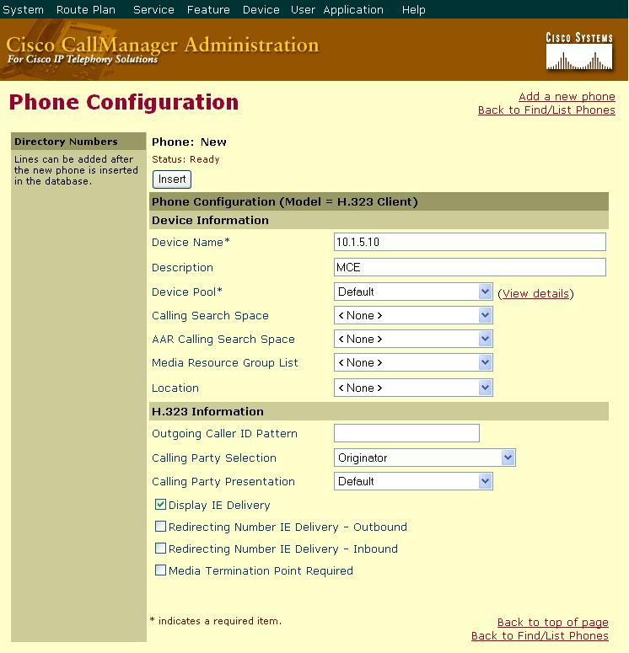
Figure 1: H.323 Phone Device Configuration

- Add a New Line to the H.323 Phone Device
DirectoryNumber: The directory number to assign to the line.

Forward Busy: Enter the directory number to forward calls to when this line is busy. Typically this directory number is another directory number that points to the MCE.

Forward No Answer: Same as Forward Busy.

All other values may remain as their default setting.

Note: You may configure the H.323 Line on this device to be within a particular partition within CallManager™. Doing this will have the same effect on the MCE’s H.323 Device as it would on a normal Cisco IP Phone.
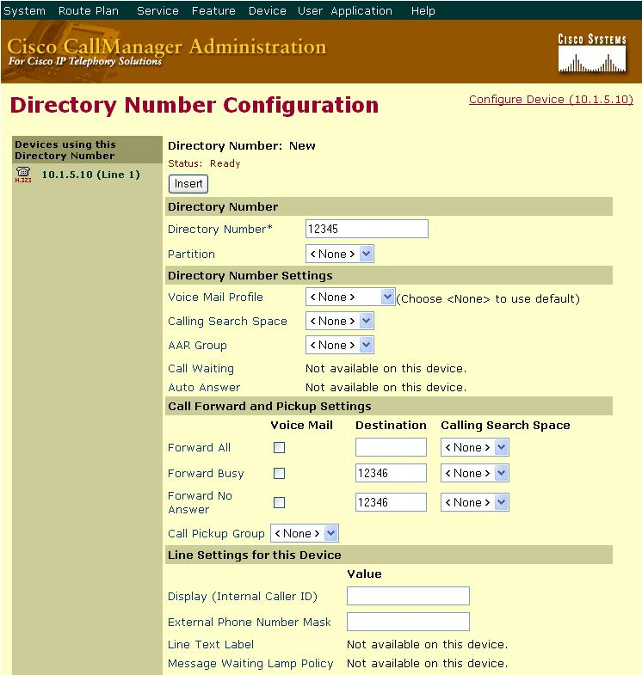
Figure 2: H.323 Phone Device Line Configuration

Repeat this step to add as many lines to the MCE’s H.323 device as required.

- Reset the H.323 Phone Device
After the configuration is complete and lines have been added to the phone device, click “Reset Phone” and then click “Reset”. After the phone resets click “Reset Phone” and then click “Restart”. This step should be done after any configuration change to the MCE’s H.323 Device.

H.323 Gateway Device Configuration (CallManager™ 4.0 and later)
Configuring the MCE as a gateway has the benefit of not requiring individual line configuration on an H.323 Phone Device. The downside is that the system administrator can not use the CallManager™ for concurrent call throttling.

- Login to the CallManager™ web management console

- Select “Device->Add New Device”

- For “Device Type” select “Gateway” and click “Next”

- For “Gateway Type” select “H.323 Gateway”

- For “Device Protocol” select “H.225” and click “Next”

- Enter the Configuration Values for the H.323 Gateway
DeviceName: This configuration value must be set to the IP address of the MCE.

Description: This can be any value.

Device Pool: This setting is dependent on the particular CallManager™ deployment. An H.323 device will be treated in the same way as any other phone or gateway device (7960, etc). Placing the MCE into a device pool will affect how CallManager™ switches inbound and outbound calls to and from the MCE; however, this effect will be exactly the same as any other phone or gateway device in the pool.

All other values may be left as their default. You may set a Calling Search Space for the MCE. As with Device Pool, this will affect the MCE in the same way as it would affect any other phone.

Note: Do not configure the MCE’s H.323 Gateway Device to require a Media Termination Point and do not add a Media Resource Group List to the MCE’s H.323 Gateway Device. The MCE is processing media for its calls directly and does not require any media processing resources from the CallManager.

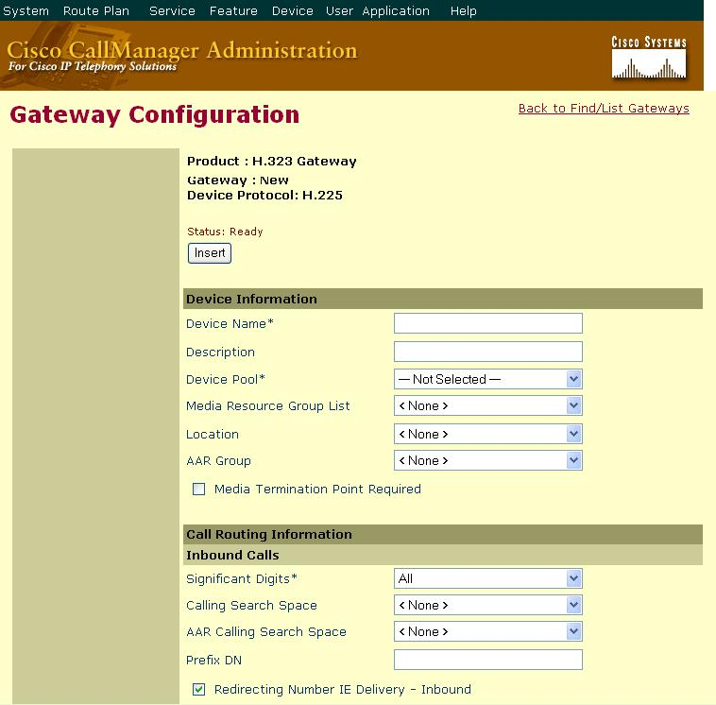
Figure 3: H.323 Gateway Configuration part A

Calling Party Selection: Choose “Originator”.

Calling Party Presentation: Choose “Default”.

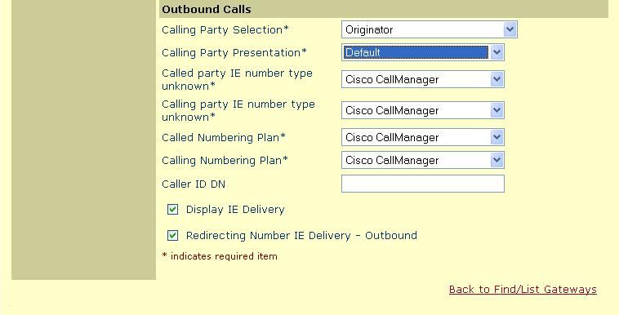
Figure 4: H.323 Gateway Configuration part B

TAPI Configuration
To add a CTI Port follow the same steps outlined in the H.323 Phone Device configuration section except make sure the type of device is “CTI Port”. The configuration is very much the same except “Device Name” does not have to be the IP address of the MCE.

Once the CTI Port devices have been added, associate a user with CTI privileges with the CTI Ports. This user must be the same user that the TAPI Service Provider running on the MCE is using to communicate with CallManager™.

DeviceListX Configuration
To configure the DeviceListX capability of the MCE the settings for the CiscoDeviceListX provider must be updated to reflect your deployment. Primarily, the provider needs to know where the CallManager™ is and what the administrative password is to download the DeviceListX report.

- Login to the MCE Web Management Console
Using a web browser, navigate to the MCE Management Console’s website. Typically, this website is installed on the same machine as the Metreos Application Server and is found at the following URL:
http://mceIpAddress/mceadmin

Note: The Metreos Application Server must be running to access the management console.

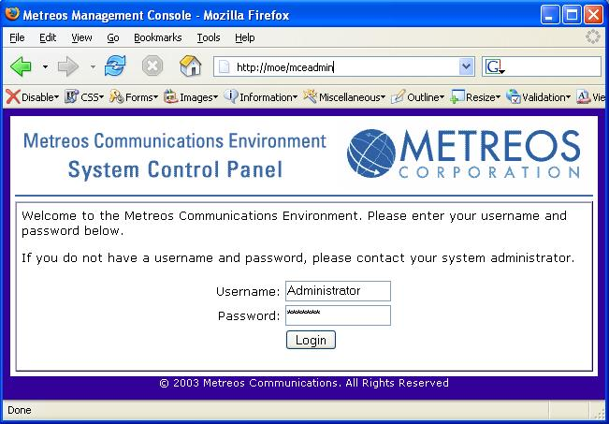
Figure 5: MCE Web Management Console Login Screen

- Navigate to Provider Configuration
Select “Providers” from the main control panel screen.

- Select CiscoDeviceListX
Click the “Configure” link next to CiscoDeviceListX. This will bring up the CiscoDeviceListX provider configuration screen.

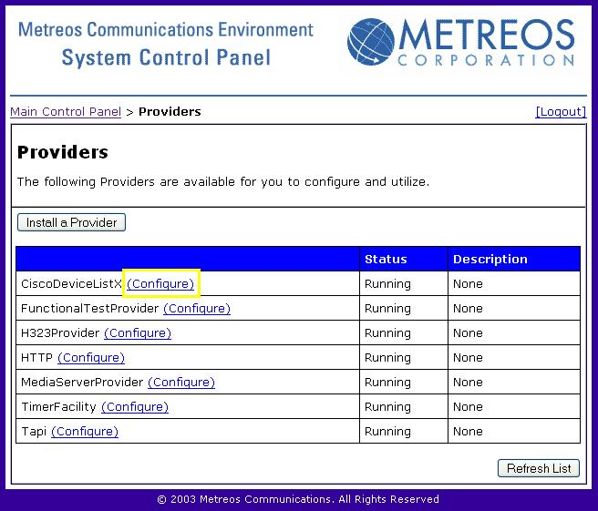
Figure 6: MCE Provider Listing

- Modify the CiscoDeviceListX Provider Settings
URL: Update the URL setting to point to your CallManager™. The default setting is:
http://callmanager/ccmadmin/reports/devicelistx.asp

To update this to reflect your deployment, change the “callmanager” component to the IP address or machine name of your primary CallManager™ subscriber.

Username: Should be “Administrator”.

Password: Enter your CallManager™ administrative password in this field. Cisco requires administrative privileges to download the DeviceListX report.

PollInterval: To modify how often the DeviceListX provider will poll CallManager™ for updated information change this value. This value is in minutes. Note: CallManager™ only allows 1 request per minute to be served by their DeviceListX interface. Settings lower than 5 minutes are not recommended.

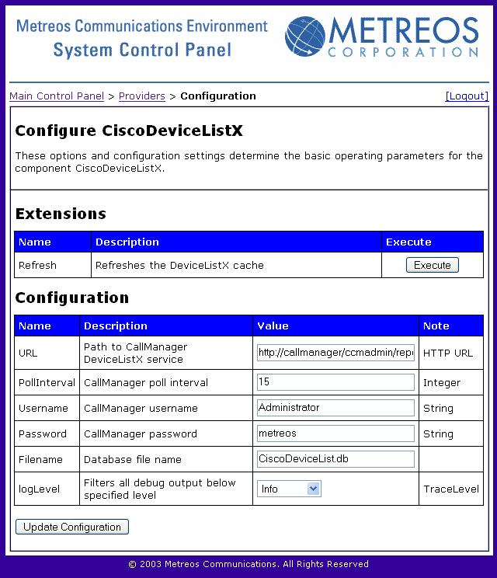
Figure 7: CiscoDeviceListX Provider Configuration

IP Phone Service Configuration
Configuration of Cisco IP Phone Services must be done on a service by service basis. Currently, there is no way for the MCE to provide the CallManager™ with a list of services currently installed on the MCE for display on IP phones. Setting up a Cisco IP Phone Service on the CallManager™ that executes on the MCE is the same as setting up any other IP Phone Service.

Note: An IP Phone Service must be added each time an application is deployed on the MCE if that application wishes to use the Cisco IP Phone as its user interface. Typically, this will be known at design time of the application so the deployment may be properly planned.

- Add a New Service
From CallManager’s administration screen select “Feature->Cisco IP Phone Services”. When the “Find and List IP Phone Services” screen appears, select “Add a New IP Phone Service”. Figure 8 shows the screen that will appear with sample values inserted into the relevant fields.

Service Name: This value may be anything and represents what will be displayed on the Cisco IP phone’s services menu.

Service Description: This value may be anything.

Service URL: This value must be a valid URL and must point to the MCE. The example provided has a URL of http://mceIpAddress:8000/applicationServiceUrl. The “:8000” is required because that is the port on which the MCE’s HTTP interface is listening for incoming requests. The “applicationServiceUrl” must be a valid URL on which an application installed on the MCE is waiting for triggering events. This URL is likely set at design time when the application is built, but may also be configurable depending on whether the application developer has chosen to do so.

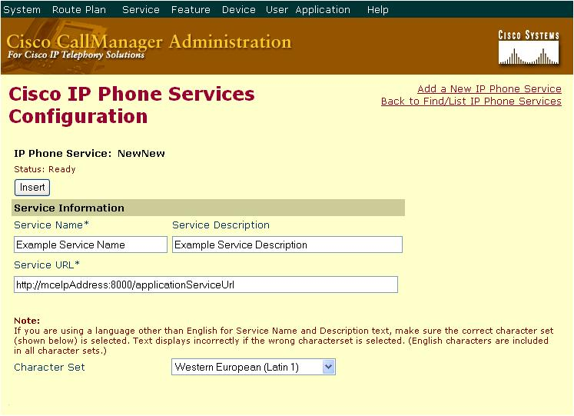
Figure 8: Insert an IP Phone Service

- Subscribe Phones to the Service
Once the IP Phone Service has been added the last step is to subscribe phones to the service. This is done in the same way as any other Cisco IP Phone Service.

