Audience
Those who have already been exposed with the interface of the Metreos Visual Designer, but are not yet familiar with the underlying concepts needed to begin making applications.

Purpose
To acclimate the new Metreos application developer with the core concepts of the Metreos Communications Environment and common design patterns, in order to facilitate the rapid development of IP telephony applications.

Document Conventions
Throughout the document we will identify the following elements beyond just the narration:
Core Concept
Tip
(D) Design Pattern
(!) Warning

Section 1: Making and Receiving Calls
At the core of the Metreos Communications Environment is the ability to make and receive IP calls. While it is important to know that the MCE can communicate using H.323, CTI, SCCP (and soon SIP), developing a script on the Metreos platform does not require an intimate understanding of the inner workings of these protocols. In fact, by using the Metreos CallControl API, it is possible to design a script which can leverage any and all of these protocols, without specifying any protocol-specific information at design time.

(C) The Metreos CallControl API abstracts IP telephony protocols into a simple, common interface.

Handling Incoming Calls
When a call is routed to the MCE as an incoming call, it is presented to the application layer as a triggering event, which will cause an application script to initiate. At that time, the script can choose to accept, answer, or reject the call. Most applications will need to answer a call, so let’s start there. Note: the HandleInboundCall script contained in the accompanying ReceivingCalls application is the end result of this section; however one can create this script by following along with the subsequent instructions.

A Metreos application, or project, can contain any number of scripts

To create a project, navigate to
File > New Project

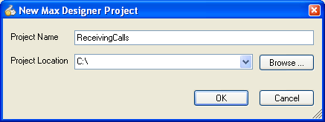
Figure 1: Creating a new project

Once a Metreos application has been created, a script must be added to the project which will handle an incoming call. Adding a script with a trigger event of type Metreos.CallControl.IncomingCall signifies to the developer that this script will initiate every time a call is received by the Metreos platform.

To add a script to the new project, navigate to
File > Add Script > New Script

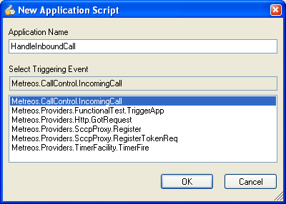
Figure 2: Creating a new script

Answering a Call
With the needed steps taken to prepare a script for development, we can focus on the act of answering an inbound call.

Every call made and received by the MCE is given a unique identifier. Every action and event in the Metreos CallControl API uses this identifier to delineate which call it should operate on.

The Metreos.CallControl.IncomingCall event specifies which call is being handled by passing the unique identifier for the call in the form of an event parameter named CallId.

Events in the Metreos development environment store information relevant to that specific event in event parameter fields.

To gain access to the value contained in the CallId event parameter, one must create a local variable in the function which handles the IncomingCall event, further specifying that the local variable should be initialized by the event parameter CallId.

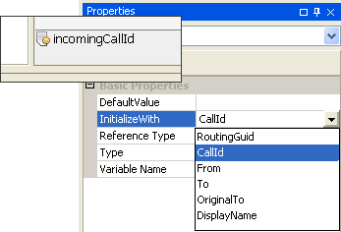
Figure 3: Initializng a variable with the CallId event parameter

With the CallId parameter accessible through a local variable, we can use the AnswerCall CallControl action to … answer the call!
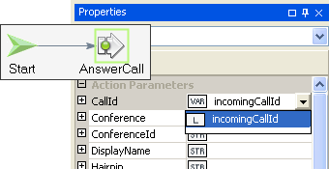
Figure 4: Answering a call

Unless the call is specified as P2P (not covered here), the MCE will automatically create a connection to a media server associated with this application. During this creation process, the transmit and receive audio streams associated with the call are synchronized with the media server connection. In other words, media being sent by this call is terminating to a media server, and the media server is sending media to the IP endpoint specified by the call. Once the AnswerCall action has completed, it is then possible to use any of the capabilities of this fully connected media server connection.

Every media server connection is given a unique identifier. Every action and event in the Metreos MediaControl API uses this identifier to delineate which media server connection it should operate on.

The AnswerCall action returns this media server connection as a result parameter, which can be stored in a variable.
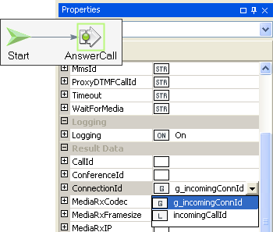
Figure 5: Storing connection ID

In this case we stored the variable in a global variable, so that all functions of this script can access the ConnectionId.

To touch upon the capabilities of the Metreos Media Server, let’s add a Play action after our AnswerCall action to stream some text-to-speech to the caller.

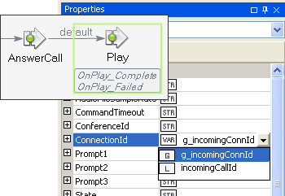
Figure 6: Preparing a Play action

In Figure 6: Preparing a Play actionFigure 6, a play command will be issued to the media server connection corresponding to the call just answered. However, to be useful, we will have to specify a text string for the media server to stream as TTS. The Play action allows one to specify up to three prompts, which can be a mixture of TTS strings and pre-recorded wave files. For this example, we will only need to provide a string value for Prompt1. In this case, we arbitrarily choose “Streaming audio is easy”.

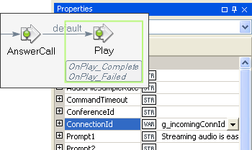
Figure 7: Specifying TTS

Because the play action can take a long time to complete, it is an asynchronous action, meaning the final response is treated as a separate event. In this example, this is obvious through the two new functions which appeared as soon as the Play action was placed on the canvas: OnPlay_Complete and OnPlay_Failed. When either one of those events fire, the developer can be assured that this play command has completed streaming the specified audio.

As an exercise, we could issue a Hangup once the Play completes, rounding out a complete example. Before we move on though, we should finish out in the OnIncomingCall function.

We need to end execution of this function such that control is relinquished so that other events can be handled by the script.

Only one event can be processed at a time for a given script.

In this case, this would be done by invoking EndFunction after the Play action.

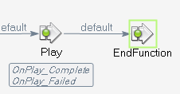
Figure 8: Placing the script into a wait state

We also need to store the incoming CallId in a global variable if we are to use it later in another function, such as OnPlay_Complete.

Going back to the AnswerCall action, we can leverage the CallId result parameter to provide an easy means of storing the CallId value passed in by incomingCallId to g_incomingCallId.
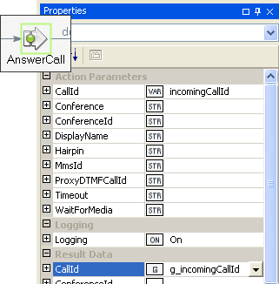
Figure 9: Storing CallId to a global variable

Some CallControl actions return CallId as a convenience, so that the input CallId can easily be stored to a global variable.

With that out of the way, let’s focus on hanging up the user once the play command has completed. By placing a Hangup action as the first node in the OnPlay_Complete function, and specifying the CallId by using the g_incomingCallId variable, the call will be hung up immediately after the play completes.

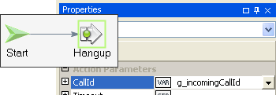
Figure 10: Hanging up the call

Once the call is hung up, there is nothing left for this script to do, and there are no further possible events that could keep execution going. Because script instances must be explicitly destroyed by the developer, an EndScript action should now be used.

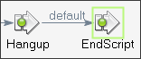
Figure 11: Ending the script

To simplify this example, duplicate what we have done so far in the OnPlay_Complete handler in the OnPlay_Failed handler: Hangup then EndScript.

The application in its present form can be built and deployed on the MCE. If you are new to this process, now would be a good time to deploy the application and test it.

Bridging the Media of Two Calls
The Metreos platform can has two distinct ways to bridge the media of two disparate calls.

- Media Conference: Place the media server connections for both calls in a conference.
- P2P: Bridge the media directly between the IP endpoints.

Each technique for bridging media has its tradeoffs.
Conferencing:
Pro:
- Powerful: once in a media conference, you can easily add more participants, record, play conference-wide announcements, control volume of the individual participants, and so on.
- When only two participants are in the conference, there is no media server conference resource capabilities used, which is a distinct component in the Metreos Media Server requiring additional licensing.
Con:
- Introduced latency of 70ms when hairpinning (2 parties in the conference), 170ms when not (more than 2 parties in the conference)
- Requires media port capabilities, which requires license purchase
- There is a slight delay in promoting to a media conference (growing the conference to more that 2 parties) ~100ms, resulting in a short time of no audio

P2P:
Pro:
- No introduced latency
- Switching to media conference requires that both participants have their media renegotiated, resulting in a significant audible disturbance
- No media server connections are used
Con:
- Only certain combinations of protocols support P2P

The key to knowing which type of media bridging to use is understanding what capabilities are used by your application, and how often those capabilities are used. For instance, if you are making an application which generally has three or more participants, it may make sense to never use P2P because of the audible disturbance.

The simplest type of media bridging to demonstrate is media conferencing. Using the script we created last time as a base, we can quickly add a second call to our script logic and bridge the two calls together. Note: the BridgingCalls script contained in the accompanying ReceivingCalls application is the end result of this section.

If you are following along with the Visual Designer, you can easily jump start where we left off by creating a new project, and add the HandleIncomingCall script from the last example by navigating to File > Add Script > Existing Script

To start, let’s no longer hang up once the OnPlay_Complete event fires. Instead, we can make a call with the goal of bridging the media of the newly formed outbound call with the inbound call.

After deleting Hangup and EndScript, the first action of the OnPlay_Complete event handler is now a MakeCall action. The only parameter that absolutely must be specified, To, determines what number is offered to CallManager when the call is placed. Specify a number here that makes sense for your own deployment.
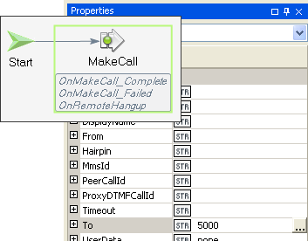
Figure 12: Making a call

When a MakeCall is issued into the Metreos platform, it is given a CallId just as incoming calls are. As with the inbound call, we should store this CallId value in a global variable so it is easily accessible later.

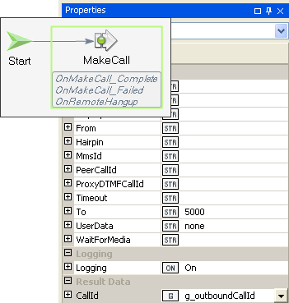
Figure 13: Saving Outbound CallId

MakeCall is an asynchronous action, so we don’t know the final outcome of the call until the OnMakeCall_Complete or OnMakeCall_Failed event fires. With nothing else to do in the OnPlay_Complete handler, let’s apply an EndFunction action to put the script back into a wait state.

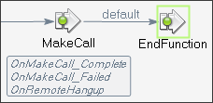
Figure 14: Placing script in wait state

With regards to media connections, the same rule applies as the AnswerCall action: when the MakeCall action completes, a media server connection has been automatically created and is accessible by the Metreos developer. If and when the outbound call is answered by the dialed party, the OnMakeCall_Complete event handler will fire, and the media server connection becomes available for that call.

To access this value, make a local variable in the OnMakeCall_Complete event handler which is initialized with the ConnectionId event parameter.

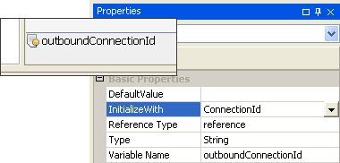
Figure 15: Storing the ConnectionId event parameter to a local variable

In order for these two separate calls to be able to hear each other, both of these media server connections will need to be placed into a media server conference. First we’ll have to create the conference. A conference on the media server must always have one participant, so for this application we have chose one of our two connections to place into the conference.

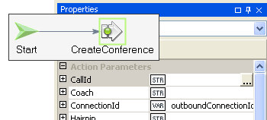
Figure 16: Creating a conference with one participant

Once the conference is created, the CreateConference action will return a unique identifier to the conference itself, so that further media operations can be performed upon it.

Every media server conference is given a unique identifier. Actions that manipulate media server conferences use this identifier to indicate which conference it will operate on.

As with callId’s and connectionId’s, the most straightforward place to store a conferenceId would be in a global variable.

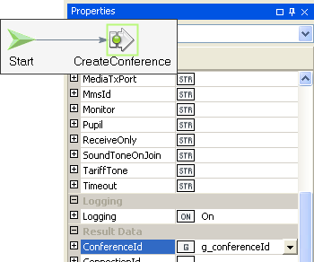
Figure 17: Storing the ConferenceId

Placing the other participant in the conference is done by using the JoinConference action. By specifying a ConnectionId and ConferenceId, the JoinConference action will place a new connection in the conference.

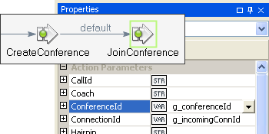
Figure 18: Adding a new connection to the conference

Once the JoinConference command completes, both parties should be able to hear each other.

With nothing else to do until one party or the other hangs up, invoking an EndFunction allows our script to enter a wait state, waiting for the OnRemoteHangup event.

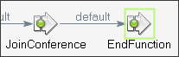
Figure 19: Entering wait state after conferencing

Before applying logic to the OnRemoteHangup event handler, let’s take a moment to define what should happen when either caller hangs up. In most two party calls, each party expects that when the other party hangs up, their own line will become disconnected. Following this as a model for how we will define the logic flow of the OnRemoteHangup event handler will give our script standard, expected behavior.

The CallId event parameter accompanies all RemoteHangup events, so that the application developer can distinguish which call leg hung up. By using the Compare action, we can quickly determine if the call that hung up was, say, the incoming call.

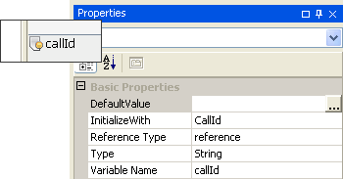
Figure 20: Initializing the CallId specifying the hung up call

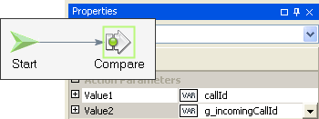
Figure 21: Determining if the hung up call is the incoming call

For the first time in this tutorial, we will need to leverage the result path returned by a native action; in this case, we are interested in the result of the Compare action. Intuitively, the Compare action returns one of two values: equal and unequal. Note that default is a special path that indicates that it should be taken in the absence of a more explicit path.

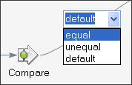
Figure 22: Utilizing specific result paths

In the case that the incomingCallId and callId variable are equal, then we know that our incoming call leg has been hung up. Therefore we should deliberately hang up the other call, or the outbound leg, to create the expected functionality described earlier.

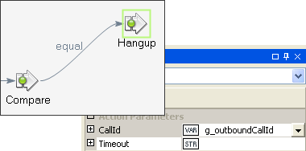
Figure 23: Hanging up the outbound call

In the other case, we should hang up the incoming call leg.

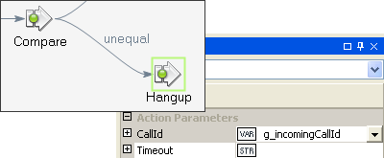
Figure 24: Hanging up the inbound call

In either case, after the Hangup action, both calls have been cleared, and the only task left is to destroy our script so as to clean up all resources associated with it.

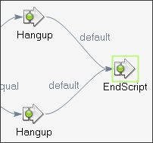
Figure 25: Ending the script after final hang up

You may have noticed even though we explicitly created a conference for our media connections to reside in, we did not ever destroy that conference. To understand why this is acceptable, it is important to note that the Metreos Media Server will automatically destroy any media server conference when the number of participants in that conference reduces to zero. Also, when a Hangup is issued or when a RemoteHangup event fires, the associated media server connection with that call is destroyed. So, the conference would be destroyed automatically in this scenario.

The Metreos Application Environment creates media server connections automatically when answering or making calls. Accordingly, media server connections are destroyed as calls are hung up.

To conclude this particular call flow, we need to provide a sequence of actions for the case that the OnMakeCall_Failed event handler is fired. To keep the script simple (although not necessarily as user-friendly as possible), we will hang up the incoming call that we have already answered and exit the script.

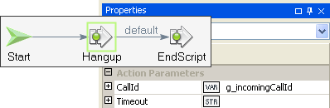
Figure 26: Hanging up the inbound call after outbound call fails

At this point, the application should be able to be built and deployed. Make sure the To parameter value on the MakeCall action routes to a real endpoint, so you can test the application.

Optimizing Conferencing
The section before creates a conference and adds the participants to the conference after both connections are created. So, there is some inherent delay added before both parties can hear each other due to the way we place each participant into conference.

From a capabilities standpoint, the Metreos Media Server can simultaneously create a connection while placing it into a conference. However, because the platform creates connections automatically when making and placing calls, the platform itself would have to leverage this feature of the media server; otherwise we would always have to create conferences as we did in the previous section!

Fortunately, the platform does have this capability: it is just a matter of telling it to do use it. Using the script as the previous example as contrast as well as a starting point for development, this section will show how to optimize conferencing such that it occurs faster and with less overall impact on the system. Note: the OptimizingBridgingCalls script contained in the accompanying ReceivingCalls application is the end result of this section.

To start, let’s remove the CreateConference action, JoinConference action, and outboundConnectionId local variable from the OnMakeCall_Complete event handler—we will not need them.

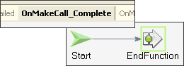
Figure 27: Removing explicit conferencing actions

Navigating back to the OnIncomingCall handler, we need to specify on the AnswerCall action that we would like to create a conference while creating that connection; additionally putting that connection into the conference in the process. The Conference parameter is the means by which we do just that. Conference accepts boolean values, so we specify a value of true.

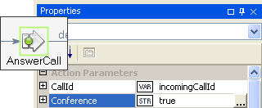
Figure 28: Requesting a conference when answering

Now, when the AnswerCall action completes, it will return a newly created ConferenceId, returned by the media server. We will need that later, so let’s save it to the same global variable we created for this purpose as in the previous section, g_conferenceId.

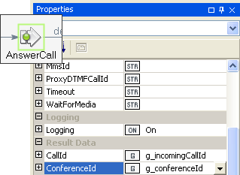
Figure 29: Storing the ConferenceId result parameter

Navigating now to the OnPlay_Complete event handler, we now not only specify true for the Conference action, but we also pass in the already-created ConferenceId. As opposed to what occurred when we answered the inbound call, at which time a new conference was created, the MakeCall action will negotiate with the media server such that the connection made for the outbound call will be added to the specified conference.

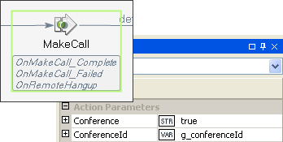
Figure 30: Adding the outbound call to the conference

Now we have the same end result as the previous example, but with less overall negotiation with the Metreos Media Server, and less initial delay in setting up the conference, resulting in the participants experiencing two-way audio sooner.

Summary
The purpose of these three examples was to give you a basic understanding of how you would use the CallControl and MediaControl API in your own applications. There is certainly more to both these APIs; however, with the fundamentals shown in this document, incorporating these other actions into your applications should be fairly more intuitive.

