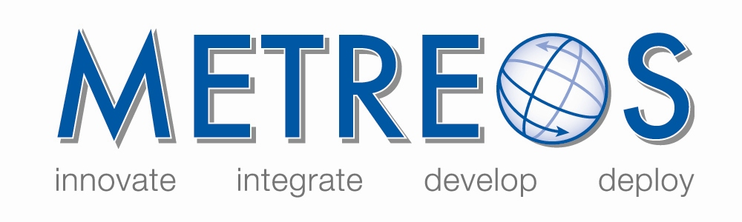
IP Communications Applications for Business Advantage

Metreos Communications Environment Quick-Start

Setting Up the Environment
Use the following procedure to prepare Cisco CallManager and the Metreos Communications Environment (MCE):

- On the Cisco CallManager administration front Web page select Device à Gateway.
- Click the Add a New Gateway link in the upper left portion of the page.
- From the Gateway type* dropdown list select H.323 Gateway. CallManager displays H.225 in the Device Protocol* field.
- Click the Next button.
- Enter AppServerIP in the DeviceName field. And fill out the rest of the form in accordance with your system requirements.
Note: If you are using CallManager version 4.0 or higher, ensure that the Wait for Far End H.245 Terminal Capability Set box is not checked.
- On the Cisco CallManager administration front Web page select Route Plan à Route Pattern.
- Click the Add Route Pattern link in the upper left portion of the page.
- Create a route pattern that can route some range of directory numbers to the H.323 Gateway you created in step 1.
- On the Metreos Management Console Main Control Panel click the Media Servers link.
- In the Name field enter a user friendly name.
- In the IP Address field enter 127.0.0.1
- On the Metreos Management Console Main Control Panel click the Telephony Servers link.
- Click the Add Server button.
- Enter Call Manager in the Name field.
- Enter your CCM publisher IP address in the Publisher IP field.
- Select your CallManager version from the Version dropdown list.
- Enter the CallManager password for user Administrator in the Publisher Admin Password and Retype Publisher Admin Password fields.
- On the Metreos Management Console Main Control Panel click the Telephony Servers link.
- Select H.323 Gateway from the Add Server dropdown list in the Add A Telephony Server section.
- Click the Create New Group button. The Management Console displays the Add H.323 Gateway page.
- Enter Call Manager in the Name field.
- Enter the version number you selected in 16 in the Version field.
- Enter the IP address of a CallManager that is running the Cisco CallManager service, that is, processing calls.
- Click the Add H.323 Gateway button.

Configuring Your Application
Use the following procedure to configure your application:

- On the Management Console Main Control Panel click the Applications link. The Management Console displays the Applications page.
- Click the application_name link. The Management Console displays the application_name page.
- Click the Edit button in the Partitions section for the appropriate partition. The Management Console will display the page for the application partition you selected.
- Click the Edit Triggering Parameters button. The management console displays the page for managing the script trigger parameters.
- Add a new triggering parameter, with a name of to and the value of the directory number you want to call to initiate the application.

Testing Your Application
Call the directory number you configured for the application. The application should start. If the application does not start, click the Server Logs link on the Main Control Panel of the Management Console.

Click the link for the most recent log and look for incoming call information being displayed to the log. The log should contain either an application error or a No handler registered for incoming event: Metreos.CallControl.IncomingCall error. If the log contains an incoming call error, repeat the procedure in Configuring Individual Applications.

If there is no log activity, CallManager might not be routing your call to the Application Server H.323 Gateway. Check your calling device CSS and your route pattern partition. If you are unable to resolve the problem using the information in this section, please contact Metreos Customer Support.

