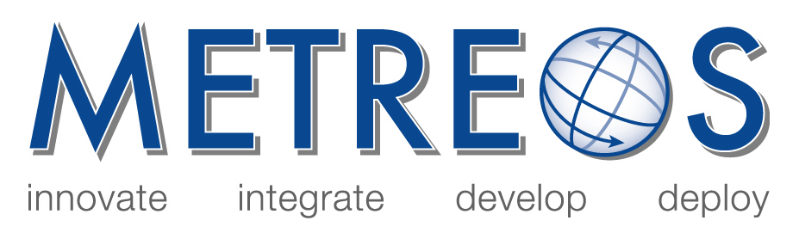

Metreos Communications Environment
Developer and Administrator Training

February 2005

- MCE Training Presentation
Overviews the Metreos Communications Environment and the major concepts around how the MCE manages and executes applications.

- Developer’s Guide
Details the operation of the Metreos Application Server and how developers may use the Metreos Visual Designer to build applications to run on the MCE.

- Administrator’s Guide
Discusses how to administer the MCE using the web-based management console.

- Framework Package API Reference
Provides a reference munal for every action and event on the MCE along with parameter information and usage descriptions.

Copyright (c) 2001-2005 Metreos Corporation
All Rights Reserved

Proprietary and Confidental Information
For Release under NDA Only

