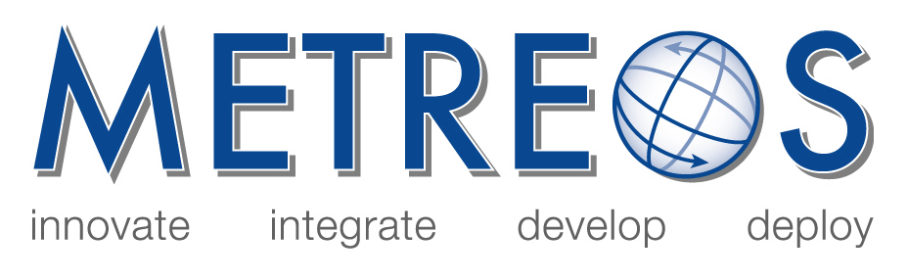

Metreos Communications Environment
Developer and Administrator Training

January 2006

- MCE Training Presentation
Overviews the Metreos Communications Environment and the major concepts around how the MCE manages and executes applications.

- IP Telephony Applications: Core Development Concepts
To acclimate the new Metreos application developer with the core concepts of the Metreos Communications Environment and common design patterns, in order to facilitate the rapid development of IP telephony applications.

- Management Console User Guide
Discusses how to administer and maintain the Metreos Ccommunications Environment using the web-based management console.

- Application Suite Administrator Guide
Describes how to deploy and configure the Metreos Application Suite to the Metreos Communication Environment.

- Developer’s Guide
Details the operation of the Metreos Application Server and how developers may use the Metreos Visual Designer to build applications to run on the MCE.

- API Framework
Defines and describes every action and event in the Metreos Application Framework.

- Metreos 2400 Appliance Installation and Setup Guide
Describes the procedures for installing the 1-rack unit (RU) MCE-2400 Appliance and for performing the initial Metreos Communication Environment startup procedure.

Copyright (c) 2001-2006 Metreos Corporation
All Rights Reserved

Proprietary and Confidental Information
For Release under NDA Only

