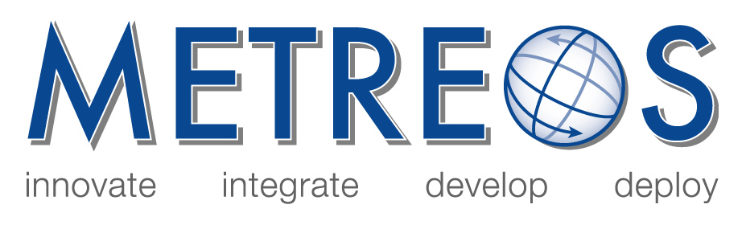

Metreos Communications Environment
Developer and Administrator Training

January 2006

- MCE Training Presentation
Overviews the Metreos Communications Environment and the major concepts around how the MCE manages and executes applications.

- Management Console User Guide
Discusses how to administer and maintain the Metreos Ccommunications Environment using the web-based management console.

- Application Suite Administrator Guide
Describes how to deploy and configure the Metreos Application Suite to the Metreos Communication Environment.

- Metreos 2400 Appliance Installation and Setup Guide
Describes the procedures for installing the 1-rack unit (RU) MCE-2400 Appliance and for performing the initial Metreos Communication Environment startup procedure.

Copyright (c) 2001-2006 Metreos Corporation
All Rights Reserved

Proprietary and Confidental Information
For Release under NDA Only

