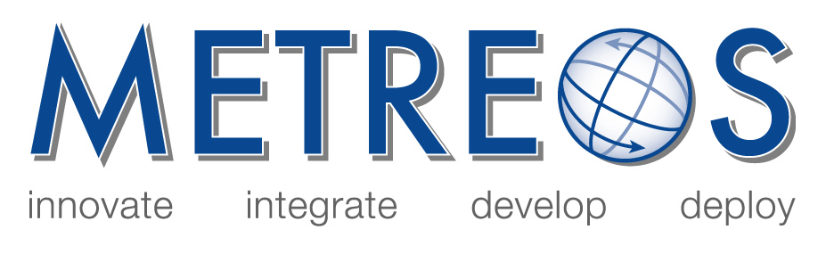

Metreos Communications Environment
Developer and Administrator Training

January 2006

- IP Telephony Applications: Core Development Concepts
To acclimate the new Metreos application developer with the core concepts of the Metreos Communications Environment and common design patterns, in order to facilitate the rapid development of IP telephony applications.
- Plug-In Developer Guide
For use by programmers wishing to learn how to develop plug-ins to the Metreos Communications Environment Runtime Engine.

- Developer’s Guide
Details the operation of the Metreos Application Server and how developers may use the Metreos Visual Designer to build applications to run on the MCE.

- API Framework
Defines and describes every action and event in the Metreos Application Framework.

Copyright (c) 2001-2006 Metreos Corporation
All Rights Reserved

Proprietary and Confidental Information
For Release under NDA Only

