For this round of perf testing, you might want to consider adding an alert to all our CUAE machines to make sure if the ‘lock’ is occurring. With build 623, the lock will still occur, although less frequently (maybe once a day). But with this alert, you can know for sure whether your test went south because of the lock issue, or because of another issue (meaning we need to investigate the logs more closely in the latter case).

To add an alert,

Start perfmon (cmd > perfmon).

Expand Perfomance Logs and Counters > Right-click Alerts > New Alert Settings.

Give it whatever name you want, and then the rest is shown below:

- Click the Add button once to add a new counter you want to alert on. In this case, we want to watch the Queue Length / sec counter for the AppServerService instance. Hit Close.

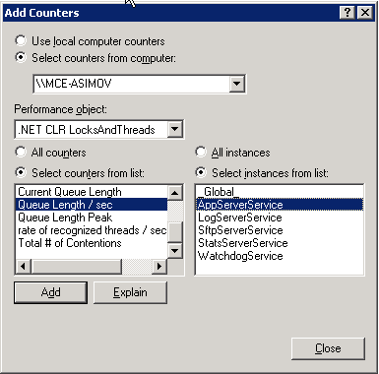

- Set the Alert value to Under and Limit = 2. (when the spike happens, we see that the Queue Length / sec counter goes to 0. So Limit could probably be 1, but whatever).
  - Also change the Interval to 1!

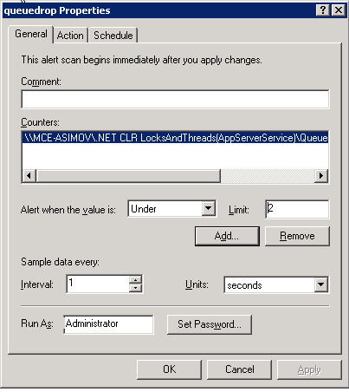
- Set the ‘Run this Program’ field to point to ‘alert.bat’. I attached alert.bat to this email—I usually throw it down on the desktop of the server of interest. Note that you shouldn’t have to change alert.bat *unless* you are logged into a user other than ‘Administrator’ because we are saving the spike.log to the desktop.

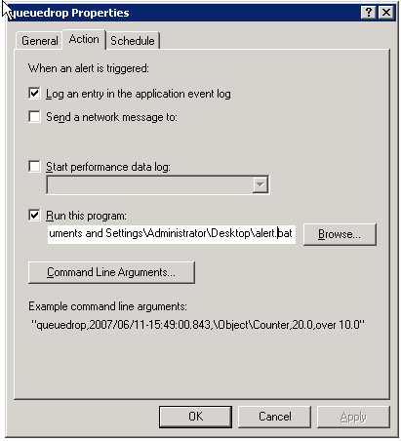

After all that, you should be able to double-click alert.bat to test that it works on ur server—and a file called Spike.log should show up on the desktop, with a timestamp and message. You can either delete spike.log now – it’ll get recreated when the lockup actually occurs. Or, you can just clear out the file of it’s contents. Alert.bat is fine with that as well.

Seth

