To add an alert,

Start perfmon (cmd > perfmon).

Expand Perfomance Logs and Counters > Right-click Alerts > New Alert Settings.

Give it whatever name you want, and then the rest is shown below:

Click the Add button once to add a new counter you want to alert on. In this case, we want to watch the CPU Usage via the processor % processor time. “This counter is the primary indicator of processor activity, and displays the average percentage of busy time observed during the sample interval. It is calculated by monitoring the time that the service is inactive, and subtracting that value from 100%.”
- Select the counter (see image below) and then select Close.

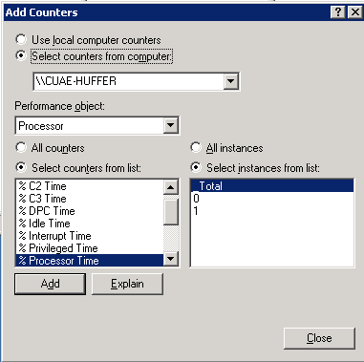

- Set the Alert value to Over and Limit = 45. (it this case we are looking to report when the overall CPU usage exceeds 45%).
  - Also change the Interval to 3!
-- see image below ---

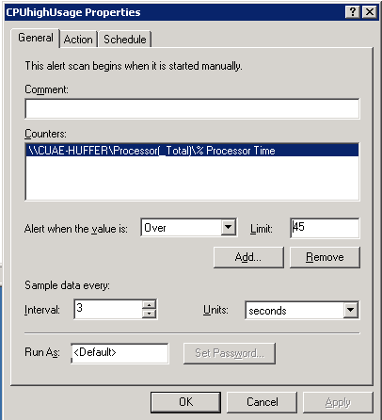

- Set the ‘Run this Program’ field to point to ‘CPUhighAlert.bat’. Note that you shouldn’t have to change CPUhighAlert.bat *unless* you are logged into a user other than ‘Administrator’ because we are saving the CPUhighAlert.log to the desktop. (see image below)

