HW 6

100 pts

Problems

B.10

B.12

B.14

B.37

B.38

Figure 1

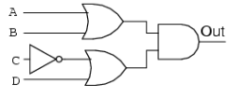

1. Write a product of sums equation to represent the circuit in figure 1
2. Write a Truth table to represent circuit in figure 1

3 Given the following sum of products equation draw a logic diagram using gates

