**Lab 3 Report**

**Name: Wen Jun Student ID: 57118230**

Task 1: Install Apache Server & Use simple page to verify

1. Use sudo apt-get install apache2 command to install apache2.

2. After apache was installed, the default website root directory is “var/www/html”, a file named index.html is in the root directory, we can open the page in VM’s browser.

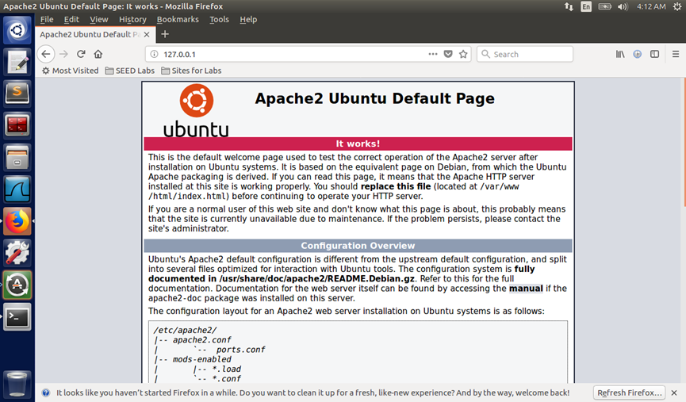

3. Visit the directory of index.html and write the file as you want.

1. **<html>**
2. **<head>**
3. **<title>**Hello HTML**</title>**
4. **</head>**
5. **<body>**
6. **<h1>**Hello HTML**</h1>**
7. **<body>**
8. **</html>**

4. After revising the html file, using browser to visit 127.0.0.1, check whether the page has been uploaded.

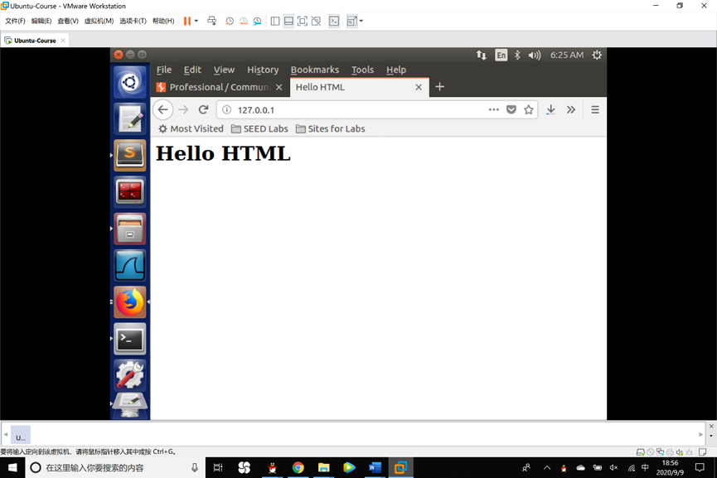

Task 2: Analysis the name by host file

1. Find the hosts file in Windows main frame, modify the hosts file, add the virtual machine’s ip address and hostname Adam, the save it.

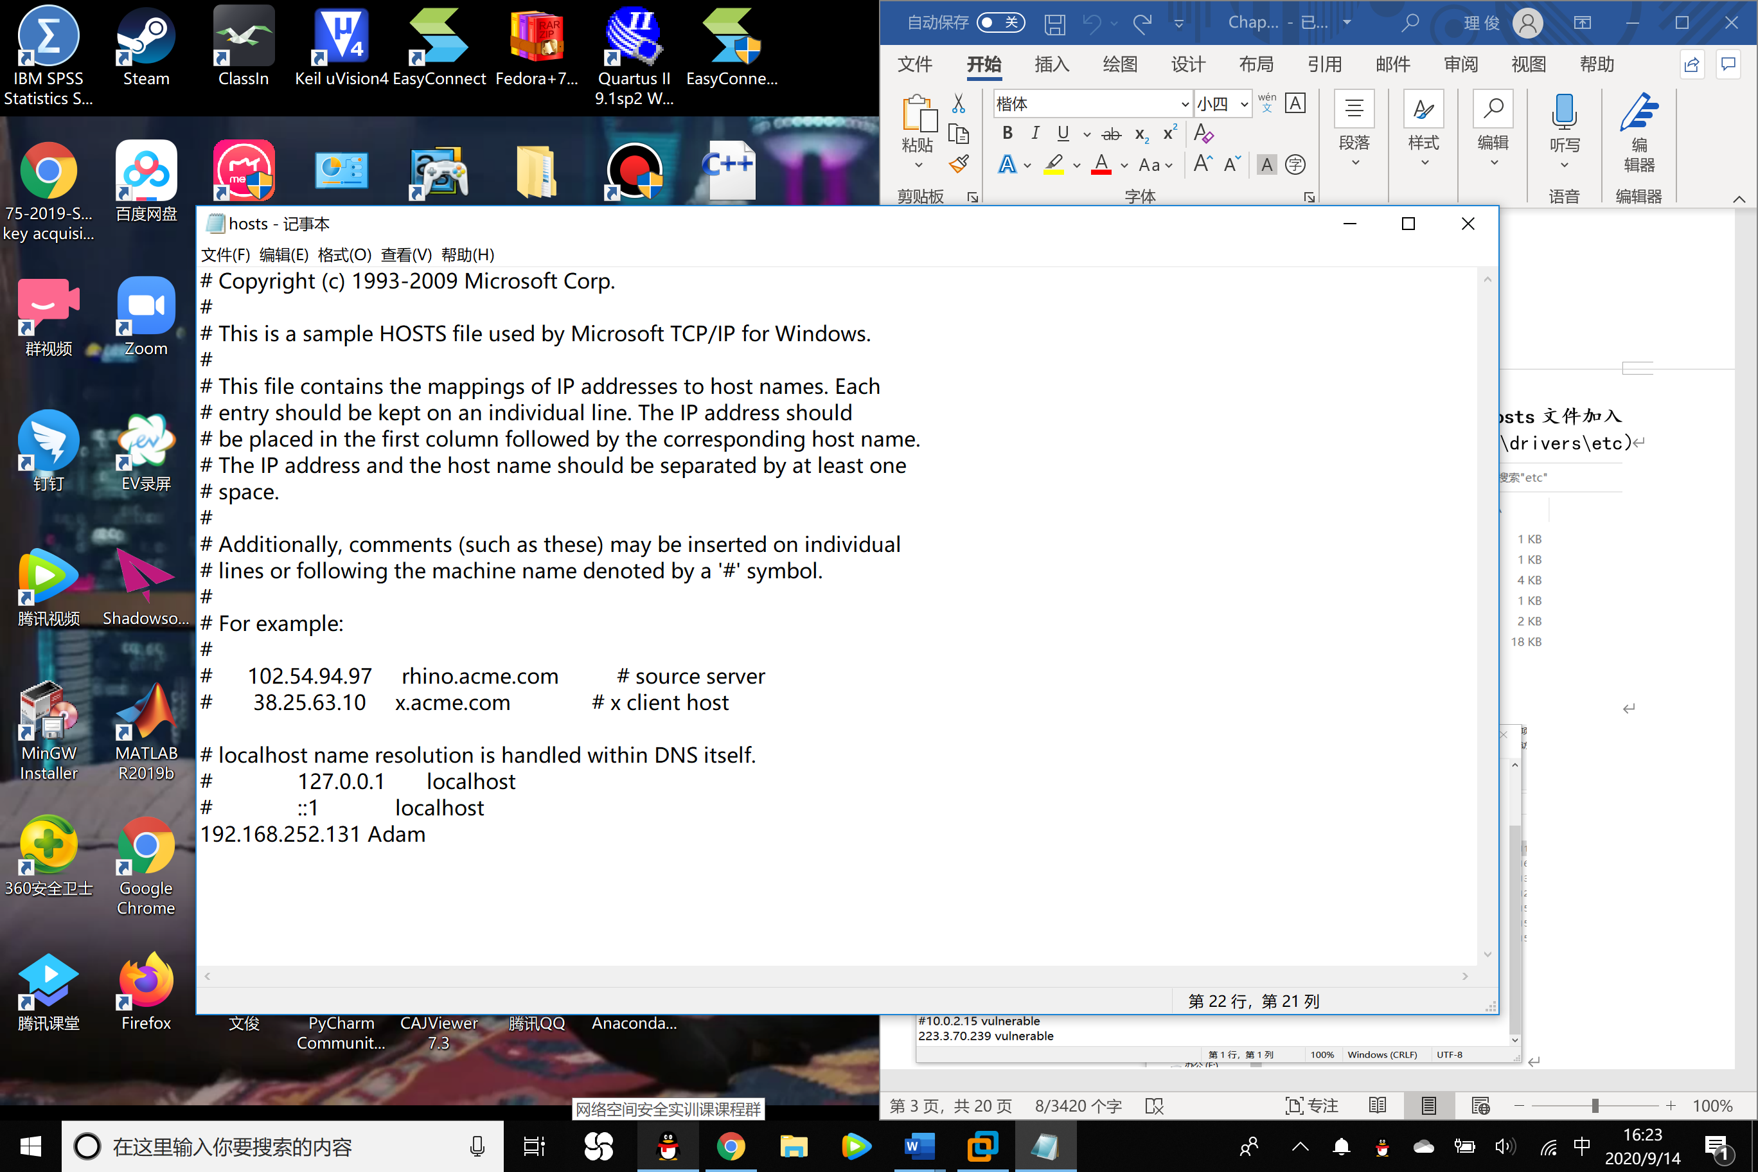

Task 3: Write HTTP client & Retrieve the homepage of the site by http library

1. Use the command curl + ip address of the virtual machine to read the index file.

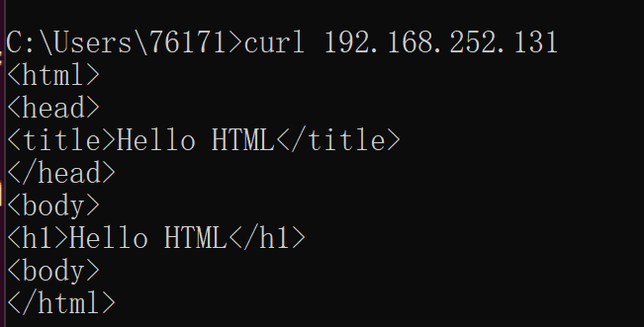

2. Verify that the virtual machine includes the python 3.5 version.

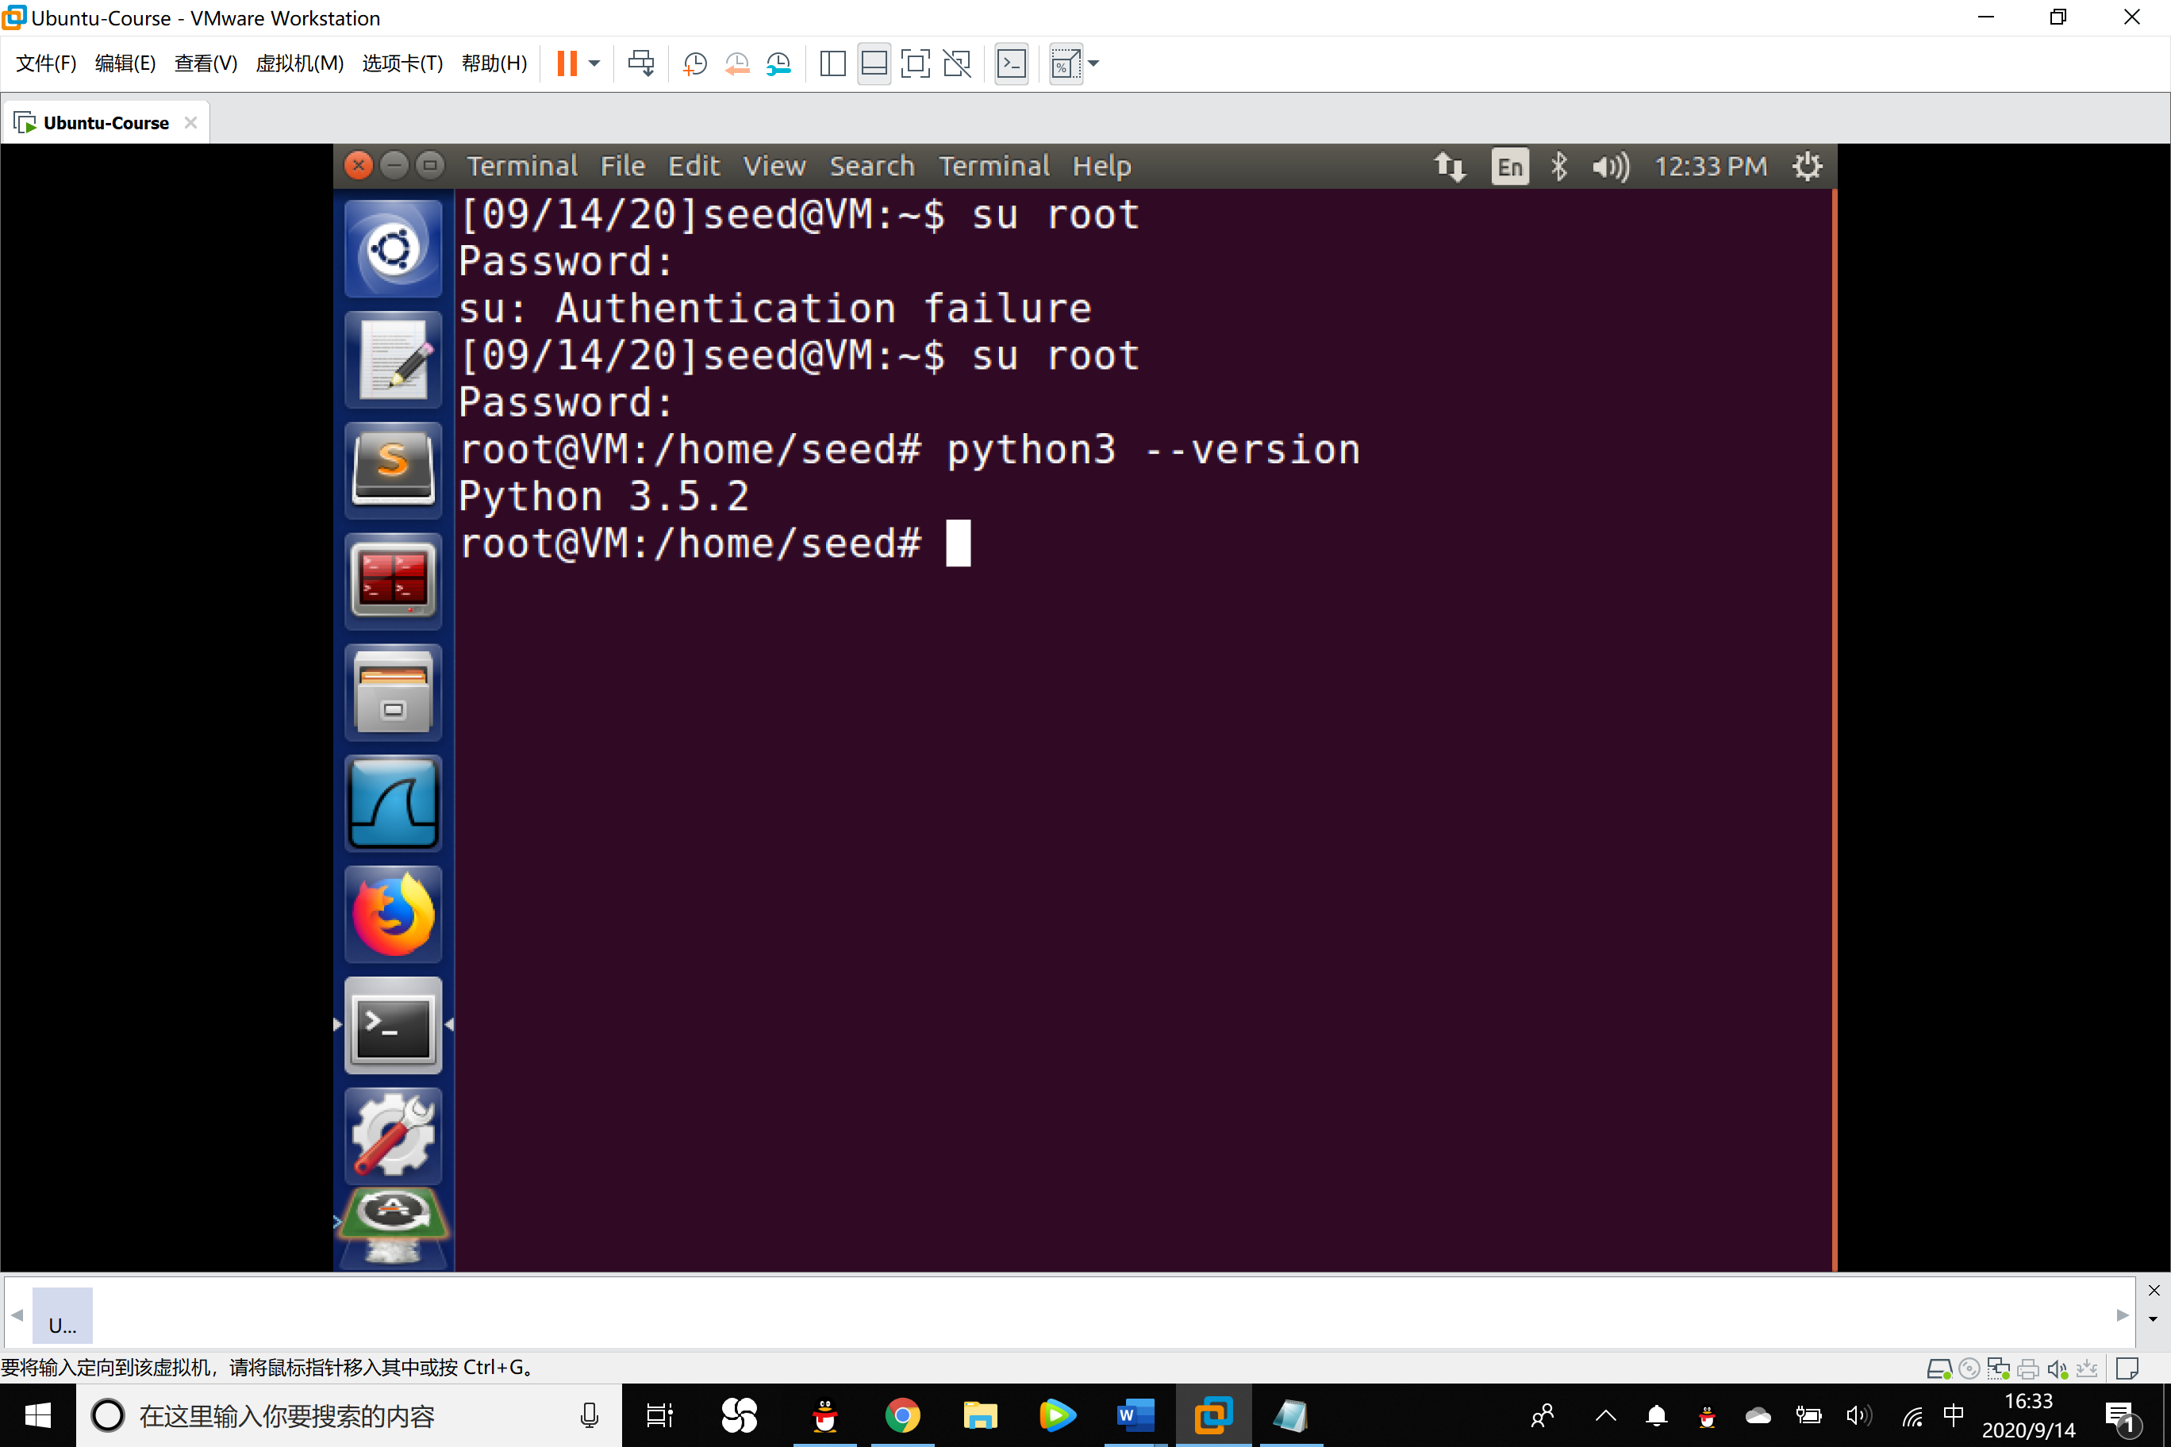

3. Create the executable python file and write HTTP client to retrieve the homepage of the site by http library.

1. **import** http.client
2. httpClient = http.client.HTTPConnection('127.0.0.1')
3. # 发送请求，直接用参数/，相当于直接访问ip
4. httpClient.request('GET','/')
5. # 获取请求
6. response = httpClient.getresponse()
7. # 分解response回应消息
8. **print**("status:"+str(response.status))
9. # print(response.reason)
10. **print**('-'*5+'Message'+'-'*5)
11. **print**(response.msg)
12. **print**('-'*5+'Contents'+'-'*5)
13. **print**(response.read())

4. Run the Search.py program then we get the response of the server 127.0.0.1.

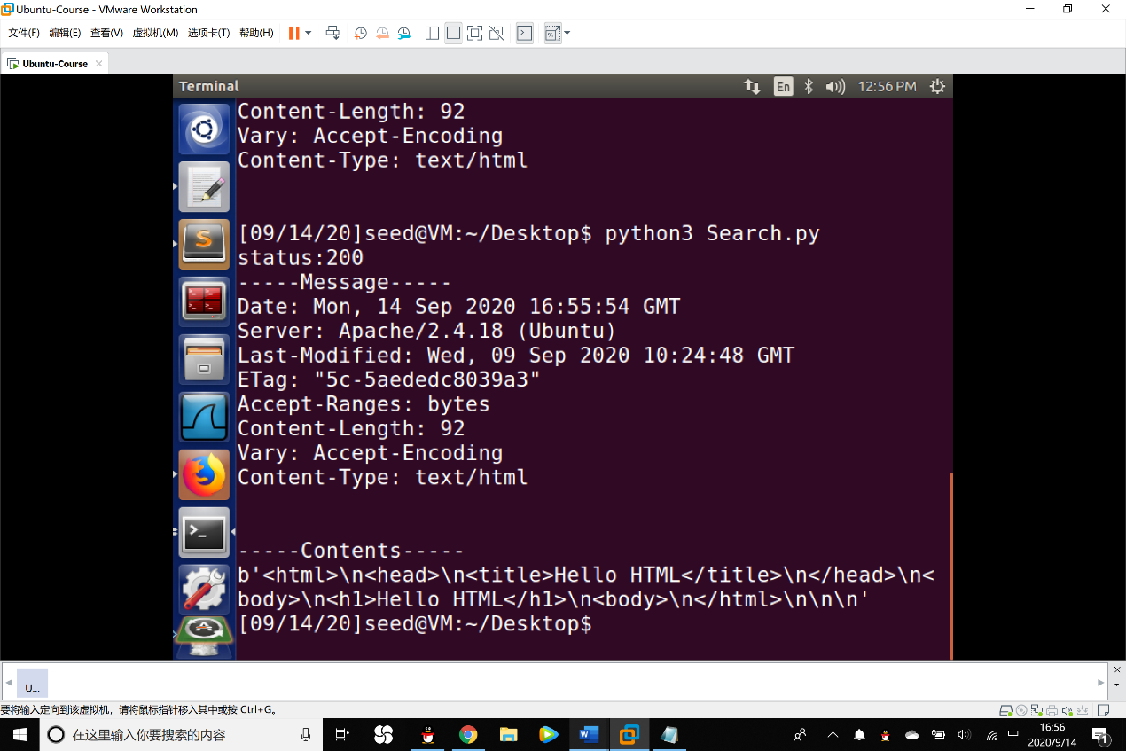

Task 4: Write an HTTP client to retrieve the homepage of the site using sockets

1. Create a C program in main frame, following is the code:

1. #include <stdio.h>
2. #include <stdlib.h>
3. #include <string.h>
4. #include <iostream>
5. #include <winsock2.h>
6. #include<time.h>
7. #pragma comment(lib,"ws2_32.lib")
8. #define _WINSOCK_DEPRECATED_NO_WARNINGS
9. #define _WINSOCK_DEPRECATED_NO WARNINIGS

12. void ReadPage(char* host)
13. {
14. WSADATA data;
15. //winsock版本2.2
16. int err = WSAStartup(MAKEWORD(2, 2), &data);
17. **if** (err)
18. **return**;
20. //用域名获取对方主机名
21. struct hostent *h = gethostbyname(host);
22. **if** (h == NULL)
23. **return**;
25. //IPV4
26. **if** (h->h_addrtype != AF_INET)
27. **return**;
28. struct in_addr ina;
29. //解析IP
30. memmove(&ina, h->h_addr, 4);
31. LPSTR ipstr = inet_ntoa(ina);
33. //Socket封装
34. struct sockaddr_in si;
35. si.sin_family = AF_INET;
36. si.sin_port = htons(80);
37. si.sin_addr.S_un.S_addr = inet_addr(ipstr);
38. int sock = socket(AF_INET, SOCK_STREAM, IPPROTO_TCP);
39. connect(sock, (SOCKADDR*)&si, sizeof(si));
40. **if** (sock == -1 || sock == -2)
41. **return**;
43. //发送请求
44. char request[1024] = "GET /?st=1 HTTP/1.1\r\nHost:";
45. strcat(request, host);
46. strcat(request, "\r\nConnection:Close\r\n\r\n");
47. int ret = send(sock, request, strlen(request), 0);
48. //获取网页内容
49. FILE *f = fopen("recieved.txt", "w");
50. int isstart = 0;
51. **while** (ret > 0)
52. {
53. const int bufsize = 1024;
54. char* buf = (char*)calloc(bufsize, 1);
55. ret = recv(sock, buf, bufsize - 1, 0);
56. printf(buf);
57. fprintf(f, "%s", buf);
58. free(buf);
59. }
60. fclose(f);
61. closesocket(sock);
62. WSACleanup();
63. printf("读取网页内容成功，已保存在recieved.txt中\n");
64. **return**;
65. }
66. void main() {
67. char* str = (char*)"Adam";
68. ReadPage(str);
69. system("pause");
70. }

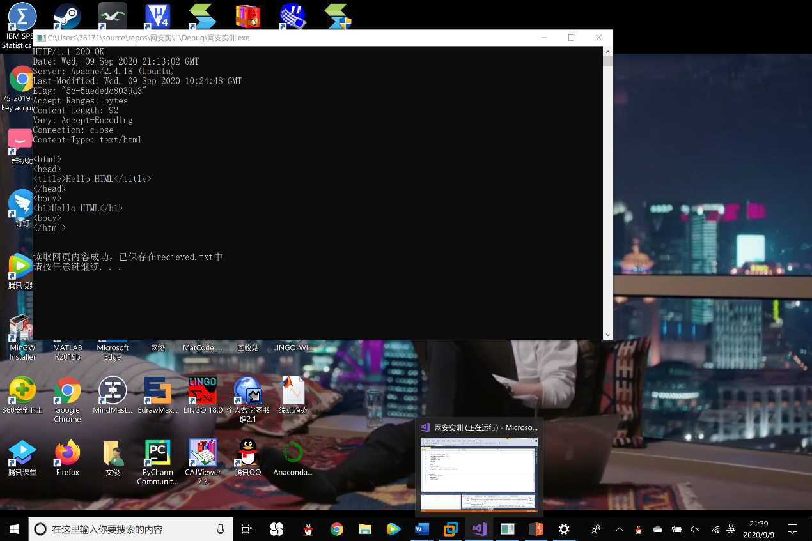2. Execute the program and check whether the home page has been retrieved.

Task 5: Download Burp Suite & Check the request and response message by visiting the website

1. Download the community version from the official website.

2. Set the proxy settings. HTTP address is 127.0.0.1 and port is 8888.

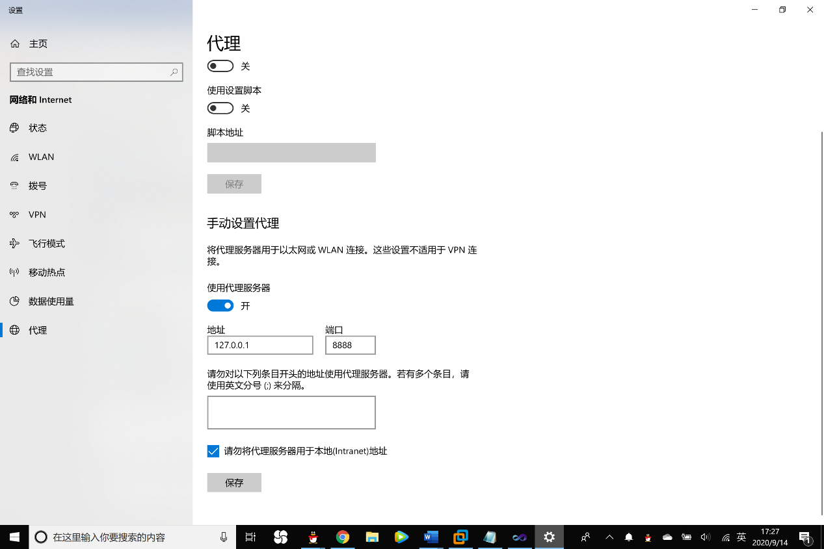

3. Set the proxy settings of the Burp Suite, settings should be the same as step 2.

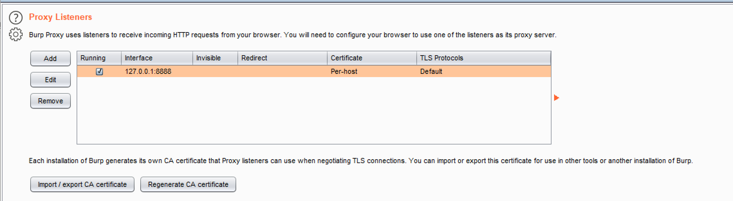

4. Use the browser to visit my.seu.edu.cn, the intercept information can be seem.

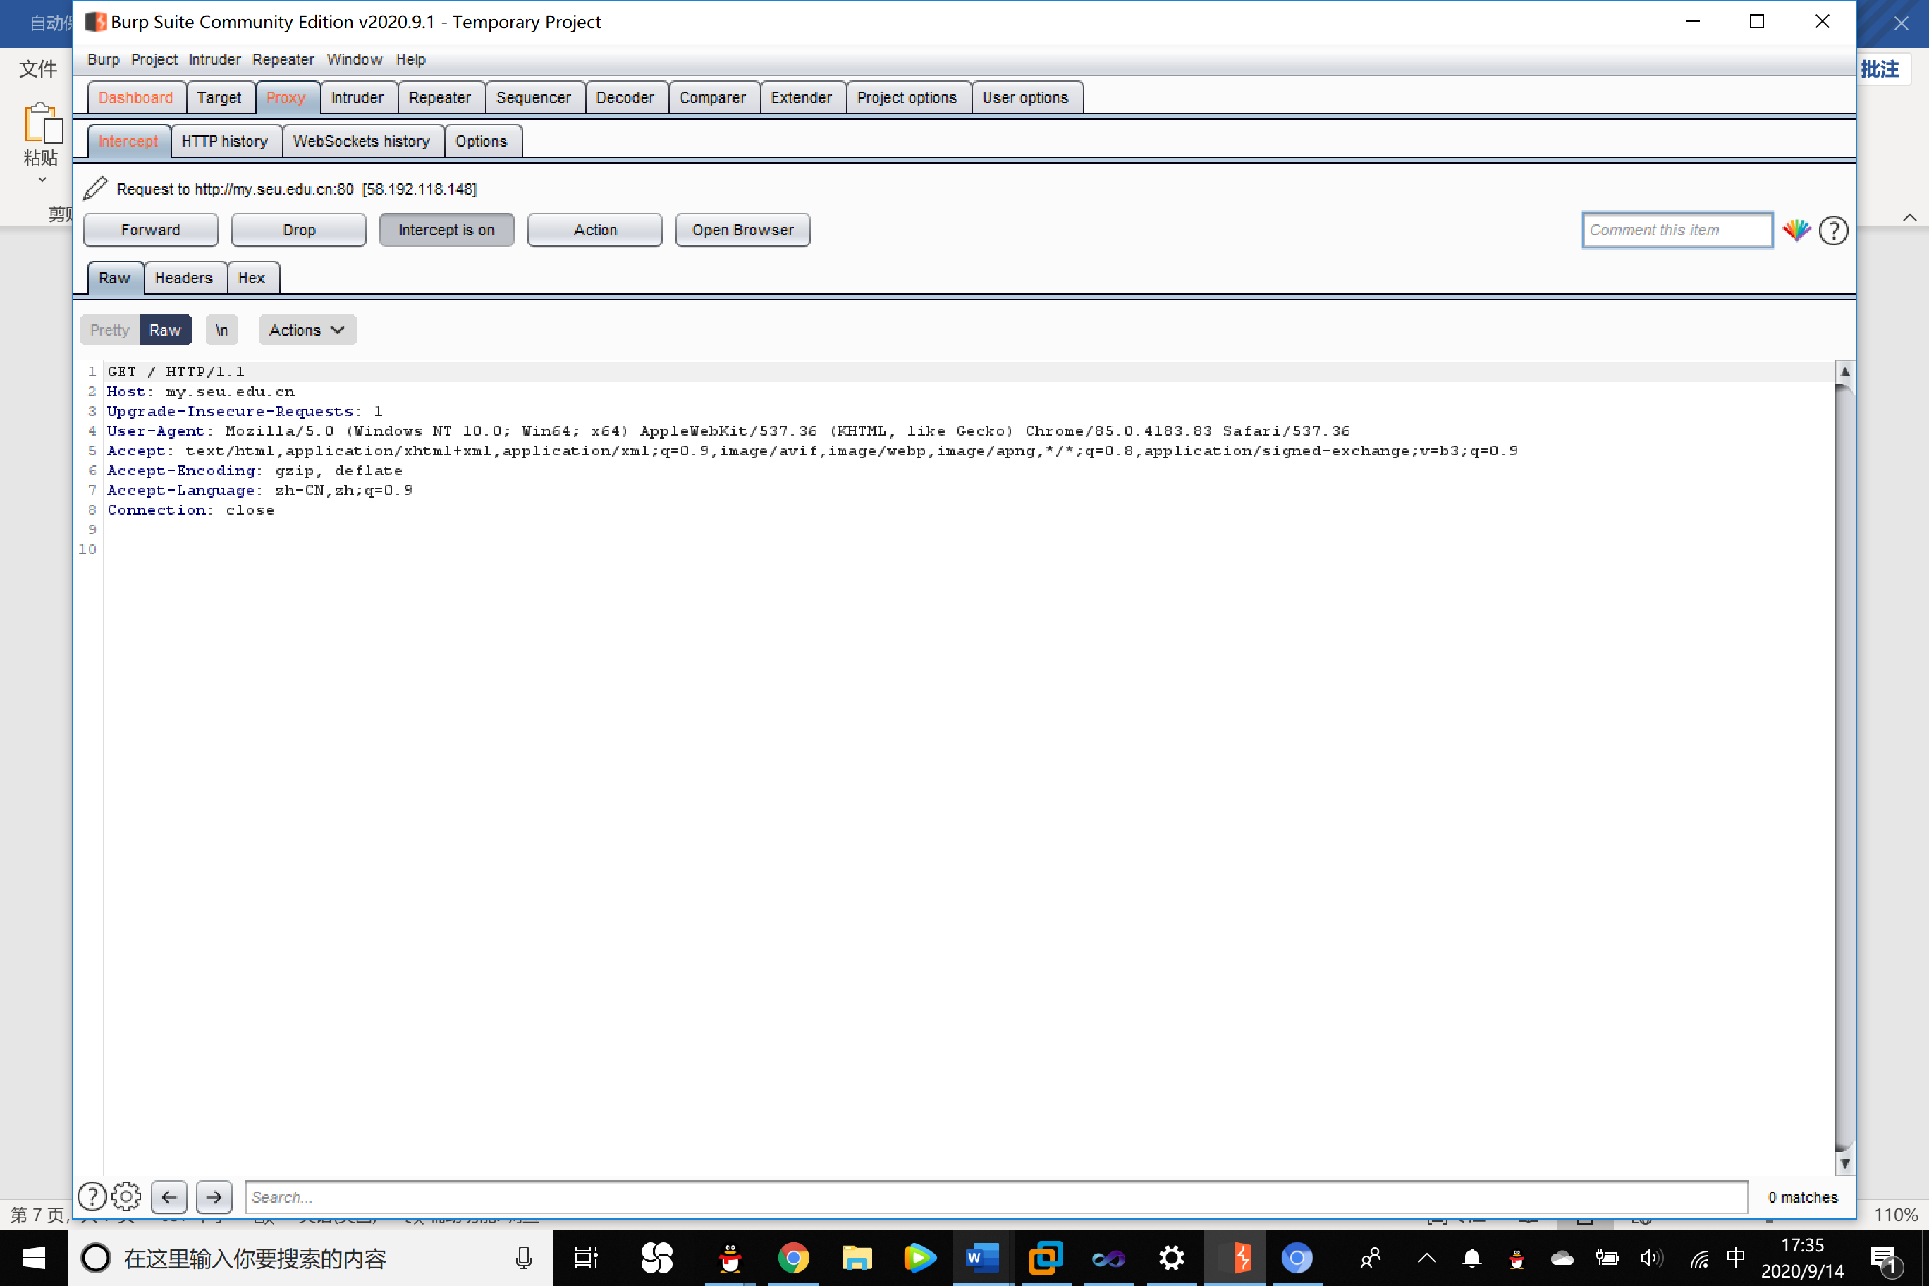

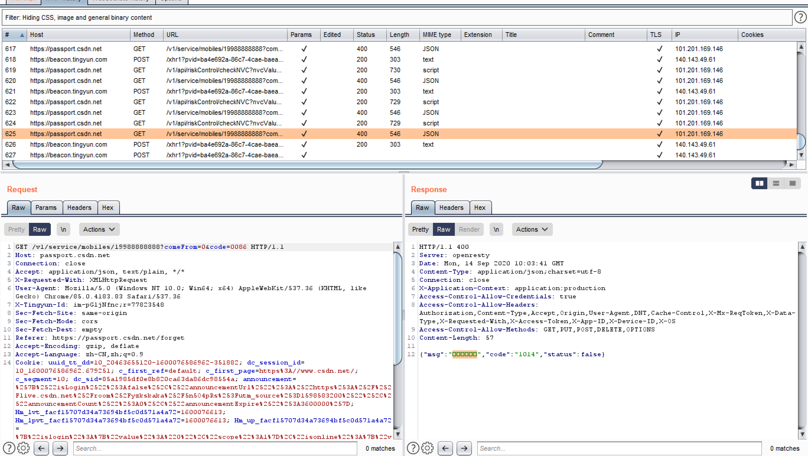5. Test the function of the retrieving the password by sending identifying code of csdn.net. Check the Request and Response module.