

South African National Biodiversity Institute

GIS METADATA : DETAILED REPORT

FILE NAME: NBA_benthic_and_coastal_habitat_map_wgs84.shp
Full Path
Description (detailed) | Benthic and coastal habitat classifications
Copyright Holder | SANBI
Data Origin | ?
Capture Source | ?
Scale Digitised at | N/A
Date Captured | 2011
Data Copyright | No
To be distributed | Yes

DATA INFORMATION AND METADATA INFORMATION
Owner Organisation | SANBI
Contact Person | Dr Kerry Sink
Position of Contact Person | Marine Program Manager, SANBI, Kirstenbosch Research Centre, Cape Town
Contact Address | Pvt Bag x7, Claremont 7735
Contact Number | 0217998855
Contact Email | K.Sink@sanbi.org.za

LEGEND PROPERTIES
Legend Title | Benthic and Coastal Habitat  The associated avl file was created in ArcView 3.3. When the file is imported into ArcMap version 8 or later, the symbols are not correctly displayed. The only way to correct for this is to manually update the unsupported symbols. Classification should be based on the Habname field.  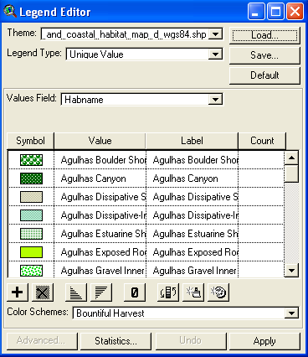
Feature Type | Habitat name
Scale Parameters | N/A

PROJECTION
Projection Name | Geographic Coordinate System
Central Meridian
Upper Parallel
Lower Parallel

DATUM
Name | WGS84
Semi Major Axis | 6378137
Semi Minor Axis | 6356752.3142451793
Inverse Flattening | N/A

DETAILED NOTES: NBA_benthic_and_coastal_habitat_map_wgs84.shp
Purpose:
The layer was prepared as part of the spatial assessment of the threat status and protection levels of South African marine and coastal ecosystems for the 2011 National Biodiversity Assessment. Prepared by Stephen Holness, Trevor Wolf, Kerry Sink, Linda Harris and Mandy Lombard with inputs from Ben Halpern and Hedley Grantham.

Methodology:
Ecosystem mapping:
The first stage in the ecosystem mapping process was the development of a classification of coastal and marine ecosystems which covers the area from 500m inland of the high-water mark to the edge of the EEZ contiguous with the South African mainland ( i.e. excluding the areas around Prince Edward Islands). The primary split in this classification is between the Coastal, Inshore, Island and Lagoon systems; and the offshore systems which extend from a 30m depth to the EEZ boundary. The classification recognizes 59 Coastal, Inshore, Island and Lagoon systems, 62 Offshore Benthic types and 16 Pelagic Offshore types.

Coastal, Inshore, Island and Lagoon biodiversity:
The production of the coastline layer is described in the metadata for NBA_Coastline.shp. The assessment could have been undertaken on this coastline, however we wished to emphasize that coastal habitats have marine and terrestrial components and consist of a three dimensional habitat rather than a single dimension line. Therefore, the area between the -5m depth offshore and 500m inland of the high water mark was classified according to the closest coastline type using a distance based least cost allocation method similar to using Thiessens Polygons. The -5m depth offshore was used to approximate depth of effective wave action, while the 500m inland cut-off was based on pragmatic considerations. Future work is required to properly map this inland boundary on ecological grounds.

Inshore habitats are those defined as being between -5m and -30m in depth, and consist of coupled benthic and pelagic systems. These systems are divided on substrate type into inshore reefs and unconsolidated types, which are in turn divided into Reefs and Hard Grounds; and Sandy, Muddy, Gravels, and Mixed respectively. Reef data consisted of points sourced from the National Reef Atlas Project. These points were buffered by 500m. Hard Grounds were derived from a subset of 5' bocks of untrawlable areas from demersal research survey grids. Types were divided on a biogeographic basis into 5 biozones. Comprehensive finer scale mapping of sediment and reefs would result in a significant improvement in the resolution of this dataset.

Islands and their surrounds are perceived to be a priority habitat, and had not been included in previous mapping (Lombard et al. 2004, Sink et al. 2010). Large islands were defined as offshore landmasses that supported permanent seabird (and potentially seal) breeding colonies, while small islands were defined as the offshore landmasses that supported permanent seal breeding colonies but not seabird breeding colonies. The large islands were buffered by 20km to defined a zone of "island influence", while the small islands were buffered by 10km. Lagoon habitats were identified using data from Lombard et al. (2004).

GIS map integration for the coastal, inshore, island and lagoon areas was undertaken by applying a set of rules: Coastal and lagoon habitats overrode all types except islands. Where islands were located close to mainland areas, the intervening habitat was assigned to the closer type, with the division between types occurring half way between the island and the mainland. Where islands were located in lagoons, only the terrestrial portions of the island was classified as island, with the areas below the high tide mark being classified as lagoon. In the inshore areas, reefs took precedence over hard grounds, which in turn took precedence over all unconsolidated sediments.

Offshore Benthic biodiversity:
Offshore is defined as the area between -30m and the edge of the EEZ. Offshore benthic habitats were split into rocky and unconsolidated types, which were in turn split into shelf (inner and outer), shelf edge (slope) and deep sea (upper bathyal, lower bathyal and abyss) topographic units, largely following the bioregionalisation exercise undertaken for the 2004 National Spatial Biodiversity Assessment (Lombard et al. 2004) and modified by the Offshore Marine Protected Area project (Sink et al. 2010). The major modification to created the bioregionalisation exercise undertaken by the Offshore Marine Protected Area project (Sink et al. 2010), was that slope habitats were grouped with their associated shelf rather than with the deeper areas were subdivided into five rather than three areas to better recognize the differences in slope biodiversity between the Agulhas, Natal and Delagoa areas. In order to avoid confusion associated with having identically named but slightly different layers, this bioregionalisation was called the "Ecoregions and Ecozones" layer.

After the division into the topographic detailed above, the shelf (inner and outer), slope and deep sea (upper bathyal, lower bathyal and abyss) were split in terms of specific substrate types. Hard sediment types included reefs, hard grounds, carbonate mounds and canyons in the shelf and shelf edge areas, and seamounts in the deep sea areas. Unconsolidated sediments included sandy, muddy, gravels and mixed areas in the shelf and shelf edge, and areas with and without ferromanganese deposits in the deep sea areas. The data sources and methods were as outlined for the inshore areas, with the additional seamount, carbonate mound and canyon data being derived directly from the Offshore Marine Protected Area project (Sink et al. 2010).

Map integration for the benthic offshore areas was undertaken by applying similar rules to the inshore areas: features such as seamounts, carbonate mounds and canyons overrode reefs, which in turn took precedence over hard grounds, which in turn took precedence over all unconsolidated sediments.

Input data:
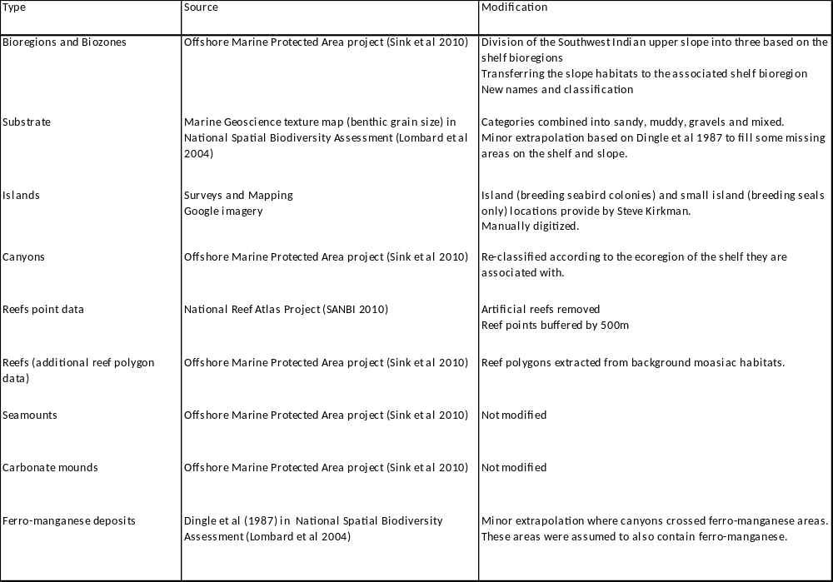

Available documentation and references:

Holness, S., Sink, K., Harris, L., Wolf, T. and Lombard, M.. 2011. Spatial assessment of the threat status and protection levels of South African marine and coastal ecosystems for the 2011 National Biodiversity Assessment: Methods and Outputs, SANBI unpublished report.

Lombard AT, Strauss T, Harris J, Sink K, Attwood C, Hutchings A. 2004. South African National Biodiversity Institute 2004: Technical Report, Volume 4: Marine Component. South Africa National Biodiversity Institute,
Pretoria.

Sink K, Lombard M, Grantham H, Attwood C, Leslie R, Samaai T, Kerwath S, Fairweather T, van der Lingen C, Atkinson A, Wolf T & Majiedt P. 2010. Systematic Biodiversity Planning to identify a potential offshore Marine Protected Area network for South Africa, SANBI, 34.

ATTRIBUTE FIELDS
Field Name | Description | Alias
FID | Feature Identification
SHAPE | Polygon
Categ | Coastal, Inshore, Islands & Lagoons or Offshore(-30m to EEZ boundary)
Topozone | Benthic, Coastal, Harbour, Inshore, Island, Lagoon
Toposubz | Basin, Coastal, Harbour, Inshore, Island, Lagoon, Shelf, Slope
Substrat | Harbour, Hard, Island, Lagoon, Mixed Coast, Rocky Coast, Sandy Coast, Unconsolidated
Expgeol | Exposed geology
Biogeog | Biogeographic zone
Location | Landward, Seaward
Name | Habitat name

