# High-resolution Global Cloud Climatology

summary(cars)

## speed dist ## Min. : 4.0 Min. : 2 ## 1st Qu.:12.0 1st Qu.: 26 ## Median :15.0 Median : 36 ## Mean :15.4 Mean : 43 ## 3rd Qu.:19.0 3rd Qu.: 56 ## Max. :25.0 Max. :120

You can also embed plots (Wilson, Parmentier, and Jetz 2014), for example:

plot(cars)

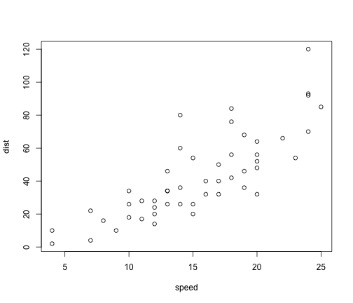

Test Caption

Wilson, Adam M., Benoit Parmentier, and Walter Jetz. 2014. “Systematic land cover bias in Collection 5 MODIS cloud mask and derived products — A global overview.” *Remote Sensing of Environment* 141 (feb): 149–154. doi:10.1016/j.rse.2013.10.025. <http://www.sciencedirect.com/science/article/pii/S0034425713003933>.