High-resolution Cloud Climatology for Global Land Areas

Adam M. Wilson & Walter Jetz

# Abstract

Clouds are a vitally important yet often overlooked driver of ecological processes. One factor limiting incorporation of cloud cover in ecological studies is the difficulty of accessing the data at sufficiently fine spatial resolution to be relevant for the study system. We introduce a new high resolution (30-arcsecond, ≈1km) set of monthly cloud frequency (CF) climatologies derived from the MODIS MOD09 cloud flag for global land areas. We validate the product using cloud observations from a global set of over 5000 stations over 1970-2009. Overall, the new CF layers explain 77% of the variability in the station dataset. We also describe a case study illustrating that the CF data can improve model performance for biogeographical processes.

# Introduction

Clouds are an extremely important component of the global climate system, affecting energy balance, latent heat flux, radiation flux, and moisture transport (Stephens and Kummerow 2007). In ecology, cloud cover is known to affect drought stress (Fischer, Still, and Williams 2009), tree growth (Fischer, Still, and Williams 2009), available photosynthetically active radiation (Graham et al. 2003), eco-physiology (Hare and Cree 2010), and animal behavior (Clench 1966; Grubb 1977). Furthermore, satellite derived cloud frequency can be a better predictor than interpolated precipitation for plant distributions (Sklenář, Bendix, and Balslev 2008). Changes in cloud patterns (including, but beyond changes in rainfall) have multi-fold consequences for biodiversity and ecosystems and require fine-grain understanding and monitoring (Hare and Cree 2010). However, cloud cover is infrequently used in ecological studies, likely due in large part to the complexity of attaining it at sufficient resolution for a study region. For example, Goldsmith, Matzke, and Dawson (2013) processed a decade of four daily swath-level (ungridded) satellite images (over 14,000 files) simply to extract mean satellite-derived cloud frequency at two points in Costa Rica.

At least nine cloud climatologies have been developed from satellite observations, primarily for validation of climate models and studies of global cloud dynamics (Table 1, Pincus et al. 2012). However, existing long-term cloud climatologies are typically available and analyzed at relatively coarse grains. For example, the recent GEWEX systematic review of satellite-derived cloud climatologies (Stubenrauch et al. 2013) and all MODIS level three (L3) atmosphere products are summarized at 1**°** (≈110km) resolution. While this may be appropriate for study of global cloud dynamics (and necessary for cross-platform comparison), it is far too coarse to capture fine-grain variability important for many ecological applications. Cloud dynamics can vary drastically over small spatial and temporal grains due to atmospheric circulation, topography, and even land cover. Topographic morphology, for example, can have profound effects on clouds and precipitation at grains finer than 2km in mountainous areas (Houze 2012) affecting important ecological processes (Goldsmith, Matzke, and Dawson 2013). Even soil moisture (Taylor et al. 2012) and deforestation (Wang et al. 2009) can affect mesoscale convective events, cloud cover, and precipitation. In the ecological community, there is growing recognition of the importance of fine-grain species-habitat (“microhabitat”) associations in a variety of systems (Ledo et al. 2012) and thus a need to increase the spatial resolution of environmental datasets (Potter, Arthur Woods, and Pincebourde 2013).

There are a few examples of finer-grain climatologies based on other sensors, such as HIRS (~20km, Wylie et al. 2005), GridSAT (a multi-satellite composite being compiled at ~8km, Knapp et al. 2011), and AVHRR PATMOS-x (~8km, Heidinger et al. 2012), but these are 8-20 times coarser than possible with the MOderate resolution Imaging Spectroradiometer (MODIS). To date there have been two efforts to produce high-resolution (<=1km) cloud climatologies from the MODIS archive. One is based on the MOD35 250m visible cloud mask (Mulligan 2006), but is spatially bounded to the tropics and incorporates only seven years of data (2000-2006). Additionally, these data were derived from the problematic collection 5 MODIS (MOD35) cloud mask and thus contain significant land-cover and processing-path biases in cloud frequency (Wilson, Parmentier, and Jetz 2013). The other MODIS-derived 1km cloud climatology avoids the problematic MOD35 algorithm through a simple cloud masking procedure based on scaled visible wavelength (RGB) images from the MODIS “Rapid Response” system (Descloitres et al. 2002). Douglas, et. al., (2010; 2013) developed an algorithm that applies a user-defined threshold to convert RGB “brightness” to “cloudiness.” However, the product is based on a derivative of surface reflectance data designed to be visually appealing, is strongly dependent on the brightness threshold, and is likely to be problematic over high-albedo surfaces (such as urban areas or snow). Furthermore, this approach does not exploit more sophisticated and accurate tests used in most cloud detection algorithms such as cloud-top infrared temperature (Stubenrauch et al. 2013) and is only available for scattered regions around the globe.

In summary, cloud frequency is a vitally important integrative predictor for applications in biogeography, but there are no globally available, high-quality, high-resolution, cloud frequency data sets. In this study we develop and validate ≈1km global monthly cloud frequency climatologies using an alternative unbiased MODIS cloud masking algorithm.

# Methods

### MOD09 Cloud Detection Algorithm

The MOD09 surface reflectance product includes an ‘internal cloud mask’ in the PGE11 program which relies on two reflective and one thermal test (Petitcolin and Vermote 2002; Roger and Vermote 1998; Vermote et al. 2001). The reflective tests include the shortwave and middle infrared data combined in the ‘middle infrared anomaly’ index (MIRA= ρ20,21-0.82ρ7+0.32ρ6, where ρ indicates MODIS band number). The second test uses reflectance at 1.38 microns (1.38mic=ρ26). The MIRA and the 1.38mic reflectance are designed to be complementary, with MIRA efficiently detecting low or high reflective clouds (Petitcolin and Vermote 2002), while 1.38mic effectively detects high (and potentially not very reflective) clouds. Additionally, a thermal test is used to identify pixels with high infrared reflectance anomalies (e.g. fires, sun-glint, and high albedo surfaces) with respect to near surface (2m) air temperature computed by the NCEP reanalysis model (Kalnay et al. 1996).

The daily 2000-2013 archive (approximately 260TB of data) were processed to calculate the mean and standard deviation of monthly cloud frequency.

Due to the algorithm’s use of tests based on reflectance data, the flag is only available for daytime scenes and thus high latitudes have missing data during winter months. These data are referred to below as the MODIS cloud frequency (MODCF) dataset. To illustrate and contrast the spatial variability in cloud frequency within and between Earth’s ecoregions, we summarized MODCF within each of the up to 14 biomes in each geographic ‘realm’ delineated by the “Terrestrial Ecoregions of the World” dataset (Olson et al. 2001).

# Results

### Spatial distribution

The MODCF captures global patterns of cloud frequency, with mean annual cloud frequencies greater than 80% over much of equatorial South America, the Congo River basin in Africa, and Southeast Asia. Intra-annual variability (standard deviation of mean monthly values) is highest over India, Brazil, and the Savannas of Africa (Figure 1).

There is considerable seasonable variability in some regions; intra-annual standard deviations range from X to Y.

Figure : Cloud frequency seasonality and variability for each terrestrial biome separated by geographic realm. The grey lines represent the seasonality for 1000 randomly selected locations within each region and the blue line is a thin-plate spline representing the overall seasonality.

### Summary by biome

Temporal variance and trends: variance within and between months, perhaps trends through time?.

The majority of global analyses of cloud climatologies have been conducted at grains coarser than 10km (e.g. Stubenrauch et al. 2013; Wylie et al. 2005; Pavolonis, Heidinger, and Uttal 2005) despite our understanding of important cloud dynamics operating at grains as fine as 1-2km (e.g. Houze 2012; Allard and Carleton 2010; Durieux, Machado, and Laurent 2003; Wang et al. 2009) and important implications of this variability on biogeography and other ecosystem properties. There has thus been a disconnect between climatologists studying clouds at coarse spatial grains and biologists’ desire to explain the significant fine-grain variability observed in ecological systems. While it may be appropriate to study global cloud dynamics at grains coarser than 100km to develop and validate climate models, it is not sufficient to explain many ecological and biogeographical patterns.

The MODIS MOD09 cloud detection algorithm is capable of explaining nearly 80% of the variability in cloud cover observed at a global set of validation stations. Furthermore, the MODCF data was nearly as accurate over the full time period (1970-2009) versus the MODIS-era (2000-2009) alone. This suggests that the MODCF, although it only represents 14 years of observations (2000-2013), is a useful metric of multi-decadal fine-grain spatial patterns of cloud frequency.

Figure 5 illustrates the increased fine-grain detail available in MODCF compared with easily available coarse-grain cloud data from the GEWEX Cloud Assessment in a region near Parque Nacional Jaua-Sarisariñama in Southern Venezuela. The 1-km dataset captures the effects of orographic cloud formation due to the complex topography (compare with elevation in the lower right panel). Figure 5 also shows mean annual precipitation from the WorldClim dataset (Hijmans et al. 2005). WorldClim is available at the same resolution (30-arc seconds) as the product described here, but was developed from interpolated station data using only latitude, longitude, and elevation as covariates. The artifacts near stations and treatment of precipitation as a simple function of elevation are apparent in the interpolated precipitation, while much finer detail of orographic cloud effects is apparent in the Cloud Frequency. While these products (cloud frequency and precipitation) are not directly related, the possibility of incorporating cloud frequency in the interpolation of precipitation is promising.

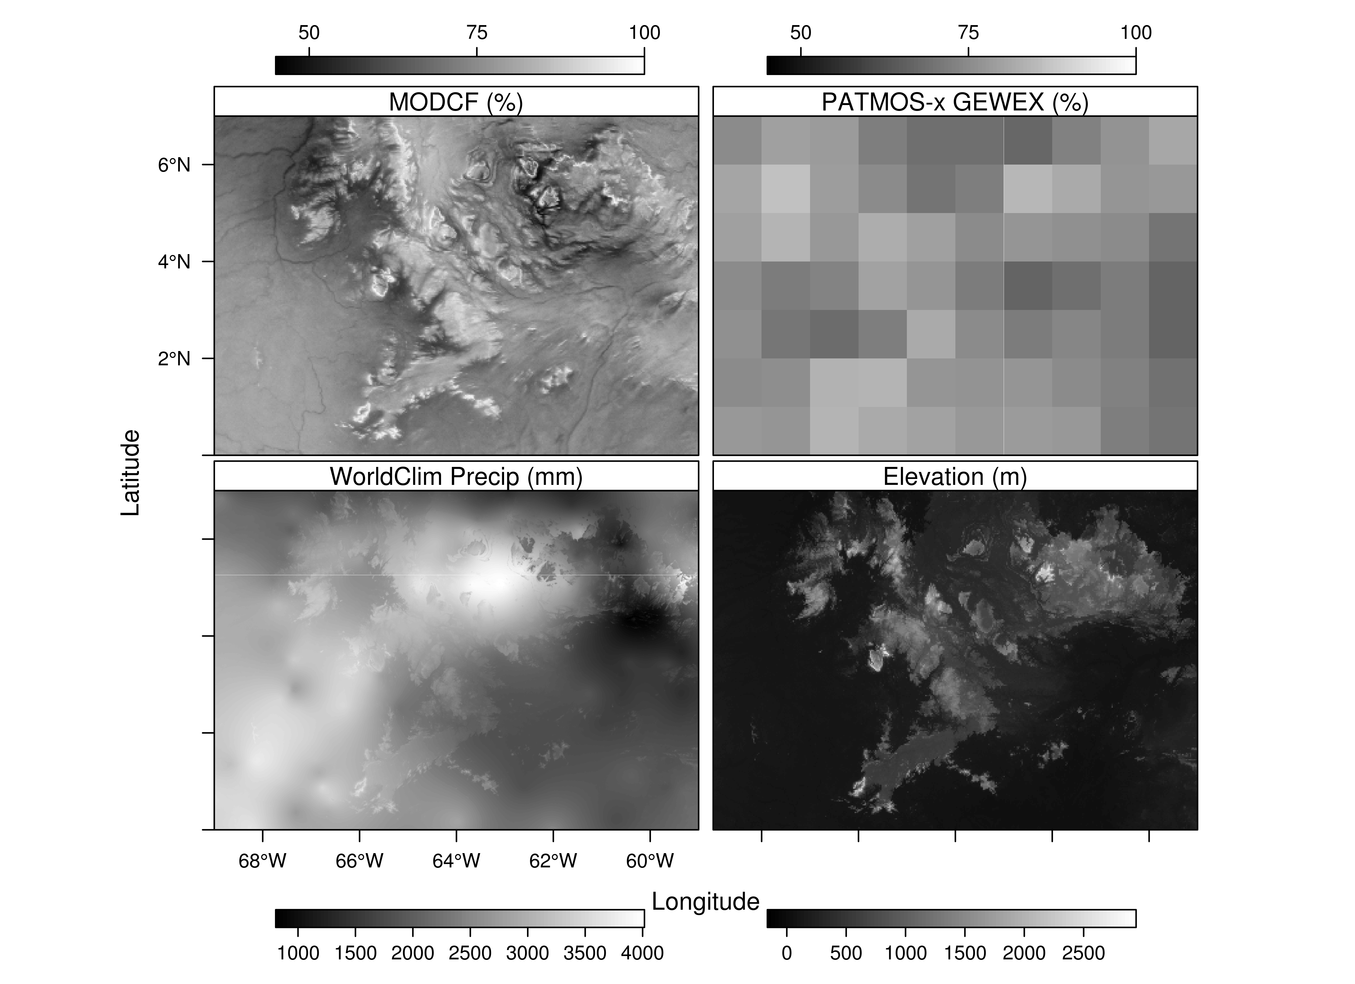

Figure : Comparison of cloud related products for a region near Parque Nacional Jaua-Sarisariñama in Southern Venezuela. Top left: MODCF developed in this paper (~1km resolution). Top right: PATMOS-x AVHRR data formatted for the Global Energy and Water cycle Experiment (GEWEX) Cloud Assessment (1 degree, ~110km). Lower left: WorldClim mean annual precipitation (mm). Lower right: Elevation (m).

### Limitations and Caveats

The MOD09 cloud algorithm was designed to minimize confusion over snow and ice by taking the surface air temperature into account, however there are possibly inflated cloud frequency over snow-covered areas which are not well represented in our validation data set. Like many cloud masks, the MOD09 detection algorithm has a binary response (cloudy/not cloudy) and does not retain an estimate of confidence in cloud state (i.e. probability that the pixel was actually cloudy given the tests). The other MODIS cloud mask (MOD35) converts the continuous probabilities into four bins (‘certainly clear,’ ‘probably clear,’ ‘probably cloudy,’ and ‘confidently cloudy’), and is available at the satellite swath-level (which would avoid any sampling problems introduced by the orbital parameters and the MODLAND selection criteria). However, due to spatially heterogeneous application of cloud tests (even in the recently reprocessed Collection 6), the MOD35 mask is unsuitable for generating spatially consistent maps of cloud frequencies at 1-km resolution (Wilson, Parmentier, and Jetz 2013). Liu and Liu (2013) introduced an interesting alternative method of estimating cloud cover based on multi-year timeseries of MOD09 surface reflectance, which is promising but currently based on the frequency of clouds between 8-day MODLAND composites and thus cannot estimate the true daily cloud frequency (e.g. a cloudy observation in a single 8-day MODLAND window indicates 8 cloudy days, but a clear observation could indicated 1-7 clear days). Other approaches have been developed to estimate continuous probabilities rather than binned classifications (e.g. Heidinger et al. 2012), but these have not been applied to MODIS data.

However, there the human-observed station data used for validation have known biases at the low and high cloud amounts (ELABORATE and cite). There is evidence of a negative bias in MODCF due to increased frequency of observations at high latitudes and the MODLAND algorithm (Figure 4).

### Applications to biodiversity and ecological modeling

Cloud cover is known to be an important factor for many biological processes ranging from ecosystem parameters (such as net primary productivity) to animal behavior. For example, Graham, et. al (2003) used data from a micrometeorological station to determine that seasonal availability in light due to cloud cover limited CO2 uptake in a rainforest tree species. Goldsmith, Matzke, and Dawson (2013) compared MODIS MOD35 cloud frequency to understand how cloud cover and leaf wetting varied across sites in tropical montane and pre-montane cloud forests. They found that the satellite-derived cloud cover was a useful predictor of leaf wetness even between sites only 2km apart. They used the MOD35 cloud data only for the pixels over their forested study locations, so the land-cover biases present in the MOD35 data (Wilson, Parmentier, and Jetz 2013) were unlikely to affect the analysis. Fischer, Still, and Williams (2009) modeled drought stress in bishop pine (*Pinus* muricata) and found that persistent cloud cover near the coast of Santa Cruz Island (California, USA) reduced annual drought stress by 22-44% compared to less cloudy areas further inland. Hare and Cree (2010) experimentally altered available radiation to simulate increased cloud cover and found it lowered maternal pregnancy success and slowed growth rates of female McCann’s skinks (*Oligosoma maccanni*). However, these studies all had very limited spatial extents and required either local cloud observations or extensive processing of satellite observations.

Quintero, et. al, recently evaluated the use of MODCF in a test of the “Asynchrony of Seasons Hypothesis” which suggests that seasonal differences in climate-derived food availability could lead to asynchronous breeding seasons and gene flow barriers. The study was conducted using genetic data from ~1600 individuals of 74 species of bird from locations around North and South America. WorldClim monthly precipitation (Hijmans et al. 2005) and the MODCF cloud climatologies were both evaluated as proxies for the seasonality of food availability and MODCF improved model performance.

CONCLUDING PARAGRAPH

solar power development (c.f. Ramachandra, Jain, and Krishnadas 2011; Tapiador 2009).

# Appendix figures

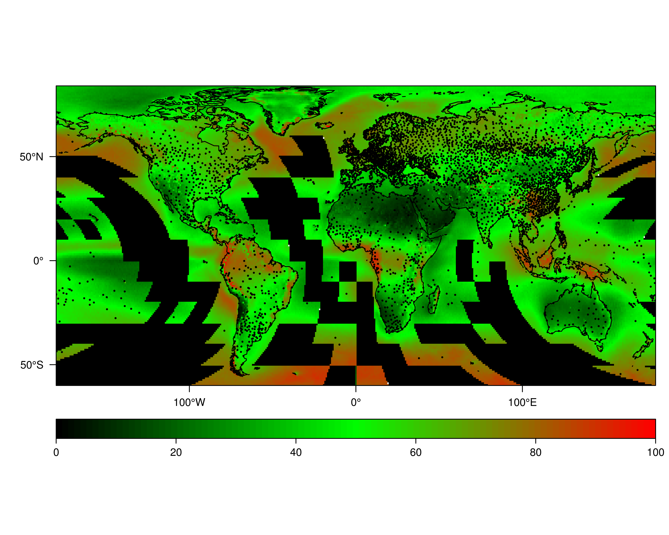

Figure : Locations of the stations used to validate the cloud product. ADD INDICATION OF STATION ERA (FULL, MODIS)

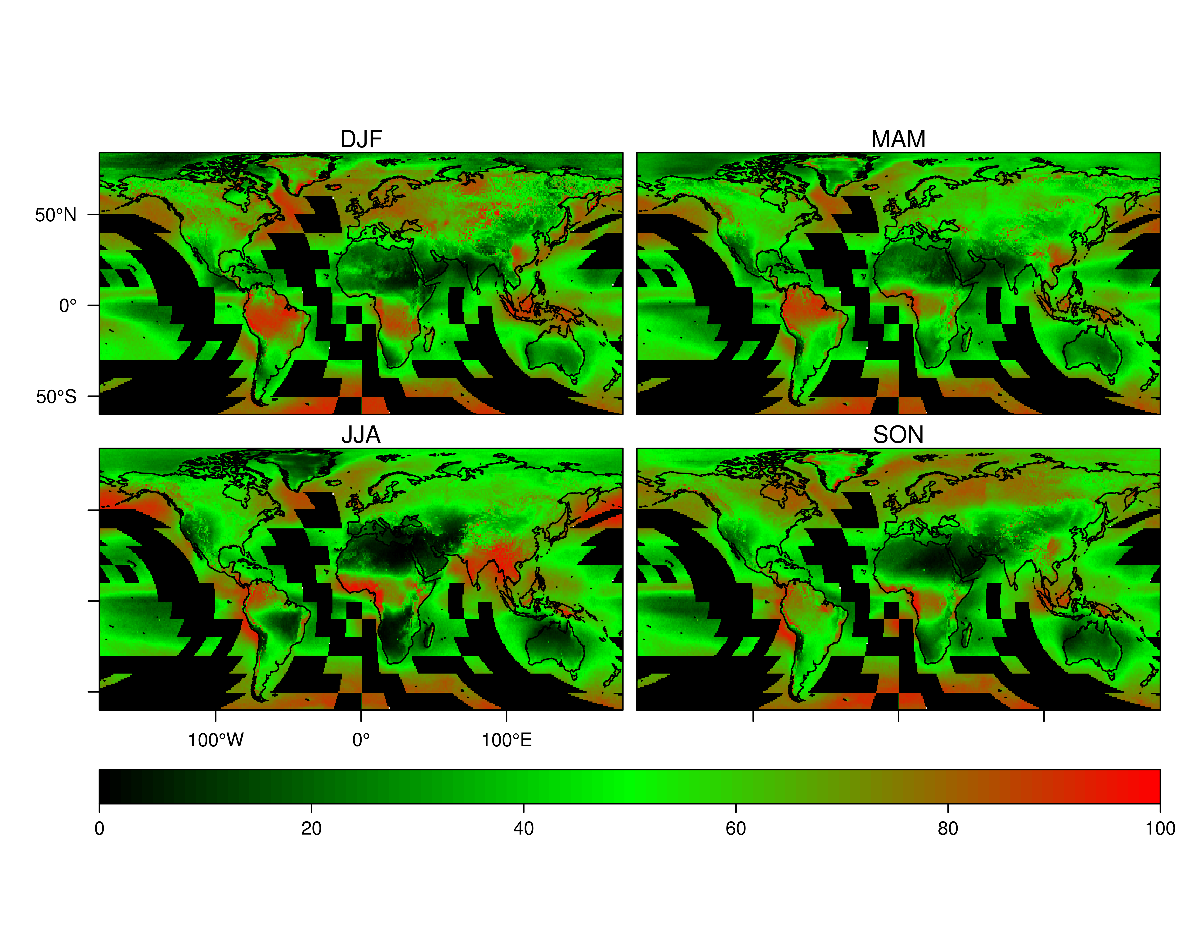

Figure : Near-global 1-km seasonal mean (DJF: December, January, February; MAM: March, April, May; JJA: June, July, August; SON: September, October, November) cloud frequency (proportion of days flagged as cloudy) derived from MODIS MOD09 internal cloud mask algorithm over 2000-2012.

# References

Allard, Jason, and Andrew Carleton. 2010. “Mesoscale Associations Between Midwest Land Surface Properties and Convective Cloud Development in the Warm Season.” *Physical Geography* 31 (2): 107–36. doi:10.2747/0272-3646.31.2.107.

Clench, Harry K. 1966. “Behavioral Thermoregulation in Butterflies.” *Ecology* 47 (6): 1021–34. doi:10.2307/1935649.

Descloitres, J., R. Sohlberg, J. Owens, L. Giglio, C. Justice, M. Carroll, J. Seaton, et al. 2002. “The MODIS Rapid Response Project.” In *Geoscience and Remote Sensing Symposium, 2002. IGARSS ’02. 2002 IEEE International*, 2:1191–1192 vol.2. doi:10.1109/IGARSS.2002.1025879.

Douglas, Michael. 2013. “A High Spatial Resolution Satellite-Based Cloud Climatology for Biogeographical Applications.” In *6th International Conference*. Miami, FL: International Biogeography Society. http://www.nssl.noaa.gov/projects/pacs/web/MODIS/.

Douglas, Michael, Rahama Beida, and Abdul Dominguez. 2010. “Developing High Spatial Resolution Daytime Cloud Climatologies for Africa.” In *Preprints, 29th Conf. on Hurricanes and Tropical Meteorology, Tucson, AZ, Amer. Meteor. Soc. P*. Vol. 2. https://ams.confex.com/ams/pdfpapers/168263.pdf.

Durieux, L., L. A. T. Machado, and H. Laurent. 2003. “The Impact of Deforestation on Cloud Cover over the Amazon Arc of Deforestation.” *Remote Sensing of Environment* 86 (1): 132–40.

Dybbroe, Adam, Karl-Göran Karlsson, and Anke Thoss. 2005. “NWCSAF AVHRR Cloud Detection and Analysis Using Dynamic Thresholds and Radiative Transfer Modeling. Part II: Tuning and Validation.” *Journal of Applied Meteorology* 44 (1): 55–71. doi:10.1175/JAM-2189.1.

Eastman, Ryan, and Stephen G. Warren. 2012. “Land Cloud Update, 1997-2009, Appended to Cloud Climatology for Land Stations Worldwide, 1971-1996.” NDP-026D. Oak Ridge, Tennessee: Climate Change Research Division Office of Biological and Environmental Research U.S. Department of Energy. http://cdiac.ornl.gov/epubs/ndp/ndp026d/ndp026d.html.

Fehrenbach, J., P. Weiss, and C. Lorenzo. 2012. “Variational Algorithms to Remove Stationary Noise: Applications to Microscopy Imaging.” *IEEE Transactions on Image Processing* 21 (10): 4420–30. doi:10.1109/TIP.2012.2206037.

Fehrenbach, Jérôme, and Pierre Weiss. 2013. “Processing Stationary Noise: Model and Parameter Selection in Variational Methods.” *arXiv Preprint arXiv:1307.4592*. http://arxiv.org/abs/1307.4592.

Fischer, Douglas T., Christopher J. Still, and A. Park Williams. 2009. “Significance of Summer Fog and Overcast for Drought Stress and Ecological Functioning of Coastal California Endemic Plant Species.” *Journal of Biogeography* 36 (4): 783–99. doi:10.1111/j.1365-2699.2008.02025.x.

Goldsmith, Gregory R., Nicholas J. Matzke, and Todd E. Dawson. 2013. “The Incidence and Implications of Clouds for Cloud Forest Plant Water Relations.” *Ecology Letters* 16 (3): 307–14. doi:10.1111/ele.12039.

Graham, Eric A., Stephen S. Mulkey, Kaoru Kitajima, Nathan G. Phillips, and S. Joseph Wright. 2003. “Cloud Cover Limits Net CO2 Uptake and Growth of a Rainforest Tree during Tropical Rainy Seasons.” *Proceedings of the National Academy of Sciences* 100 (2): 572–76. doi:10.1073/pnas.0133045100.

Gregg, Watson W., and Nancy W. Casey. 2007. “Sampling Biases in MODIS and SeaWiFS Ocean Chlorophyll Data.” *Remote Sensing of Environment* 111 (1): 25–35. doi:10.1016/j.rse.2007.03.008.

Grubb, Thomas C., Jr. 1977. “Weather-Dependent Foraging Behavior of Some Birds Wintering in a Deciduous Woodland: Horizontal Adjustments.” *The Condor* 79 (2): 271–74. doi:10.2307/1367175.

Hare, Kelly M., and Alison Cree. 2010. “Exploring the Consequences of Climate-Induced Changes in Cloud Cover on Offspring of a Cool-Temperate Viviparous Lizard.” *Biological Journal of the Linnean Society* 101 (4): 844–51. doi:10.1111/j.1095-8312.2010.01536.x.

Heidinger, Andrew K., Amato T. Evan, Michael J. Foster, and Andi Walther. 2012. “A Naive Bayesian Cloud-Detection Scheme Derived from CALIPSO and Applied within PATMOS-X.” *Journal of Applied Meteorology and Climatology* 51 (6): 1129–44.

Hijmans, R J, S E Cameron, J L Parra, P G Jones, A. Jarvis, and Others. 2005. “Very High Resolution Interpolated Climate Surfaces for Global Land Areas.” *International Journal of Climatology* 25 (15): 1965–78.

Houze, Robert A. 2012. “Orographic Effects on Precipitating Clouds.” *Reviews of Geophysics* 50 (RG1001). doi:10.1029/2011RG000365. http://onlinelibrary.wiley.com/doi/10.1029/2011RG000365/abstract.

Kalnay, E., M. Kanamitsu, R. Kistler, W. Collins, D. Deaven, L. Gandin, M. Iredell, et al. 1996. “The NCEP/NCAR 40-Year Reanalysis Project.” *Bulletin of the American Meteorological Society* 77 (3): 437–71. doi:10.1175/1520-0477(1996)077<0437:TNYRP>2.0.CO;2.

Knapp, K.R., S. Ansari, C.L. Bain, M.A. Bourassa, M.J. Dickinson, C. Funk, C.N. Helms, et al. 2011. “Globally Gridded Satellite Observations for Climate Studies.” *Bulletin of the American Meteorological Society* 92 (7): 893.

Ledo, Alicia, David F.R.P. Burslem, Sonia Condés, and Fernando Montes. 2012. “Micro-Scale Habitat Associations of Woody Plants in a Neotropical Cloud Forest.” *Journal of Vegetation Science*, n/a–n/a. doi:10.1111/jvs.12023.

Liu, Ronggao, and Yang Liu. 2013. “Generation of New Cloud Masks from MODIS Land Surface Reflectance Products.” *Remote Sensing of Environment* 133 (June): 21–37. doi:10.1016/j.rse.2013.01.019.

Mulligan, Mark. 2006. “MODIS MOD35 Pan-Tropical Cloud Climatology.” *MODIS Cloud Climatology, Version 1*. http://www.ambiotek.com/clouds/.

Olson, David M., Eric Dinerstein, Eric D. Wikramanayake, Neil D. Burgess, George V. N. Powell, Emma C. Underwood, Jennifer A. D’amico, et al. 2001. “Terrestrial Ecoregions of the World: A New Map of Life on Earth.” *BioScience* 51 (11): 933–38. doi:10.1641/0006-3568(2001)051[0933:TEOTWA]2.0.CO;2.

Pavolonis, Michael J., Andrew K. Heidinger, and Taneil Uttal. 2005. “Daytime Global Cloud Typing from AVHRR and VIIRS: Algorithm Description, Validation, and Comparisons.” *Journal of Applied Meteorology* 44 (6): 804–26.

Petitcolin, François, and Eric Vermote. 2002. “Land Surface Reflectance, Emissivity and Temperature from MODIS Middle and Thermal Infrared Data.” *Remote Sensing of Environment* 83 (1–2): 112–34. doi:10.1016/S0034-4257(02)00094-9.

Pincus, Robert, Steven Platnick, Steven A. Ackerman, Richard S. Hemler, and Robert J. Patrick Hofmann. 2012. “Reconciling Simulated and Observed Views of Clouds: MODIS, ISCCP, and the Limits of Instrument Simulators.” *Journal of Climate* 25 (13): 4699–4720. doi:10.1175/JCLI-D-11-00267.1.

Potter, Kristen A., H. Arthur Woods, and Sylvain Pincebourde. 2013. “Microclimatic Challenges in Global Change Biology.” *Global Change Biology* 19 (10): 2932–39. doi:10.1111/gcb.12257.

Ramachandra, T.V., Rishabh Jain, and Gautham Krishnadas. 2011. “Hotspots of Solar Potential in India.” *Renewable and Sustainable Energy Reviews* 15 (6): 3178–86. doi:10.1016/j.rser.2011.04.007.

Roger, J.C., and E.F. Vermote. 1998. “A Method to Retrieve the Reflectivity Signature at 3.75 Μm from AVHRR Data.” *Remote Sensing of Environment* 64 (1): 103–14. doi:10.1016/S0034-4257(97)00173-9.

Sklenář, Petr, Jörg Bendix, and Henrik Balslev. 2008. “Cloud Frequency Correlates to Plant Species Composition in the High Andes of Ecuador.” *Basic and Applied Ecology* 9 (5): 504–13. doi:10.1016/j.baae.2007.09.007.

Stephens, G. L, and C. D Kummerow. 2007. “The Remote Sensing of Clouds and Precipitation from Space: A Review.” *Journal of the Atmospheric Sciences* 64 (11): 3742–65.

Stubenrauch, C .J., W. B. Rossow, S. Kinne, S. Ackerman, G. Cesana, H. Chepfer, L. Di Girolamo, et al. 2013. “Assessment of Global Cloud Datasets from Satellites: Project and Database Initiated by the GEWEX Radiation Panel.” *Bulletin of the American Meteorological Society*, January, 130117123745009. doi:10.1175/BAMS-D-12-00117.

Tapiador, Francisco J. 2009. “Assessment of Renewable Energy Potential through Satellite Data and Numerical Models.” *Energy & Environmental Science* 2 (11): 1142–61. doi:10.1039/B914121A.

Taylor, Christopher M., Richard A. M. de Jeu, Françoise Guichard, Phil P. Harris, and Wouter A. Dorigo. 2012. “Afternoon Rain More Likely over Drier Soils.” *Nature* 489 (7416): 423–26. doi:10.1038/nature11377.

Vermote, E. F., S. Y. Kotchenova, and J. P. Ray. 2011. “MODIS Surface Reflectance User’s Guide”. Version 1.3. Department of Geography, University of Maryland, College Park, MD, USA: MODIS Land Surface Reflectance Science Computing Facility. http://modis-sr.ltdri.org.

Vermote, E. F., John O’Bannon, Rhonda Davis, Francois PetitColin, James Ray, and Nazmi El Saleous. 2001. “Land Surface Reflectance Code Development, Testing and Delivery”. Contract Number NAS5-96062. MODIS Science Team Member Semi-Annual Report. University of Maryland: University of Maryland.

Wang, Jingfeng, Frédéric J. F. Chagnon, Earle R. Williams, Alan K. Betts, Nilton O. Renno, Luiz A. T. Machado, Gautam Bisht, Ryan Knox, and Rafael L. Bras. 2009. “Impact of Deforestation in the Amazon Basin on Cloud Climatology.” *Proceedings of the National Academy of Sciences* 106 (10): 3670–74. doi:10.1073/pnas.0810156106.

Wilson, Adam M., Benoit Parmentier, and Walter Jetz. 2013. “Systematic Landcover Bias in Collection 5 MODIS Cloud Mask and Derived Products – a Global Overview.” *Remote Sensing of Environment* in press. doi:10.1016/j.rse.2013.10.025.

Wilson, Adam M., Benoit Parmentier, Brian McGill, Robert Guralnick, and Walter Jetz. 2013. “Incorporating Satellite Derived Cloud Climatologies to Improve High Resolution Interpolation of Daily Precipitation.” In *6th International Conference*. Miami, FL: International Biogeography Society. http://www.biogeography.org/html/Meetings/2013/.

Wylie, Donald, Darren L. Jackson, W. Paul Menzel, and John J. Bates. 2005. “Trends in Global Cloud Cover in Two Decades of HIRS Observations.” *Journal of Climate* 18 (15): 3021–31.